Understanding the Durability of the Paul Biya Regime in Cameroon: A Micro-Level Analysis Using Afrobarometer Data

Adrien Ratsimbaharison and Benn Bongang

March 12, 2019

## Abstract

The durability (or stability) of the Paul Biya regime, which is an extension of the Ahmadou Ahidjo regime, could be a blessing or a curse for the Cameroonian people. Indeed, almost every study on the relationship between regime durability (or political stability) and economic development would lead to the conclusion that the former is an important condition of the latter. Nevertheless, the fact that a country has been ruled for so many years by the same individual, without being a monarchy, is certainly a sign of autocracy. Also, having the same leader for decades may result in sclerosis and lack of innovations for further development of the country. Most of those who attempted to explain the durability of the Biya regime adopted a top-down approach or macro-level analysis. They tried to understand what the Biya regime did in order to stay in power for so long. In this sense, very few (if any) studies used a micro-level analysis or bottom-up approach and attempted to understand the Cameroonian people’s opinions and attitudes to explain why they were willing to stay under the same ruler for at least two generations. We adopt such micro-level analysis or bottom-up approach in this study. Using the data from rounds 5, 6, and 7 of the Afrobarometer national surveys on Cameroon, we apply different statistical techniques to find out to what extent the Cameroonian people trust their president and his regime and to identify the factors that may influence them to support or reject him. As a result, we find despite the marked difference between French-speaking and English-speaking communities, the majority of the population of the country, especially the French speaking still trust the President Paul Biya, and believe that the country is on a democratic path, while the majority of the English-speaking population believe the country is undemocratic. In sum, using a micro-level analysis, we can draw the conclusion that the people’s opinions and attitudes explain the Biya regime remained in power for several decades.

**Keywords:** Africa, Cameroon, political stability, regime durability, micro-level analysis, Afrobarometer national survey

## Introduction

President Paul Biya was elected for the seventh time as the president of Cameroon in October 2018, despite the protests from the opposition from different parts of the countries. This seventh term in office will consolidate his title as the “longest serving president in the world,” and he is expected to stay in power until 2025 or for 43 years. The durability (or stability) of the Paul Biya regime could be a blessing or a curse for the Cameroonian people. Indeed, almost every study on the relationship between regime durability (or political stability) and economic development would lead to the conclusion that the former is an important condition of the latter. Nevertheless, the fact that a country has been ruled for so many years by the same individual, without being a monarchy, is certainly a sign of autocracy. Also, having the same leader for decades may also result in sclerosis and lack of innovations for further development of the country.

This study is based on a micro-level analysis or bottom-up approach to the durability of the Paul Biya regime. In this sense, instead of analyzing what the president and his regime are doing to stay in power for so long, we try to understand what the Cameroonian people think about their president and his rule. Thus, using the data from rounds 5, 6 and 7 of the Afrobarometer national surveys on Cameroon, we try to find out to what extent the Cameroonian people trust their president and his regime and to identify the factors that may influence them in their support or lack thereof.

## Literature Review

A quick review of the literature shows that most of those who tried to explain the durability of the Paul Biya regime took a top-down approach or a macro-level analysis. In other words, they tried to understand what the Biya regime did in order to stay in power for so long. In this sense, very few (if any) studies used a bottom-up approach or micro-level analysis and attempted to understand the Cameroonian people’s opinions and attitudes to explain the durability of this regime. Cameroon was barely a decade in existence as an independent federal republic when Victor T. Levine (1971) noted its political stability and hinted at the potential for future instability inherent in the “complexity” of its political, social, and economic configurations.” No doubt then that Levine found Cameroon’s stability “most remarkable.” Unlike Cameroon, he observed, other African countries federations fractured, including the Central African Federation, Ethiopian-Eritrean Federation, as well as the Federal Republic of Nigeria and the secession of Biafra. In his study on the origins of radical nationalism in Cameroon, Richard A. Joseph (1977) traces the post-World 11birth of the nationalist party, Union des Populations du Cameroon (UPC) and documents the brutal repression of its militants by the French and their allies in Cameroon who eventually became the leadership of the country under Ahmadou Ahidjo at independence. UPC militants were exiled for several years, lured back in the early 1970s, their leaders were publicly executed. Nicolas Argenti (2007) anthropological examination of the origins of youth violence in the Grassfields of Cameroon suggests, for instance, that repression of those who challenged colonial authorities led the youth in places such as Oku to resort to secret societies and masked warrior dances to confront and frighten their oppressors. Other authors (Takougang, 1998; Konings and Nyamnyoh, 2003; Fowler and Zeitlyn 1996) provide insightful explanations of political and structural factors that explain the durability and relative political stability of the Biya regime. However, they do not fully explain citizens attitudes as a factor in understanding Cameroon under Biya.

## Data and Methodology

Afrobarometer is “a pan-African, non-partisan research network that conducts public attitude surveys on democracy, governance, economic conditions, and related issues in more than 35 countries in Africa.” (Afrobarometer, 2019) Over the years, Afrobarometer’s surveys became one of the most trusted and reliable sources of information on African people’s opinions and attitudes toward their political and economic conditions, as well as their rulers. Cameroon was included in rounds 5, 6, and 7 of the national surveys conducted by Afrobarometer. Even if the surveys data do not directly address the questions about the durability of the Paul Biya regime, the data from they allow us to understand the Cameroonian people’s opinions and attitudes toward the president and his regime and explain why they are willing to stay under the same regime for so many years. In this study, we first assess to what extent the Cameroonian people support or reject President Biya to make his regime durable. In this sense, we will use the respondents’ responses to the questions about their trust to the institutions, including the president, as a proxy to their support or lack thereof. We assume that the more a respondent trust the president, the more likely he/she would allow his regime to endure. Next, we will analyze the trends and regional variations of their responses, particularly the difference between the French speaking and English speaking communities. Lastly, using machine learning techniques, we will also identify the factors that may be associated with their trust or not in the institutions. As, we will see these factors include: opinions regarding the performance of the regime, satisfaction with democracy, and satisfaction with freedom. The statistical and programming software R will be used to handle the data manipulation and analysis. As such, we particularly rely on the Caret package in our machine learning procedures.

## Findings

### Descriptive Statistics

Afrobarometer’s round 7 survey consists of the responses of 1204 respondents to some 297 questions. These respondents were randomly selected by Afrobarometer in taking into consideration the following factors:

* urban or rural location of the respondent,
* region of the respondent,
* age of the respondent,
* primary language spoken by the respondent at home

# Distribution between urban and rural location of the respondents  
table(cameroonRound7$URBRUR)

##   
## 1 2   
## 636 568

# Distribution of respondents by region of origin  
table(cameroonRound7$REGION)

##   
## 1220 1221 1222 1223 1224 1225 1226 1227 1228 1229 1230 1231   
## 122 136 64 104 40 216 48 137 104 104 40 89

# Distribution of respondents by age  
table(cameroonRound7$Q1)

##   
## 18 19 20 21 22 23 24 25 26 27 28 29 30 31 32 33 34 35   
## 58 59 63 36 53 49 34 83 44 40 38 23 72 18 41 21 18 43   
## 36 37 38 39 40 41 42 43 44 45 46 47 48 49 50 51 52 53   
## 13 17 21 21 32 14 14 8 13 30 8 10 14 4 24 4 11 7   
## 54 55 56 57 58 59 60 61 62 63 64 65 66 67 68 69 70 71   
## 5 9 8 8 7 6 25 5 5 8 4 8 3 2 3 1 10 2   
## 72 73 74 75 76 79 80 83 85 90 93 998   
## 5 2 2 2 1 3 6 2 1 1 1 1

# Distribution of respondents by primary language at home  
table(cameroonRound7$Q2B)

##   
## 1 2 1220 1221 1222 1223 1224 1225 1226 1227 1228 1229 1230 1231 1232   
## 86 371 257 74 18 6 5 2 4 6 1 9 34 5 1   
## 1233 1234 1236 1237 1238 1239 1242 1243 1244 1245 1246 1247 1248 1249 1250   
## 3 24 1 15 2 12 8 2 9 5 9 16 2 3 14   
## 1252 1253 1254 1255 1257 1258 1259 2220 2223 2231 9995 9998 9999   
## 9 4 16 1 6 1 3 5 10 11 132 1 1

In this study, we will focus on two major factors that may help us understand why Paul Biya’s regime has been one of the most durable regime in Africa. These two factors are:

* the trust of the respondents in the President,
* the approval of the way the President performed his job

Assuming that the people who trust the President tend also to approve the way he performs his job, and tend also to vote for him or let him stay in power for a long time, we will identify in this study the factors that lead these people this trust and approval.

Concerning the level of trust, we find that:

* the great majority of Cameroonians (over 59%) trust “a lot” or “somewhat” the President (See Figure 1 below)
* about 35% of them do not trust “at all” or “trust a little”

trustLevel <- table(cameroonRound7$trustInThePresident)  
  
prop.table(trustLevel)

##   
## 1. Not at all 2. Just a little 3. Somewhat 4. A lot   
## 0.18355482 0.16528239 0.16279070 0.42857143   
## 5. Don't know   
## 0.05980066

ggplot(data = cameroonRound7, aes(trustInThePresident)) +  
 geom_bar()

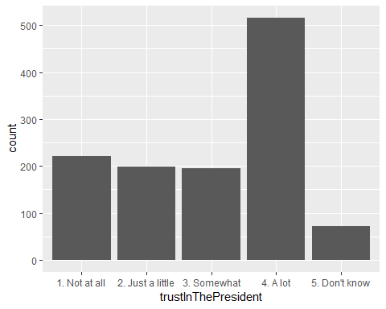

Concerning the level of trust, we also find that:

approvalLevel <- table(cameroonRound7$approvalOfThePresident)  
prop.table(approvalLevel)

##   
## 1. Strongly disapprove 2. Disapprove 3. Approve   
## 0.1528239 0.1818937 0.3779070   
## 4. Strongly approve 5. Don't know   
## 0.1827243 0.1046512

ggplot(data = cameroonRound7, aes(approvalOfThePresident)) +  
 geom_bar()

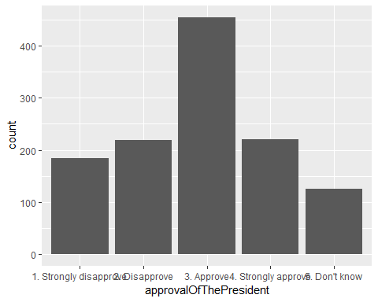

* the great majority of Cameroonians (over 56%) either “approve”" or “strongly approve” the way the President performed his job, and
* only about 33.5% of them do not “approve” or “stongly disapprove”.

It is worth noting that the trust in the President and approval of his job performance are very low among the people in the Anglophone areas (North-East and South-East).

# Subsetting the Anglophone respondents (inhabitants of the North-East and South_East regions, respectively No. 1228 and 1231 in the Afrobarometer survey)  
  
anglophone <- filter(cameroonRound7, REGION == 1228 | REGION == 1231)  
francophone <- filter(cameroonRound7, REGION != 1228 & REGION != 1231)  
  
# Trust level among Anglophone  
trustLevelAnglo <- table(anglophone$trustInThePresident)  
  
prop.table(trustLevelAnglo)

##   
## 1. Not at all 2. Just a little 3. Somewhat 4. A lot   
## 0.48186528 0.24352332 0.06217617 0.04145078   
## 5. Don't know   
## 0.17098446

ggplot(data = anglophone, aes(trustInThePresident)) +  
 geom_bar()

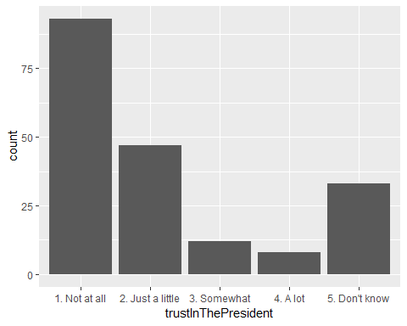

# Approval level among Anglophone  
approvalLevelAnglo <- table(anglophone$approvalOfThePresident)  
prop.table(approvalLevelAnglo)

##   
## 1. Strongly disapprove 2. Disapprove 3. Approve   
## 0.38860104 0.22797927 0.10880829   
## 4. Strongly approve 5. Don't know   
## 0.01036269 0.26424870

ggplot(data = anglophone, aes(approvalOfThePresident)) +  
 geom_bar()

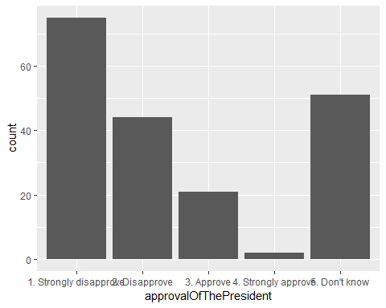 The correlation between “trust” and “approval”:

In order to determine whether “trust” and “approval” are correlated and can be used interchangeable, we compute and plot the correlation between the two variables.

# First, we need to transform the variables to numeric  
cameroonRound7$Q43A <- as.numeric(cameroonRound7$Q43A)  
cameroonRound7$Q58A <- as.numeric(cameroonRound7$Q58A)  
  
cor(cameroonRound7$Q43A, cameroonRound7$Q58A)

## [1] 0.3117326

The correlation between “trust”, “approval”, and “voting”:

In order to determine whether “trust” or “approval” are correlated with “voting intention”, we crosstabulate these variable Q99, which is the answer to the question “If presidential elections were held tomorrow, which party’s candidate would you vote for?”

prop.table(votingIntention)

##   
## 1. Vote for the President 2. Vote for other candidates   
## 0.45099668 0.07973422   
## 3. Don't know   
## 0.46926910

ggplot(data = cameroonRound7, aes(voteForThePresident)) +  
 geom_bar()

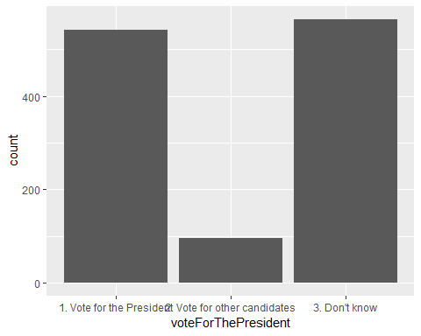

votingIntentionTrust <- table(cameroonRound7$trust, cameroonRound7$voteForThePresident)  
prop.table(votingIntentionTrust)

##   
## 1. Vote for the President 2. Vote for other candidates  
## 1. Trust 0.351328904 0.027408638  
## 2. Distrust 0.092192691 0.047342193  
## 3. Don't know 0.007475083 0.004983389  
##   
## 3. Don't know  
## 1. Trust 0.212624585  
## 2. Distrust 0.209302326  
## 3. Don't know 0.047342193

votingIntentionApproval <- table(cameroonRound7$approval, cameroonRound7$voteForThePresident)  
prop.table(votingIntentionApproval)

##   
## 1. Vote for the President 2. Vote for other candidates  
## Approve 0.34385382 0.02408638  
## Disapprove 0.08803987 0.04318937  
## Don't know 0.01910299 0.01245847  
##   
## 3. Don't know  
## Approve 0.19269103  
## Disapprove 0.20348837  
## Don't know 0.07308970

### The Determinants of the Popular Trust in the President and Approval of his Job Performance

We run two machine learning scripts to identify the factors that led to the trust in the President and the approval of his job performance.

The results of these machine learning scripts are as follows:

#### 1) The predictors of trust in the President are:

gbm variable importance

only 20 most important variables shown (out of 1741)

Overall

Q43B3 100.000 Q43B2 72.138 Q43H3 70.212 Q43B9 39.969 Q43L_CAM2 20.865 REGION1231 15.828 Q43E3 14.454 Q1 11.612 Q43E9 11.186 Q43G2 9.696 Q2B2 8.560 Q43H9 7.583 Q43F1 7.366 Q361 6.616 Q61A5 6.552 Q932 6.391 Q43I2 6.325 Q43D2 6.062 Q58A4 5.990 Q61C2 5.946

#### 2) The predictors of the approval of the President’s job performance are:

rf variable importance

variables are sorted by maximum importance across the classes only 20 most important variables shown (out of 1741)

0 1 2

Q43A3 100.00 74.75 64.65 Q58B3 92.30 87.98 60.46 Q58B9 49.81 38.20 84.46 Q43H3 75.05 52.88 62.48 Q43E3 69.53 35.47 57.17 REGION1228 27.44 67.31 47.15 REGION1231 42.87 67.04 26.20 Q43D3 65.68 45.77 50.32 Q43B3 64.90 26.18 53.26 Q4A4 64.66 34.41 23.31 Q44A9 63.75 22.36 36.66 Q58C3 37.04 63.27 41.88 Q43C3 62.17 44.87 58.50 Q58B2 61.64 45.19 44.46 Q43G3 57.36 40.25 61.41 Q58C9 40.60 38.05 60.98 Q58C2 54.91 59.64 43.07 Q61A5 59.62 29.62 44.87 Q43A9 19.78 42.67 59.14 Q32 59.08 47.06 40.79

## Discussion and Conclusion

## References