Case Study on Cameroon

Adrien Ratsimbaharison

9/28/2018

### Abstract

## Introduction

### Literature Review

### Research Questions

1. The regime has been unstable since the mid-1990s, but how did it manage to survive and prevent the escalation of conflict to crisis and civil war for so long?
2. The figure on stability trend shows two clear tendencies: first, a tendency toward stabilization between 1995 and 2005, second, a tendency toward destabilization since 2005, with a period of high instability and crisis (stability score lower than -1) in 2014-2015. So how can we explain these two tendencies? What did the regime or the opposition do during the stabilization period? What did the regime or the opposition do during the destabilization period?

### Methodology

This research project combine both quantitative research and qualitative research methods.

The quantitative data are collected from available data online provided by different organization such as the World Bank, The United Nations Development Progammes (UNDP), the Center for Systemic Peace (Polity IV Project), Freedom House. The data are managed and analyzed in R with different packages.

The qualitative data consist of new reports and analysis provided by different organizations, new agencies and various analysts and scholars. The data are mostly available online.They are managed and analyzed coded using RQDA software, following the “grounded theory” methodology.

## Political Stability Average and Trend for Cameroon

# Summary statistics  
summary(cameroon$stability)

## Min. 1st Qu. Median Mean 3rd Qu. Max.   
## -1.0593 -0.7710 -0.5757 -0.6148 -0.4410 -0.1831

# Boxplot of the political stability  
boxplot(cameroon$stability)

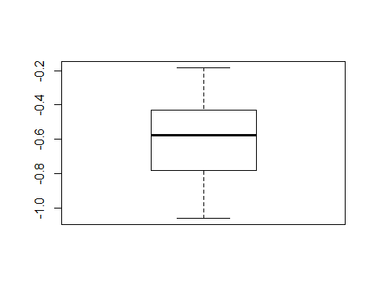

# General trend of political stability since 1996  
  
stabilityTrend <- ggplot(cameroon, aes(x= date, y = stability)) +  
 geom_line(color = "blue", size = 1.5) +  
 geom_hline(yintercept=0, linetype="dashed", color = "red", size=2) +  
 xlim(1996, 2016) +  
 ylim(-1.5, 1)  
  
stabilityTrend

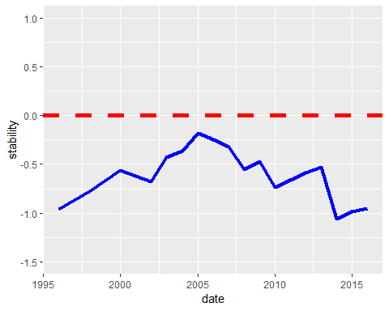

## Correlations between Political Stability and the Economic and Social Indicators

# summary statistics of the GNI per capita  
  
summary(cameroon$GNIperCapita)

## Min. 1st Qu. Median Mean 3rd Qu. Max.   
## 1026 1193 1279 1263 1325 1466

# General trend of GNI per capita since 1996  
  
ggplot(cameroon, aes(x= date, y = GNIperCapita)) +  
 geom_line(color = "blue", size = 1.5) +  
 ylim(0, 1500)

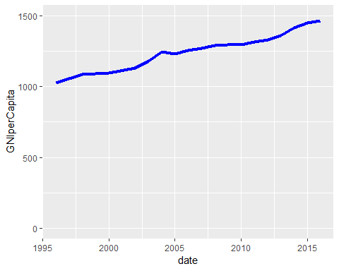

# summary statistics of the HDI  
  
summary(cameroon$HDI)

## Min. 1st Qu. Median Mean 3rd Qu. Max.   
## 0.4220 0.4595 0.4880 0.4885 0.5232 0.5530

# General trend of HDI since 1996  
  
ggplot(cameroon, aes(x= date, y = HDI)) +  
 geom_line(color = "red", linetype="dashed", size = 1.5) +  
 ylim(0.0, 0.9)

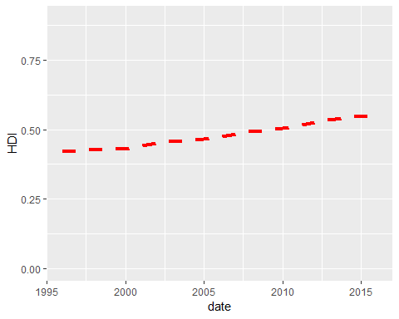

# correlation test between stability and GNI per capita and HDI  
  
cameroonEcoSoc <- cameroon %>%  
 select(stability, GNIperCapita, HDI)  
  
cor.test(cameroon$stability, cameroon$GNIperCapita)

##   
## Pearson's product-moment correlation  
##   
## data: cameroon$stability and cameroon$GNIperCapita  
## t = -0.90605, df = 16, p-value = 0.3784  
## alternative hypothesis: true correlation is not equal to 0  
## 95 percent confidence interval:  
## -0.6234805 0.2742393  
## sample estimates:  
## cor   
## -0.2209155

cor.test(cameroon$stability, cameroon$HDI)

##   
## Pearson's product-moment correlation  
##   
## data: cameroon$stability and cameroon$HDI  
## t = -1.3928, df = 16, p-value = 0.1827  
## alternative hypothesis: true correlation is not equal to 0  
## 95 percent confidence interval:  
## -0.6897995 0.1630787  
## sample estimates:  
## cor   
## -0.3288271

# plotting the correlation between stability and GNI per capita and HDI  
  
cameroonEcoSoc <- cameroon %>%  
 select(stability, GNIperCapita, HDI)  
  
  
plot(cameroonEcoSoc)

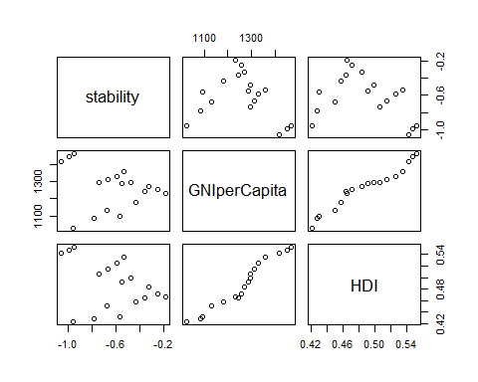

## Correlations between Political Stability and the Regime Type Indicators

# summary statistics of the polityScore  
  
summary(cameroon$polityScore)

## Min. 1st Qu. Median Mean 3rd Qu. Max.   
## -4 -4 -4 -4 -4 -4

# General trend of polityScore since 1996  
  
ggplot(cameroon, aes(x= date, y = polityScore)) +  
 geom_line(color = "blue", size = 1.5) +  
 ylim(-10, 10)

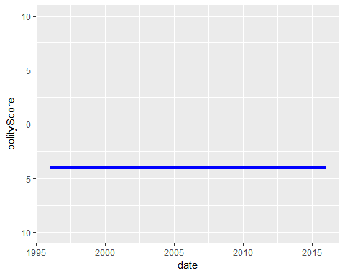

# summary statistics of the Freedom House reversed combined score  
  
summary(cameroon$inverse_mean)

## Min. 1st Qu. Median Mean 3rd Qu. Max.   
## 2.000 3.000 3.000 2.889 3.000 3.000

# General trend of the Freedom House reversed combined score  
  
ggplot(cameroon, aes(x= date, y = inverse_mean)) +  
 geom_line(color = "red", linetype="dashed", size = 1.5) +  
 ylim(0.0, 7)

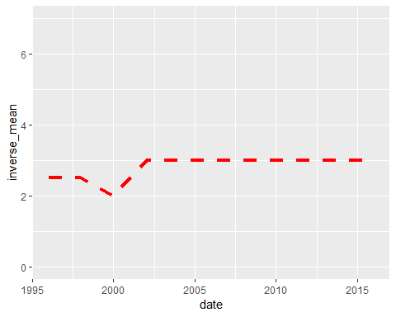

# correlation test between stability and polityScore and Freedom House's inversed combined scores of political rights and civil liberty  
  
cor.test(cameroon$stability, cameroon$polityScore)

##   
## Pearson's product-moment correlation  
##   
## data: cameroon$stability and cameroon$polityScore  
## t = NA, df = 16, p-value = NA  
## alternative hypothesis: true correlation is not equal to 0  
## 95 percent confidence interval:  
## NA NA  
## sample estimates:  
## cor   
## NA

cor.test(cameroon$stability, cameroon$inverse_mean)

##   
## Pearson's product-moment correlation  
##   
## data: cameroon$stability and cameroon$inverse_mean  
## t = 0.67696, df = 16, p-value = 0.5081  
## alternative hypothesis: true correlation is not equal to 0  
## 95 percent confidence interval:  
## -0.3253498 0.5879337  
## sample estimates:  
## cor   
## 0.1668667

# Scatterplot of the correlations between stability and regime type indicators  
  
cameroonRegimeType <- cameroon %>%  
 select(stability, polityScore, democ, autoc, inverse_pr, inverse_cl, inverse_mean)  
  
plot(cameroonRegimeType)

