Quantitative Data Analysis

Adrien Ratsimbaharison

9/29/2018

Table of Contents

## Descriptive statistics on political stability around the world:

### Political Stability Average and Trend for the Period of 1996-2017

#### Political stability average

The summary statistics of political stability shows that the world has been slightly unstable during the period of 1996 to 2016, but for the majority of the observations have been been stable:

* mean = -0.03591
* median = 0.06886

However, whle the maximum value of stability was only 1.96, the minimum value was -3.31

The boxplot and histogram of political stability also demonstrate that the majority of the observations were positive, but there were some extreme values of instability (the histogram is skewed to the left).

# The summary statistics of political stability estimate around the world  
  
summary(WGIbyCountryAndRegion$stability)

## Min. 1st Qu. Median Mean 3rd Qu. Max.   
## -3.31494 -0.69464 0.06886 -0.03591 0.81523 1.96148

boxplot(WGIbyCountryAndRegion$stability, ylab = "Political Stability")  
abline(h = 0, lwd= 1.5)

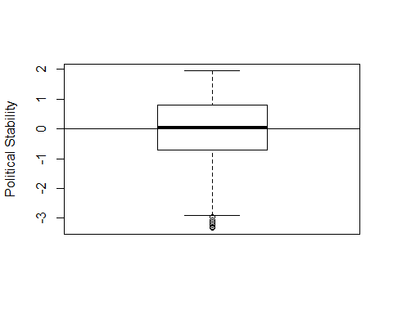

The Political Stability Average of the World (1996-2016)

hist(WGIbyCountryAndRegion$stability, main = "", xlab = "Political Stability")  
abline(v = median(WGIbyCountryAndRegion$stability, na.rm = TRUE), lwd = 2)  
text(x = -1, y = 650, "Median= 0.06886")

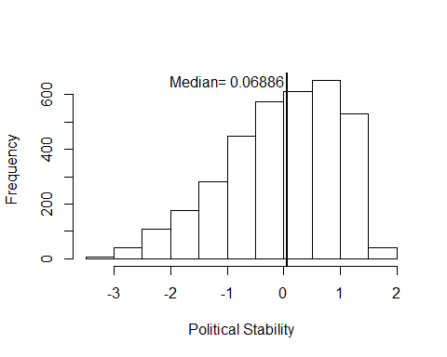

Frequency of Political Stability of the World (1996-2016)

#Proportion of stability and instability for the whole world  
  
stabilityProp <- table(WGIbyCountryAndRegion$stabilityDummy)  
stabilityProp

##   
## 0 1   
## 1634 1837

prop.table(stabilityProp)

##   
## 0 1   
## 0.4707577 0.5292423

#### Political stability by categories:

stabilityByCat <- table(WGIbyCountryAndRegion$stabilityCategory)  
stabilityByCat

##   
## Highly Stable Highly Unstable Moderately Stable   
## 571 611 1266   
## Moderately Unstable   
## 1023

prop.table(stabilityByCat)

##   
## Highly Stable Highly Unstable Moderately Stable   
## 0.1645059 0.1760300 0.3647364   
## Moderately Unstable   
## 0.2947277

#### Political stability trend

When looking at the trend of political stability around the world for the period of 1996-2016, the table on the annual average of political stability was hovering around zero, although it has slightly delined in recent years.

# generating a table of political stability trend of the world for the period of 1996-2016  
  
stabilityTrend <- WGIbyCountryAndRegion %>%  
 group_by(date) %>%  
 summarise(stabilityAnnualAverage = mean(stability, na.rm=TRUE))  
stabilityTrend

## # A tibble: 18 x 2  
## date stabilityAnnualAverage  
## <dbl> <dbl>  
## 1 1996 -0.0284   
## 2 1998 -0.00579  
## 3 2000 -0.00326  
## 4 2002 -0.00437  
## 5 2003 -0.0361   
## 6 2004 -0.0462   
## 7 2005 -0.0495   
## 8 2006 -0.0495   
## 9 2007 -0.0499   
## 10 2008 -0.0461   
## 11 2009 -0.0495   
## 12 2010 -0.0451   
## 13 2011 -0.0413   
## 14 2012 -0.0428   
## 15 2013 -0.0392   
## 16 2014 -0.0336   
## 17 2015 -0.0346   
## 18 2016 -0.0348

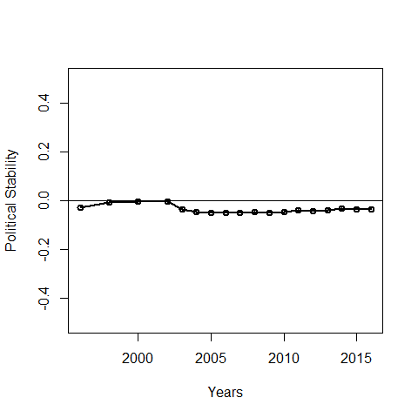

Trend of the Political Stability of the World for the Period of 1996-2016

### Political Stability by Region

* Political stability average by region

##   
## Africa Americas Asia Europe Oceania  
## 0 664 269 541 132 28  
## 1 278 425 356 581 197

##   
## Africa Americas Asia Europe Oceania  
## 0 0.19129934 0.07749928 0.15586286 0.03802939 0.00806684  
## 1 0.08009219 0.12244310 0.10256410 0.16738692 0.05675598

# generating political stability average for each region of the world for the period of 1996-2016  
  
WGIbyCountryAndRegion %>%  
 group_by(region) %>%  
 summarise_each(funs(mean), stability)

## # A tibble: 5 x 2  
## region stability  
## <fct> <dbl>  
## 1 Africa -0.575  
## 2 Americas 0.207  
## 3 Asia -0.393  
## 4 Europe 0.628  
## 5 Oceania 0.791

# Boxplot of Political Stability by Region  
boxplot(stability~region,data=WGIbyCountryAndRegion, main="",  
 xlab="Regions", ylab="Political Stability")  
abline(h = 0, lwd = 2)

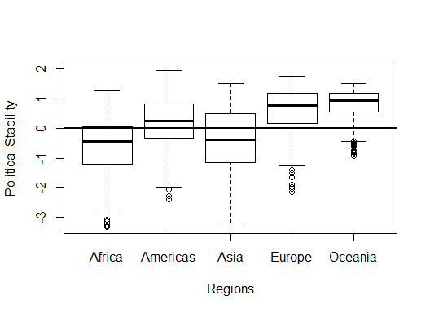

Political Stability of the Different Regions of the World

#### Political stability trends by region

# generating a table of political stability trend of the world for the period of 1996-2016  
  
stabilityTrend <- WGIbyCountryAndRegion %>%  
 group_by(date) %>%  
 summarise(stabilityAnnualAverage = mean(stability, na.rm=TRUE))  
stabilityTrend

## # A tibble: 18 x 2  
## date stabilityAnnualAverage  
## <dbl> <dbl>  
## 1 1996 -0.0284   
## 2 1998 -0.00579  
## 3 2000 -0.00326  
## 4 2002 -0.00437  
## 5 2003 -0.0361   
## 6 2004 -0.0462   
## 7 2005 -0.0495   
## 8 2006 -0.0495   
## 9 2007 -0.0499   
## 10 2008 -0.0461   
## 11 2009 -0.0495   
## 12 2010 -0.0451   
## 13 2011 -0.0413   
## 14 2012 -0.0428   
## 15 2013 -0.0392   
## 16 2014 -0.0336   
## 17 2015 -0.0346   
## 18 2016 -0.0348

## # A tibble: 6 x 2  
## date stabilityAnnualAverage  
## <dbl> <dbl>  
## 1 1996 -0.557  
## 2 1998 -0.534  
## 3 2000 -0.501  
## 4 2002 -0.552  
## 5 2003 -0.536  
## 6 2004 -0.516

# plotting the stability trend in Africa  
plot(stabilityTrendAf$date, stabilityTrendAf$stabilityAnnualAverage, type="o", lwd = 2,  
 ylim=range(-1, 1),  
 main="Fig. 1.3 - Trend of the Political Stability in Africa for the Period of 1996-2016",  
 xlab = "Years", ylab = "Political Stability Estimate (Annual Average)")  
abline(h = 0, lwd = 1.5)

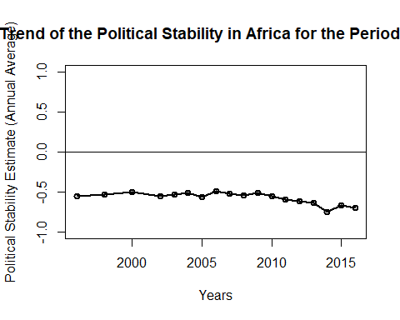

# stability trend for the rest of the world  
restOfWorldDF <- filter(WGIbyCountryAndRegion, region != "Africa")  
stabilityTrendRoW <- restOfWorldDF %>%  
 group_by(date) %>%   
 summarise(stabilityAnnualAverage = mean(stability, na.rm=TRUE))  
head(stabilityTrendRoW)

## # A tibble: 6 x 2  
## date stabilityAnnualAverage  
## <dbl> <dbl>  
## 1 1996 0.188  
## 2 1998 0.204  
## 3 2000 0.194  
## 4 2002 0.211  
## 5 2003 0.154  
## 6 2004 0.127

# plotting the stability trend for the rest of the world  
plot(stabilityTrendRoW$date, stabilityTrendRoW$stabilityAnnualAverage, type="o", lwd = 2,  
 ylim=range(-1, 1),  
 main="Fig. 1.3 - Trend of the Political Stability for the Rest of the World for the Period of 1996-2016",  
 xlab = "Years", ylab = "Political Stability Estimate (Annual Average)")  
abline(h = 0, lwd = 1.5)

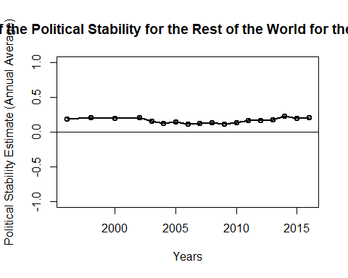

## Why Political Stability Matters: Simple Correlations Between Political Stability and Other Variables

### Political Stability and Economic Performance

WGIdevIneqPovDF <- read.csv("WGIdevIneqPovDF.csv")  
WGIdevIneqPovDF <- tbl_df(WGIdevIneqPovDF)  
  
# scaterplot of political stability and GDP annual growth  
plot(WGIdevIneqPovDF$stability, WGIdevIneqPovDF$GDPannualGrowthRate)

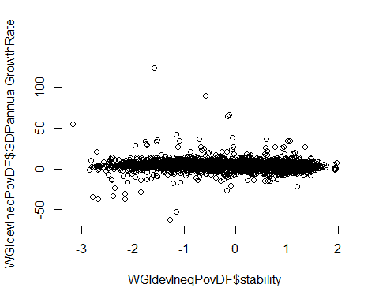

# scaterplot of political stability and GNI per capita  
  
plot(WGIdevIneqPovDF$stability, WGIdevIneqPovDF$GNIperCapita)

