Chang’an University 2022－2023 The 2nd semester （ B ）
Course | Hydraulic and Pneumatic Transmission |  |  | Date |  | / / |  | 18 questions
Name |  | School |  |  | Class |  | ID
I Fill in the blanks. (20 points, 1 point for each blank)
- The vacuum of a hydraulic system is equal to the difference between and .
- In hydraulic systems, cavitation occurs when the pressure of a flowing liquid somewhere is lower than .
- Hydraulic pump movement mode is divided into 、 、 .
- Hydraulic system auxiliary components mainly include: 、 、
、 .
- 、 and are three basic equations of fluid Kinematics and fluid dynamics.
- The flow state of fluids can be divided into and .
- In hydraulic transmission system, the Hydraulic motor is an energy conversion device to transform to of fluid.
- As the temperature increases, the viscosity of hydraulic oil will (increase/decrease).
- The flow rate of the hydraulic system is determined by of the executing components, while the pressure of the hydraulic system is determined by of the executing components.
II Short answer question items. (30 points, 6 points for each)
- What are the main components of the hydraulic system?

- What is the phenomenon of surrounded oil? How to eliminate the hazards caused by phenomenon of surrounded oil?

- Briefly describe the basic conditions for forming a positive displacement hydraulic pump.

- Please write out the differences between pilot-operated relief valves and pilot operated pressure reducing valves.

- What are the three types of speed control circuits? How many subcategories does the throttle speed-regulating circuit include?

第 1 页(共 4 页)
III Calculations. (20 points, 10 points for each)
- The ideal liquid flows to the right in the horizontal tube shown in the figure below, with the outlet connected to the atmosphere. V₁=3m/s, d₁=80mm, d₂=50mm, α=1. The liquid density is 900kg/m³, Neglecting all losses.
- What is the flow rate q at section 1-1 of the horizontal pipe? (3 points)
- What is the outlet flow velocity v₂ of the horizontal pipe? (3 points)
- What is the pressure difference(Δp) between section 1-1 and section 2-2 of the horizontal pipe?(4 points)

2. As shown in the figure, there are three types of hydraulic cylinders with piston and piston rod diameters of D and d. If the flow rate into the hydraulic cylinder is q and the pressure is p, analyze the thrust, velocity, and direction of motion generated by each cylinder. (10 points)

第 2 页(共 4 页)

IV Diagramming question. (15 points)
Please state the circuit name described in the following hydraulic schematic diagram (9 points) and indicate the component name (6 points)
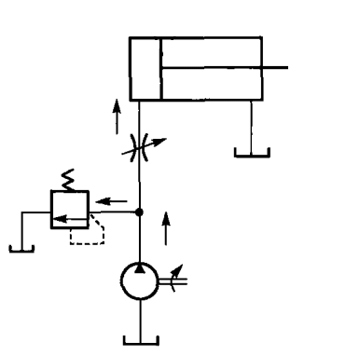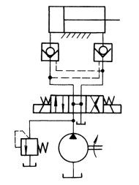
4
5
3
1
2
（1） （2）
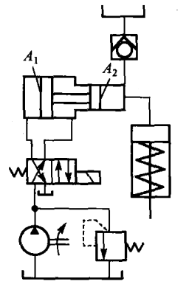
6
（3）
第 3 页(共 4 页)
V Analysis. (15 Points)
In the hydraulic system shown in the diagram, pump 1 is a small flow pump, pump 2 is a large flow pump, and actuator 9 can achieve an automatic working cycle of "quick feed→working feed→quick retract". Please read the diagram and answer the following questions.
(1) How does the system implement quick feed action? What is the flow path of the oil in the oil circuit at this time? What is the basic circuit name used?
(2) How does the system implement working feed action? What is the flow path of the oil in the oil circuit at this time? What is the basic circuit name used?
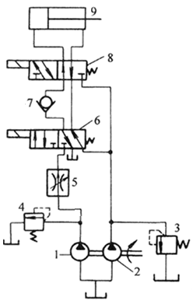

第 4 页(共 4 页

