Chang’an University 2022－2023 The 2nd semester （ B ）
Course | Hydraulic and Pneumatic Transmission |  |  | Date |  | / / |  | 18 questions
Name |  | School |  |  | Class |  | ID
I Fill in the blanks. (20 points, 1 point for each blank)
- The vacuum of a hydraulic system is equal to the difference between and .
- In hydraulic systems, cavitation occurs somewhere when the pressure of flowing liquid is lower than .
- Hydraulic pumps can be classified by the forms of main moving components and their moving manners as , and .
- Hydraulic system auxiliary components mainly include , ,
and .
- The three basic motion equations to describe the dynamics laws in flowing fluid are ,
and .
- According to Reynolds test, the main states of fluid flow are and .
- In hydraulic transmission system, the hydraulic motor is an energy conversion device to transform to .
- As the temperature decreases, the viscosity of hydraulic oil will (increase/decrease).
- The speed of hydraulic actuator is determined by of hydraulic system, and pressure of hydraulic system is determined by of hydraulic actuators.
II Short answer question items. (30 points, 6 points for each)
- What are the main components of the hydraulic system?

- What is the phenomenon of surrounded oil for gear pump? How to eliminate the hazards caused by phenomenon of surrounded oil?

- Briefly describe the three basic conditions to constitute a hydraulic pump.

- Please write out the differences between pilot-operated relief valves and pilot-operated pressure reducing valves.

- What are the three types of speed control circuits? Please write the three names of throttle speed-regulating circuit?

第 1 页(共 4 页)
III Calculations. (20 points, 10 points for each)
- The ideal liquid flows to the right in the horizontal pipe shown in the figure below, with the outlet connected to the atmosphere. v₁=3m/s, d₁=80mm, d₂=50mm, α=1. The density of liquid is 900kg/m³, Neglecting all losses.
- What is the flow rate q at section 1-1 of the horizontal pipe? (3 points)
- What is the outlet flow velocity v₂ of the horizontal pipe? (3 points)
- What is the pressure difference(Δp) between section 1-1 and section 2-2 of the horizontal pipe? (4 points)

2. As shown in the figure, there are three types of hydraulic cylinders with diameters D for piston and d for piston rod. If the flow rate into the hydraulic cylinder is q and the pressure is p, analyze the thrust, velocity, and direction of motion generated by each cylinder. (10 points)

第 2 页(共 4 页)

IV Diagramming question. (15 points)
Please state the circuit name described in the following hydraulic schematic diagram (9 points) and write out the names of the six hydraulic components. (6 points)
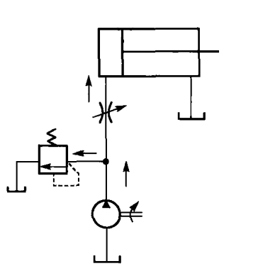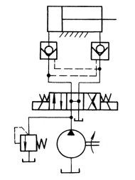
4
5
3
1
2
（1） （2）
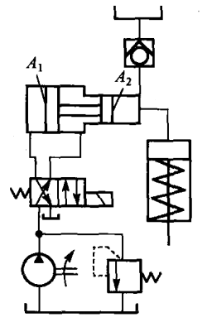
6
（3）
第 3 页(共 4 页)
V Analysis. (15 Points)
In the hydraulic system shown in the figure, the hydraulic system consists of pump 1 with small flow rate and pump 2 with large flow rate to achieve an automatic working cycle of actuator 9 as "quick feed→working feed→quick retract". Please read the hydraulic system and answer the following questions.
(1) How does the hydraulic system accomplish quick feed action? What is the main oil line for quick feed action? What is the name of main basic hydraulic circuit?
(2) How does the hydraulic system accomplish working feed action? What is the main oil line for working feed action? What is the name of main basic hydraulic circuit?
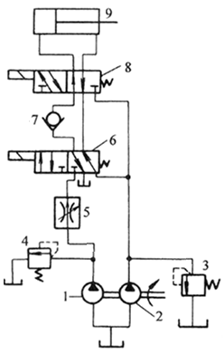

第 4 页(共 4 页

