Chang’an University 2022－2023 The 2nd semester （ A ）
Course | Hydraulic and Pneumatic Transmission |  |  | Date |  | / / |  | 19 questions
Name |  | School |  |  | Class |  | ID
I Fill in the blanks. (20 points, 1 point for each blank)
- The hydraulic system can be divided into five logical segments, they are 、 、 、 and working oil.
- Please write out three hydraulic auxiliary components: 、 、 .
- The three basic motion equations to describe the dynamics laws in flowing fluid are 、 、 .
- According to Reynolds test, the main states of fluid flow are and in a pipe.
- In hydraulic transmission system, the hydraulic pump is an energy conversion device to transform to of fluid.
- As the temperature increases, the viscosity of hydraulic oil will (increase/decrease).
- The hydraulic pumps could be classified by the forms of main moving components and their moving manners as 、 、 and screw pump.
- The hydraulic pressure in hydraulic transmission system depends on , and the motion speed of actuator depends on .
II Short answer question items. (20 points, 5 points for each)
- What is the cavitation phenomenon and the harm of cavitation?

- What is the delivery of hydraulic pump? What are the theoretical flow rate and practical flow rate?

- The basic conditions that make up a hydraulic pump.

- Please write out the differences between pilot operated relief valves and pilot operated pressure reducing valves.

第 1 页(共 4 页)
III Calculations. (20 points, 10 points for each)
1. As shown in figure, the depth of water is H=10 m, the cross-section areas are A₁=0.02 m² and A₂=0.04 m². Please calculate the flow rate of orifice and the gauge pressure of point 2 (a=1 and neglecting all losses).

2. Two structurally identical hydraulic cylinders are in series as shown in figure. The effective area of non-rod chamber is A₁=0.01m², the effective area of rod chamber is A₂=0.008m². The hydraulic oil is discharged into the piston cylinder 1 with pressure p₁=0.9 MPa and flow rate q₁=12 L/min. Neglecting all losses.
(1) When the two hydraulic cylinders exert the same external load F₁=F₂, what are the thrust and motion speed of the two hydraulic cylinders? (4 points)
(2) When the hydraulic cylinder 1 doesn’t exert load (F₁=0), what does hydraulic cylinder 2 endure the external load? (3 points)
(3) When the hydraulic cylinder 2 doesn’t exert load (F₂=0), what does hydraulic cylinder 1 endure the external load? (3 points)

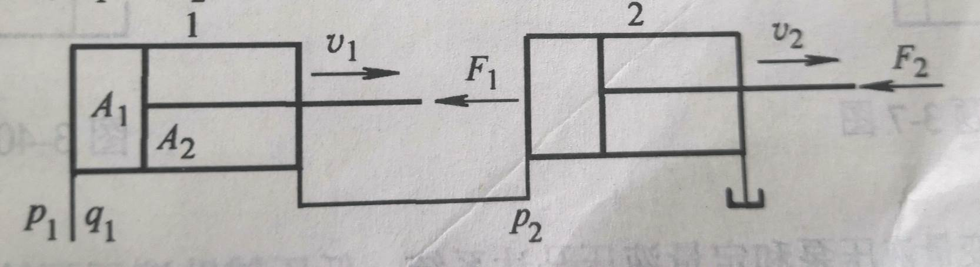
第 2 页(共 4 页)

IV Diagramming question. (20 points)
Please write the name of basic hydraulic circuits (8 points) and hydraulic components (12 points).
（1） （2）
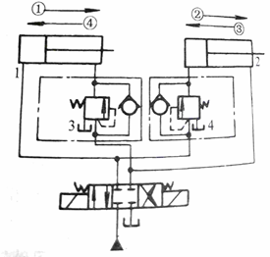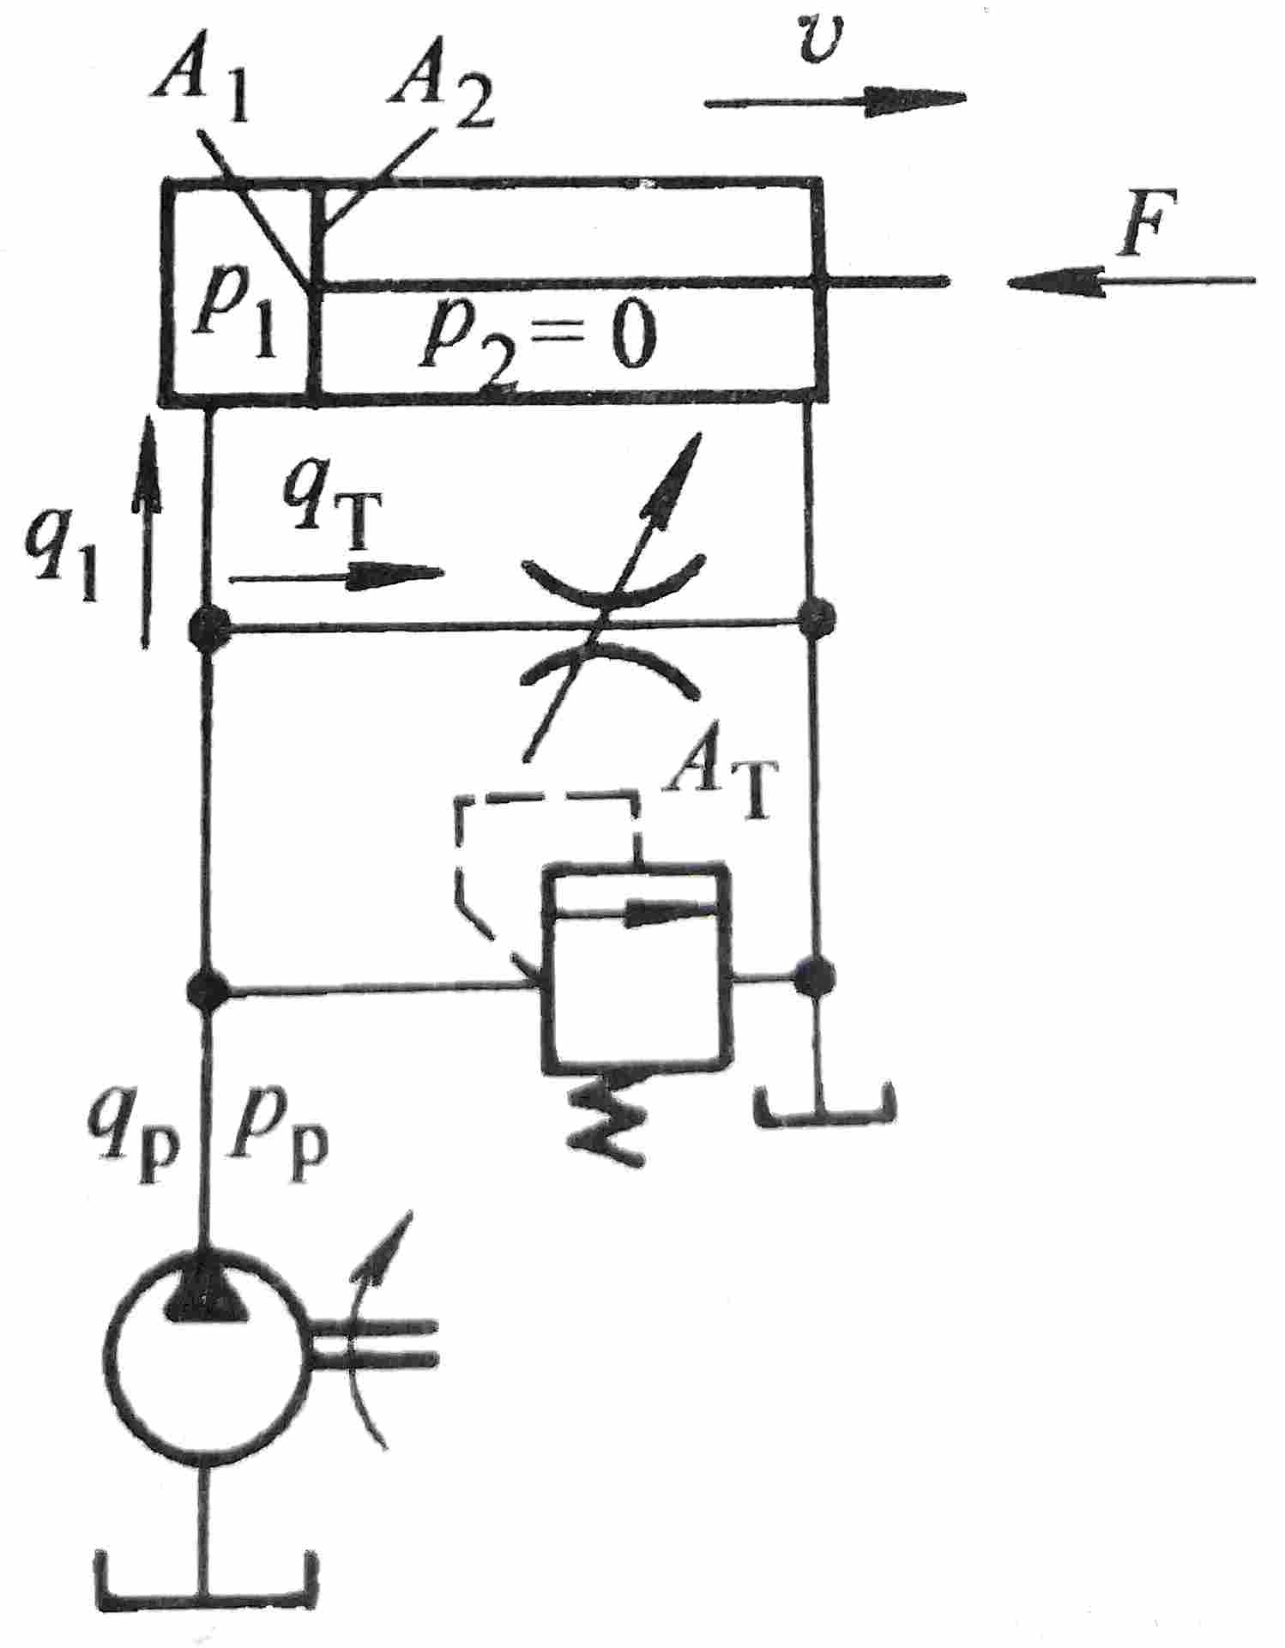
C
B
A
A
B
C

Hydraulic basic circuit |  |  | Hydraulic basic circuit
Component A |  |  | Component A
Component B |  |  | Component B
Component C |  |  | Component C

（3） （4）
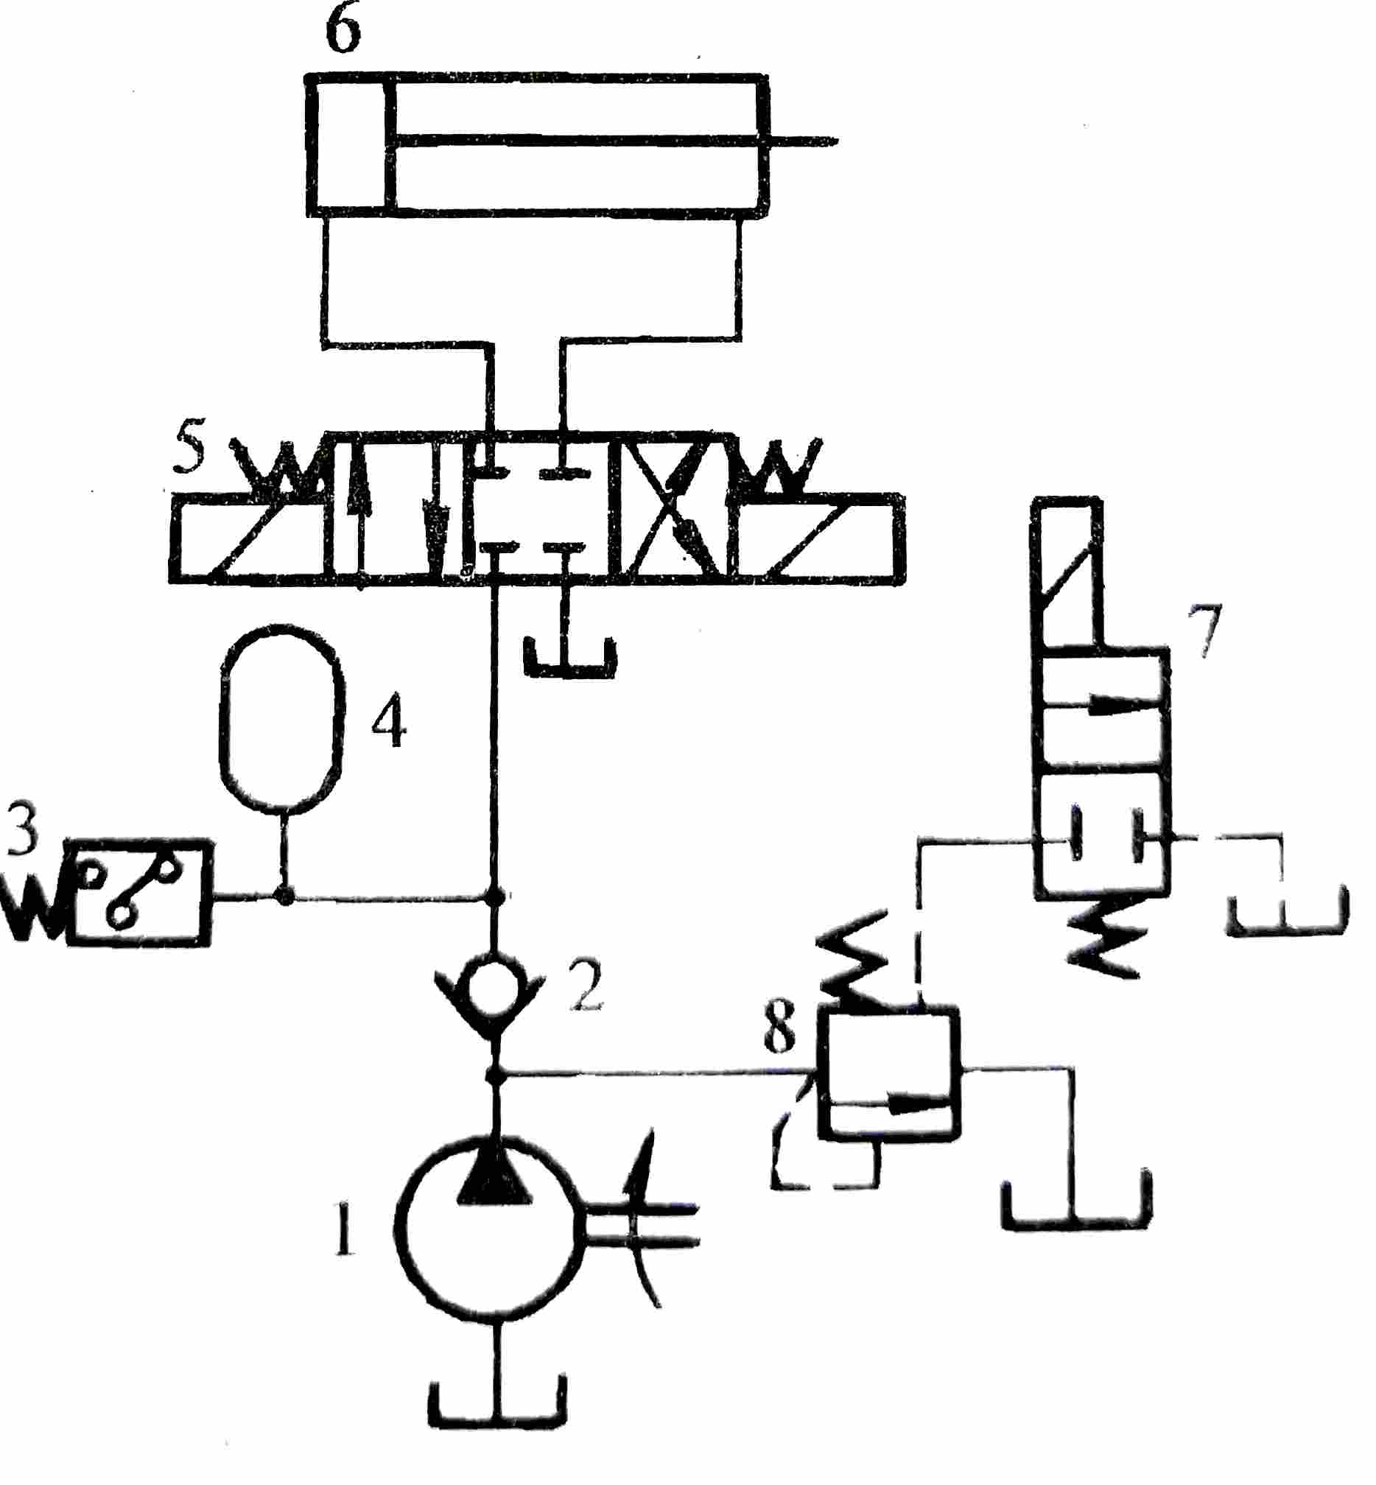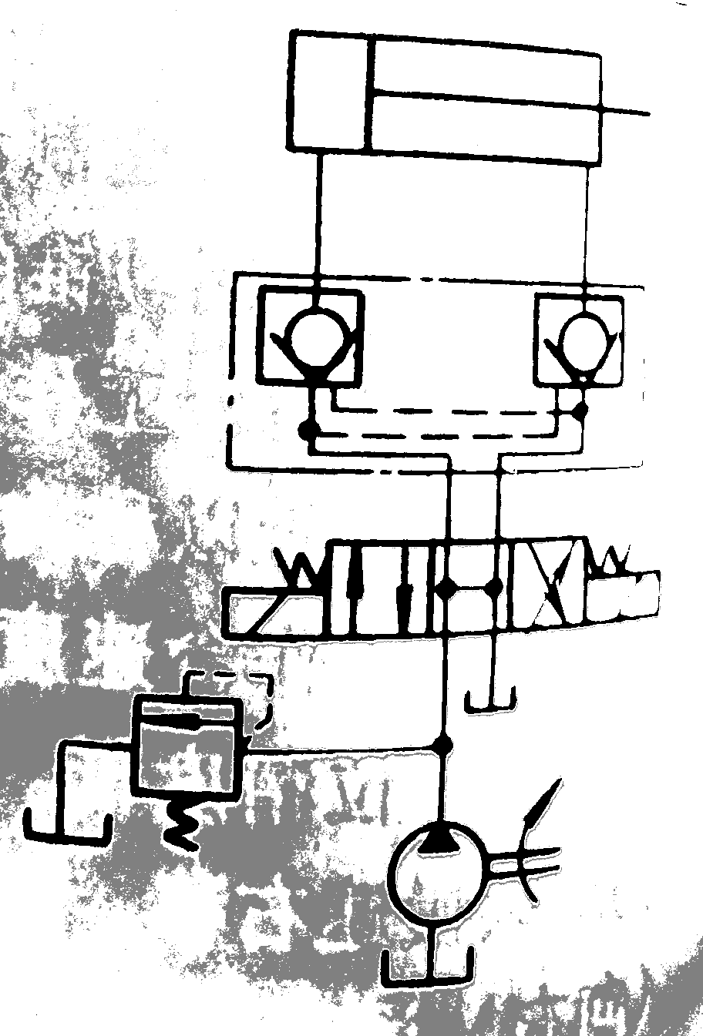
A
B
C
A
B
C
Hydraulic basic circuit |  |  | Hydraulic basic circuit
Component A |  |  | Component A
Component B |  |  | Component B
Component C |  |  | Component C

第 3 页(共 4 页)
V Analysis. (20 Points)
The hydraulic system as shown in figure can accomplish serval working procedures with quick feed → working feed → end block dwell → quick retract → stop. Read the sketch of the hydraulic system and answer the following questions.
(1) When the solenoids 1YA, 3YA are energized and 2YA is de-energized, the hydraulic system accomplished quick feed. Please write the main oil line. What is the name of main basic hydraulic circuit? (8 points)
(2) When hydraulic system accomplished working feed, what are the states of the solenoids? Please write the main oil line. What is the name of main basic hydraulic circuit? (8 points)
(3) When the solenoids 1YA, 3YA are de-energized and 2YA is energized, the hydraulic system accomplished quick retract. Please write the main oil line. (4 points)
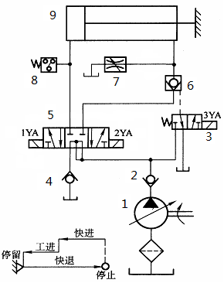

第 4 页(共 4 页)

