2022-2023学年第二学期《液压与气压传动》期末考试
A卷答案及评分标准

一、Fill in the blanks. (20 points, 1 point for each blank)
1．power input segment power output segment control elements assistant element
2．accumulator filter reservoir (piping or seals)
3．Equation of continuity (conservation of mass) Bernoulli equation (conservation of energy) Equation of momentum (conservation of momentum)
4．laminar turbulent
5．mechanical energy hydraulic energy
6．decrease
7．gear pump vane pump piston pump
8．external load flow rate

二、Short answer question items. (20 points, 5 points for each)

1. Cavitation phenomenon: if the pressure at a point is reduced far enough, hydraulic oil will vaporize and vapor cavities will be formed in liquid, which will make air separated from oil and result in large numbers of air bubble. (3 points)

Harm: The cavitation will result in high temperature, air-corrosion and shock, the bubble having oxygen will cause acidification and cauterization. This will damage working pieces of hydraulic machinery and also shorten the machine’s life. (2 points)

2. The delivery of hydraulic pump is the discharged oil volume per revolution without oil leakage. (3 points)

The theoretical flow rate is the discharge oil volume per unit time in theory. (1 point)

The practical flow rate is the discharge oil volume per unit time in practice. (1 point)

3. The basic conditions that make up a hydraulic pump are:

1) Oil tight chamber. The size of this oil tight chamber will change periodically.

2) Flow deploying. The corresponding mechanism is used to ensure the inlet port is separate from outlet port.

3) The absolute oil pressure in the reservoir should be equal or more than the atmospheric pressure which is absolutely necessary external condition for a capacity pump. (5 points)

4. Differences:

1) the pressure reducing valve holds the outlet pressure constant, whereas the relief valve holds the desired reduced pressure at the inlet.

2) the pressure reducing valve is normally open while the relief valve is normally closed.

3) the pressure exists in both inlet and outlet ports of pressure reducing valves, so the leaking oil from the spring port of pilot valve must induced separately to the reservoir. But the outlet pressure oil of relief valve flows directly into the reservoir and the leaking oil from the spring port of pilot valve discharge out through the inner passages of valve body. (5 points)

三、Calculations. (20 points, 10 points for each)
1. Consider the cross-section area 0-0 and cross-section area 2-2, the ideal equation of Bernoulli is
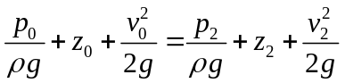
Consider the cross-section area 1-1 and cross-section area 2-2, the ideal equation of Bernoulli is
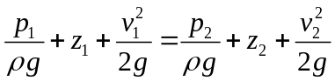
As 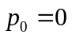, 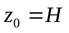, 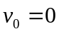, 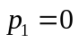, 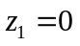, the velocity of point 1 is
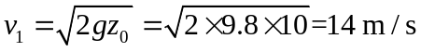
So the flow rate of point 1 is
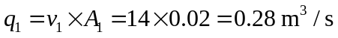
According to equation of continuity, the velocity of point 2 is
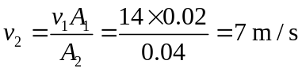
So the gauge pressure of point 2 is
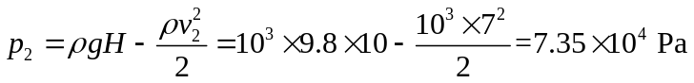
2. For cylinder 1: 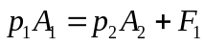
For cylinder 2: 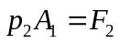
（1）As 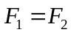, thus
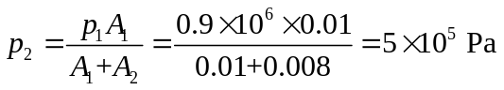
The thrust of the two hydraulic cylinders are
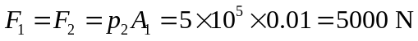
The speed motion of the hydraulic cylinder 1 is
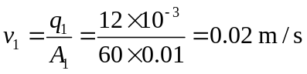
The speed motion of the hydraulic cylinder 2 is
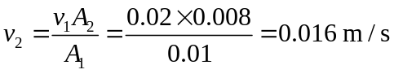
（2）As 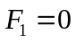, thus
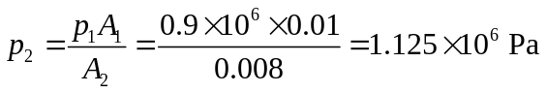
The thrust of the hydraulic cylinder 2 is
（3）As 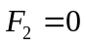, thus 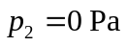.
The thrust of the hydraulic cylinder 1 is

四、Diagramming question. (20 points)

（1）
Hydraulic basic circuit | Sequence action circuit
Component A | Non-return valve (Check valve)
Component B | Sequence valve
Component C | Three-position, four-way directional control valve

（2）
Hydraulic basic circuit | Bypass throttle speed-regulating circuit
Component A | Hydraulic cylinder
Component B | Throttle valve
Component C | Reservoir

（3）
Hydraulic basic circuit | Fast speed circuit
Component A | Pressure relay
Component B | Accumulator
Component C | Two-position, two-way directional control valve

（4）
Hydraulic basic circuit | Locked circuit
Component A | Hydraulic operated non-return valve (Check valve)
Component B | Relief valve
Component C | Pump

五、Analysis. (20 Points)
（1）The main oil line:
Inlet oil line is pump 1 → left position of direction control valve 5 → left chamber of hydraulic cylinder 9.
Return oil line is right chamber of hydraulic cylinder 9 → non-return valve 6 → left position of direction control valve 5 → left chamber of hydraulic cylinder 9.
The name of main basic hydraulic circuit is differential connection circuit. (8 points)
（2）The solenoids 1YA is energized, the solenoids 2YA and 3YA are de-energized.
The main oil line:
Inlet oil line is pump 1 → left position of direction control valve 5 → left chamber of hydraulic cylinder 9.
Return oil line is right chamber of hydraulic cylinder 9 → speed regulating 7 → reservoir.
The name of main basic hydraulic circuit is outlet throttle speed-regulating circuit. (8 points)
（3）The main oil line:
Inlet oil line is pump 1 → right position of direction control valve 5 → non-return valve 6 → right chamber of hydraulic cylinder 9.
Return oil line is left chamber of hydraulic cylinder 9 → right position of direction control valve 5 → non-return valve 4 → reservoir. (4 points)

