2023-2024学年第二学期《液压与气压传动》期末考试
A卷答案及评分标准

I Fill in the blanks. (20 points, 1 point for each blank)
1．power input segment power output segment control elements assistant element
2．accumulator filter reservoir (piping or seals)
3．Equation of continuity (conservation of mass) Bernoulli equation (conservation of energy) Equation of momentum (conservation of momentum)
4．laminar turbulent
5．throttle speed-regulating circuit volume speed-regulating circuit volume-throttle speed-regulating circuit
6．losses along circle parallel pipe minor losses in pipe system
7．relief valves pressure-reducing valves sequence valves

II Short answer question items. (20 points, 5 points for each)

1. Phenomenon of surrounded oil: An oil tight chamber is formed between the two pairs of teeth when they mesh at the same time, As the gears rotate, the size of the chamber constantly changes from zero to the maximum and then back to zero during one complete revolution. As the size begins to increase, a vacuum is formed without oil compensation , which will cause cavitation and noise. As the gears continue to rotate , the size of the chamber decreases and the oil is forced out through the gap, which not only increases pressure and makes the gear bearing undertake periodic pressure pulsation, but also increases the temperature of the oil. The action described above is called phenomenon of surrounded oil. (3 points)

Load relief measure: Most gear pumps are designed with relief grooves on the front and rear cover boards or floating bearing sets ( floating sideboard). The grooves can minimize the size of the oil tight chamber (the chamber connects with the out let port when the volume of the chamber changes from the maximum to zero, and with the inlet port when it changes back from zero to the maximum). (2 points)

2. The delivery of hydraulic motor is defined as the needed oil volume per revolution of the motor output shaft without oil leakage when the volumetric efficiency equals 1. (3 points)

The volumetric efficiency of hydraulic motor is the ratio of theoretical flow rate to the practical flow rate. (1 point)

The mechanical efficiency of hydraulic motor is the ratio of practical output torque to the theoretical torque. (1 point)

3. The basic conditions that make up a hydraulic pump are:

1) Oil tight chamber. The size of this oil tight chamber will change periodically. (2 points)

2) Flow deploying. The corresponding mechanism is used to ensure the inlet port is separate from outlet port. (2 points)

3) The absolute oil pressure in the reservoir should be equal or more than the atmospheric pressure which is absolutely necessary external condition for a capacity pump. (1 point)

4. Differences:

1) the pressure reducing valve holds the outlet pressure constant, whereas the relief valve holds the desired reduced pressure at the inlet. (2 points)

2) the pressure reducing valve is normally open while the relief valve is normally closed. (2 points)

3) the pressure exists in both inlet and outlet ports of pressure reducing valves, so the leaking oil from the spring port of pilot valve must induced separately to the reservoir. But the outlet pressure oil of relief valve flows directly into the reservoir and the leaking oil from the spring port of pilot valve discharge out through the inner passages of valve body. (1 point)

III Calculations. (25 points)
1. （1）Flow rate calculation：
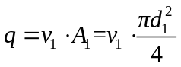 (2 points)
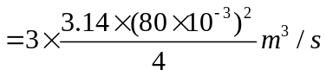
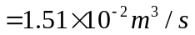 (1 point)
（2）Continuity equation：
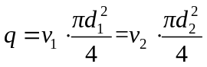 (1 point)
then： 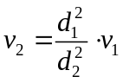 (1 point)
so： 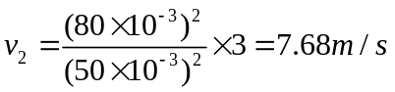 (1 point)

（3）Bernoulli equation at the cross-section 1-1 and 2-2:
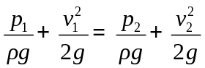 (2 points)
Pressure difference between the cross-section 1-1 and 2-2
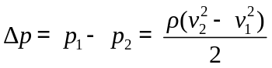 (1 point)
Thus：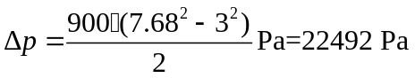 (1 point)
2. （a）Thrust 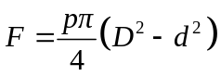 (1 point) velocity：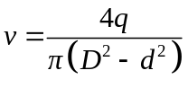 (1 point) movement direction：The cylinder body moves to the left. (1 point)
（b）Thrust 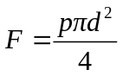 (1.5 points) velocity：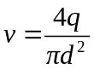 (1 point) movement direction：The cylinder body moves to the right. (1分)
（c）Thrust (1 point) velocity： (1.5 points) movement direction：The cylinder body moves to the right. (1 point)
3. (1) Force analysis: P_{B}=F_{L}/A=1000/(50×10⁻⁴)=2MPa (1 point)
At this time, the pressure at point B has not reached the set pressure of the pressure reducing valve, causing the valve to be fully open, allowing free flow between the inlet and outlet. As a result, the pressures at points A and B are equal, with p_{A}=p_{B}=2 MPa. （2 points）
(2)When the piston stops at the end position, the outlet of the pressure reducing valve no longer outputs oil, and its outlet pressure (p_{B}) rises from 2 MPa to the set pressure of 3 MPa, which it maintains consistently.
At this time, the pressure reducing valve is in operation. Since only a small amount of oil leaks through the pressure reducing valve back to the tank, the hydraulic oil output from the pump can only return to the tank by opening the relief valve. Therefore, the pressure at point A should equal the set pressure of the relief valve, which is p_{A}=5 MPa. （2 points）

IV Diagramming question. (15 points, 5 points for each)
（1）
Hydraulic basic circuit | Sequence action circuit
Component A | Non-return valve (Check valve)
Component B | Sequence valve
Component C | Three-position, four-way directional control valve

（2）
Hydraulic basic circuit | Bypass throttle speed-regulating circuit
Component A | Hydraulic cylinder
Component B | Throttle valve
Component C | Reservoir

(3)
Hydraulic basic circuit | Pressure-increasing circuit
Component A | Single action pressure-increasing cylinder
Component B | Invariable displacement pump
Component C | Relief valve

V Analysis. (20 Points)
(1) When the left electromagnet of the two-position five-ways solenoid operated valve 8 is activated, the hydraulic cylinder is only supplied by the large-flow-rate pump 2, performing a fast extend via a differential connection. （2 points）
The oil inlet path is: Hydraulic Pump 2 → two-position five-ways solenoid operated valve 6 (right envelop) → two-position five-ways solenoid operated valve 8 (left envelop) → left chamber of Hydraulic Cylinder 9. （2 points）
The return path is: right chamber of Hydraulic Cylinder 9 → two-position five-ways solenoid operated valve 8 (left envelop) → two-position five-ways solenoid operated valve 6 (right envelop) → left chamber of Hydraulic Cylinder 9. （2 points）
The basic circuit employed is a differential connection and fast-speed movement circuit by double pumps oil supply. （1 point）
(2) When the left electromagnet of the two-position five-ways solenoid operated valve 6 is activated, and the left electromagnet of the two-position five-ways solenoid operated valve 8 is inactivated, the large-flow-rate pump 2 disconnects the left chamber of the cylinder 9. The small-flow-rate pump 1 and the flow control valve 5 are integrated into the circuit, initiating the ‘slow extend’ motion. （2 points）
The oil inlet path is: The small-flow-rate pump 1 → flow control valve 5 → the two-position five-ways solenoid operated valve 6 (left envelop) → check valve 7 → two-position five-ways solenoid operated valve 8 (right envelop) → right chamber of cylinder 9. （2 points）
The return path is: right chamber of cylinder 9 → two-position five-ways solenoid operated valve 8 (right envelop) → two-position five-ways solenoid operated valve 6 (left envelop) → reservoir. （2 points）
The basic circuit employed is inlet throttle orifice speed-regulating circuit. （1 points）
(3) When the left electromagnet of the two-position five-ways solenoid operated valve 6 and 8 are activated, the hydraulic cylinder is only supplied by the large-flow-rate pump 2, performing a ‘quick retract’ motion. （2 points）
The oil inlet path is: pump 2 → two-position five-ways solenoid operated valve 8 (left envelop) → right chamber of cylinder. （2 points）
The return path is: left chamber of cylinder → two-position five-ways solenoid operated valve 8 (left envelop) → two-position five-ways solenoid operated valve 6 (left envelop) → reservoir. （2 points）

