<Main title>

- <Secondary title>


LTH School of Engineering at Campus Helsingborg
<Institution / department>

Bachelor thesis:
Alexander Sköld

© Copyright Alexander Sköld

LTH School of Engineering
Lund University
Box 882
SE-251 08 Helsingborg
Sweden

LTH Ingenjörshögskolan vid Campus Helsingborg
Lunds universitet
Box 882
251 08 Helsingborg

Printed in Sweden
Media-Tryck
Biblioteksdirektionen
Lunds universitet
Lund 2017
Abstract

Vad har jag arbetat med I examensarbetet och vad blev resultatet
tänk på att sammanfattningen är något av det första som blir läst I en rapport så gör den bra
½ till 1 sida lång

The Bitcraze drone CrazyFlie has issues with being easy to hijack from any user by downloading the mobile app and simply trying to access it.

Adding AES-GCM encryption to the communication would stop the ease of hijacking the drone.

The encryption does what it is supposed to do to. The parts that are not encrypted require either hardware access or is RSSI.

Keywords: <put your keywords here> 5/6 nyckel ord varav 2 från titeln
Sammanfattning

abstract fast på svenska

CrazyFlie drönaren har problem med att kontroll-datan är inte krypterad vilket gör det enkelt för någon att ladda ned en mobilapp som kan ta kontrollen från den som styr.

Kryptering av CrazyFlie kontroll kommunikation löser problemet med att den är så lätt stulen.

Krypteringen löser det direkta problemet med att drönaren inte blir ”stulen” av någon som laddat ned appen och försöker kontrollera en drönare. Då all data till och från drönaren inte är krypterad så finns et fortfarande svagheter. Ifall drönaren blir fysiskt tagen av någon så är krypteringen otillräcklig. RSSI meddelandena är inte heller krypterade men de ska inte vara något problem.

Nyckelord: <här skrivs nyckelord in> samma som på abstract
Foreword

Valfri text får innehålla jag eller vi.
List of contents

1 Introduction 8
1.1 Background 8
1.1.1 Bitcraze 8
1.1.2 Needed functionality 8
1.2 Purpose 8
1.3 Goals 9
1.4 Problem definition 9
1.5 Motivation 9
1.6 Scope limits 9
2 Technical background 11
2.1 The CrazyFlie drone 11
2.1.1 nRF51822 12
2.1.2 STM32F405 12
2.1.3 FreeRTOS 12
2.1.4 WolfSSL 13
2.2 The Crazyradio 13
2.2.1 nRF24LU1+ 14
2.2.2 Python 14
2.2.3 Crazyradio Library 14
2.2.4 Cryptography 14
2.3 Communications protocol 14
2.3.1 Enhanced Shockburst 14
2.3.2 Crazy Real Time Protocol 14
2.4 AES-GCM 15
2.4.1 Advanced Encryption Standard 15
2.4.2 AES Galois Counter Mode 15
2.4.2.1 Counter mode 15
2.4.2.2 Galois MAC generation 16
3 Methodology 17
3.1 Analysis phase 17
3.2 Prototyping phase 18
3.3 Implemeting phase 19
4 Analysis 20
4.1 Requirements 20
4.1.1 List of requirements 20
4.2 Choice motivation 20
4.2.1 WolfSSL 20
4.2.2 Cryptography 20
4.3 Substantial problems and their sollutions 20
4.3.1 Multi packet “packet” 20
5 Results 21
5.1 Drone 21
5.1.1 Receiving 21
5.1.2 Sending 21
5.2 Radio 22
5.2.1 Receiving 22
5.2.2 Sending 23
6 Conclusion 24
6.1 Ethical reflection 24
6.1.1 Secrecy or security through obscurity 24
6.2 Further development 24
7 Terminology 26
8 References 27
9 Appendicies 28

Introduction

Background
The CrazyFlie drone began as a competence development project in 2009. The project was started by Arnaud Taffanel, Marcus Eliasson and Tobias antonsson. The CrazyFlie is an open-source hardware and software drone. As the first CrazyFlie was completed in 2011 the group started a company called Bitcraze to fund further development.(as well as new products relating to the CrazyFlie)

Bitcraze
Bitcraze as a company was founded in early 2011 by the creators of the CrazyFlie. The main purpose of Bitcraze is to fund the further development and production of the CrazyFlie. Since the launch of the CrazyFlie there has been additional editions and additional projects that have launched.[16]

The CrazyFlie is not the only product bitcraze produces however. CrazyRadio is a USB-radio card used to connect to the CrazyFlie using Enhanced shockburst among other products. One mentionable product is the android application to controll the CrazyFlie 2.0 via Bluetooth Low Energy or BLE.

Needed functionality
Customers have a special use case for the small drone that is currently not accounted for. Using the CrazyFlie drone in a space with attending like an air show or publicity event. As the drone does not currently have any type of hijacking protection adding a layer of encryption to the controlling communication would provide sufficient protection for these events.

In the current version is missing protection against hijacking. Customers using the CrazyFlie drone in a public space
Nuvarande drönaren saknar kryptering vilket innebär att det är möjligt att kapa drönaren. Saknar kryptering mellan styrenhet och drönare, tydligare. This is important because customers are buying the drones specifically for airshows and public events where control over the drones is of very high importance.

Purpose
Encrypting the communication between the CrazyFlie and Crazyradio is the main purpose of the project. Encrypting the control communication has two main benefits. As the drone currently has no hijacking protection using it in public spaces becomes a risk.
Controlling multiple drones in an enclosed space has issues with which drone responds to what command. Encryption solves both of these issues by allowing only one source of commands to communicate with a drone.

Goals
Adding encryption to the communication between the drone and radio is the main goal of this project. The encryption should be added to existing code in such a way to maximise modularity. This means that the encryption functionality should be isolated in such a way to easily be able to disable or remove encryption with minimal changes to the code. The way modularity was planned was to make the encryption acting as a tunnel. The encryption and decryption is done in a link between the rest of the system and the radio.

Problem definition
What encryption algorithm is to be used to encrypt the communication?
What programming language will be used to implement encryption on the client?
What programming language will be used to implement encryption on the drone?
How will encryption be available to the drone?
How will encryption be available to the client?

Motivation
Drones have become a large part of society in recent years and pose as an interesting question when it comes to computer safety. Because drones are flying machines they almost exclusively are controlled by radio communication and because the publicly available bandwidth is rather limited it can become the limiting factor in drone usage. Hijacking a flying drone consists not only of a risk to personal property but also towards the health of all those in the surrounding area, although in this case the health risk is minute.
The most direct solution to these problems is to ensure that the drones are controllable is to make the communication unique to every drone.

Scope limits
Controlling the drone with the android application is not covered in this project, only using the USB-dongle.
The communication is to be encrypted using AES 128-bit Galois Counter Mode. Sharing of the key is limited to programming it in before flashing the drone.
There are a few exceptions to namely the Received signal strength indication (RSSI) and flashing the drone with new firmware.

Technical background
Ha notiser till referens listan.
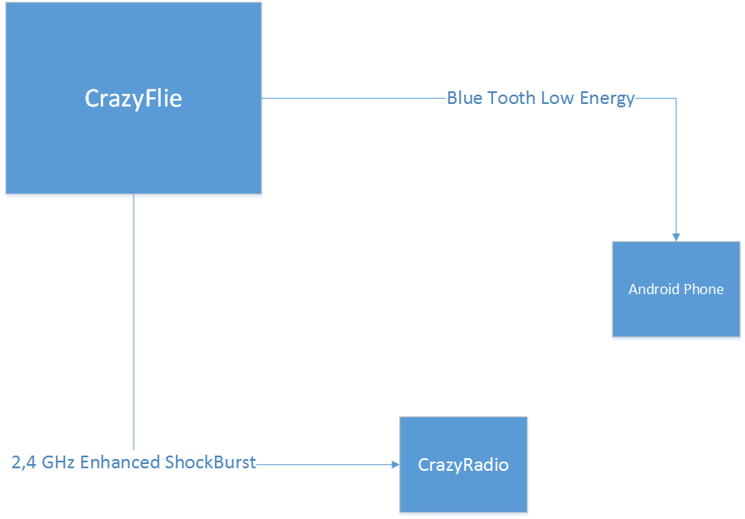Fig. 1: Communication options for the CrazyFlie drone.

The technical background of this project is really divided in to four parts. The CrazyFlie drone parts and what they do. The CrazyRadio and how to interact with it. Both chapters also explain the cryptographic library used in respective parts. The communications protocol used are described in the third part of this chapter. The fourth part describes in detail how AES-GCM works.

The CrazyFlie drone
The following describes the central parts of the hardware on the CrazyFlie.

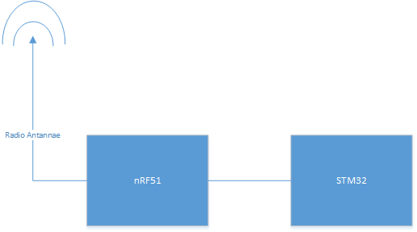Fig. 2: Simplified overview of the drone components.

The CrazyRadio is divided into two main components, the radio(nRF24) and the main calculation chip(STM32). The nRF24 handles all of the radio communication in the way that it has a specific header it manages and the rest is sent as-is to the STM.[15]

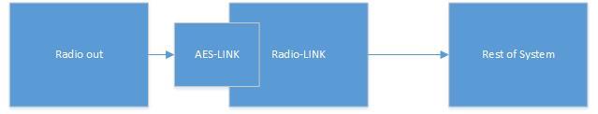Fig. 3: Simplified overview of communication links.

nRF51822
The nRF51822 chip is the communications microcontroller used on the CrazyFlie. The chip was developed by Nordic Semiconductor and is a chip specialising in 2.4 GHz wireless communication. The chip is based on a ARM Cortex M0 processing core with 128 Kbytes of flash memory and 16 Kbytes of RAM. On the CrazyFlie the nRF51 sends and receives all of the communication whether by Bluetooth Low Energy or by the Nordic Semiconductor proprietary protocol of Enhanced ShockBurst. The data protocol used within these physical protocols is the Crazy RealTime Protocol (CRTP). This protocol is quite simple as it is only a header byte and 31 databytes. The nRF51 comes with a selection of precompiled binaries called soft devices. The one used in the CrazyFlie is Soft device 110.[6]

STM32F405
STM32F405RG is the main microcontroller used in the CrazyFlie. The chip handles all of the flight controls and the majority of signal processing. The chip was developed by ST micro electronics and has a ARM 32bit Cortex M4 processing core. The chip has 1 Mbyte of flash memory, 129 Kbytes of SRAM and has a clock speed of 168MHz. The libraries used are the STM32F10x and STM324xx. The Cube library was not available at the time of initial development.[8]

FreeRTOS
FreeRTOS is essentially the operating system of the CrazyFlie handling the scheduling of processes. FreeRTOS is a real time operating system used on the CrazyFlie drone to control the flight calculations. It is owned, developed and maintained by Realtime Engineers Ltd. FreeRTOS is used to schedule and buffer the incoming and outgoing packets. It to is used in the project as it is a C library. The choice of FreeRTOS is suitable as it has native support for ARM Cortex M3.[4]

WolfSSL
WolfSSL is a cryptographic library for the C programming language. It was developed by the WolfSSL company and written in ANSI C. ANSI C is a standard of the C programming language published by the American National Standards Institute. Due to it being a published standard it is supported by most of the modern C compilers.

The WolfSSL library is designed to be used in embedded devices. To allow this WolfSSL is able to have its memory footprint be reduced rather substantially. The minimal memory size is around 20Kbyte and runtime memory size is about 1Kbyte.

The cryptographic engine used in WolfSSL is the wolfCrypt library. A cryptographic engine is the part of the library that houses the code implementation of encryption algorithms. For example, The WolfSSL library has support for DTLS, DTLS is a communication protocol that uses the AES encryption algorithm. WolfCrypt contains the AES encryption algorithm and the WolfSSL library contains the necessary parts for DTLS to function.

Versions 3.6.0, 3.6.1, 3.6.6 of the wolfCrypt library has a FIPS 140-2 certificate. The FIPS 140-2 certificate is an indication of security level assessed by the CMVP. FIPS is the Federal Information Processing Standard and CMVP is the Cryptographic Module Validation Program, both are operated under NIST. The security level attained by wolfCrypt 2.8 is level 1, this is the lowest level of security however it is suficcient.[9]

The Crazyradio
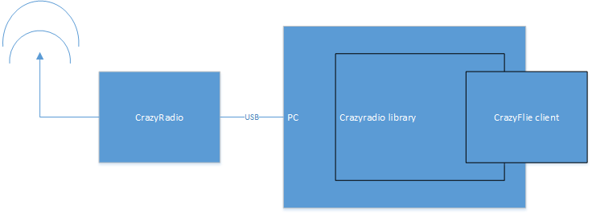Fig. 4: Structure of PC client software.

The CrazyRadio is a USB-radio. Connected to a computer the CrazyRadio is controlled through a software called CrazyFlie Client. The CrazyFlie Client is a python program that uses the Crazyradio Library to interact with the CrazyRadio.

nRF24LU1+
The nRF24LU1+ is the microcontroller used on the CrazyRadio unit. The chips main purpose is to communicate with the CrazyFlie drone and thereby handling the lower level protocol Enhanced ShockBurst. The chip has an 8-bit processing core at 16MHz with 2Kbytes + 256 Kbytes RAM and 16 to 32 Kbytes of flash memory.[5]

Python
Python was created by Guido van Rossum as a successor of a language called ABC. It began development during december 1989 and its first version was published 1991. In this project Python is used to send commands to the CrazyFlie via the CrazyRadio using the CrazyRadio Library.[22]

Crazyradio Library
The Crazyradio library is a library developed by BitCraze in python to handle the communication with the crazyflie via the Crazyradio. This library is where the encryption was implemented for the Crazyradio.[13]

Cryptography
Cryptography is a cryptographic library for the Python programming language. It is an open source project available on github with over 100 contributors. The repository is controlled by the Python Cryptographic Authority (PyCa). The functionality of Cryptography is more than adequate for the scope of the project.[18, 19]

Communications protocol

Enhanced Shockburst
Enhanced shockburst is a proprietary radio protocol used by Nordic Semiconductor products. The protocol is using the 2,6 GHz band space. It has a maximum payload of 32 bytes.[7]

Crazy Real Time Protocol
The Crazy Real Time Protocol (CRTP) is the protocol developed by Bitcraze to manage communication between the CrazyFlie and both clients. The CRTP protocol is implemented above both Bluetooth Low Energy and Enhanced Shockburst. One property of CRTP is that it supports 31 bytes of data using 1 byte for header information.[17]

AES-GCM
This entire chapter has three references. All of them essentially describe the different parts equally well but in different ways. Specifically the references 1, 2, and 3.

Advanced Encryption Standard
Advanced Encryption Standard(AES) is an encryption standard published by the National Institute of Standards and Technology (NIST). It was published in November of 2001. AES is based on the Rijndael block cipher specifically the 128 bit block size version.

The 128 bit Rijndael cipher, called AES for the rest of the report, is a cipher based on Galois fields or finite fields specifically. The cipher works by first dividing the clear data in to blocks of 16 bytes or 128 bits and then processes them individually at first and then scrambling them together. The cipher works in four layers, the byte substitution layer, shift row layer, mix column layer, and key addition layer.
In the byte substitution layer the block has all of its bytes substituted using a matrix where its value in hexadecimal decided what byte it will be substituted with.
The shift row and mix column layers are there to disrupt the original order of the bytes and to spread them out evenly from every block to every other block.
Key addition is done with a bitwise exclusive-or operation of the block and a subkey derived from the input key.
The layers are executed in a specific order called rounds. These rounds consist of in order the byte substitution layer, shift row layer, mix column layer, and the key addition layer. The number of rounds AES uses to encrypt any data is determined by the size of the key. The different key sizes AES supports are 128, 192, and 256 bits of length and the number of rounds for the respective keys are 10, 12, and 14 rounds. The orders are however not used identically in every round. In the first round there is an additional key addition layer before the byte substitution layer while the last round contains no mix column layer.

AES Galois Counter Mode
Galois Counter Mode (GCM) is a combination of the AES counter mode and a method to generate a Message Authentication Code (MAC). These functions are called GCTR and GHASH. GCTR is simply AES in counter mode and GHASH is a hashing function using galois fields.

Counter mode
CTR or Counter mode is a mode of AES encryption.
Every block of data to be encrypted is combined with an initial value and a counter, they are added by the use of an or-operation. There are a few important aspects of the CTR mode. CTR is able to being computed in parallel. Because none of the blocks are dependant on any other and only on the counter and the initial value the encryption is able to be scaled up. The initial value used is an important factor. The value is based on the block size of the data to be encrypted. Due to AES only supporting 128bit block size the initial value is a 96 bit string the counter is the remaining 32 bits to ensure the entire string is the same size as the block. The initial value is special in the sense that it may only be used once, a so-called nonce.

Galois MAC generation
The MAC is generated through a process of hashing and encrypting the already encrypted data and some additional data. The MAC is generated by using a function called GHASH and then encrypting the resulting output. GHASH works by multiplying the blocks of the data with the blocks of a hash key, then with an exclusive-OR operation add these blocks together. The hash key is a string of blocks the same size as the data that needs a MAC generated. After the GHASH function is complete the resulting block is then encrypted with AES-CTR to ensure the message authentication.

Methodology
There were three types of phases in this project. There were the Analysis phase, the prototyping phase and the implementation phase.

The analysis phase main point was to decide what to use as the encryption suit, what type of development environment was going to be used, learning the product, and setting up the communication with BitCraze.

The Prototyping phase consisted of setting up the development environment, adding the cryptographic libraries, setting up testable sub-systems on the drone and learning to use the cryptographic libraries.

The implementation phase was making a functional tunnel and then adding the encryption while making it as modular as possible with the already existing code.

Analysis phase
Firstly the problems the project is supposed to solve have to be described.
What is hijacking. Hijacking is when an outside agent takes control of a drone from an inside agent. In this case a USB radio is the inside agent controlling the drone and any other USB radio is the outside agent trying to take control.

As of before this project the outside agent would quite easily take control of the drone. To stop this the inside agent needs to stop any other radio from communicating with the drone and to do this an encryption algorithm will be introduced.

The encryption algorithm chosen needs to have a certain set of properties. Because the size of the packet is limited the encryption algorithm needs to be small. The speed of encrypting and decrypting is important as the part of the drone that handles ciphering also handles the flight controls. The cipher needs to be cryptographically strong to ensure that the key or keys are not easily solved. The underlying radio communication protocol is asynchronous so this too had to be taken into account. DTLS was an early contender for cipher algorithm, however due to the software structure of the drone and USB-radio there was a lack of support systems requiered to have fully functional DTLS. The choice of cipher was AES-GCM as it had all of the prerequisite properties needed for this project.

How to best implement the encryption is an important question. Either there had to be a change to the entirety of the code base that handles with incoming and outgoing packets or there could be an added after each packet has been completed and is about to be sent where encryption can take place. Obviously a tunnel was chosen as the easiest and most modular way to implement encryption.

Communication with Bitcraze was done through either in person or through the messaging and VoIP service Skype. As the Bitcraze offices are no in the same city as the writers, most communication was done through Skype.

The environment in which the programming took place was using the virtual machine software VirtualBox. The machine run on the virtualisation software was the official Bitcraze VM 2016-06-06. This virtual machine had almost every thing needed to develop for the CrazyFlie. The one thing it was lacking were the encryption libraries.

As previously mentioned the easiest way to implement the encryption is to make a tunnel in between the radio and the rest of the system.

For the CrazyFlie this means that an encryption “link” is made which can slot in for the radio link. Reference figure 4.

For the Crazyradio however it is not quite that simple. Changes in the python library has to be made in the specific send and receive functions. This has the drawback of not being as modular in the way of turning off or disabling the encryption for whatever reason but it does still leave the rest of the code the same as changes only needs to be done in one file.

Prototyping phase
Prototyping the possible solutions is the next step to make a complete solution. In this phase there were a lot of trial and error when working to learn a sufficient way of implementing the different parts of the final solution.

The first step in prototyping was making a subsystem where messages could be sent and have a measurable response. The subsystem made would simply take a packet with a certain header setup and respond with a fixed string at first. Later this subsystem was used for debugging and error responses as it was available and separate from any other system.

Due to the memory limitation on the drone the WolfSSL library needed to be scaled down to as small a memory footprint as it could possibly be. There was unfortunately no great way to determine the size of the library on the memory The way of scaling down the size of WolfSSL is simply following the documentation and realising what parts of the library that are important. Isolating the core AES functionality and the GCM mode.

A big part of AES-GCM is the message authentication tag and initialising vector. The size of these does have an effect on the cipher strength. The main reason a shorter authentication tag and initialisation value were chosen is simply because of the message length.

Implemeting phase
During the implementing phase the lessons from the previous two phases is put into action.

The modularity of the code proved to be a significant problem when it came to the USB-radio code as the structure was completely different. The structure of the code on the drone was so that communication was done through a variable link connected to the radio and then the rest of the system. <in med bild som visar> The link in this case could consist of different types of communications channels such as USB or radio.

Analysis

Requirements
The single initial requirement was to encrypt the communication between the Crazyradio and the Crazyflie. This was expanded into choosing the encryption algorithm and making the encryption invisible to the rest of the system.

Choosing the encryption algorithm

Choice motivation

WolfSSL
Choosing the cryptographic library to use on the drone was essentially a choice between mbed TLS and WolfSSL. Both were good choices with good forum support, documentation, and both were according to their documentation easy to port to new embedded hardware. WolfSSL was chosen as a request by Bitcraze when both were given as viable and suitable options.

Cryptography
The number of choices for cryptographic libraries available for python were unfortunately quite limited. The closest comparable to a stable and supported release was for the Cryptography library originally by the Python Cryptographic authority (PyCa). This github library has the largest number of contributers to a single cryptography library that had support for AES-GCM. The bigest drawback about open source projects where no official group has claimed responsibility is that there is no certificate of functionality or security to hold the responsible organisation to if it fails.

Substantial problems and their sollutions

Multi packet “packet”
ESB is the main limiting factor. This caused CRTP to have a limit. ESB is asynchronous so CRTP is aswell. Because encryption adds data to be sent a packet with 31 databytes has to be split into two packets instead. This forced the need for package ID. Package ID is used to combine two packets before decryption to ensure that everything is as it should.

Results
Ge kod exempel.

Ny figur, den visar hela drönar flödet, ESB paket I luften mellan drönaren och Crazyradio samt hela crazyradio flödet.

The results of this project was to implement a secure connection between the Crazyradio and the Crazyflie. This was accomplished by introducing encryption. The detailed description of how and where encryption was implemented is described in the following subchapters. <Ny figur> is a more detailed overview of the drone and crazyflie communicating through ESB.

Drone
On the drone.

Receiving
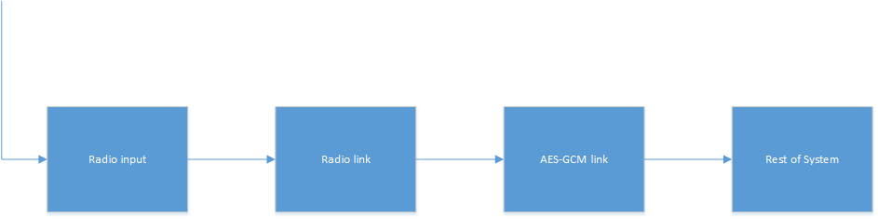Fig. 5: Chain of events for a received package on the drone.
It takes a raw packet from the radio, if the packet is a split packet it stores the IV, TAG, AD, and data into buffers, waits for the next packet with the same PID number. If the next packet does not contain the same PID number the new packet overwrites the first packet, if it does have the same PID number the new packet has its data added to the buffer of the first packet data. The IV, AD, and TAG is then used to decrypt the data in a decrypt function from the WolfSSL library. The packet is then reencoded in to the unencrypted version with its previous header and unencrypted data and passed into the system via the CRTP service or a FreeRTOS qeue.

Sending
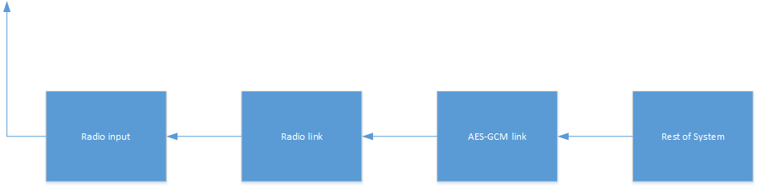Fig. 6: Chain of events to send a packet on the drone.
What AES-GCM section does.
It takes the unencrypted packet from the rest of the system. Seperates the header from the rest of the data. The header is added as additional data to the encryption process together with a PID that contains the multipacket-bit, the PID number and the length of the unencrypted data. The Initializing vector is produced. Using the IV, AD and the data the encrypted packet is created. A custom header is added to the packet. The AD, IV and TAG are added to the packet. If the length of the data was more than 20 bytes long the first packet only contains the first 20 encrypted bytes. A second packet then gets created and has the two AD bytes first and then the remaining encrypted data bytes.

Radio
On client.
On the clientside there is no specific tunnel or subsystem, instead the encryption and decryption is in the send and receive functions of the python radio interface.

Receiving
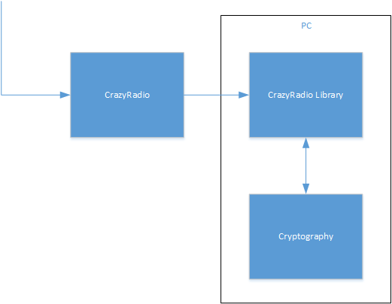Fig. 7: Chain of events upon receiving a packet for the client.

When receiving a packet the header is removed, the AD bytes, IV bytes and
TAG bytes are buffered. The data is put in a different buffer, if the received packet has more than 20 bytes of encrypted data there will be a second packet with the same PID. The second packet will add its encrypted data to the data buffer. A custom function using the Cryptography library will decrypt the data. Using the decrypted data a new packet with the first byte in the AD is used as the header and the decrypted data as the payload.

Sending
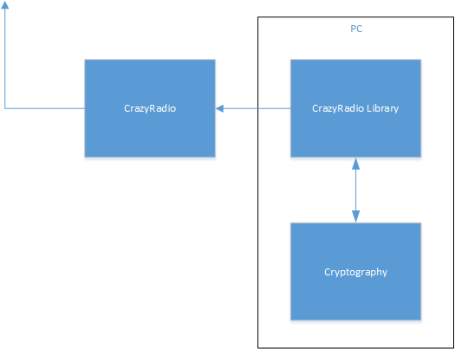Fig. 8: Chain of event when sending a packet for the client.

When sending a packet the python interface directly uses the packet. The data is separated from the header and put in a buffer. The header is used together with a generated PID to produce the additional data for AES-GCM encryption. A IV is randomised, the IV and the AD are used to encrypt the data. The new packet gets a new header and its data buffer gets filled with AD, IV, TAG and then the encrypted data. Depending on the size of the unencrypted data the packet can be split in two if it is more than 20 bytes of data.

Conclusion
This project was to minimise the possibility of hijacking the crazyflie drone when flown in public spaces. This was done by adding encryption to the communication. The encryption added was AES using GCM mode.

The encryption was added in such a way as to make a tunnel. Both sides are encrypted before the packet is sent via the radio and decrypted before entering any packet management. This way there needed to be almost no change to how the rest of the drone functions.

AES was chosen as it is a highly secure cipher and can be made rather small. There was no AES implementation already on the drone or the client so this had to be added. They became available by adding cryptographic libraries to the programs. WolfSSL was chosen as it could configured to reduce its memory footprint to a small size. WolfSSL is a C library with FIPS 140-2 certificate and was deemed more than sufficiently cryptographically sound.
For the client program the library Cryptography was chosen. Cryptography was chosen as it was deemed to be sufficiently secure.

Ethical reflection

Secrecy or security through obscurity
The number of ethical implications of this project are minimal however there is one big question of Security through obscurity as a type of IT security. This project is open source and therefore has no wall for people to run into when doing security analysis.

Security through obscurity is the concept of having obscure or hidden source code and design of the software. This as a means of security is probably enough to dissuade any benign “attackers”. Any other type of “attacker” is more then likely not to either report the issue found or if it has any benefit for them use it to their advantage. The problem with this that it can give a false sense of security to both developers and users as the security holes will more than likely not be published or reported. Another real issue with the security through obscurity line of thought is that no program is perfect. There are always problems with every program to ever need any type of security.

Further development
The way AES GCM was implemented to fit a pre-existing protocol posed some challenges. The solution to those challenges was to shorten the tag and the initialisation vector. This is not a problem in and of itself if done thoroughly. Unfortunately there were one NIST recommendation out of scope for this project. Namely the changing of the hash-subkey at a frequent interval. This is controlled by the WolfSSL library and was therefore not in the hands of the developers of this project. This is a matter to look into however and therefore is fit to be further development.

As mentioned in the scope limit there are a list of more features that are desired. Making the client program able to change the encryption key and write it to the drone via USB is one of the future projects of the Crazyflie. Another perhaps more necessary than the previous one is to enable and disable encryption when using the Crazyradio library.

Future development for the Crazyflie hardware is in progress and is being actively discussed at Bitcraze. One of the changes that could be made is the size of the packets. The size of the packets could be larger to accommodate both the encryption and the data required for the secure communication between the drone and the Crazyradio.

Terminology
What is AES-GCM, TLS, DTLS and so on.
AES
AES-GCM
TLS
DTLS
MAC
HASH

References
Which references were for development purposes and which were for research purposes.

- http://nvlpubs.nist.gov/nistpubs/FIPS/NIST.FIPS.197.pdf
Federal Information Processing Standards Publication 197. (2001).
Announcing the Advanced Encryption Standard (AES).
Federal Information Processing Standards.

- http://nvlpubs.nist.gov/nistpubs/Legacy/SP/nistspecialpublication800-38d.pdf
Morris Dworkin. (2007)
Recomendation for Block Cipher Modes of Operation: Galois/Counter mode
(GCM) and GMAC.
National Institute of Standards and Technology.

- Christof Paar, Jan Pelzl. (2010).
Understanding cryptography.
Springer.

- http://www.freertos.org/
Real Time Engineers ltd. (2017).
FreeRTOS.
Real Time Engineers ltd.

- https://www.nordicsemi.com/eng/Products/2.4GHz-RF/nRF24LU1P
https://www.nordicsemi.com/eng/content/download/2724/34051/file/nRF24LU1P_Product_Spec_v1_1.pdf
Nordic Semiconductor. (2010).
nRF24LU1+ Single Chip 2.4 GHz Transceiver with USB Microcontroller and Flash Memory.
Nordic Semiconductor.

- https://www.nordicsemi.com/eng/Products/Bluetooth-low-energy/nRF51822
http://infocenter.nordicsemi.com/pdf/nRF51822_PS_v3.3.pdf
Nordic Semiconductor. (2014).
nRF51822 Multiprotocol Bluetooth low energy/2.4 GHz RF System on Chip. Product Specification v3.3
Nordic Semiconductor.

- https://devzone.nordicsemi.com/blogs/783/intro-to-shockburstenhanced-shockburst/
Daniel Veilleux. (2015).
Intro to ShockBurst/Enhanced ShockBurst.
Nordic Semiconductor.

- http://www.st.com/en/microcontrollers/stm32f405rg.html
http://www.st.com/content/ccc/resource/technical/document/datasheet/ef/92/76/6d/bb/c2/4f/f7/DM00037051.pdf/files/DM00037051.pdf/jcr:content/translations/en.DM00037051.pdf
STMicroelectronics. (2016).
ARM Cortex-M4 32b MCU+FPU, 210DMIPS, up yo 1MB Flash/192+4KB RAM, USB OTG HS/FS, Ethernet, 17TIMs, 3 ADCs, 15 comm. Interfaces & camera
STMicroelectornics.

- http://csrc.nist.gov/groups/STM/cmvp/documents/140-1/140val-all.htm#2425
Todd Ouska, Larry Stefonic. (2017).
Validated FIPS 140-2 Cryptographic modules.
National Institute of Standards and Technology.

- http://csrc.nist.gov/groups/STM/cmvp/
National Institute of Standards and Technology.(2017)
Cryptographic module validation program.
National Institute of Standards and Technology.

- https://wiki.bitcraze.io/projects:crazyradio:index
Arnaud Taffanel, Marcus Eliasson, Fred, Tobias Antonsson. (2016).
Crazyradio.
BitCraze.

- https://wiki.bitcraze.io/doc:crazyradio:usb:index
Arnaud Taffanel, Fred, Marcus Eliasson. (2017).
USB and Radio protocol of the Crazyradio dongle.
Bitcraze.

- https://wiki.bitcraze.io/projects:crazyradio:python_lib
Arnaud Taffanel. (2015).
Python Crazyradio Library.
Bitcraze.

- https://wiki.bitcraze.io/projects:virtualmachine:index
Arnaud Taffanel, Kristoffer Richardsson, Marcus Eliasson, Björn Mauritz, Tobias Antonsson. (2017).
Bitcraze Virtual Machine.
Bitcraze.

- https://wiki.bitcraze.io/projects:crazyflie2:architecture:index
Arnaud Taffanel. (2015).
Crazyflie 2.0 System Architecture.
Bitcraze.

- https://www.bitcraze.io/about/
Bitcraze. (2017).
Bitcraze.
Bitcraze.

- https://wiki.bitcraze.io/projects:crazyflie:crtp
Arnaud Taffanel, Marcus Eliasson. (2017).
Crazy RealTime Protocol.
Bitcraze.

- https://github.com/pyca/cryptography
Each of the 136 individual contributors. (2017)
Cryptography.
Github.com

- https://cryptography.io/en/latest/
Each of the 136 individual contributors. (2017).
pyca/cryptography.
Cryptography.io

- https://www.wolfssl.com/wolfSSL/Docs-wolfssl-porting-guide.html
WolfSSL. (2017).
WolfSSL Porting Guide.
WolfSSL.

- https://www.wolfssl.com/wolfSSL/Docs-wolfssl-manual-toc.html
WolfSSL. (2017)
WolfSSL (formerly CyaSSL) Manual.
WolfSSL.

- https://docs.python.org/3/faq/general.html#why-was-python-created-in-the-first-place
Python Software Foundation. (2017)
General Python FAQ.
Python Software Foundation.

Appendicies
Probably code snippets
figures and similar stuff

