**BABA MASTNATH UNIVERSITY (ROHTAK)**

**LAB PRACTICALS ASSIGNMENT**

**Name : Pranav**

**Roll no.: 244094**

**Subject: Programming for Problem Solving**

**Class: BTech 1st Year CSE (AI/ML)**

**Submitted To: Dr. Sarika Choudhary**

**Program 1**

**Aim:** To write a C program to calculate the Simple Interest and Compound Interest.

**Procedure:**

Step 1: Start the program execution

Step 2: Declare the variables p, n, r, ch

Step 3: Input the variables p, n, r

Step 4: Get the choice from user whether to calculate simple interest or compound interest.

Step 5: Calculate and print the values of Simple Interest and Compound Interest

Step 6: Stop the program execution.

**Code:**

#include <stdio.h>

#include <math.h>

// #include <conio.h>

int main()

{

    int p, n, ch;

    float r;

    printf("\nEnter the choice:\n1. Simple interest\n2. Compound interest\nChoice: ");

    scanf("%d", &ch);

    printf("\nEnter the value of amount (principal), number of years, and rate of interest:");

    scanf("%d %d %f", &p, &n, &r);

switch(ch)

        {

        case 1:

            printf("\nThe simple interest is = %f", (p * n * r) / 100);

            break;

        case 2:

            printf("\nThe compound interest is = %f", (p * pow((1 + (r / 100)), n) - p));

            break;

            default:

            printf("\nEnter the correct choice.\n");

        }

    return 0;

}

**OUTPUT:**

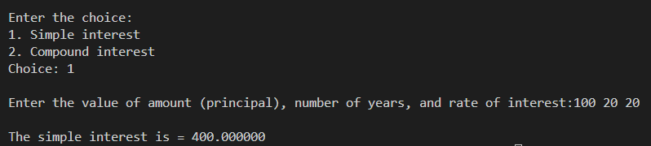

**Program 2**

**AIM:** To write a C Program to find the area and perimeter of circle, triangle, rectangle, and square.

**Procedure:**

Step 1: Start the program execution.

Step 2: Declare the variables ch, a, b, c, h, r.

Step 3: Get the choice whether to select 1.circle, 2.square, 3.rectangle, and 4.triangle.

Step 4: If ch=1, read r and compute area and perimeter of circle.

Step 5: Print the area and perimeter of circle.

Step 6: If ch=2, read a and compute area and perimeter of square.

Step 7: Print the area and perimeter of square.

Step 8: If ch=3, read b, h and compute area and perimeter of triangle.

Step 9: Print the area and perimeter of triangle.

Step 10: If ch=4, read a, b, c, and compute area and perimeter of triangle.

Step 11: Print the area and perimeter of triangle.

Step 12: Stop the program execution.

**Code:**

#include <stdio.h>

#include <conio.h>

void main()

{

    int ch, b, h, a, c;

    float r;

    printf("Enter the choice:\n1.Circle\n2.Square\n3.Rectange\n4.Triangle\nChoice:");

    scanf("%d", &ch);

    switch(ch)

{

    case 1:printf("\nEnter the radius of the circle : ");

    scanf("%f", &r);

    printf("\nArea of circle=%f", 3.14*r*r);

    printf("\nPerimeter of Circle=%f", 2*3.14*r);

    break;

case 2:printf("\nEnter the side of the square : ");

    scanf("%d", &a);

    printf("\nThe area of the square is %d", a*a);

    printf("\nPerimeter of square is %d", 4*a);

    break;

case 3:printf("\nEnter the breadth and height of rectangle:");

    scanf("%d%d", &b, &h);

    printf("\nArea of the rectangle:%d", a*a);

    printf("\nPerimeter of the rectangle :%d", b*h);

}

}

**OUTPUT :**

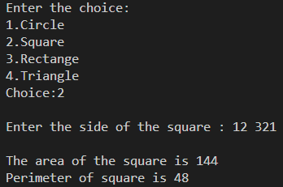

**Program 3**

**AIM:** To design a simple menu-driven calculator.

**ALGORITHM:**

Step 1: Start the program execution.

Step 2: Declare variables a, b, ch, c.

Step 3: Get the choice 1.addition 2.subtraction 3.multiplication 4.division 5.modulo

Step 4: If ch=1, perform addition and print the results.

Step 5: If ch=2, perform subtraction and print the results.

Step 6: If ch=3, perform multiplication and print the results.

Step 7: If ch=4, perform division and print the results.

Step 8: If ch=5, perform modulo and print the results.

Step 9: If the choice is not in them then print “Enter correct choice”

Step 10: Stop the program execution.

**Program:**

#include <stdio.h>

#include <conio.h>

void main()

{

    int a,b,c,ch;

    printf("\nEnter two values :");

    scanf("%d%d", &a, &b);

    printf("\nEnter the choice:\n1.Addition\n2.Suntraction\n3.Multiplaction\n4.Division\n5.Modulo\nchoice: ");

    scanf("%d", &ch);

    switch(ch)

{

    case 1: printf("\nAddition of %d+%d is %d", a, b, a+b);

    break;

    case 2:printf("\nSubtraction of %d-%d is %d", a, b, a-b);

    break;

    case 3:printf("\nMultiplication of %d*%d is %d", a, b, a*b);

    break;

    case 4:if(b==0)

    printf("\nDivisionis not possible");

    else

    printf("\nDivision od %d/%d is %f", a, b,(float)a/b);

    break;

    case5:printf("\nModulus of %d%%d is %d", a, b, a%b);

    break;

    deafult: printf("\nEnter correct choice:");

    break;

}

getch();

}

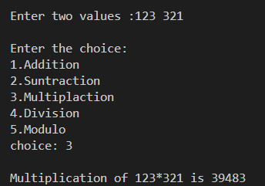**OUTPUT:**

**Program 4**

**AIM :** To write a C-Program to convert a given decimal number to binary number.

**ALGORITHM :**

Step 1 : Start the program execution.

Step 2 : Read the decimal number.

Step 3 : Perform number mod 2 to find the remainder and save the remainded in sum.

Step 4 : Divide the number by 10 to get the quotient.

Step 5 : Print the binary number saved in sum.

Step 6 : Stop the program execution.

**PROGRAM :**

# include <stdio.h>

# include <conio.h>

void main()

{

    long int n, i=1, sum=0, r;

    printf("\nEnter the Decimal Nimber : ");

    scanf("%ld", &n);

    while(n>0)

    {

        r=n%2;

        sum=sum+(r*i);

        i=i*10;

        n=n/2;

    }

printf("\nEquivalent binary number is %ld", sum);

getch();

}

**OUTPUT :**

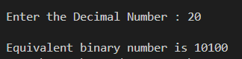

**PROGRAM 5**

**AIM :** Program to read an array of integers and print the sum of the elements of the array.

**Code :**

#include<stdio.h>

void main ()

{

int arr[10],i,n, sum=0;

printf("\n enter the number of elements in the array : ");

// reading the size of the array

scanf("%d",&n);

// reading the elements of the array

printf("\n enter the values for the elements of the array : ");

for(i=0;i<n;i++)

{

printf("\n Enter the element %d : ",i+1);

scanf ("%d",&arr[i]);

}

// finding the sum of the elements of the array

for(i=0;i<n;i++)

sum=sum+arr[i];

// printing the elements of the array

printf ("\n Printing the sum array elements ..... ");

printf("\n The value for the sum of elements of the array : ");

for(i=0;i<n;i++)

printf("\n the element %d : %d",i+1,arr[i]);

printf ("\n printing the array sum ..... ");

printf ("%d ",sum);

}

**OUTPUT :**

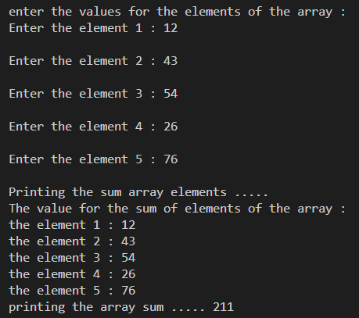

**Program 6 :**

**AIM :** To write a C-Program to print the prime number between 100 and 500.

**ALGORITHM :**

Step 1 : Start the program execution.

Step 2 : Declare the variable i, j, n.

Step 3 : Read the limit.

Step 4 : i%j==0, break

Step 5 : if i==j, the print “i is a prime number”.

Step 6 : Stop the program execution.

**PROGRAM :**

#include<stdio.h>

#include<conio.h>

void main ()

{

int n,i,j;

// clrscr () ;

printf("\nEnter the limit:");

scanf("%d", &n);

for(i=1;i <= n;i++)

{

for(j=2;j<i;j++)

{

if(i%j == 0)

break;

}

if(i == j)

printf("\n%d",i);

}

getch ();

}

**OUTPUT :**

