1. 三角形

**import** java.util.Scanner;

**public** **class** Main {

**public** **static** **void** main(String[] args) {

Scanner sc = **new** Scanner(System.***in***);

**int** i = sc.nextInt();

Star s = **new** Star(i);

s.printStar();

}

}

**public** **class** Star {

**public** **static** **int** *number*;

**public** **void** printStar()

{ **int** h = *number*;

**for** (**int** i = 1; i <= h; i++)

{

**if**(i==h)

{

**for** (**int** j = 0; j < 2*h-1; j++)

{

System.***out***.print("*");

}

}**else**

{

**for** (**int** j = 1; j <= h - i; j++)

{

System.***out***.print(" ");

}

**for** (**int** k = 1; k <= 2 * i - 1; k++)

{

**if** (k == 1 || k == 2 * i - 1)

{

System.***out***.print("*");

} **else**

{

System.***out***.print(" ");

}

}

}

System.***out***.println();

}

}

**public** Star(**int** number)

{

**this**.*number* = number;

}

}

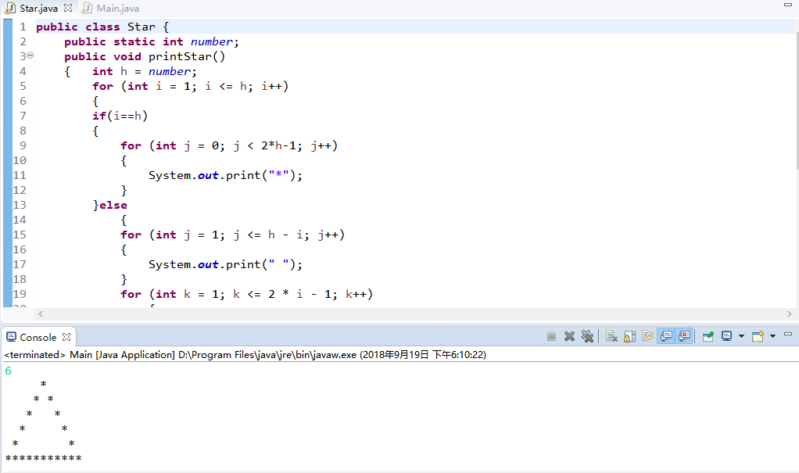

二、99乘法表

**public** **class** Test3 {

**public** **void** printNine()

{

**int** i = 1;

**while**(i<=9)

{

**for**(**int** j = 1; j<=i; j++)

{

System.***out***.print(j+"*"+i+"="+(i*j)+"\t");

}

System.***out***.println();

i++;

}

}

**public** **static** **void** main(String[] args) {

Test3 t = **new** Test3();

t.printNine();

}

}

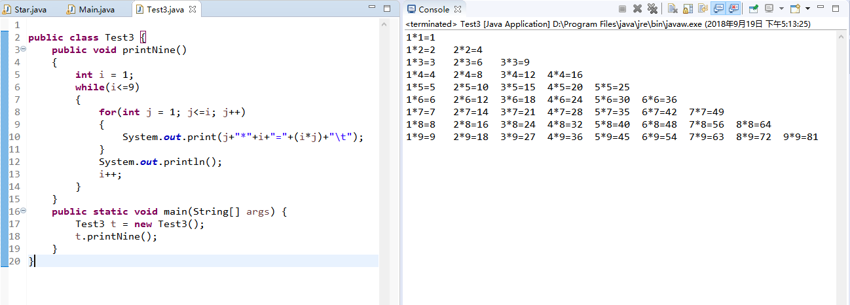

三、属相

**import** java.util.Scanner;

**public** **class** Test4 {

**public** **static** **int** *year*;

**public** **static** String *ra*;

**public** **static** **void** rat()

{ **int** z = (2018-*year*) % 12;

**switch**(z)

{

**case** 0:*ra* = "狗";**break**;

**case** 1:*ra* = "鸡";**break**;

**case** 2:*ra* = "猴";**break**;

**case** 3:*ra* = "羊";**break**;

**case** 4:*ra* = "马";**break**;

**case** 5:*ra* = "蛇";**break**;

**case** 6:*ra* = "龙";**break**;

**case** 7:*ra* = "兔";**break**;

**case** 8:*ra* = "虎";**break**;

**case** 9:*ra* = "牛";**break**;

**case** 10:*ra* = "鼠";**break**;

**case** 11:*ra* = "猪";**break**;

**default**:System.***out***.println("你的输入有误"); **break**;

}

System.***out***.println("属相："+*ra*);

}

**public** Test4(**int** year,String ra)

{

**this**.*year* = year;

**this**.*ra* = ra;

}

**public** **static** **void** main(String[] args) {

System.***out***.println("请输入年份：");

Scanner sc = **new** Scanner(System.***in***);

**int** n = sc.nextInt();

Test4 t = **new** Test4(n, *ra*);

t.*rat*();

}

}

