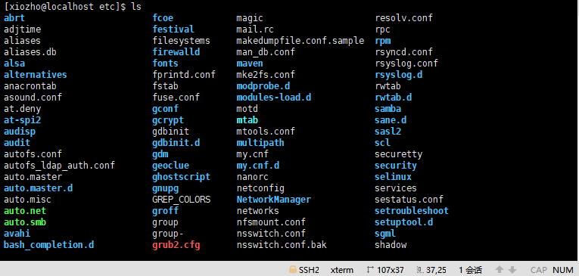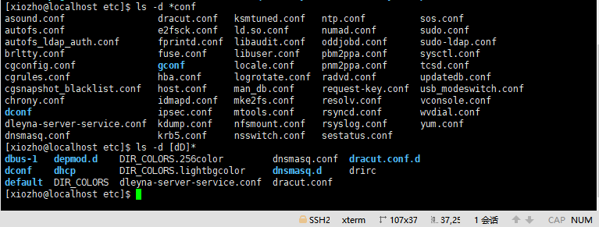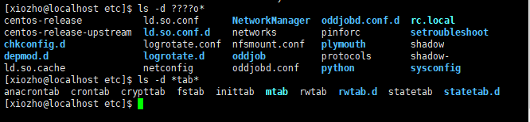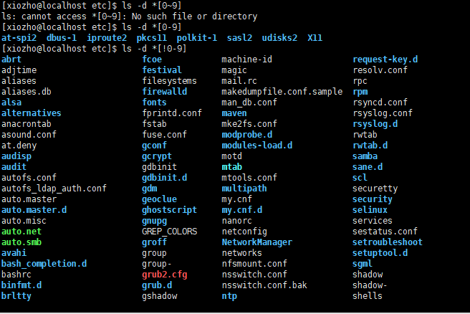

1.3匹配第二个字符不是y并且以e/f结尾的文件

Fcoe

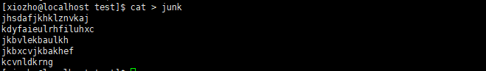

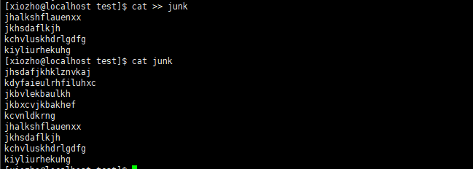



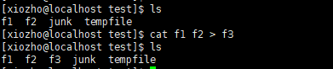

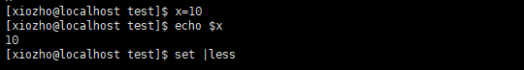

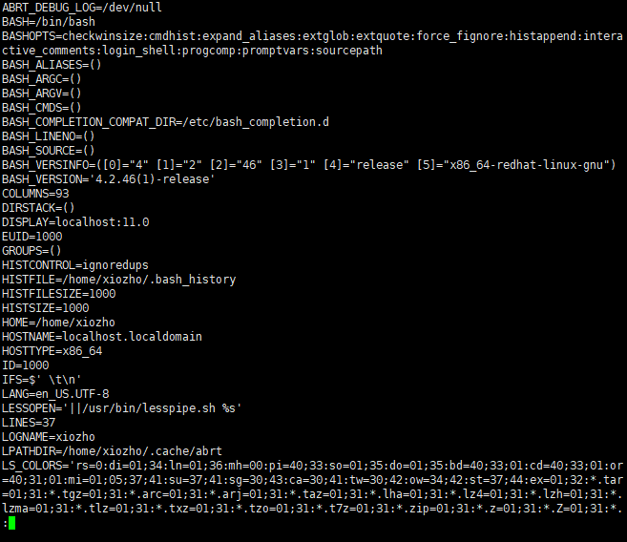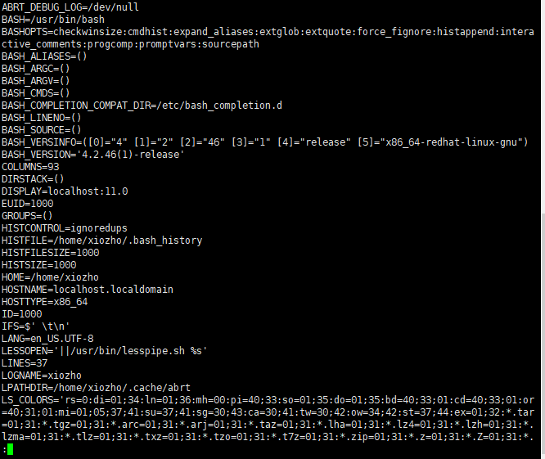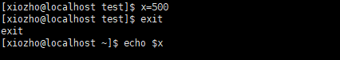

1. ex1

**#!/bin/bash**

**#shell special character**

**echo "current directory is `pwd`" //打印当前工作目录**

**echo "current directory is 'pwd'"**

**echo "home directory is $HOME" //打印当前用户**

**echo "file*.?" //打印当前目录下以file开头的文件**

**today=`date`**

**echo Today is :$today //显示日期**

**ls ex\***

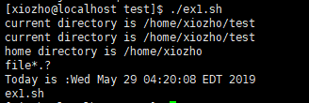

1. ex2

**#!/bin/bash**

**#bash script programming**

**if test $# == 0**

**then**

**ls -l|grep '^d'**

**else**

**for i**

**do**

**ls -l $i|grep '^d'**

**done**

**fi**

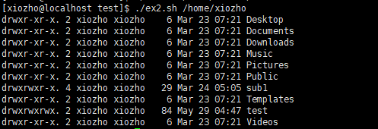

1. ex3

**case $1 in**

**-b) count=`grep ^b $2 | wc -l`**

**echo "The number of lines in $2 that start with b is $count.";;**

**-s) count=`grep ^s $2 | wc -l`**

**echo "The number of lines in $2 that start with s is $count.";;**

**\*) echo "That option is not recognized.";;**

**esac**

1. ex4

**dir=$1;shift**

**if [ -d $dir ]**

**then**

**cd $dir**

**for name**

**do**

**if [ -f $name ]**

**then**

**cat $name**

**echo "End of ${dir}/$name"**

**else**

**echo "Invalid file name:${dir}/$name"**

**fi**

**done**

**else**

**echo "Bad directory name:$dir"**

**fi**



6、编写脚本

1. 编写shell 脚本，计算1-100 的和；

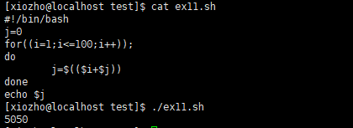

1. 编写shell 脚本，要求输入一个数字，然后计算出从1 到输入数字的和，要求，如果输入的数字小于1，则重新输入，直到输入正确的数字为止；

