1. X64

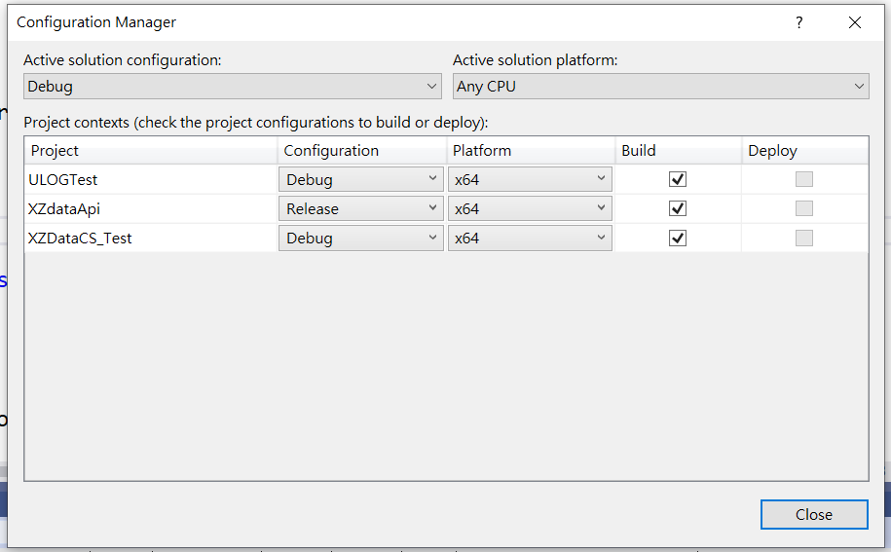

//D:\2020NextPOS\SRC\XZDATA\XZdataApi\x64\Release\XZdataApi.dll ==> x64

1. X32

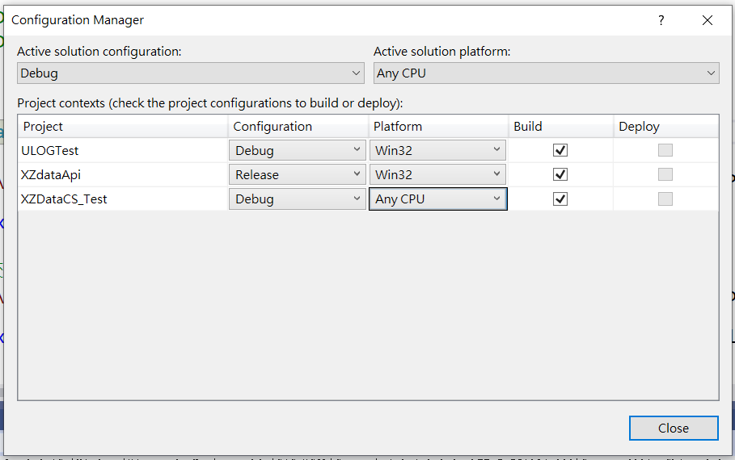

//D:\2020NextPOS\SRC\XZDATA\XZdataApi\Release\XZdataApi.dll ==>x32