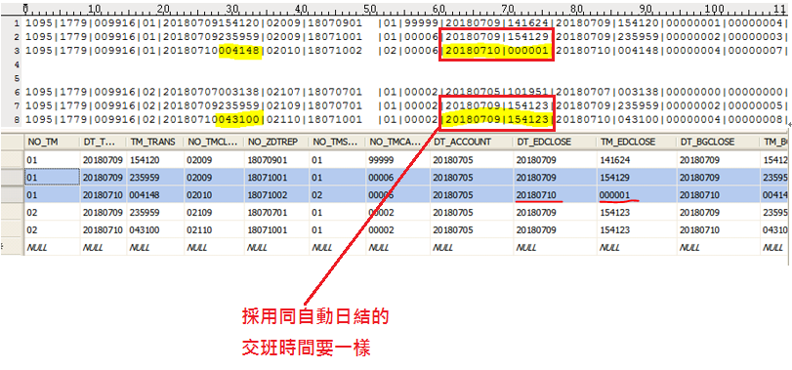

x->dt_begin=sSalesLoginDttm.SubString(1,8);

x->tm_begin=sSalesLoginDttm.SubString(9,6);

x->dt_end = ed_date_time.SubString(1,8); ????????????????

x->tm_end = ed_date_time.SubString(9,6); ??????????????????

//收銀員/交班 手動交班

int __fastcall XDATA::WriteData(const String StoreNO, const String EcrNO, const String SalesNo ,

const String SalFileName, const String Version)

{

for( int i=0; i< Z_CntLst->Count; i++)

{

//sIdx:: 01:第一筆, 10:最後一筆, 11:只有一筆

if( Z_CntLst->Count == 1 )

sIdx="11";

else if( i== 0 )

sIdx="01";

else if( i==Z_CntLst->Count-1)

sIdx="10";

else

sIdx="09";

sRec=Z_CntLst->Strings[i];

TmpZcnt=_StringSegment_EX(sRec, "|", 6); //日結序號

//sTmpDttm=_StringSegment_EX(sRec, "|", 5);

//XRPFile.sprintf("c:\\FtlPos\\XZDATA\\%s%s.Xrp",TmpZcnt.c_str(), str_nxno_seq.c_str() );

//CRPFile.sprintf("c:\\FtlPos\\XZDATA\\%s%s.Crp",TmpZcnt.c_str(), str_nxno_seq.c_str() );

XRPFile.sprintf("c:\\FtlPos\\XZDATA\\Tmp.Xrp");

CRPFile.sprintf("c:\\FtlPos\\XZDATA\\Tmp.Crp");

//CRPFile=ChangeFileExt( str_x_filename, ".Crp");

GetZCNT_SalData(TmpZcnt) ;

if( gtsl_tot->Count > 0 || gtsl_drop->Count > 0)

{

iIdx++;

str_nxno_seq.sprintf("%02d", (_StrToInt(str_nxno_seq,"pxno_seq") + 1)); //目前x次到第幾次

if (_StrToInt(str_nxno_seq,"nxno_seq") > 99) //最多99次X帳

str_nxno_seq = "01";

for( int i=0 ; i< 20; i++) //INIT 代售付ｔａｂｌｅ 15-17 代售, 18-19 代付

{

BaseTbSubrev[i].iqt5_totrev=0;

BaseTbSubrev[i].iam5_totrev=0;

for( int j=0 ; j<10; j++)

{

BaseTbSubrev[i].it8_subrev[j].iqt_subrev=0;

BaseTbSubrev[i].it8_subrev[j].iam_subrev=0;

}

}

GetXDTData(TmpZcnt, String(gchar_tencode), String(gchar_ecr_no), String(gchar_cashier), XDTYYYYMMDD, str_nxno_seq,

String(str_ver_num), str_date_z, DDZ_1099, sRec, sIdx, SaleXDT, XRPFile, CRPFile );

// int __fastcall XDATA::GetXDTData(String StrZCnt, String StoreNO, String EcrNO, String SalesNo , String StrNxnoSeq,

// String Version, String Z_date, String DDZ_1099, String ZNT_1099,

// String &RtnXDTData, String &RtnXRPFile, String &RtnCRPFile );

sLog.sprintf("★ XDATA::產生交班表(%s, XRPFile=%s, CRPFile=%s)",SaleXDT.c_str(), XRPFile.c_str(), CRPFile.c_str() );

writelog( sLog);

ZDT_Lst->Add(SaleXDT);

str_xrp+=SaleXDT;

SaleXDT="";

file_cat( XRPFile.c_str(), StrXRPFileName.c_str() );

sLog.sprintf("XDATA::file_cat(%s, %s)",XRPFile.c_str(), StrXRPFileName.c_str() );

writelog( sLog);

file_cat( CRPFile.c_str(), StrCRPFileName.c_str() );

sLog.sprintf("XDATA::file_cat(%s, %s)",CRPFile.c_str(), StrCRPFileName.c_str() );

writelog( sLog);

}

else

{

sLog.sprintf("XDATA::(%s) 不輸出交班表",sRec.c_str() );

writelog( sLog);

}

} // end of for( int i=0; i< Z_CntLst->Count; i++)

}

int __fastcall XDATA::GetXDTData(String StrZCnt, String StoreNO, String EcrNO, String SalesNo, String XDTsysDttm, String StrNxnoSeq,

String Version, String Z_date, String DDZ_1099, String ZNT_1099, String sIdx,

String &RtnXDTData, String &RtnXRPFile, String &RtnCRPFile )

{

AutoXFg="1"; //0:當作是自動日結之交班

if( Trim(sIdx)=="01" ) //01:第一筆

{

if( sSalesLoginDttm.Trim()=="")

sSalesLoginDttm=_StringSegment_EX(ZNT_1099, "|", 5);

x->dt_begin=sSalesLoginDttm.SubString(1,8); //前次結帳日期

x->tm_begin=sSalesLoginDttm.SubString(9,6); //前次結帳時間

x->dt_end = x->dt_begin;

x->tm_end = "235959";

AutoXFg="0"; //0:當作是自動日結之交班

}

else if( Trim(sIdx)=="10" ) //10:最後一筆

{

x->dt_begin = _StringSegment_EX(ZNT_1099, "|", 5).SubString(1,8);

x->tm_begin = "000001";

x->dt_end = x->dt_begin;

x->tm_end = ed_date_time.SubString(9,6);

AutoXFg="1"; //0:當作是自動日結之交班

}

else if( Trim(sIdx)=="11" ) //11:只有一筆

{

if( sSalesLoginDttm.Trim()=="")

sSalesLoginDttm=_StringSegment_EX(ZNT_1099, "|", 5);

// 預防換日後,馬上日結

if( ed_date_time.SubString(1,8) > _StringSegment_EX(ZNT_1099, "|", 5).SubString(1,8) )

{

sTmp.printf("★ XDATA::計算班表 只有一筆, (ed_date_time:%s) > (1099_Dttm:%s) 取 1099_Dttm 為交班之日期.",

ed_date_time, _StringSegment_EX(ZNT_1099, "|", 5).SubString(1,8) );

writelog(sTmp);

x->dt_begin=sSalesLoginDttm.SubString(1,8); //前次結帳日期

x->tm_begin=sSalesLoginDttm.SubString(9,6); //前次結帳時間

x->dt_end = _StringSegment_EX(ZNT_1099, "|", 5).SubString(1,8); // x->dt_begin;

x->tm_end = "235959";

AutoXFg="1"; //0:當作是自動日結之交班

}

else

{

x->dt_begin=sSalesLoginDttm.SubString(1,8);

x->tm_begin=sSalesLoginDttm.SubString(9,6);

x->dt_end = ed_date_time.SubString(1,8);

x->tm_end = ed_date_time.SubString(9,6);

AutoXFg="1"; //0:當作是自動日結之交班

}

}

else

{

x->dt_begin = _StringSegment_EX(ZNT_1099, "|", 5).SubString(1,8); //前次結帳日期

x->tm_begin = "000001"; //前次結帳時間

x->dt_end = x->dt_begin;

x->tm_end = "235959";

AutoXFg="0"; //0:當作是自動日結之交班

}

}