**Unit 1 Project – MadLibs Name: Junu Choi**

Project Objective:

Create a MadLibs game

* Fun way to tell a story.
* The story is pre-written except for a few missing words.
* The story is hidden from the user.
* The user is asked a series of questions in order to fill in the missing words before seeing the story.
* Then the story is read off with the user's words mixed in!

Criteria:

1. 10 different words inputted
2. Variable names must be meaningful (e.g. noun1, verb2, etc)
3. Story must be school-appropriate
4. No errors!
5. Clean, easy to read output
6. User comments (for code readability)
7. Research & use at least one aspect of String formatting in Python:
   * Escape sequence (easy level)
   * Parameters with print() (medium level)
   * String Formatting (challenge level)

Before you start coding:

1. Create your story
2. Select the missing words
3. Determine each word part of speech
4. Create introduction
5. Create questions
6. Divide story into print statements

**verify your plan with Ms. Cook for plan completion mark

Example of output:

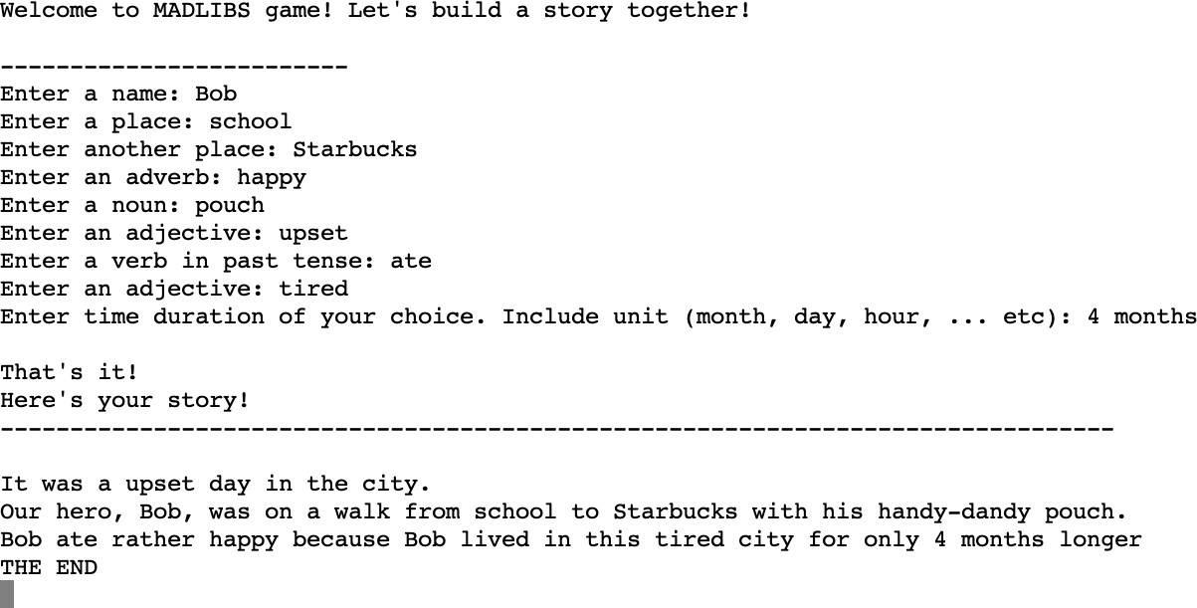

**Save your .py file as **unit1 project_your name.py**

1. Create introduction

**Story 🡪**

**It was a cloudy day in the city.**

**The unknown person was approaching my mom.**

**Suddenly I felt uncomfortable even though nothing was weird.**

**The person was holding a gigantic chocolate.**

**My mom without a single hesitation, told me to run as fast as I could.**

**I instinctively reacted with a big smile.**

**The person was my dad! Dad surprised us with gigantic chocolate 😊.**

**Mom just tried to eat that whole chocolate without me -_-!**

**Missing words 🡪** Mom, Chocolate, fast, gigantic, dad, cloudy, hesitation, run, smile, weird.

**Questions 🡪**

Enter your favorite person:

Enter your favorite food:

Enter your current feelings:

Enter an adverb:

Enter your adjective:

Enter one of your parents:

Enter current weather:

Enter a noun:

Enter a verb:

Enter a facial expression:

Enter an adjective:

**Introduction 🡪**

**Welcome to the game😊 Let’s build a story together!**

**Blah**

**Blah**

**Blah**

**That’s all you have to answer!**

**Now, let’s take a look at your unique story.**

**Story starts\***