Nama : Royyan Candrawinata
Kelas : 1B-TT
No.Absen : 17
Project 2 MQTT
#include <Wire.h>
#include <Adafruit_GFX.h>
#include <Adafruit_SSD1306.h>
#include <SimpleDHT.h>
#include <WiFi.h>
#include <PubSubClient.h>
#define SCREEN_WIDTH 128
#define SCREEN_HEIGHT 64
#define OLED_RESET -1
#define pinDHT 34
#define pinLEDHijau 13
#define pinLEDMerah 12
// Kredensial WiFi
const char* ssid = "Polinema Hotspot";
const char* password = " ";

// Kredensial MQTT Broker
const char* mqtt_server = "broker.emqx.io";
const int mqtt_port = 1883;
const char* mqtt_topic_temp = "esp32/temperature";
const char* mqtt_topic_hum = "esp32/humidity";

WiFiClient espClient;
PubSubClient client(espClient);
Adafruit_SSD1306 display(SCREEN_WIDTH, SCREEN_HEIGHT, &Wire, OLED_RESET);
SimpleDHT11 dht11(pinDHT);

void setup_wifi() {
delay(10);
Serial.println();
Serial.print("Connecting to ");
Serial.println(ssid);

WiFi.begin(ssid, password);

while (WiFi.status() != WL_CONNECTED) {
delay(500);
Serial.print(".");
}

Serial.println("");
Serial.println("WiFi connected");
Serial.println("IP address: ");
Serial.println(WiFi.localIP());
}

void reconnect() {
while (!client.connected()) {
Serial.print("Attempting MQTT connection...");
if (client.connect("ESP32Client")) {
Serial.println("connected");
} else {
Serial.print("failed, rc=");
Serial.print(client.state());
Serial.println(" try again in 5 seconds");
delay(5000);
}
}
}

void setup() {
Serial.begin(115200);

// Inisialisasi OLED
if(!display.begin(SSD1306_SWITCHCAPVCC, 0x3C)) {
Serial.println(F("SSD1306 allocation failed"));
for(;;);
}
display.display();
delay(2000);
display.clearDisplay();
display.setTextSize(1);
display.setTextColor(SSD1306_WHITE);
display.setCursor(0,0);

// Inisialisasi LED
pinMode(pinLEDHijau, OUTPUT);
pinMode(pinLEDMerah, OUTPUT);

// Setup WiFi dan MQTT
setup_wifi();
client.setServer(mqtt_server, mqtt_port);
}

void loop() {
if (!client.connected()) {
reconnect();
}
client.loop();

byte temperature = 0;
byte humidity = 0;
int err = SimpleDHTErrSuccess;

// Membaca data dari DHT11
if ((err = dht11.read(&temperature, &humidity, NULL)) !=
SimpleDHTErrSuccess) {
Serial.print("Read DHT11 failed, err="); Serial.println(err);
delay(1000);
return;
}

// Menampilkan data suhu dan kelembaban pada OLED
display.clearDisplay();
display.setCursor(0,0);
display.print("Temperature: ");
display.print((int)temperature);
display.println(" C");
display.print("Humidity: ");
display.print((int)humidity);
display.println(" H");
display.display();

// Kontrol LED berdasarkan kelembaban
if (humidity < 69) {
digitalWrite(pinLEDHijau, HIGH);
digitalWrite(pinLEDMerah, LOW);
} else {
digitalWrite(pinLEDHijau, LOW);
digitalWrite(pinLEDMerah, HIGH);
}

// Publish data suhu dan kelembaban ke MQTT
char tempString[8];
snprintf(tempString, sizeof(tempString), "%d", (int)temperature);
client.publish(mqtt_topic_temp, tempString);
Serial.print("Published Temperature: ");
Serial.println(tempString);

char humString[8];
snprintf(humString, sizeof(humString), "%d", (int)humidity);
client.publish(mqtt_topic_hum, humString);
Serial.print("Published Humidity: ");
Serial.println(humString);
delay(2000); // Jeda 2 detik sebelum membaca dan mempublish data lagi
}
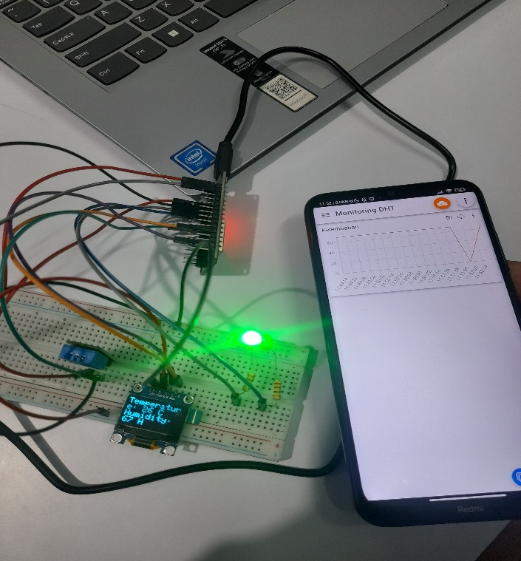
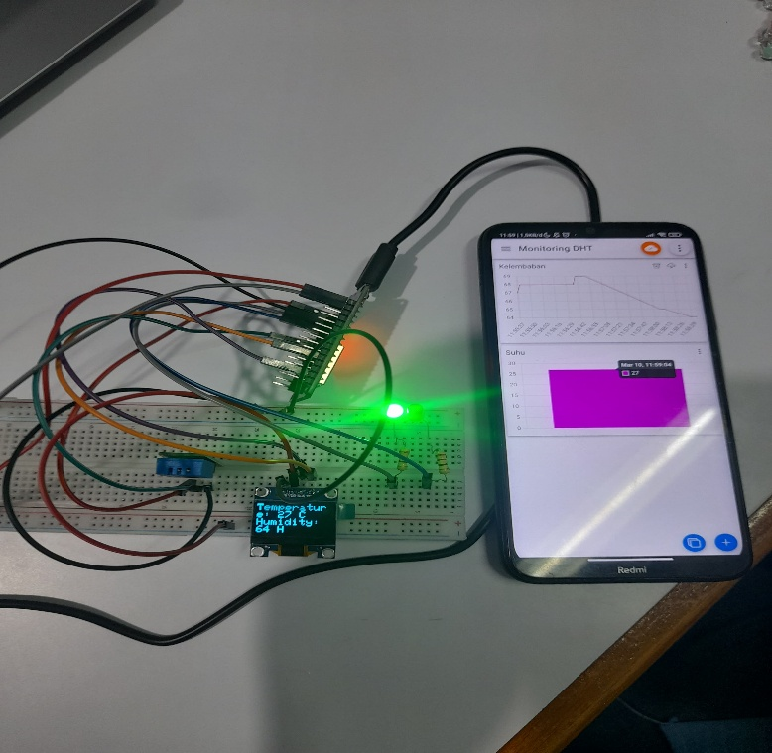
FOTO PROJECT

