MUNICIPAL SERVICES
APPLICATION
README & Technical Documentation
C# • .NET Framework 4.8 • Windows Forms • Visual Studio
Prepared by: Millenium Msomi
Project: MunicipalServicesApp
Documentation Version: Part 2 – Local Events and Announcements

1. Project Overview
The Municipal Services Application is a C# Windows Forms desktop application designed to provide residents with access to municipal services through a simple graphical interface. Part 1 implemented the Report Issues workflow. Part 2 extends the same application with a Local Events and Announcements component while preserving the existing functionality.
The completed Part 2 allows residents to browse upcoming events, search event information, filter events by category and date, inspect event details, and receive recommendations influenced by category interest. This stage also demonstrates advanced collection structures and search/filtering logic required by the project brief.

2. Technologies and Data Structures
Technology / Structure | Purpose
C# | Primary programming language
.NET Framework 4.8 | Application framework
Windows Forms | Desktop graphical user interface
Visual Studio | Development environment
List<T> | Stores related objects, including events sharing a date
Queue<MunicipalEvent> | Maintains upcoming events in insertion order
HashSet<string> | Maintains unique event categories
Dictionary<string, int> | Tracks category-interest counts for recommendations
SortedDictionary<DateTime, List<MunicipalEvent>> | Organises event groups automatically by date

3. Features Implemented
- Existing Report Issues functionality from Part 1 remains available from the Main Menu.
- Local Events and Announcements is enabled from the Main Menu.
- Upcoming municipal events are displayed in chronological order.
- Residents can search across event title, category, location and description.
- Residents can filter events by category.
- Residents can enable a date filter and select a specific event date.
- Search text, category and date conditions can operate together.
- Selecting an event displays its title, date, category, location and description.
- Category selections are recorded as user-interest signals.
- Recommend an Event uses recorded category interest to favour suitable upcoming events.
- Back to Main returns the resident to the Municipal Services Main Menu.
- Service Request Status remains reserved for Part 3.

4. Local Events and Announcements Walkthrough
The screenshots below show the completed Part 2 workflow and the main user interactions tested in the application.
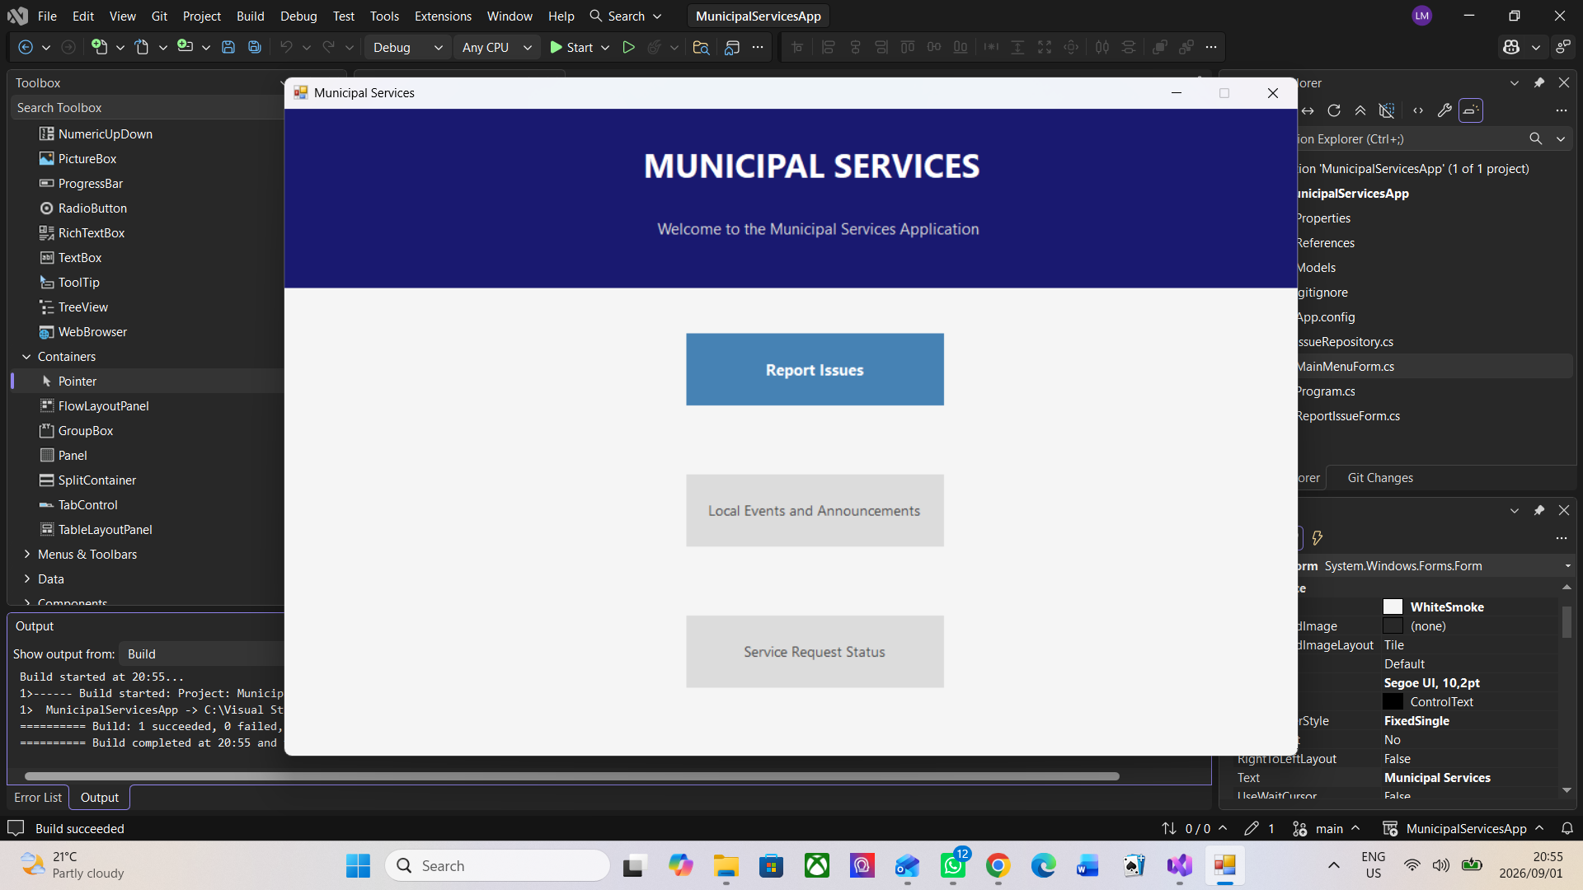
Figure 1: Municipal Services Main Menu with Local Events and Announcements enabled.
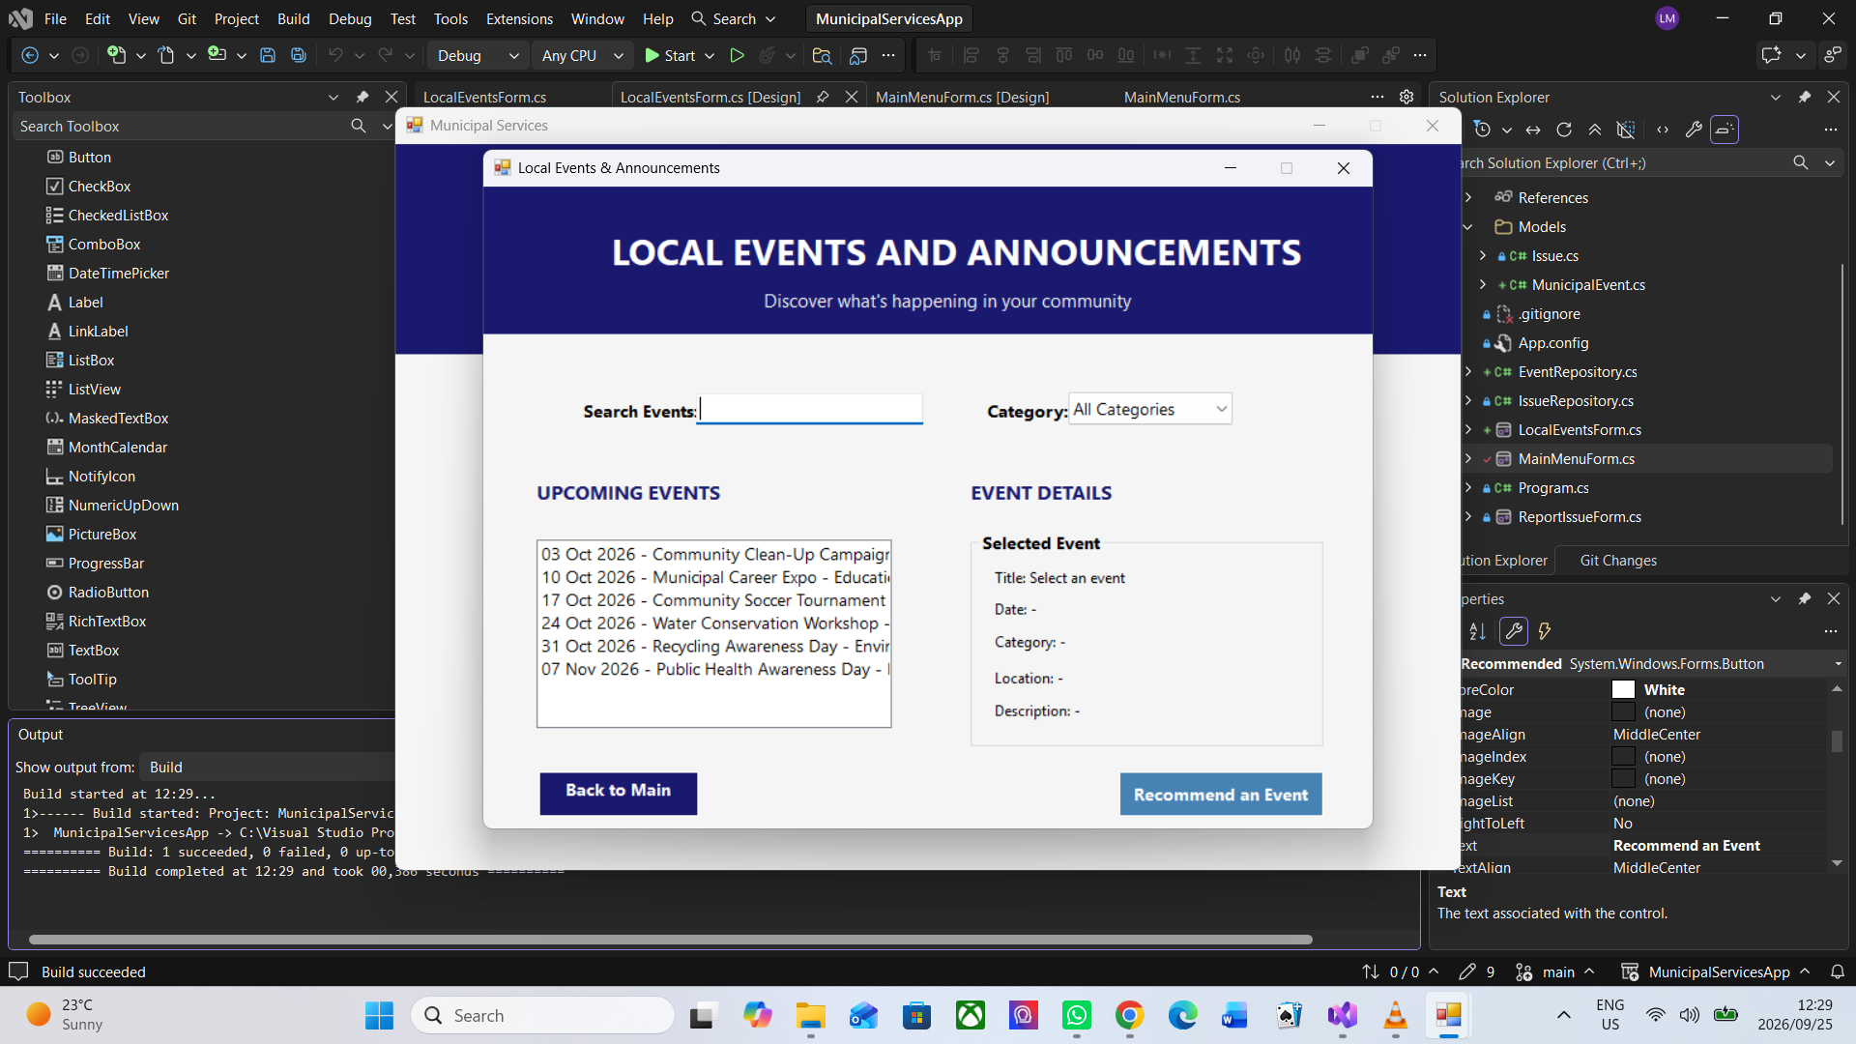
Figure 2: Local Events and Announcements showing the upcoming-event list.
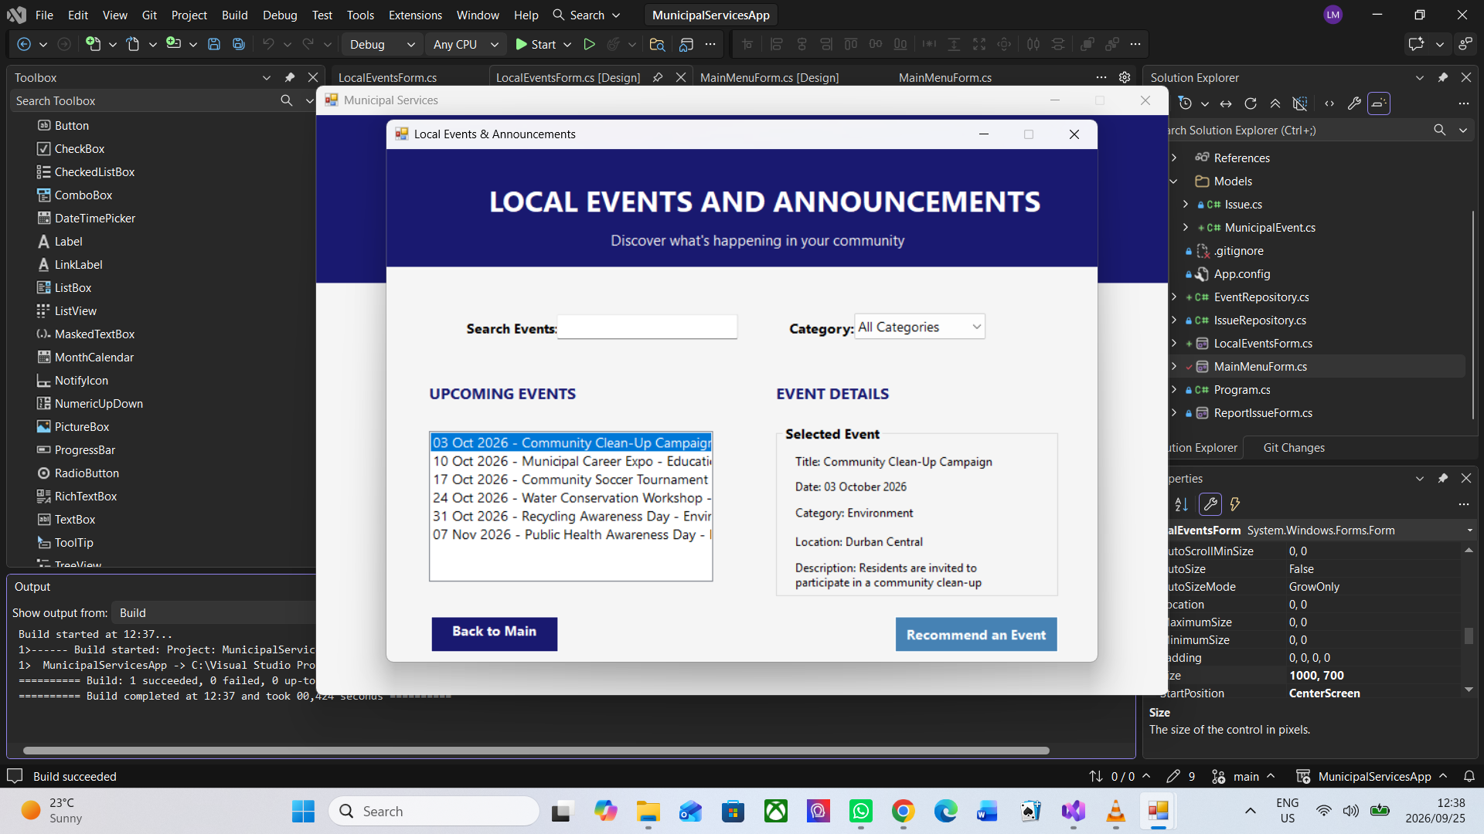
Figure 3: Event selection displaying detailed event information.
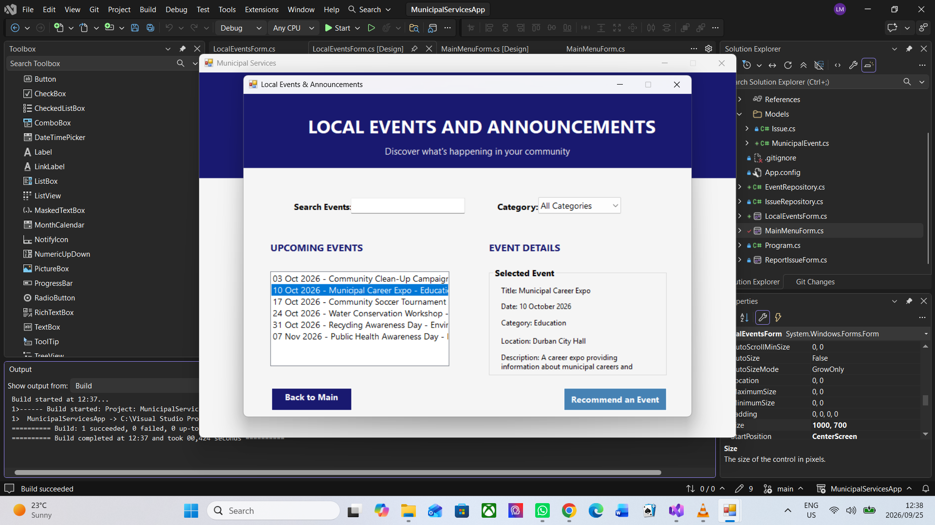
Figure 4: Category filtering applied to the event list.
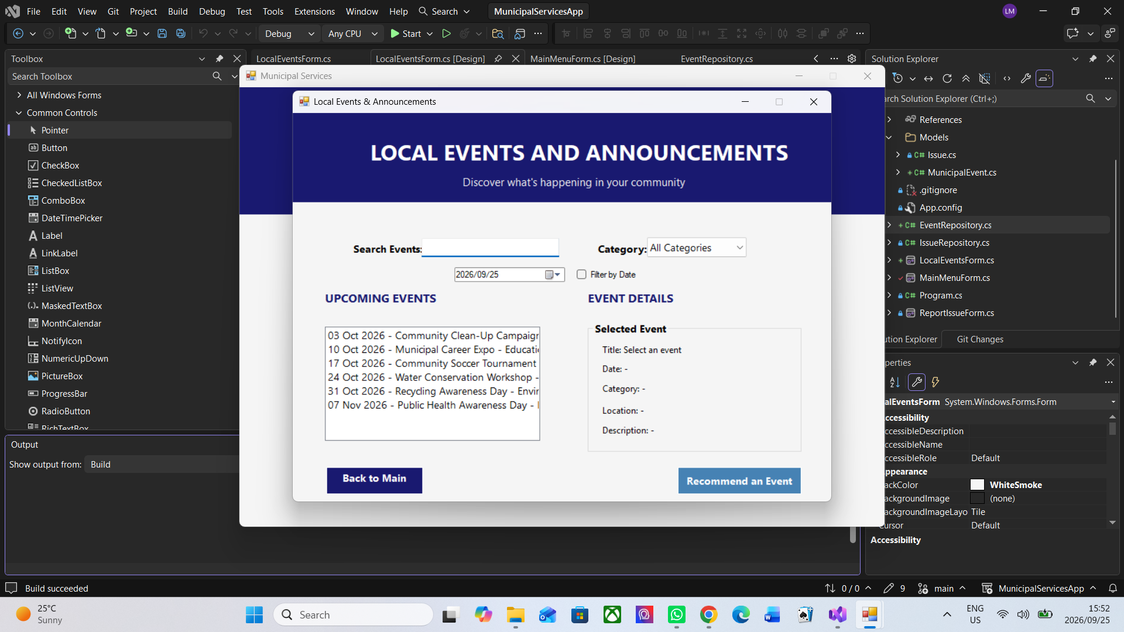
Figure 5: Date filtering applied to locate a specific event date.
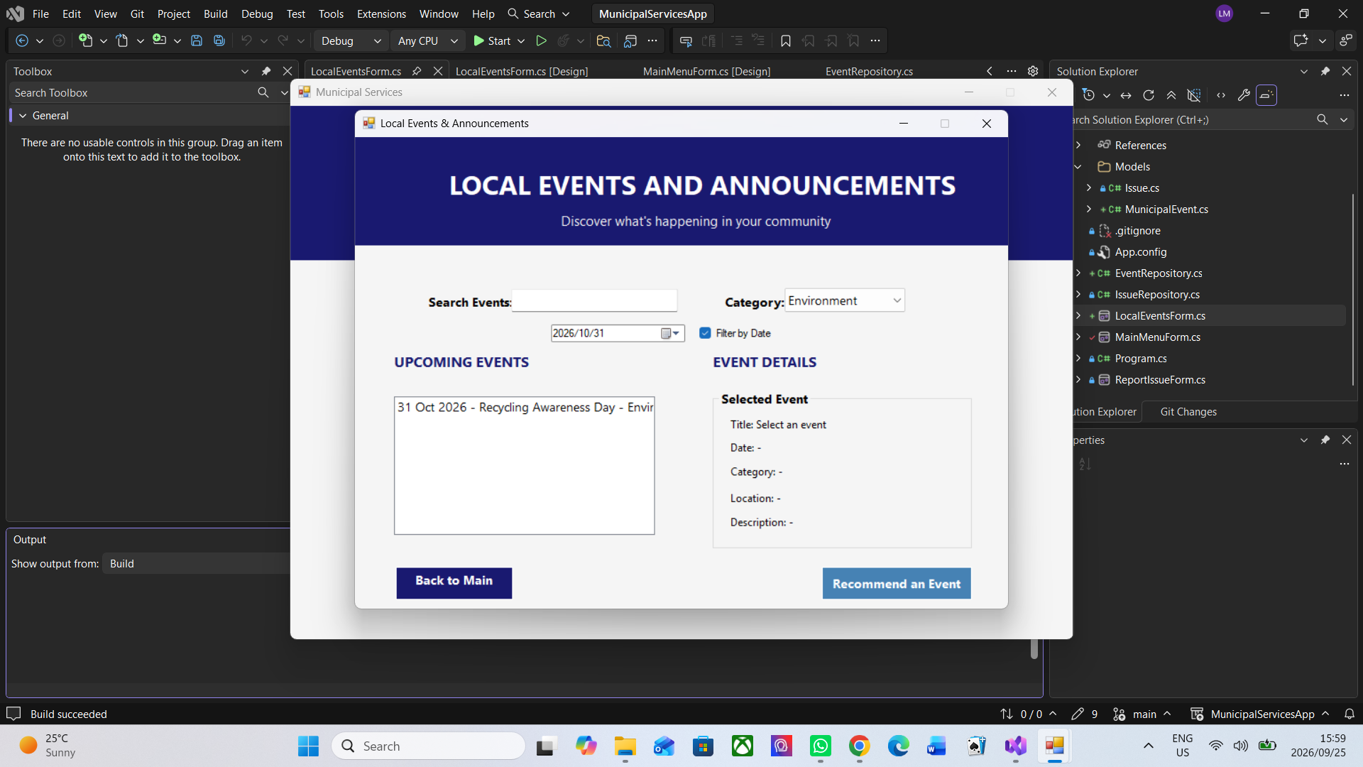
Figure 6: Recommendation functionality selecting and presenting an event to the user.

5. Advanced Data Structures

5.1 SortedDictionary for Chronological Event Storage
Events are organised by date using a SortedDictionary. The key is the event date and the value is a list, allowing more than one event to share the same date while the keys remain automatically ordered.
private static readonly SortedDictionary<DateTime, List<MunicipalEvent>>
eventsByDate = new SortedDictionary<DateTime, List<MunicipalEvent>>();
This supports chronological display and efficient date-oriented retrieval without repeatedly sorting the entire event collection.

5.2 HashSet for Unique Categories
private static readonly HashSet<string>
categories = new HashSet<string>();
A HashSet stores each category only once. For example, multiple Environment events can exist while the Category ComboBox still receives a single Environment entry.

5.3 Queue for Upcoming Events
private static readonly Queue<MunicipalEvent>
upcomingEvents = new Queue<MunicipalEvent>();
The queue demonstrates FIFO (First In, First Out) handling of upcoming events. New MunicipalEvent objects are enqueued when they are added to the repository.

5.4 Dictionary for Category Interest
private static readonly Dictionary<string, int>
categorySearchHistory = new Dictionary<string, int>(
StringComparer.OrdinalIgnoreCase);
The dictionary records how often a resident selects event categories. The category name is the key and the accumulated interest count is the value. These counts provide a simple preference signal for recommendation logic.

6. Search and Filtering Logic
The Local Events form combines several conditions before an event is shown. Search text can match the title, category, location or description. The selected category must also match unless All Categories is active. When Filter by Date is enabled, the event date must match the selected date as well.
matchesSearch && matchesCategory && matchesDate
This design allows the filters to work together. For example, the resident can select Environment and 31 October 2026 to narrow the list to the Recycling Awareness Day event.

7. Event Recommendation System
The recommendation feature uses category interaction history rather than relying only on an arbitrary event choice. When the resident selects categories while browsing, the repository increases the corresponding category-interest count. The recommendation logic can identify the strongest category preference and select a suitable upcoming event from that category.
During testing, repeated Environment interest resulted in Environment recommendations such as Community Clean-Up Campaign and Recycling Awareness Day. The recommended event is selected in the event list so its details are visible, and a MessageBox presents the event title, date and location.

8. Event Repository and Model

8.1 MunicipalEvent Model
Each event is represented as a MunicipalEvent object containing an identifier, title, category, event date, location and description. Keeping these values in one model supports clear object-oriented organisation.

8.2 EventRepository
EventRepository centralises event storage and related operations. It adds events to the required structures, exposes event and category collections to the form, loads sample events, records category interest, and returns recommendations. This separation keeps data-management logic away from most user-interface code.

9. Sample Event Data
Date | Event | Category | Location
03 Oct 2026 | Community Clean-Up Campaign | Environment | Durban Central
10 Oct 2026 | Municipal Career Expo | Education | Durban City Hall
17 Oct 2026 | Community Soccer Tournament | Sports | Kings Park Sports Grounds
24 Oct 2026 | Water Conservation Workshop | Community | Municipal Community Centre
31 Oct 2026 | Recycling Awareness Day | Environment | Durban Beachfront
07 Nov 2026 | Public Health Awareness Day | Health | Community Health Centre

10. Testing Summary
Test Scenario | Expected / Observed Result | Status
Open Local Events | Upcoming events display in the list. | Passed
Select an event | Event details display correctly. | Passed
Search by text | Only matching events remain visible. | Passed
Category filter | Only matching categories remain visible. | Passed
Date filter | Only events on the selected date remain visible. | Passed
Combined filters | Event must satisfy all active conditions. | Passed
Recommendation | A suitable upcoming event is selected and displayed. | Passed
Repeated category interest | Recommendation favours the category with stronger recorded interest. | Passed
Back to Main | Application returns to the Main Menu. | Passed
Build | Solution builds successfully after implementation changes. | Passed

11. How to Compile and Run
- Extract or clone the MunicipalServicesApp project to a local folder.
- Open the MunicipalServicesApp solution in Visual Studio.
- Confirm that the .NET Framework 4.8 developer components are available.
- Select Build > Rebuild Solution and confirm that the build succeeds.
- Run the application using Start or F5.
- From the Main Menu, select Local Events and Announcements.

12. How to Use the Local Events Feature
- Browse the events displayed under Upcoming Events.
- Select an event to view its detailed information.
- Type into Search Events to search across event information.
- Choose a value from Category to filter the list.
- Choose a date and enable Filter by Date when date-specific filtering is required.
- Combine search text, category and date filtering where necessary.
- Select Recommend an Event to receive a suggested event.
- Select Back to Main to return to the Main Menu.

13. Project Source Structure
MunicipalServicesApp
│
├── Models
│ ├── Issue.cs
│ └── MunicipalEvent.cs
├── EventRepository.cs
├── IssueRepository.cs
├── MainMenuForm.cs
├── LocalEventsForm.cs
├── ReportIssueForm.cs
├── Program.cs
├── App.config
└── .gitignore

14. GitHub Repository
The project is maintained on GitHub for version control and submission evidence.
Repository: https://github.com/MillenniumHub21/MunicipalServicesApp
Before the Part 2 submission, the repository should contain the latest source code and this updated documentation. Generated development folders such as .vs, bin and obj should normally remain excluded through .gitignore.

15. Current Limitations
- Event information is currently stored in memory and populated from sample data.
- Submitted issues are also stored in memory.
- Information is not persisted when the application closes.
- The recommendation history is session-based rather than linked to a persistent user profile.
- No live municipal event service or database is connected.
- Service Request Status has not yet been implemented.

16. Future Development
Part 3 will implement Service Request Status and complete the full Municipal Services Application. The project brief reserves the next stage for advanced structures and algorithms used to organise, retrieve and display service-request information. Future production improvements could also include persistent database storage, authenticated user accounts, administrator event management and live municipal data integration.

17. Conclusion
Part 2 successfully extends the Municipal Services Application with a functional Local Events and Announcements component. Residents can browse, search and filter event information, inspect event details and receive recommendations influenced by category interest. The implementation demonstrates practical use of SortedDictionary, HashSet, Queue and Dictionary structures while maintaining the Report Issues functionality completed in Part 1. The application is now prepared for the final Service Request Status stage.

