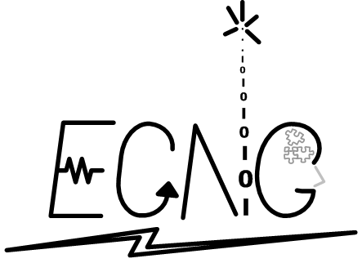THE UNIVERSITY OF THE WEST INDIES

ST. AUGUSTINE, TRINIDAD & TOBAGO, WEST INDIES

FACULTY OF ENGINEERING

**Department of Electrical & Computer Engineering**

BSc. in Electrical & Computer Engineering

**ECNG 3020 SPECIAL PROJECT**

**PROGRESS REPORT:**

Hardware-Based Agriculture Maintenance System

Luther Jn. Baptiste

8151117459

Contents

1 Introduction 1

2 Approach 2

2.1 System Overview 3

2.2 Managing the Project 6

3 Status of Completion of objectives 9

4 Challenges 10

4.1 Overdesign 10

4.2 Lack of Experience 11

5 Preliminary Results 11

References 12

Appendix 13

Figure 1 Conceptual Block Diagram of slave Node 4

Figure 2 System Block Diagram of the Slave Node 5

Figure 3 System Block Diagram of the Master Node 5

Figure 4 Milestones 6

Figure 5 Work Breakdown Structure 7

Figure 6 Tracking Gantt Chart 8

Figure 7 ADC records Submodule Simulation 13

Figure 8 Message Submodule Behavioural Simulation 14

Figure 9 UART RX module Behavioural Simulation 17

Figure 10 UART RX module Behavioural Simulation 17

# Introduction

Precision agriculture is a relatively new and expanding field from which emergent technologies have proven to increase crop yields with reduced water usage (Gutierrez et al. 2014, Dinh Le and Ho Tan 2015). The implications of these technologies on developing economies situated in areas prone to drought and pests are positive (Mafuta et al. 2013). Crop production and maintenance in the Caribbean context is an activity of paramount importance in the effort to increase regional food security and to reduce food import bills (FAO 2013). Irrigation and fertigation of crops incurs most of the cost operation through crop cycles. Over-irrigation and over-fertigation wastes limited water resources and expensive fertilisers in addition to adverse effects on crop yield. Inadequate irrigation and fertigation also reduces production. Optimum crop production can be achieved by monitoring soil conditions and taking appropriate and precise actions to maintain optimum conditions. The Hardware-based Agriculture Maintenance System is a scalable field programmable gate array (FPGA) implementation for remote crop monitoring and maintenance.

The aim of the project is to design and develop the minimal constituent parts of the scalable wireless sensor network (WSN): the master administrator node and the slave sensor node. The nodes communicate over general packet radio service (GPRS) using GSM modems.

The functions of the slave node include the following:

1. Monitoring soil moisture and soil pH
2. Allowing the administrator to set moisture thresholds using a keypad and 14-segment display interface
3. Transmitting warning signals to the master node when moisture values move out of administrator defined values
4. Initiating irrigation actuators at the command of the administrator node.
5. Halting irrigation when moisture levels return to values within administrator defined thresholds.
6. Informing the administrator node that the issues have rectified

The functions of the master node include:

1. Allowing the administrator to start and irrigation session in response to low moisture using a keypad interface
2. Displaying warning messages on an 14-segment display
3. Identify slave nodes by a unique ID.

This project is categorized as a Type IV: Investigation with System Development and/or Design.

# Approach

Many implementations cited in the literature on wireless sensor networks for precision agriculture consisted of an on-site accumulator node which receives data from sensor nodes before forwarding the data to a control centre (computer or mobile phone) for analysis or appropriate a (Gutierrez et al. 2014, Le and Tan 2015, Mafuta et al. 2013). There is a ubiquitous use of microcontroller, software based systems. Wireless communication between sensor nodes and master nodes/coordinator nodes was performed using IEEE 802.15.4 (ZigBee) protocol. Some chose to eliminate the master node, opting to use an on-site computer (laptop) to communicate to sensor nodes (Bhanu, Hussain, and Ande 2014). Gutierrez et al. (2014) used a cellular internet protocol interface over General Packet Radio Service (GPRS) to allow administrators to interact with and control the system via a Web application. Le and Tan (2015) described a system with the objective acquiring and recording large amounts of data for stochastic modelling of environmental conditions for determining future irrigation requirements. Bhanu, Hussain, and Ande (2014) implemented an irrigation system that adjusts the irrigation run time in response to changes in air humidity, a feature atypical of commercial irrigation systems. The FPGA based irrigation system developed by Lai and Dai (2012) allows manual configuration of parameters using a keypad, and a multiple user management/authentication scheme.

The approach taken for the Hardware Based Agricultural Management System is simplistic. When completed, the slave node will encapsulate a data frame in the form of an SMS message and transmit it using a GPRS module on request from the master node or when pH or moisture detected deviates from the user defined ranges or re-enters the ranges. The slave node will not commence Irrigation automatically. Thresholds will be entered manually into the slave node using a keypad.

## System Overview

The first phase of the project has been to design the slave node. The rationale behind this decision is that the much of functionality of the slave nodes will be duplicated in the master node. Also, the functionality of the IP cores may be tested fully for the slave node with a mobile phone acting as the master node.



Figure 1 Conceptual Block Diagram of slave Node

The figure above shows the conceptual block diagram for the slave node. The most recent revision proposes a 4x3 keypad and eliminates the need for an ASIC keypad encoder. To support alphanumeric characters, 14-segment LED displays have been procured and the design of the display will support 6 14-segment displays. The use cases and user manual for both master nodes and slave nodes are in development.



Figure 2 System Block Diagram of the Slave Node

The system layout above is modelled after a similar FPGA based irrigation controlled cited in a journal encountered in the literature survey (Lai and Dai 2012).



Figure 3 System Block Diagram of the Master Node

The function of the master node is to display the most recent messages/warnings and configurations of a maximum of 10 slave nodes. The display drive may require 8 displays, but this is yet to be determined.

## Managing the Project

The project has been broken down into the tasks shown in the table below. A very aggressive schedule has been followed to ensure completion of the project by mid-March.

|  |  |
| --- | --- |
| **Activity** | **Estimated time** |
| Define Module Algorithms | 2 weeks |
| FSM-D module interfaces | 3 weeks |
| Front end design | 1 weeks |
| Translate Modules to VHDL | 3 weeks |
| Unit Testing | 2 week |
| Integration testing | 2 weeks |
| Literature survey | 8 weeks |
| Write literature review | 2 weeks |
| Write methodology | 2 Weeks |
| Conclude report and Format | 1 Week |
| **Total Effort** | **24 Weeks** |



Figure 4 Milestones



Figure 5 Work Breakdown Structure

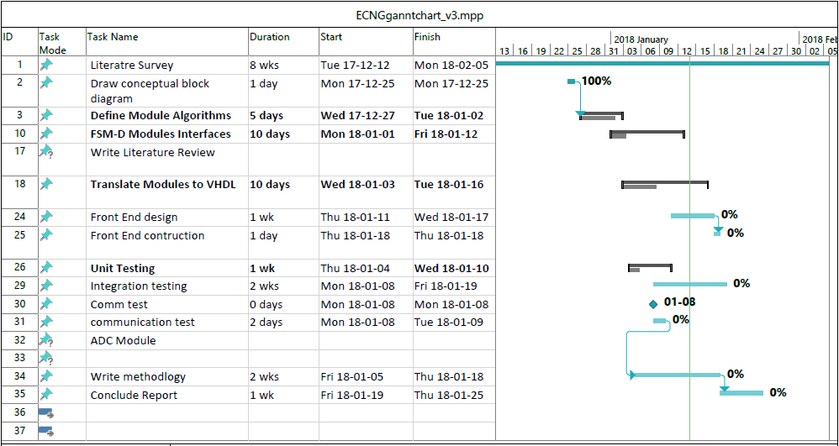

Figure 6 Tracking Gantt Chart

# Status of Completion of objectives

|  |  |
| --- | --- |
| Requirement | Status |
| Literature survey of agricultural maintenance systems especially those monitoring soil PH and moisture. | Complete, The state of the art has deferred pH measuring components to future development. |
| a) Moisture Level - Measures soil moisture and transmits real-time information about soil moisture using GSM modem form a variety of locations within the portion of land to administrator for analysis. | System designed to transmit data on request form administrator. Communication Modules translated to VHDL, simulated and synthesized successfully. The system will sample pH and moisture every minute. |
| Capable of allowing setting of optimum moisture level for different crops. - If moisture level below the min threshold required then an irrigation system turned on for that portion of land and kept on until optimum moisture level reached. | Configuration modules designed, but not implemented. FSM must be revisited. Scheme for calculating 8-bit threshold using packed BCD value input by user has been developed for moisture values.  System designed to start irrigation on request from administrator. Will halt irrigation when optimum moisture value is attained |
| If moisture level above max allowable then warning messages to be send to administrator using GSM modem. | The system has been designed to transmit to the administrator when every the measured Moisture crosses a threshold. That is when it deviates and when it is rectified. |
| b) PH Level - Measures soil PH and transmits real-time information about soil PH using GSM modem from a variety of locations within the portion of land to administrator for analysis. | System designed to transmit data on request form administrator. Communication Modules translated to VHDL, simulated and synthesized successfully. The system will sample pH and moisture every minute. |
| -Capable of allowing setting of optimum PH level for different crops. | Scheme for calculating 8-bit threshold using packed BCD value input by user must be developed for pH values. |
| . - If PH level not appropriate then warning messages to be send to administrator using GSM modem. | The system has been designed to transmit to the administrator when every the measured Moisture crosses a threshold. That is when it deviates and when it is rectified. |
| d) System portable and capable of being powered via batteries or the 12V outlet of a vehicle (Cigarette lighter | The GSM module can operate anywhere from from 9 – 36V. Appropriate power electronics will have to be designed for the Spartan 6 board. |
| Prepare a manuscript in IEEE-format, page length not exceeding 10 pages | This has yet to be commenced |

# Challenges

Inexperience, overdesign and the unavailability of desired components are the factors that have posed a challenge to the completion of the project. This project has been rescoped and restarted twice since it was commenced.

## Overdesign

The original concept included any timer features with data logging and fully automated irrigation control in mind. This was to match the functionality of some of the systems described in the literature. The features included, a variable data acquisition delay timer which shortens the acquisition interval when the system is irrigating (Mafuta et al. 2013). Variable data transmission intervals for data logging. A variable irrigation timer to control irrigation run time and a variable percolation delay to account for the time taken for water to be absorbed through the soil. These features, though useful would make add complexity to the project and decrease feasibility.

The first attempt was to model the system after a microcontroller with bidirectional data buses and a single control path module to manage all the functionality of the system in several VHDL process declarations, this was a symptom of my inexperience.

## Lack of Experience

This system has required VHDL language constructs and specification and modelling concepts not introduced to me before. Thankfully, material on the subject is widely available.

# Preliminary Results

Modules and submodules for major functionality requirements have been translated simulated and synthesized successfully. See appendix for the timing simulations of the UART transmission module, UART receive module and ADC records modules. The ADC records module communicates the status of pH and Moisture using to the message module a 5 bit code and the associated ASCII number symbol. 8 bit Binary values are converted to 3 ASCII characters using lookup tables.

# References

Bhanu, B. Balaji, M. A. Hussain, and P. Ande. 2014. "Monitoring of soil parameters for effective irrigation using Wireless Sensor Networks." 2014 Sixth International Conference on Advanced Computing (ICoAC), 17-19 Dec. 2014.

Dinh Le, Tuan , and Dat Ho Tan. 2015. "Design and Deploy a Wireless Sensor Network for Precision Agriculture." 2015 2nd National Foundation for Science and Technology Development Conference on Information and Computer Science (NICS), Ho Chi Minh City, Vietnam.

FAO. 2013. CARICOM Food Import Bill, Food Security and Nutrition,Subregional Office for the Caribbean. Food and Agriculture Organization of the United Nations

Gutierrez, Joaquin, Juan Francisco Villa-Medina, Alejandra Nieto-Garibay, and Miguel Angel Porta-Gandara. 2014. "Automated Irrigation System Using a Wireless Sensor Network and GPRS Module." *IEEE Transactions on Instrumentation and Measurement* 63 (1):166-176. doi: 10.1109/tim.2013.2276487.

Joly, Matthieu, Laurent Mazenq, Maurane Marlet, Pierre Temple-Boyer, Céline Durieu, and Jérôme Launay. 2017. "Multimodal Probe Based on ISFET Electrochemical Microsensors for In-Situ Monitoring of Soil Nutrients in Agriculture." *Proceedings* 1 (4). doi: 10.3390/proceedings1040420.

Lai, Z., and Y. Dai. 2012. "An Irrigation Control System Based on an FPGA." 2012 Second International Conference on Instrumentation, Measurement, Computer, Communication and Control, 8-10 Dec. 2012.

Le, T. Dinh, and D. H. Tan. 2015. "Design and deploy a wireless sensor network for precision agriculture." 2015 2nd National Foundation for Science and Technology Development Conference on Information and Computer Science (NICS), 16-18 Sept. 2015.

Mafuta, Million, Marco Zennaro, Antoine Bagula, Graham Ault, Harry Gombachika, and Timothy Chadza. 2013. "Successful Deployment of a Wireless Sensor Network for Precision Agriculture in Malawi." *International Journal of Distributed Sensor Networks* 9 (5):150703. doi: 10.1155/2013/150703.al Simulation

# Appendix

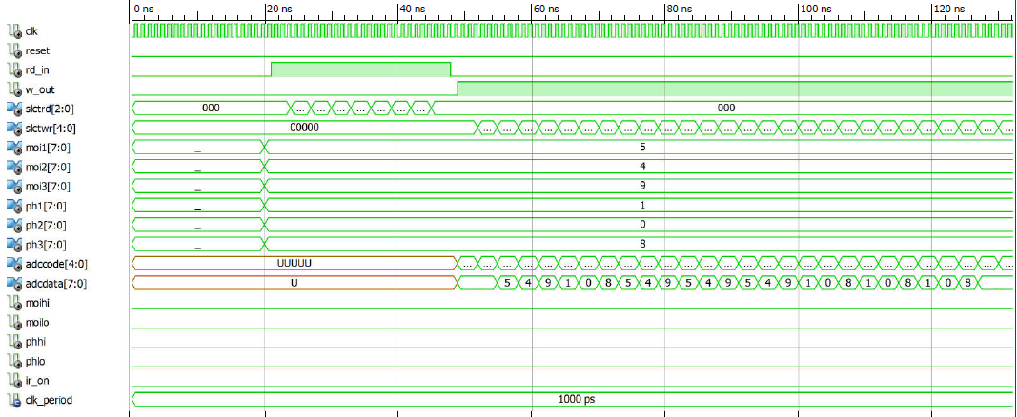

Figure 7 ADC records Submodule Simulation

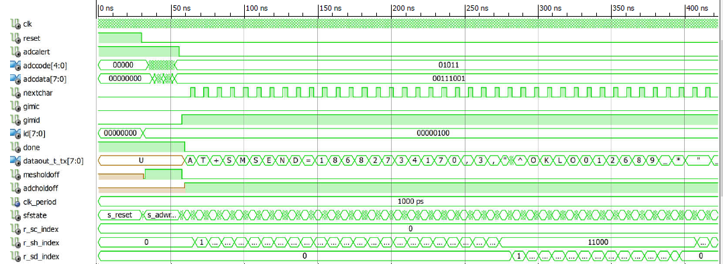

Figure 8 Message Submodule Behavioural Simulation

SMS Data Frame

1 Char = 8 bits

|  |  |  |  |  |  |  |  |
| --- | --- | --- | --- | --- | --- | --- | --- |
| ID | Type | H20 warning | pH warning | H20 level | pH level | irrigating | END |
| 1 | 1 | 2 | 2 | 3 | 3 | 1 | 1 |

1+1+2+2+3+3+1+1 = 14 Char

Type: ‘^’

‘^’ – Data frame

‘#’ – Configuration frame

SMS configuration frame

|  |  |  |  |  |  |  |  |  |
| --- | --- | --- | --- | --- | --- | --- | --- | --- |
| ID | Type | Moisture Config | | | pH Config | | | END |
| 1 | 1 | U | O | L | U | O | L | 1 |
| 3 | 3 | 3 | 3 | 3 | 3 |

U – Upper threshold

O – Optimum level

L – Lower threshold

1+1+3+3+3+3+3+3+1= 21 Char

Type: ‘#’

|  |  |  |
| --- | --- | --- |
| **Code** | **Alert** | **Description** |
| 00000 | Moisture OK | Set moisture warning to “OK” in data SMS |
| 00001 | Moisture high | Set moisture warning to “HI” in data SMS |
| 00010 | Moisture low | Set moisture warning to “LO” in data SMS |
| 00011 | pH OK | Set pH warning to “OK” in data SMS |
| 00100 | pH high | Set pH warning to “HI” in data SMS |
| 00101 | pH low | Set pH warning to “LO” in data SMS |
| 00110 | Moisture Data1 | Set Moisture Char1 |
| 00111 | Moisture Data2 | Set Moisture Char2 |
| 01000 | Moisture Data3 | Set Moisture Char3 |
| 01001 | pH Data1 | Set pH Char1 |
| 01010 | pH Data2 | Set pH Char2 |
| 01011 | pH Data3 | Set pH Char3 |
| 01100 | H20 U Threshold1 | Set H20 Upper Threshold Char |
| 01101 | H20 U Threshold2 | Set H20 Upper Threshold Char |
| 01110 | H20 U Threshold3 | Set H20 Upper Threshold Char |
| 01111 | H20 Optimum1 | Set H20 Optimum Level Char |
| 10000 | H20 Optimum2 | Set H20 Optimum Level Char |
| 10001 | H20 Optimum3 | Set H20 Optimum Level Char |
| 10010 | H20 L Threshold1 | Set H20 Lower Threshold Char |
| 10011 | H20 L Threshold2 | Set H20 Lower Threshold Char |
| 10100 | H20 L Threshold3 | Set H20 Lower threshold Char |
| 10101 | pH U Threshold1 | Set pH Upper Threshold Char |
| 10110 | pH U Threshold2 | Set pH Upper Threshold Char |
| 10111 | pH U Threshold3 | Set pH Upper Threshold Char |
| 11000 | pH Optimum1 | Set pH Optimum Level Char |
| 11001 | pH Optimum2 | Set pH Optimum Level Char |
| 11010 | pH Optimum3 | Set pH Optimum Level Char |
| 11011 | pH L Threshold1 | Set pH Lower Threshold Char |
| 11100 | pH L Threshold2 | Set pH Lower Threshold Char |
| 11101 | pH L Threshold3 | Set pH Lower Threshold Char |
| 11110 | Irrigation OFF | Set Irrigation Char to ‘N’ |
| 11111 | Irrigation ON | Set irrigation Char to ‘Y’ |

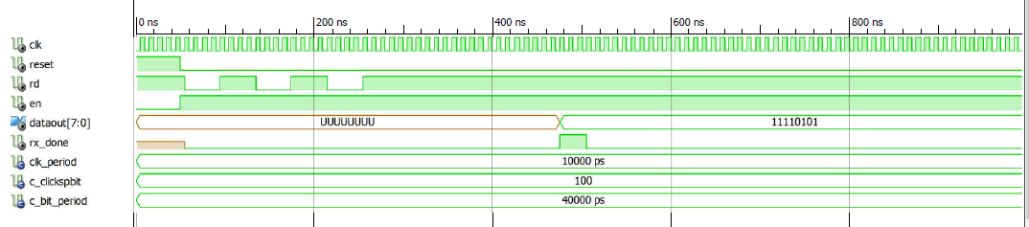

Figure 9 UART RX module Behavioural Simulation

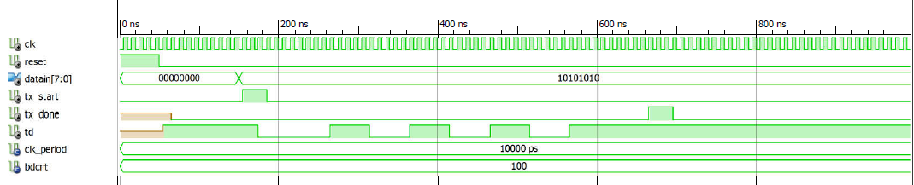

Figure 10 UART RX module Behavioural Simulation