Problem 1

1.Determine the fund financials with leverage

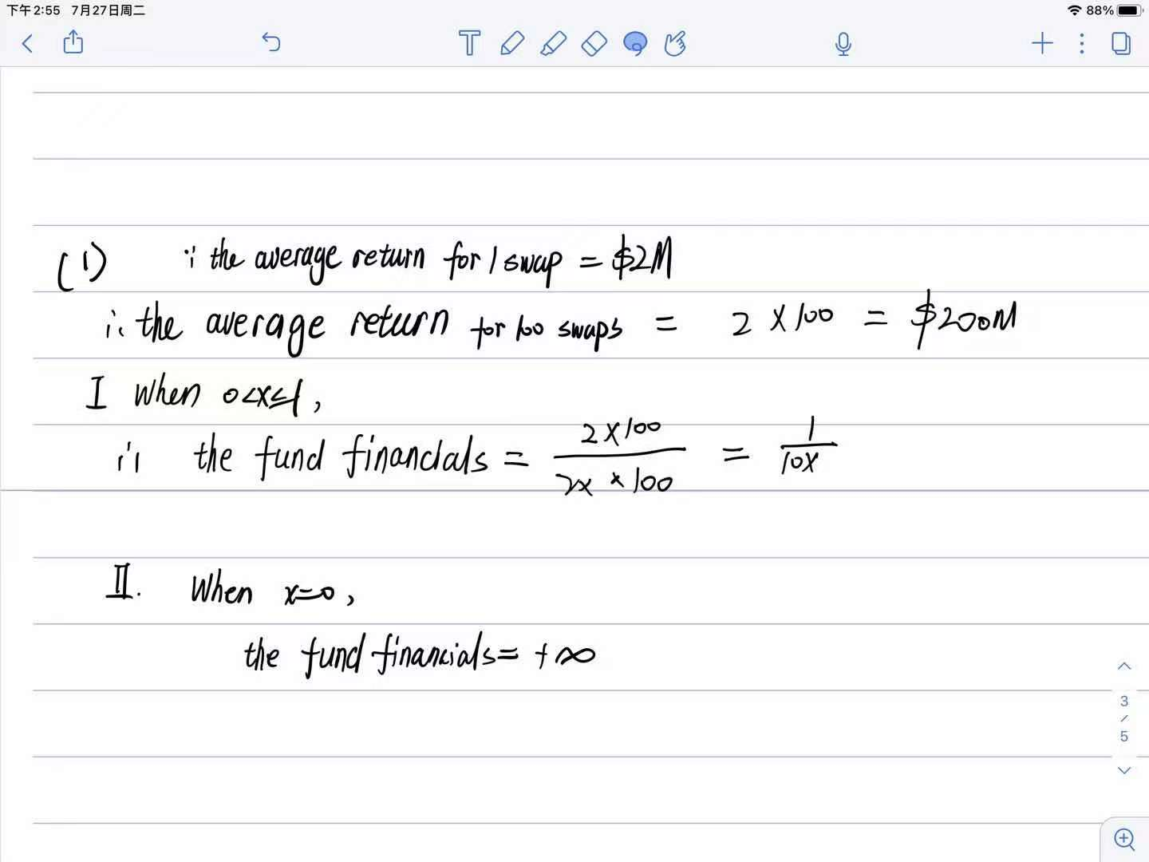

2.Determine the Probability of Default.

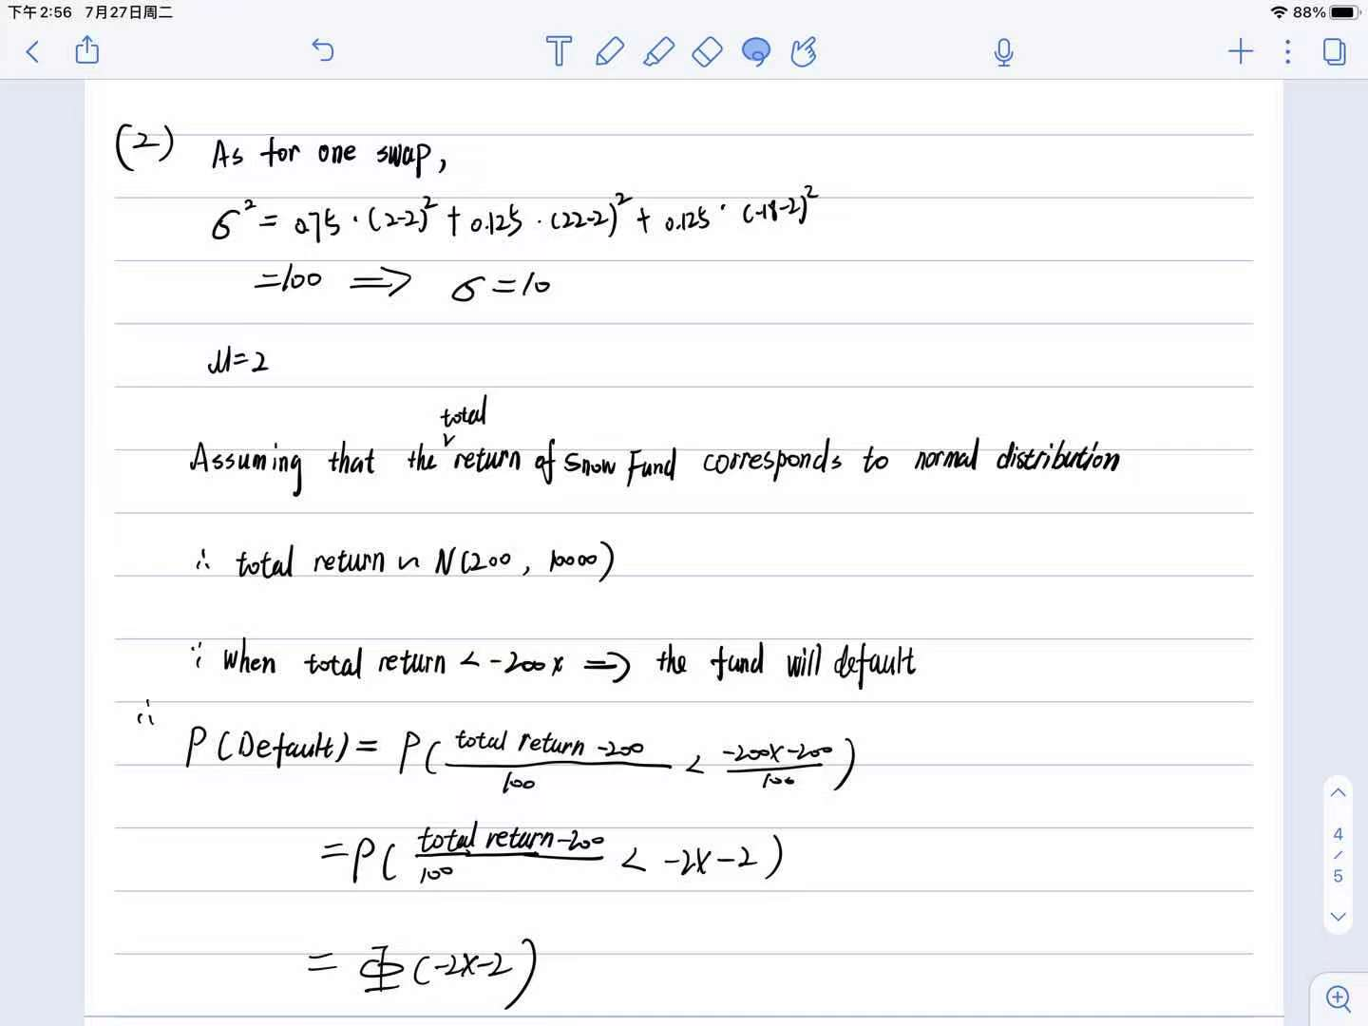

In this problem, we assume that the total return of Snow Fund corresponds to normal distribution, and calculate its μ as 200 and σ as 100. From another side, Monte Carlo simulation can be employed to verify our assumption of normal distribution and calculation of μ and σ.

The graphs below demonstrate its normal distribution , μ as 200 and σ as 100 with 10,000 times Monte Carlo simulation.

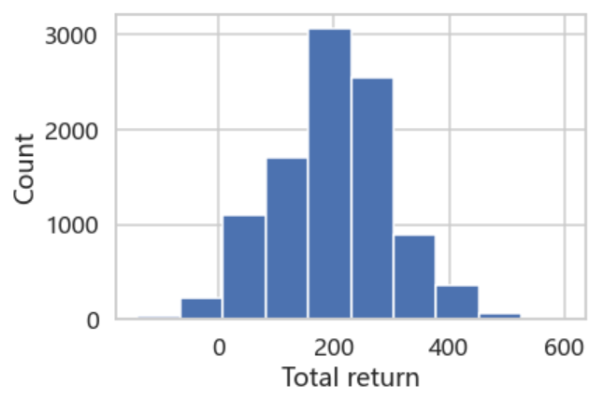

Graph 1-2-1 Distribution of total return with 10,000 times Monte Carlo simulation

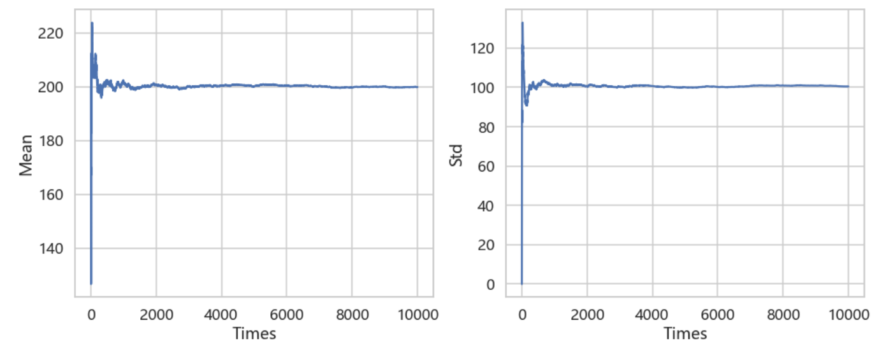

Graph 1-2-2 μ and σ with 10,000 times Monte Carlo simulation

Problem 2

1.Mean, std, skewness and kurtosis, on a two year window, moving the window daily one day forward.

1.1 Graphs of nine financial variables

First, graphs of the four statistics for each of those financial variables are displayed. In addition, the Chinese stock as chosen as Gree electricity which is a famous air conditioner manufacturer in China.

Graph 2-1-1 HFRX Global HFI

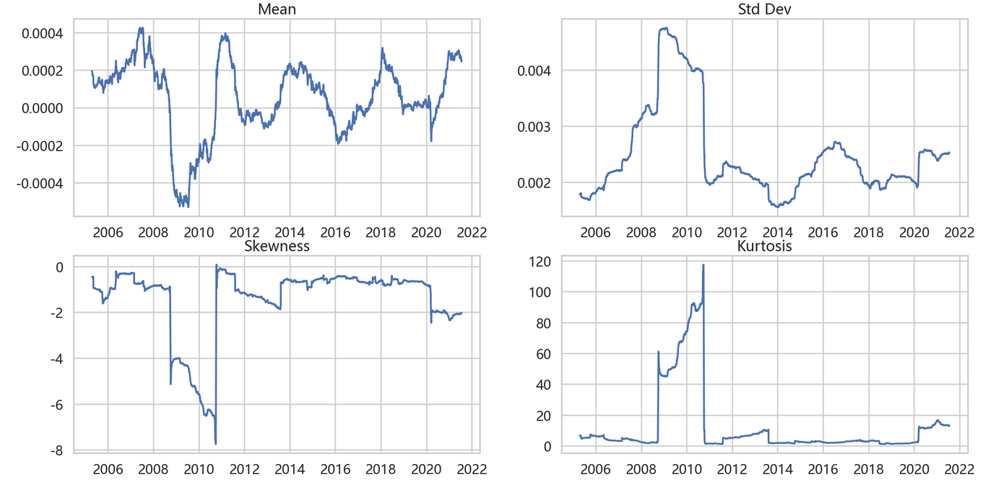

Graph 2-1-2 HFRX Equity Hedge

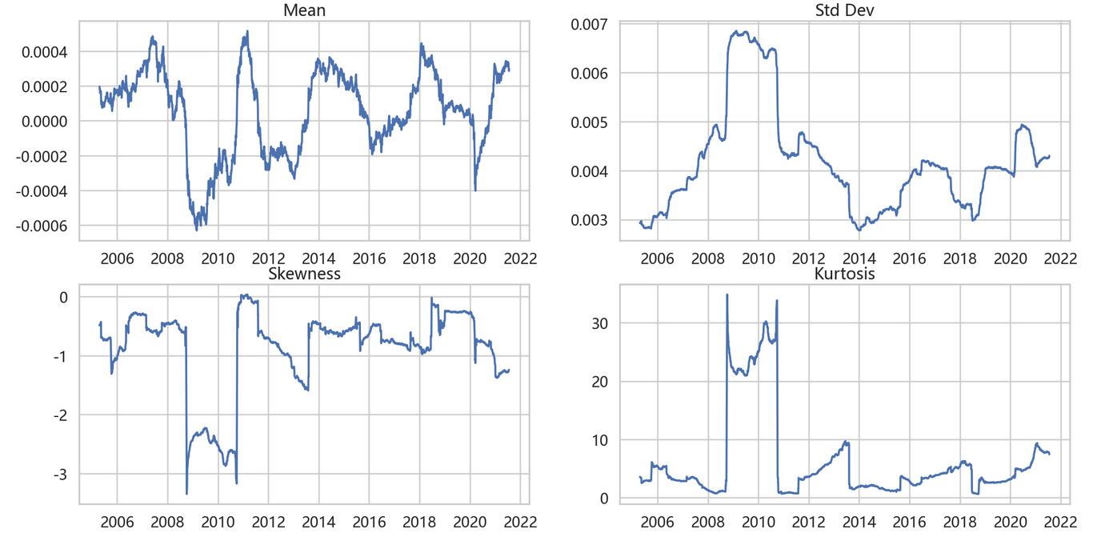

Graph 2-1-3 HFRX Event Driven

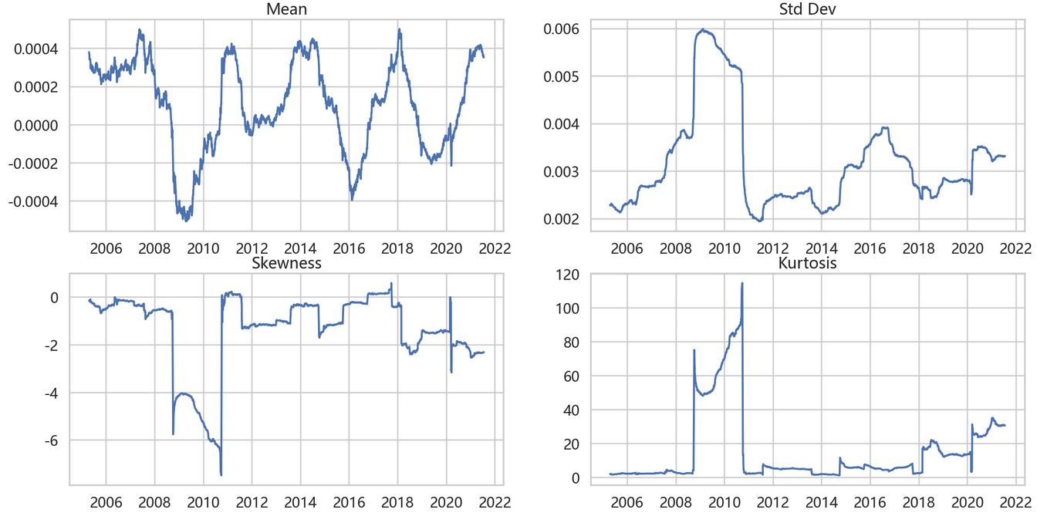

Graph 2-1-4 HFRX Macro/CTA

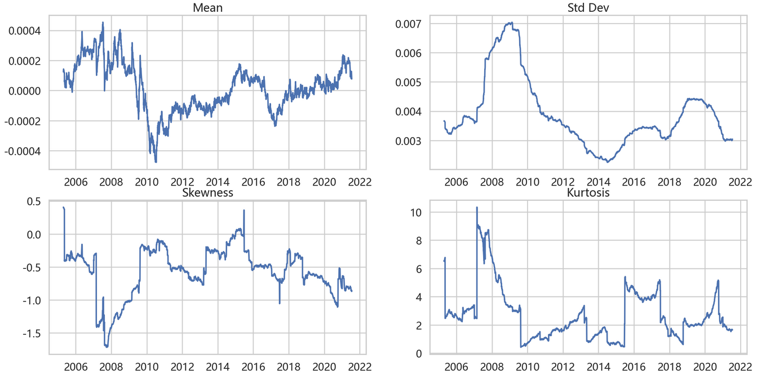

Graph 2-1-5 HFRX Relative Value

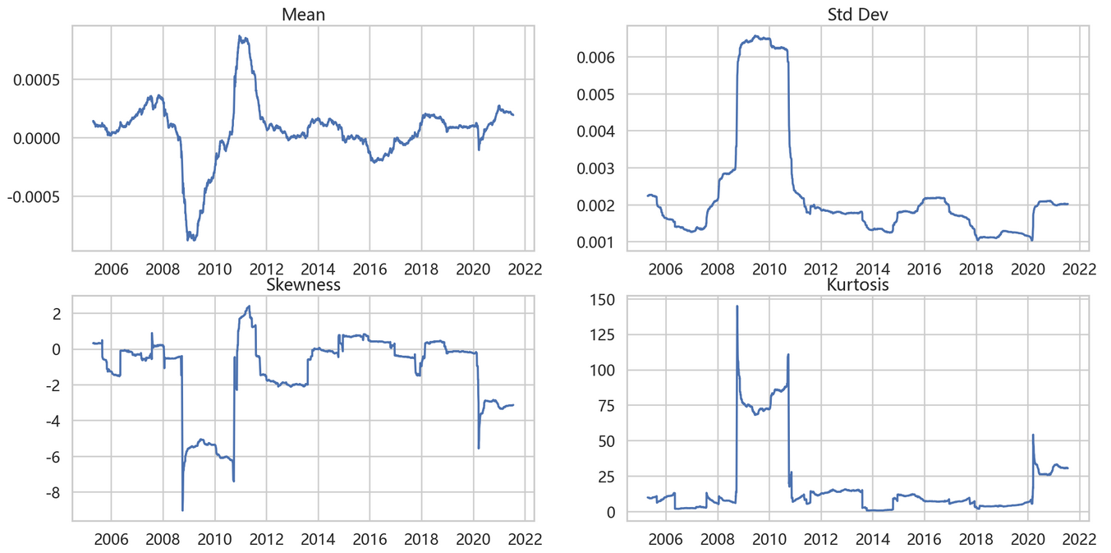

Graph 2-1-6 HFRX RV:FI Convertible Arbitrage

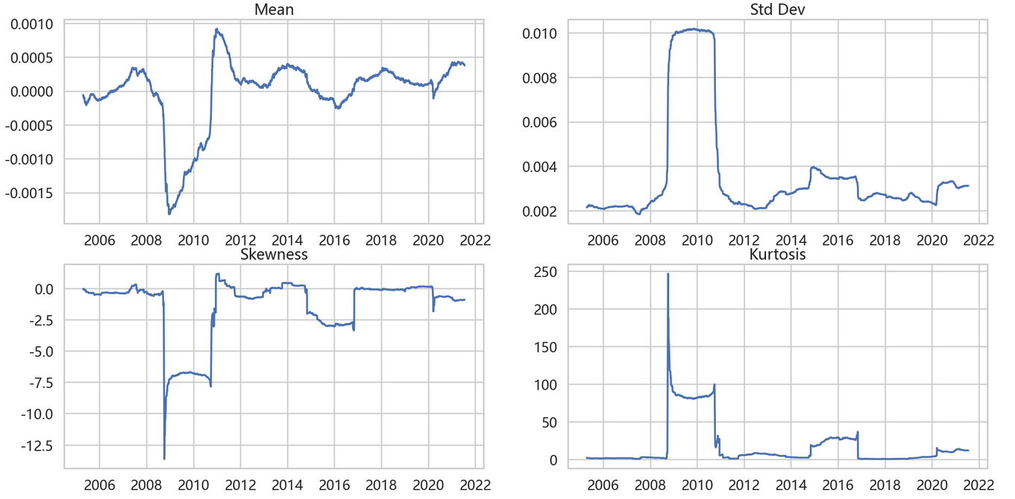

Graph 2-1-7 S&P500

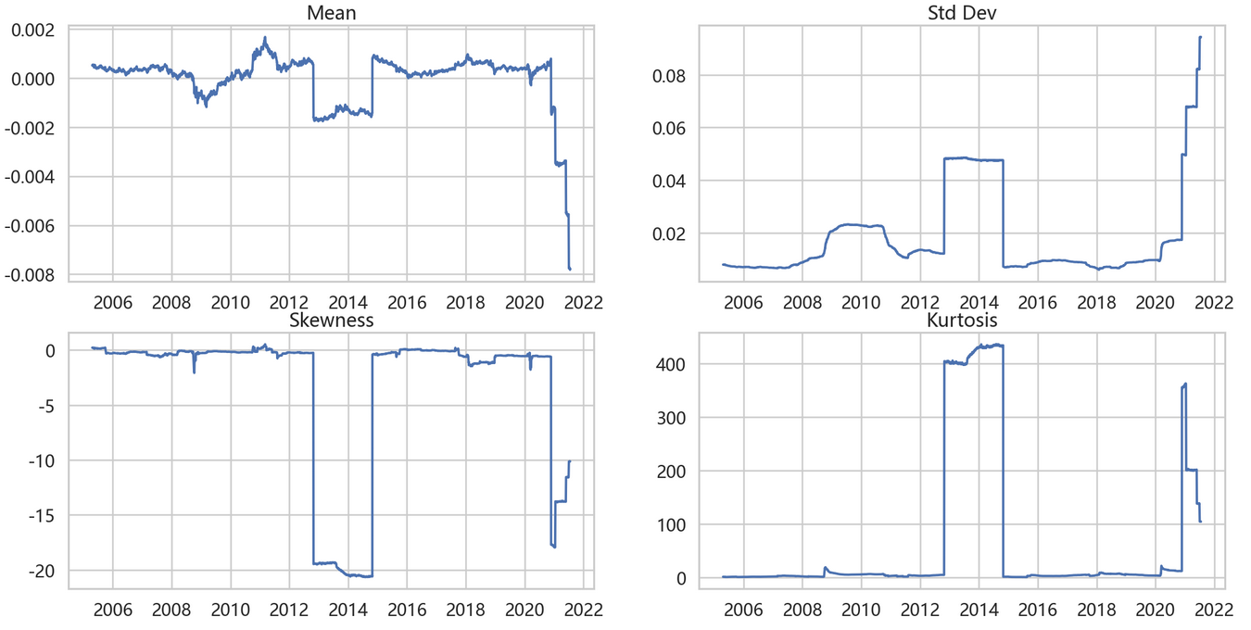

Graph 2-1-8 HSI

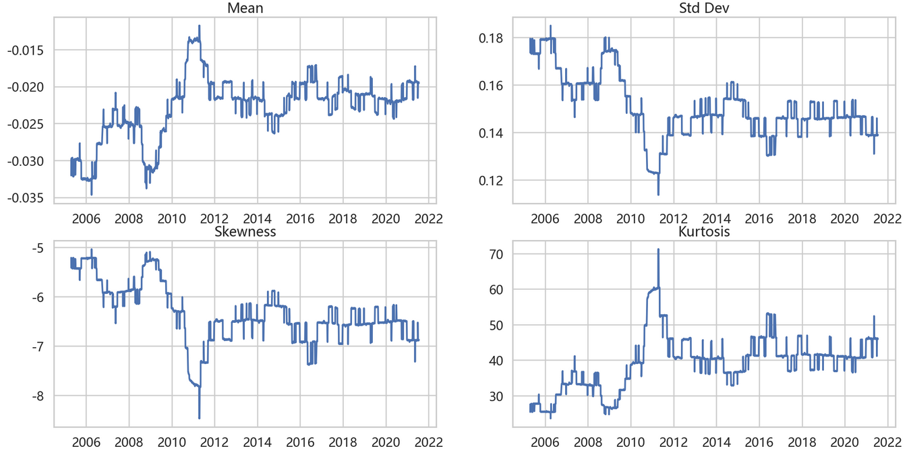

Graph 2-1-9 A Chinese stock: Gree Electricity

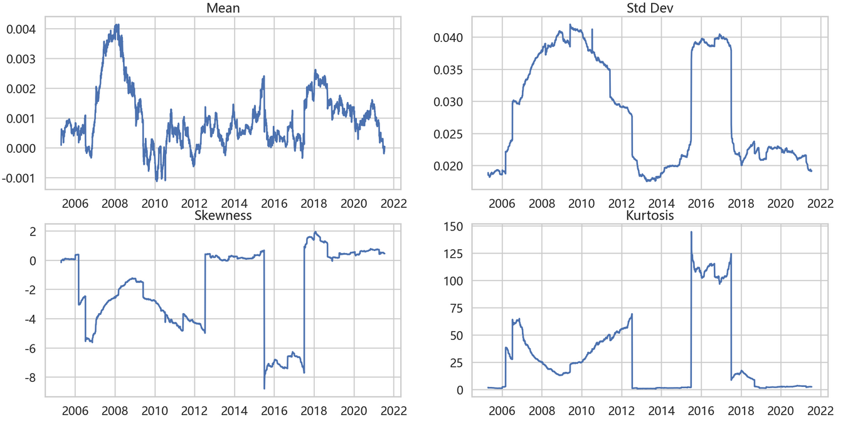

1.2 Graphs of four statistics

Then, four graphs of statistics for those nine financial variables are as follows.

Graph 2-1-10 Mean

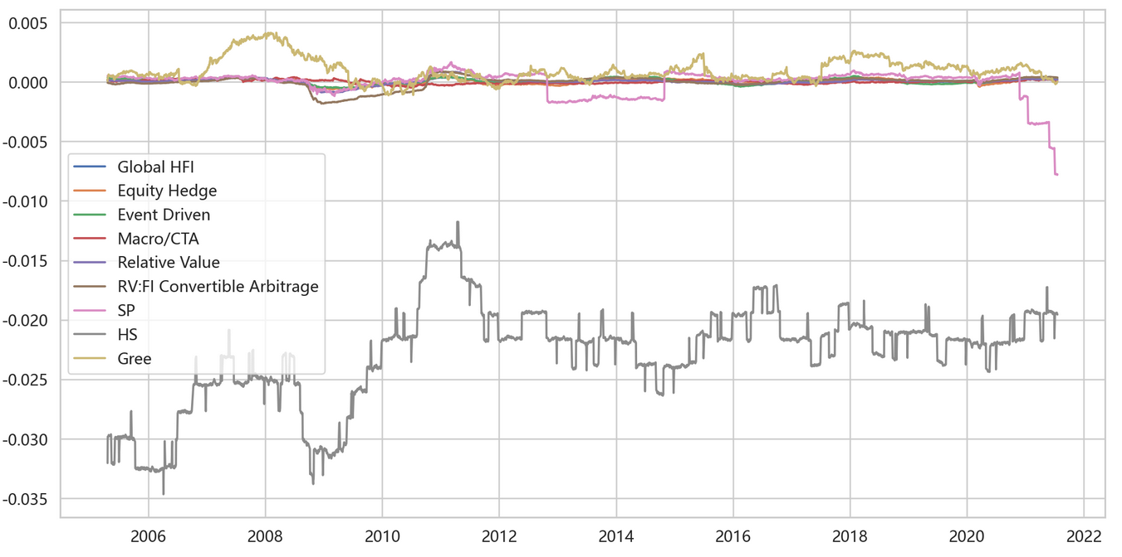

Graph 2-1-11 Std

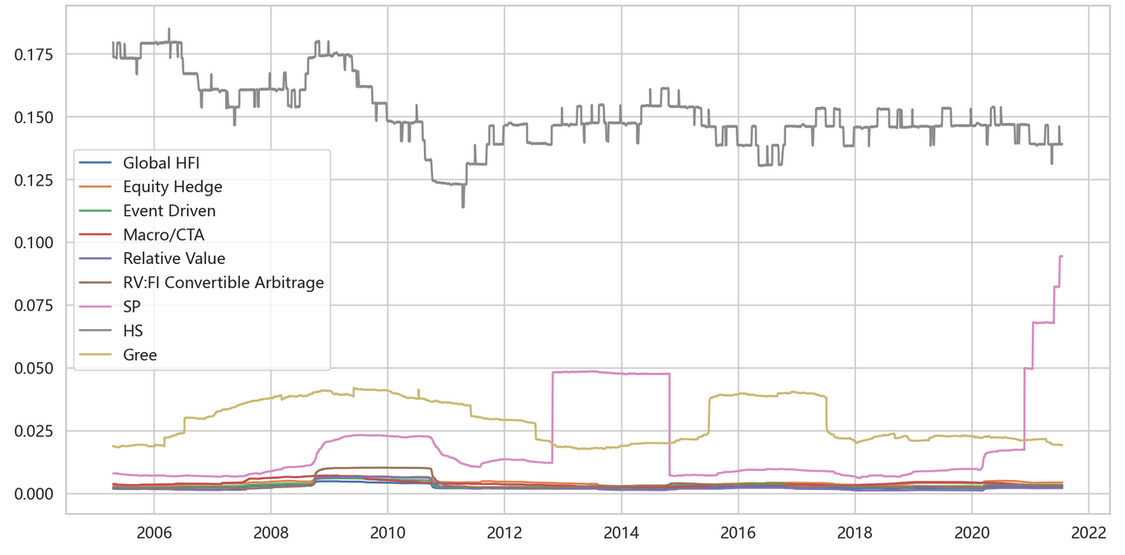

Graph 2-1-12 Skewness

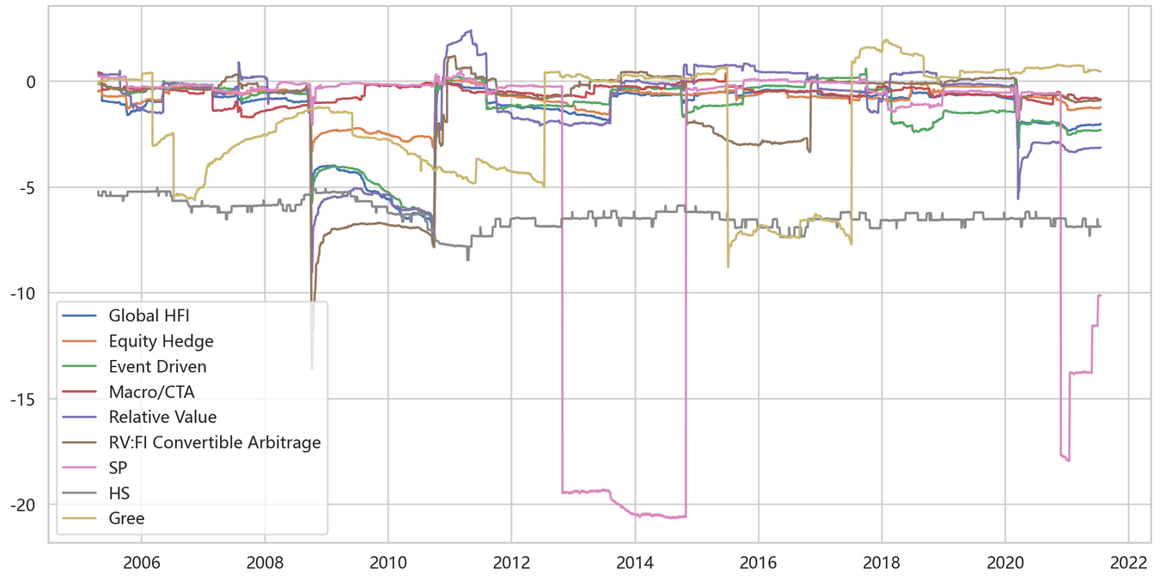

Graph 2-1-13 Kurtosis

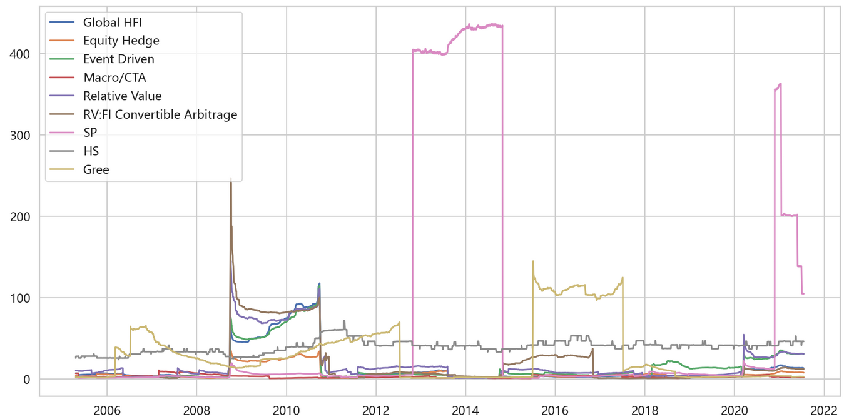

2.Alphas and betas of Gree, and HFRX indices to the S&P500 and HSI

|  |  |  |  |
| --- | --- | --- | --- |
|  | alpha | beta_S&P500 | beta_HSI |
| Global HFI | 0.0001070 | 0.0146548 | 0.0006622 |
| Equity Hedge | 0.0001383 | 0.0282853 | 0.0010506 |
| Event Driven | 0.0001696 | 0.0180229 | 0.0008163 |
| Macro/CTA | 0.0000361 | 0.0027320 | 0.0000224 |
| Relative Value | 0.0000956 | 0.0075822 | 0.0006842 |
| RV:FI Convertible Arbitrage | 0.0000221 | 0.0026778 | 0.0001920 |
| Gree | 0.0011115 | 0.0289401 | 0.0091438 |

Table 2-2-1 Alphas and betas based on daily returns

|  |  |  |  |
| --- | --- | --- | --- |
|  | alpha | beta_S&P500 | beta_HSI |
| Global HFI | 952.6163 | 0.0301170 | 0.009067 |
| Equity Hedge | 965.0227 | 0.0295290 | 0.007376 |
| Event Driven | 874.4110 | 0.0879180 | 0.018605 |
| Macro/CTA | 1089.2525 | -0.0579130 | 0.009363 |
| Relative Value | 882.9312 | 0.0450390 | 0.008624 |
| RV:FI Convertible Arbitrage | 985.7461 | 0.0932720 | -0.015655 |
| Gree | -20.0917 | 0.0092140 | 0.001492 |

Table 2-2-2 Alphas and betas based on daily prices

3. Correlation matrix between the HFRX indices. Correlation Histogram

3.1 Correlation matrix

|  |  |  |  |  |  |  |
| --- | --- | --- | --- | --- | --- | --- |
|  | Global HFI | Equity Hedge | Event Driven | Macro/CTA | Relative Value | RV:FI Convertible Arbitrage |
| Global HFI | 1.000 | 0.906 | 0.849 | 0.466 | 0.675 | 0.363 |
| Equity Hedge | 0.906 | 1.000 | 0.748 | 0.244 | 0.492 | 0.229 |
| Event Driven | 0.849 | 0.748 | 1.000 | 0.177 | 0.542 | 0.298 |
| Macro/CTA | 0.466 | 0.244 | 0.177 | 1.000 | 0.094 | 0.007 |
| Relative Value | 0.675 | 0.492 | 0.542 | 0.094 | 1.000 | 0.557 |
| RV:FI Convertible Arbitrage | 0.363 | 0.229 | 0.298 | 0.007 | 0.557 | 1.000 |

Table 2-3-1 Correlation matrix based on daily returns

|  |  |  |  |  |  |  |
| --- | --- | --- | --- | --- | --- | --- |
|  | Global HFI | Equity Hedge | Event Driven | Macro/CTA | Relative Value | RV:FI Convertible Arbitrage |
| Global HFI | 1.000 | 0.905 | 0.861 | 0.287 | 0.867 | 0.370 |
| Equity Hedge | 0.905 | 1.000 | 0.633 | 0.289 | 0.674 | 0.567 |
| Event Driven | 0.861 | 0.633 | 1.000 | 0.085 | 0.811 | 0.002 |
| Macro/CTA | 0.287 | 0.289 | 0.085 | 1.000 | -0.085 | -0.176 |
| Relative Value | 0.867 | 0.674 | 0.811 | -0.085 | 1.000 | 0.341 |
| RV:FI Convertible Arbitrage | 0.370 | 0.567 | 0.002 | -0.176 | 0.341 | 1.000 |

Table 2-3-1 Correlation matrix based on daily prices

3.2 Correlation heatmap

Graph 2-3-1 Correlation matrix heatmap based on daily returns

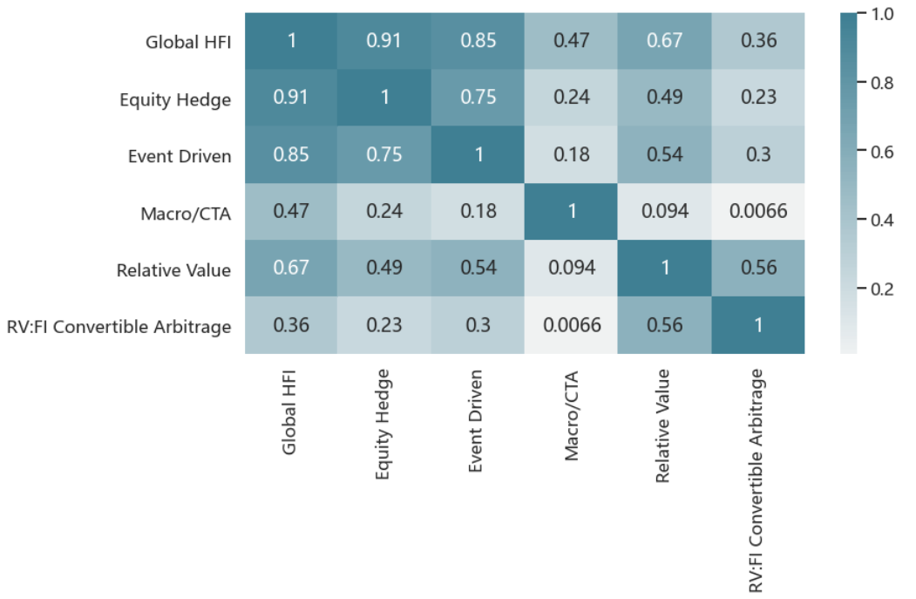

Graph 2-3-2 Correlation matrix heatmap based on daily prices

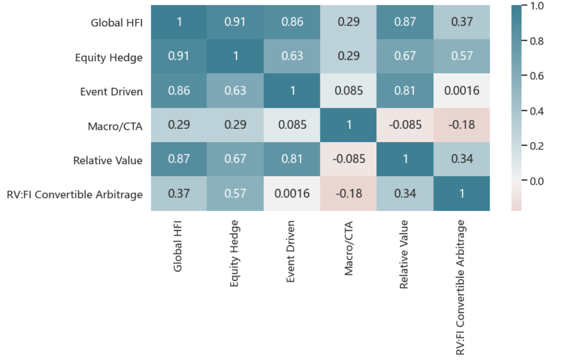

3.3 Correlation histogram

Graph 2-3-3 Correlation histogram based on daily returns

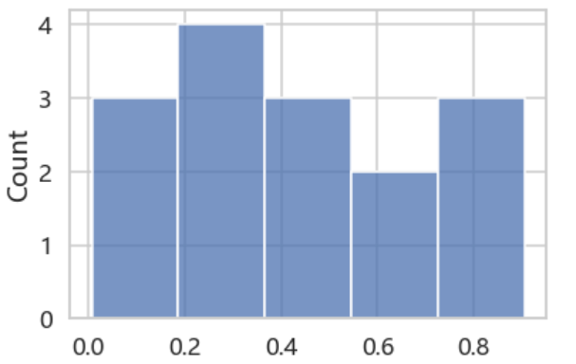

Graph 2-3-4 Correlation histogram based on daily returns

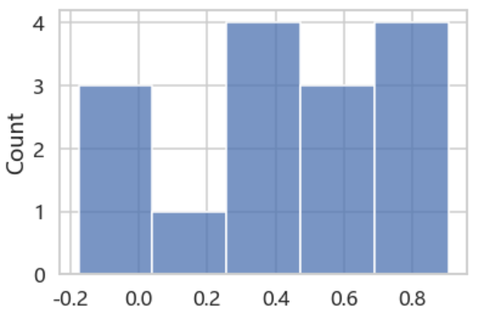

4. Correlation matrix between the Chinese stock and equity indices

Table 2-4-1 Correlation matrix between Gree and equity indices based on daily returns

|  |  |  |  |
| --- | --- | --- | --- |
|  | SP | HS | Gree |
| SP | 1.000 | 0.004 | 0.037 |
| HS | 0.004 | 1.000 | 0.049 |
| Gree | 0.037 | 0.049 | 1.000 |

Table 2-4-2 Correlation matrix between Gree and equity indices based on daily prices

|  |  |  |  |
| --- | --- | --- | --- |
|  | SP | HS | Gree |
| SP | 1.000 | 0.749 | 0.811 |
| HS | 0.749 | 1.000 | 0.818 |
| Gree | 0.811 | 0.818 | 1.000 |