|  |  |
| --- | --- |
| User Action | System Response |
| 1. User types in PIN into main screen | 1. System checks validity of PIN and presents options to user on another screen |
| 2. User chooses Withdraw function | 2. System shows Withdraw Screen |
| 3. User enters Withdraw Amount | 3. System checks user’s balance and sends cash out and receipt. |

**Group 1 – Lab 1**

Eman Mohammed 986642  
Thi Quynh Mai Tran 986609  
Thi Kim Hoa Luu 986647

Q1. WITHDRAW_MONEY Use Case Description: Main Flow

Q2. Use Case Diagram for the ATM system

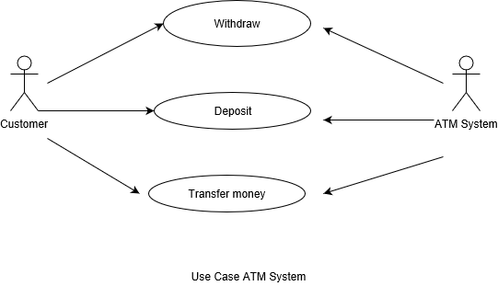

Q 3. The Project Management Tracking System

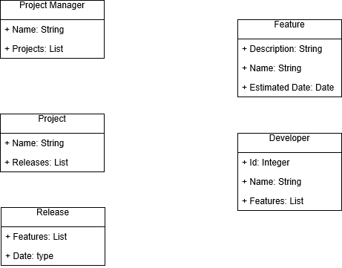

Q4. Properties Management System

