Weekly Reflection (week 2)
Date: | 27th Feb 2026
Team Members: | Thien Bao Minh Dang, Hooward Kangdrew, Viet Anh Pham, Xuxian Lu, Luu Minh Thong Tran
Project topic | A Comprehensive Evaluation of Phishing Detection Methods Across Traditional ML, Deep Learning, and LLM-Based Models
- Provide a summary:
This reflection covers the early phase of our project, focusing on project proposing, initial solution design, communication, and overall team experience while not reflecting much on implementation planning and verification thinking as our group had no activities related to those field at this stage.
Over the past two weeks, our team formed, introduced ourselves, and aligned our expectations. We agreed to commit responsibly to the course and scheduled Saturday as our weekly meeting time to track progress and upcoming tasks. After discussion, we selected our research theme: AI applications in cybersecurity, narrowing it to machine learning techniques for phishing email classification in the logistics sector.
My personal focus was ensuring that our proposal was not overly broad. Initially, “AI in cybersecurity” lacked specificity. I contributed by suggesting we narrow the scope to phishing detection and further contextualise it within logistics, where phishing causes significant financial risk. I also encouraged the team to prioritise background research before discussing solution architecture, aligning with our supervisor’s advice that a strong proposal forms the foundation of the entire project.
If I could improve something, I would encourage more structured preparation before meetings. At times, ideas were not clearly articulated, which led to minor misunderstandings. Pre-meeting brainstorming and clearer communication would strengthen efficiency.
- Provide evidence for teamwork and your contribution as summarized above
During our meetings (both in class and online), I was responsible for:
- Conducting preliminary research on phishing trends in logistics.
- Created, editted and managed the shared documents and meeting notes and communication platform on Microsoft Teams.
- Contributing to refining the problem statement.
- Supporting scope definition to avoid over-complexity.

One issue I raised was scope creep. The topic was initially too broad, which risked making the project unmanageable. Through discussion, we agreed to constrain it to one attack type (phishing), one sector (logistics), and one technical approach (ML classification). This improved clarity and feasibility.
A minor challenge raised about my contribution was that some of my explanations of ML methods were too technical for early discussion. I adjusted by simplifying terminology, which improved group understanding. This taught me that effective collaboration requires adapting communication to the audience.
Collaboration challenges included varying technical backgrounds and occasional spontaneous brainstorming without preparation. To address this, I suggested clearer agendas and structured weekly checkpoints.
Overall, this experience helped me recognise the importance of scope management, research justification, and communication clarity. I learned that strong technical projects begin with disciplined problem definition and collaborative alignment.
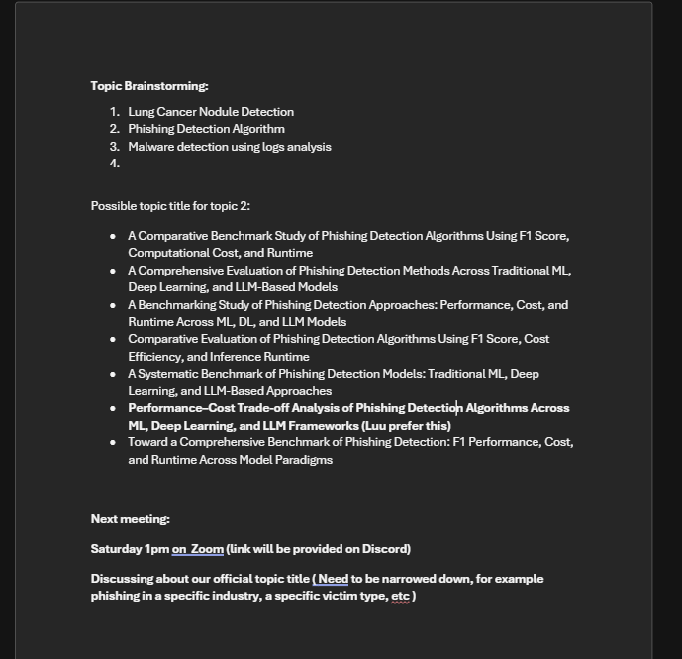
Our meeting note
- Use of AI in this Assessment
I used a GenAI application to reorganise my ideas and polish the clarity of my writing for this reflection. The original draft was written independently by me, based on my personal experiences, meeting notes, and contributions in Computing Studio 2. However, my initial version lacked structure, contained repetitive phrasing, and did not flow clearly across sections.
The GenAI tool was used specifically to:
- Improve sentence clarity and academic tone
- Reorganise paragraphs to better align with the assessment structure
- Remove redundancy while keeping my original meaning
- Enhance coherence between summary and evidence sections

Importantly, the ideas, experiences, examples, and reflections were entirely my own. The tool did not generate new project content or fabricate contributions. Instead, it functioned as an editing assistant, similar to grammar-checking software, helping refine expression rather than create ideas.

