Weekly Reflection (week 2)
Date: | 27th Feb 2026
Team Members: | Thien Bao Minh Dang, Hooward Kangdrew, Viet Anh Pham, Xuxian Lu, Luu Minh Thong Tran
Project topic
- Provide a summary:
This reflection covers the next stage of our project development, focusing on refining plan for all the project’s components through the pitch template, early solution design, team coordination, and communication within the group. At this stage, the project has progressed from broad topic discussion toward defining clearer ideas about the potential application and research direction.
During this week’s class, our group worked on completing the pitch template provided by the tutor. This activity helped us organise the key concepts of the project, including defining the research problem, identifying the motivation behind the study, and outlining the potential solution direction. The template also helped us clarify how the project should be communicated during our upcoming class presentation.
In addition to defining the research idea, we divided the responsibilities of the pitch among team members. Each member was assigned a specific section that they will present next week. This ensured that everyone contributes to both the preparation and the presentation. We also agreed to meet on Saturday to collaboratively prepare the presentation slides and practise our delivery to improve the clarity and confidence of our pitch.
One important piece of feedback from our tutor was that our research direction appeared too abstract and theoretical, which could make it difficult to present clearly. After discussing this feedback, our group decided to make the research more practical by proposing a potential application of our work: a browser plugin that can detect phishing emails and provide explanations for why the email is classified as phishing. This idea allows us to demonstrate how explainable AI could be applied in a real-world cybersecurity context.
If there is something that could be improved, it would be the way some group members engage with others’ ideas during discussions. At times, some members tend to focus only on their individual tasks rather than fully considering suggestions from the rest of the group. Encouraging more active listening and respect for each other’s opinions would strengthen collaboration and lead to more effective group decision-making.

2. Provide evidence for teamwork and your contribution as summarized above
During our meetings this week (both in class and through group discussions), my contributions included:
Helping complete the project pitch template by contributing ideas about the project concept and possible practical applications, with a focus on the data section.
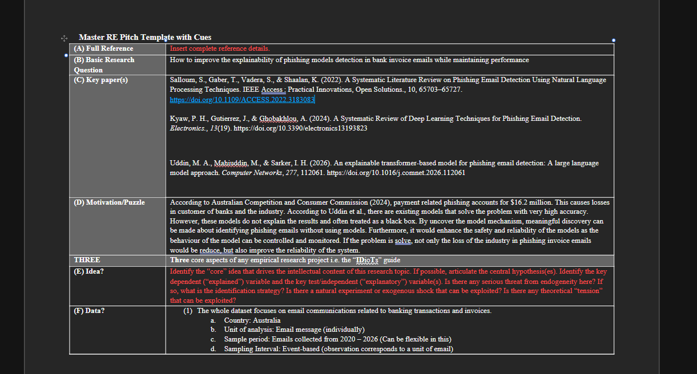
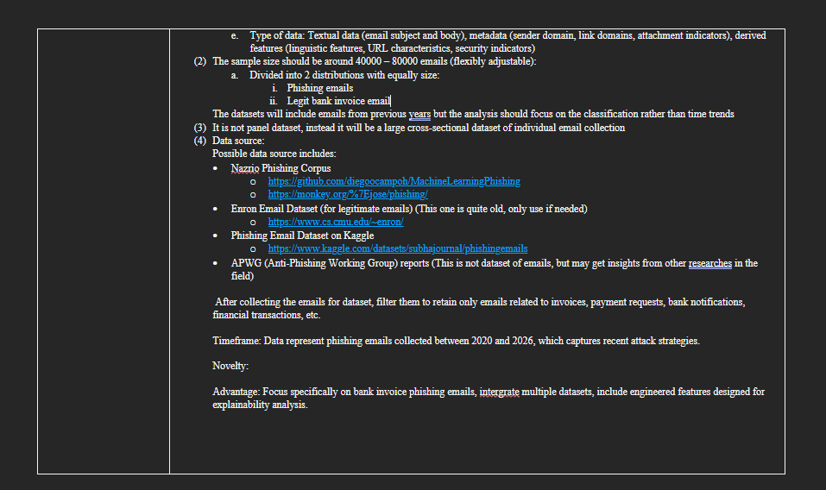
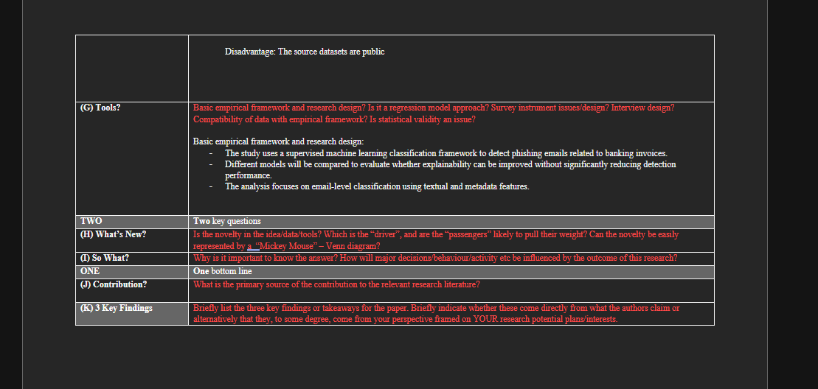
Participating in discussions about how to transform our research topic into a more practical solution after receiving tutor feedback.
Supporting the idea of developing a browser plugin that can detect phishing emails while providing explainability for the detection results.
Contributing to discussions about how the pitch should be structured for next week’s presentation.
Agreeing on the plan to meet on Saturday to collaboratively design slides and practise the presentation as a team.
One important issue raised during our discussion was the concern that our research could become too theoretical and difficult to demonstrate in practice. Based on the tutor’s suggestion, we worked together to identify a practical implementation idea. The browser plugin concept was developed as a way to bridge the gap between research and real-world cybersecurity applications.
A minor challenge in teamwork was that some discussions felt slightly fragmented because members were focusing on their own assigned tasks. I suggested that we should spend more time discussing ideas collectively before dividing tasks so that everyone has a clearer shared understanding of the project direction.
Overall, this week helped me better understand the importance of transforming theoretical research into practical applications. It also reinforced the value of collaborative discussion and structured planning when preparing a project presentation.

3. Use of AI in this Assessment
I used a GenAI application to reorganise my ideas and polish the clarity of my writing for this reflection. The original draft was written independently by me, based on my personal experiences, meeting notes, and contributions in Computing Studio 2. However, my initial version lacked structure, contained repetitive phrasing, and did not flow clearly across sections.
The GenAI tool was used specifically to:
- Improve sentence clarity and academic tone
- Reorganise paragraphs to better align with the assessment structure
- Remove redundancy while keeping my original meaning
- Enhance coherence between summary and evidence sections

Importantly, the ideas, experiences, examples, and reflections were entirely my own. The tool did not generate new project content or fabricate contributions. Instead, it functioned as an editing assistant, similar to grammar-checking software, helping refine expression rather than create ideas.

