Weekly Reflection (week 4)
Date: | 27th Feb 2026
Team Members: | Thien Bao Minh Dang, Hooward Kangdrew, Viet Anh Pham, Xuxian Lu, Luu Minh Thong Tran
Project topic
- Provide a summary:
This reflection focuses on the stage of our project where we prepared and delivered the proposal pitch presentation. During this week, our group went through several internal demo presentations to refine our proposal content and ensure that each member clearly understood their assigned section. After each member completed their part of the proposal pitch, we started designing the presentation slides and practising the script to ensure that our speaking time remained within the required limit.
The preparation stage involved several rounds of practice where we attempted to balance the presentation time across five members. We also revised the slides multiple times to improve clarity and organisation. Eventually, the final presentation in class went very well. Our tutors and professors gave positive feedback and compliments regarding the clarity of the proposal and the quality of our explanation.
However, the preparation process was not entirely smooth. There were several disagreements within the team regarding decision-making and presentation design. In particular, our group leader tended to make decisions independently without sufficiently considering other members’ opinions. This created tension during the preparation process and made collaboration more challenging than expected.
Overall, this week highlighted both the importance of teamwork in preparing a strong presentation and the challenges that can arise when communication and decision-making are not shared equally among team members.

2. Provide evidence for teamwork and your contribution as summarized above
During this week, my main contributions involved helping develop the presentation slides, practising the proposal pitch, and improving the visual quality of the slides. I worked together with another team member, Pham, to redesign the presentation slides because the original version contained large blocks of text on plain white backgrounds, with very small images and diagrams that were difficult to read.

Our intention was to make the slides clearer and more visually connected by applying a consistent theme, improving layout structure, and presenting key points through visuals instead of dense text. Initially, the group leader disagreed with our redesigned slides and believed that colourful slides were not “academic” or “professional.” However, after the entire group discussed both versions and conducted a vote, the team eventually agreed to use our redesigned slides for the final presentation.

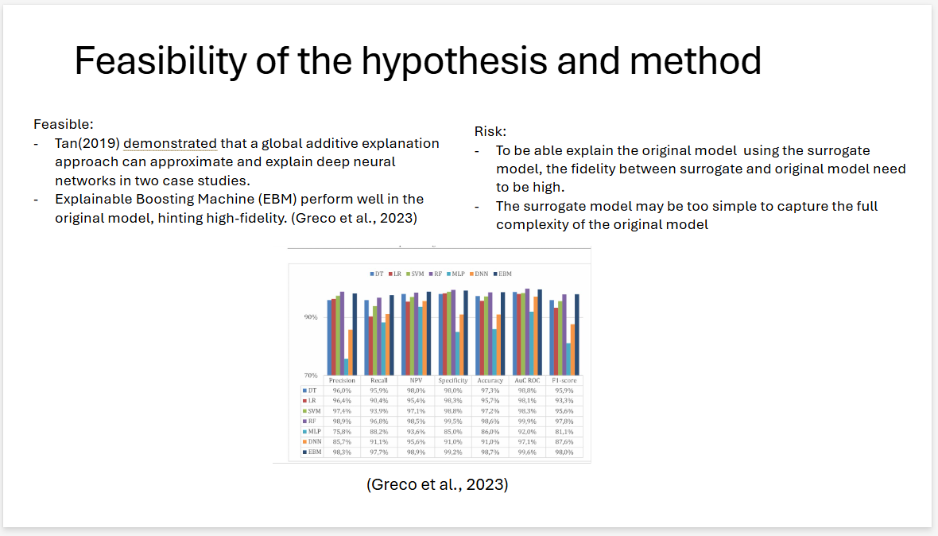
Figure 1: Original Slide
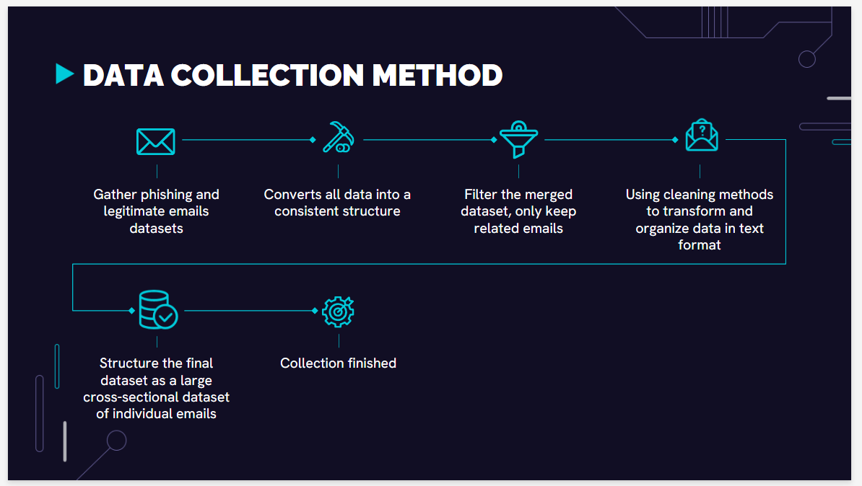
Figure 2: Latter version

Another issue during preparation was the allocation of presentation time. Since the presentation limit was fifteen minutes and there were five team members, the logical distribution would have been approximately three minutes per person. However, the group leader decided to take around six minutes for his own section, which required other members to significantly shorten their parts. As a result, some members had only around one minute to present their content. This caused frustration within the team and led to several arguments about fairness and workload distribution.
Despite these challenges, the team managed to finalise the slides and practise the presentation together. The final presentation was delivered successfully, and the positive feedback from tutors showed that our preparation efforts were ultimately effective.
This experience helped me realise that successful teamwork requires not only technical contribution but also respectful communication and balanced decision-making. In future teamwork situations, I believe clearer role definitions and more democratic discussion processes as well as more respectfulless from our leader to the group members would help prevent similar conflicts and improve collaboration efficiency.
3. Use of AI in this Assessment
I used a GenAI application to reorganise my ideas and polish the clarity of my writing for this reflection. The original draft was written independently by me, based on my personal experiences, meeting notes, and contributions in Computing Studio 2. However, my initial version lacked structure, contained repetitive phrasing, and did not flow clearly across sections.
The GenAI tool was used specifically to:
- Improve sentence clarity and academic tone
- Reorganise paragraphs to better align with the assessment structure
- Remove redundancy while keeping my original meaning
- Enhance coherence between summary and evidence sections

Importantly, the ideas, experiences, examples, and reflections were entirely my own. The tool did not generate new project content or fabricate contributions. Instead, it functioned as an editing assistant, similar to grammar-checking software, helping refine expression rather than create ideas.

