

International School
CDIO Project

CMU-CS 447 JIS – 3T1B

Database Design
Version 1.1 Date: Jan 26th, 2026

Smart Traffic Management System

Submitted by
Thong, Nguyen Cao
Thien, Luu Vu
Thong, Le Huu
Bao, Nguyen Gia

Approved by
MSc Huy, Truong Dinh

Proposal Review Panel Representative:

Name Signature Date

CDIO Project - Mentor:

Name Signature Date
PROJECT INFORMATION

Project acronym | STMS
Project Title | Smart Traffic Management System
Start Date | 25 Jan 2026 | End Date | 26 Jan 2026
Lead Institution | International School, Duy Tan University
Project Mentor | MSc Huy, Truong Dinh
Scrum master / Project Leader & contact details | Thong, Nguyen Cao  Email: pandatech0610@gmail.com  Tel: 0934909569
Partner Organization | Duy Tan University
Project Web URL
Team members | Name | Email | Tel
 | Thong, Nguyen Cao | pandatech0610@gmail.com | 0934909569
 | Thien, Luu Vu | warface2005tk@gmail.com | 0919324219
 | Thong, Le Huu | bass030196@gmail.com | 0768463655
 | Bao, Nguyen Gia | ngbaog@gmail.com | 0938086668

DOCUMENT APPROVALS
The following signatures are required for approval of this document.

Thong, Nguyen Cao  Student ID: 29219053135  Scrum Master | Signature | Date
Thien, Luu Vu  Student ID: 29211140533  Team Member | Signature | Date
Thong, Le Huu  Student ID: 29219038101  Team Member | Signature | Date
Bao, Nguyen Gia  Student ID: 29219053725  Team Member | Signature | Date

REVISION HISTORY

Version | Date | Comments | Author | Approval
1.0 | January 20th, 2026 | Initial Release | Nguyen Cao Thong

TABLE OF CONTENT
- Introduction 5
  - Purpose 5
  - Scope 5
  - Introduction about MongoDB 5
- Database Diagram 6
  - Table Overview 6
  - Entity Relationship Diagram 7
  - Table Relationship Diagram 8
- Database Design for Sprint 9
  - Table Group 9
  - Table User 9
  - Table Frame 10
  - Table PrivateMessage 11
  - Table PublicMessage 11
  - Table Events 11
  - Table Course 12
  - Table CourseVocabulary 12
  - Table CourseOfUsser 13
  - Table Rating 13
- Hardware and software Requirements 14

Introduction
The Database Design phase translates the logical data model into a physical database structure that is compatible with the selected Database Management System (DBMS). This process focuses on transforming conceptual data elements into physical components such as tables, indexes, and relationships, while ensuring that the design satisfies system performance and scalability requirements.

Purpose
The objective of the Database Design is to guarantee that all database operations and transactions are executed efficiently and meet defined performance standards. This document considers factors such as data size, growth rate, and transaction frequency in order to define a database schema and deployment environment capable of supporting the system’s operational needs..

Scope
The Database Design Document has the following objectives:
    - Present a detailed description of the database structure, including collections of related data stored in one or more computerized files, which can be accessed and managed through a DBMS by users and developers.
    - Provide a foundation for the implementation of the database and associated software components, enabling stakeholders to clearly understand the design and supporting the development, integration, and maintenance of the system.

Introduction about PostgreSQL
PostgreSQL is a powerful, open-source object-relational database management system (ORDBMS) that stores data in the form of structured tables (rows and columns) and can be deployed on multiple platforms such as Windows, Linux, and macOS. It is designed to deliver reliability, robust feature sets, and high performance for complex applications, ensuring strict data integrity through ACID (Atomicity, Consistency, Isolation, Durability) compliance.
In addition, PostgreSQL supports advanced extensibility, allowing the system to handle geospatial data effectively via PostGIS—a critical feature for mapping systems. It also supports JSONB, which enables the storage of semi-structured data (similar to NoSQL) within a relational framework, offering the flexibility of document-oriented databases while maintaining the strong consistency of SQL.
In PostgreSQL, a Record (row) represents a data entity defined by a strict schema, where relationships between tables are managed via Foreign Keys. This structure allows developers to define clear constraints and data types. However, with JSONB support, developers can also map complex objects or nested lists directly into a column. For example, a Camera object may include fixed attributes such as id, ip_address, and a flexible coordinates attribute stored as JSON.
Data record for a Camera in PostgreSQL will be like: 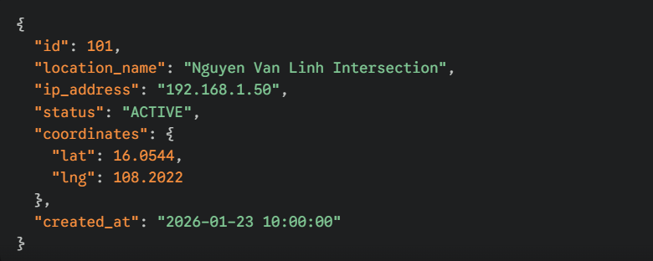
PostgreSQL combines the power of rigorous SQL queries with the flexibility of JSON storage. By using relational tables for core data (Users, Violations) and JSONB for dynamic data (AI output, configuration), PostgreSQL reduces the complexity of data migration and optimizes query performance for the Traffic Management System.

Database Diagram

Table Overview

Table Name | Short Description
Camera | Manages camera devices, including their coordinates (for the Live Map) and connection status.
User | Stores account information for Admins, Management Department, and Public Users
Notification | Stores system alerts and user notifications (fire/flood alerts) to display history.
Traffic Data | Stores statistical data regarding vehicle counts, classification, and traffic density for reporting.
Incident | Records hazardous events such as fires, floods, or accidents detected in real-time.
Violation | Stores evidence of traffic violations detected by the AI system for enforcement.
Area | Contain contextual information that helps the Management Department or Admin quickly identify the characteristics of that specific zone

Entity Relationship Diagram
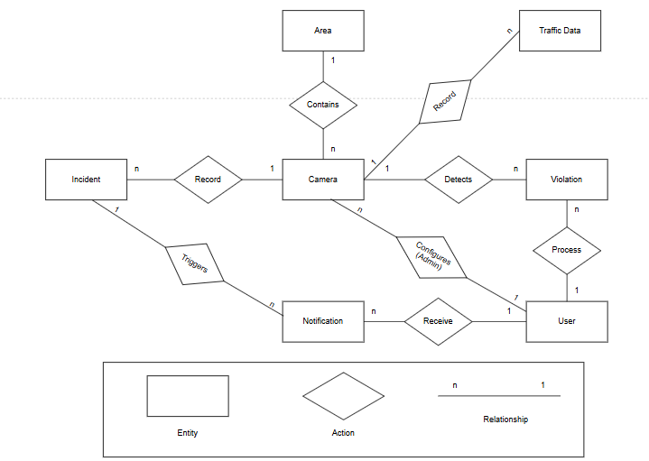

Table Relationship Diagram
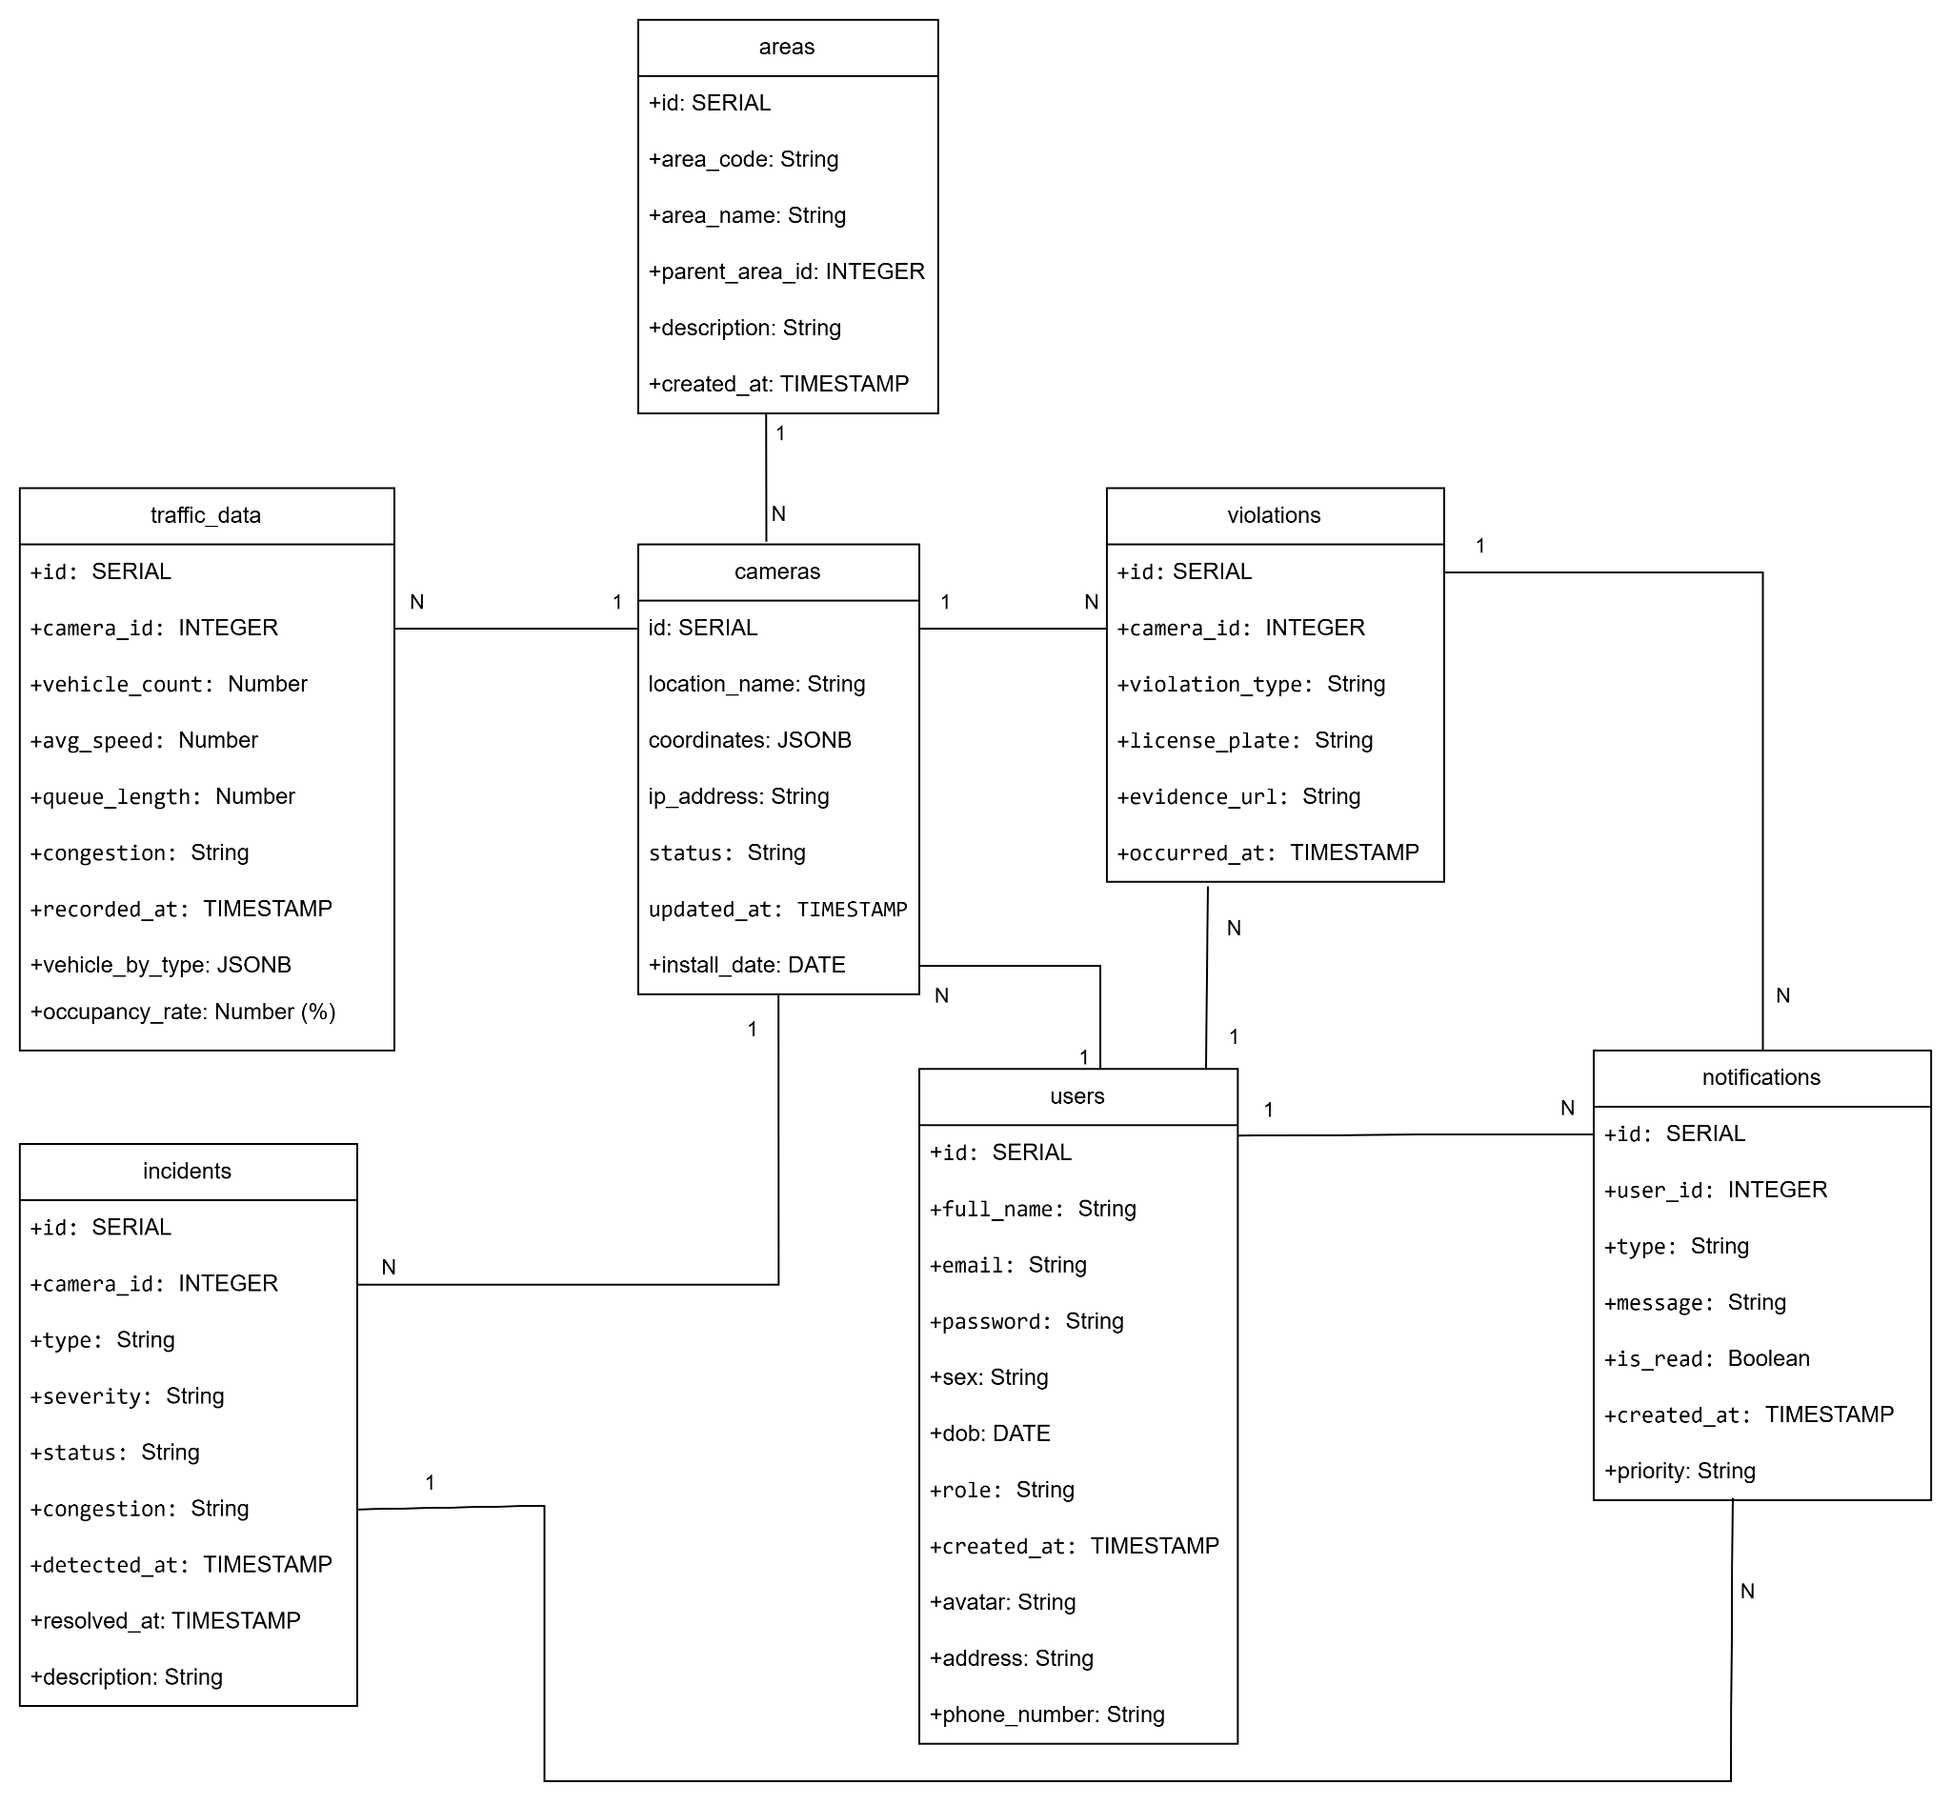

Database Design for Sprint

Table Users

Users
Id | Field | Type | Constrain | Description
1 | id | SERIAL | PK | Unique identifier (Auto-increment).
2 | full_name | VARCHAR (100) | NOT NULL | User's full name.
3 | email | VARCHAR (100) | UNIQUE, NOT NULL | Login email / Contact email.
4 | password | VARCHAR (255) | NOT NULL | Hashed password.
5 | sex | VARCHAR (10) |  | Gender (Male, Female, Other).
6 | dob | DATE |  | Date of Birth.
7 | role | VARCHAR (20) | NOT NULL | User role: ADMIN, POLICE, USER.
8 | phone_number | VARCHAR (15) |  | Contact phone number.
9 | address | TEXT |  | Permanent address.
 | avatar | TEXT |  | URL to profile picture.
 | created_at | TIMESTAMP | DEFAULT NOW () | Account creation timestamp.

Table Areas

Areas
Id | Field | Type | Constrain | Description
1 | id | SERIAL | PK | Area unique identifier.
2 | area_code | VARCHAR (20) | UNIQUE, NOT NULL | Area code
3 | area_name | VARCHAR (100) | NOT NULL | Display name.
4 | parent_area_id | INTEGER | FK (areas.id) | Parent Area ID (Nullable if top-level).
5 | description | TEXT |  | Detailed area description.
6 | created_at | TIMESTAMP | DEFAULT NOW () | Record creation timestamp.

Table Cameras

Cameras
Id | Field | Type | Constrain | Description
1 | id | SERIAL | PK | Camera unique identifier.
2 | area_id | INTEGER | FK (areas.id) | Associated area ID.
3 | location_name | VARCHAR (200) | NOT NULL | Specific installation location.
4 | ip_address | VARCHAR (50) | NOT NULL | IP Address or RTSP stream URL.
5 | coordinates | JSONB |  | GPS Coordinates.
6 | status | VARCHAR (20) | DEFAULT 'ACTIVE' | Status: ACTIVE, INACTIVE, MAINTENANCE.
7 | install_date | DATE |  | Installation date.
8 | updated_at | TIMESTAMP |  | Last status update timestamp.

Table Traffic Data

Traffic Data
Id | Field | Type | Constrain | Description
1 | id | BIGSERIAL | PK | Record ID (BigInt for high volume).
2 | camera_id | INTEGER | FK (cameras.id) | Source camera ID.
3 | vehicle_count | INTEGER |  | Total vehicle counts in frame.
4 | vehicle_by_type | JSONB |  | Vehicle breakdown.
5 | avg_speed | FLOAT |  | Average speed (km/h).
6 | queue_length | FLOAT |  | Estimated queue length (meters).
7 | occupancy_rate | FLOAT |  | Road occupancy rate (%).
8 | congestion | VARCHAR (20) |  | Congestion level: LOW, HIGH.
9 | recorded_at | TIMESTAMP | DEFAULT NOW () | Data recording timestamp.

Table Violations

Violations
Id | Field | Type | Constrain | Description
1 | id | BIGSERIAL | PK | Violation unique identifier.
2 | camera_id | INTEGER | FK (cameras.id) | Recording camera ID.
3 | violation_type | VARCHAR (50) | NOT NULL | Type: SPEEDING, RED_LIGHT, WRONG_WAY.
4 | license_plate | VARCHAR (20) |  | Recognized license plate number.
5 | evidence_url | TEXT |  | Evidence image/video URL (Cloudinary/S3).
6 | occurred_at | TIMESTAMP | NOT NULL | Occurrence timestamp.

Table Incidents

Incidents
Id | Field | Type | Constrain | Description
1 | id | SERIAL | PK | Incident unique identifier.
2 | camera_id | INTEGER | FK (cameras.id) | Detecting camera ID.
3 | type | VARCHAR (50) | NOT NULL | Incident type: FIRE, ACCIDENT, FLOOD.
4 | severity | VARCHAR (20) |  | Severity level: LOW, MEDIUM, HIGH.
5 | status | VARCHAR (20) | DEFAULT 'NEW' | Resolution status: NEW, RESOLVED.
6 | description | TEXT |  | AI-generated detailed description.
 | detected_at | TIMESTAMP | DEFAULT NOW () | Detection timestamp.
 | resolved_at | TIMESTAMP |  | Resolution timestamp.

Table Notifications

Notifications
Id | Field | Type | Constrain | Description
1 | id | BIGSERIAL | PK | Notification unique identifier.
2 | user_id | INTEGER | FK (users.id) | Recipient User ID.
3 | type | VARCHAR (50) |  | Notification type: ALERT, SYSTEM, FINE.
4 | message | TEXT | NOT NULL | Notification content.
5 | priority | VARCHAR (20) |  | Priority level: HIGH, NORMAL.
6 | is_read | BOOLEAN | DEFAULT FALSE | Read status (True/False).
7 | created_at | TIMESTAMP | DEFAULT NOW () | Creation timestamp.

Hardware and software Requirements
This section provides an overview of hardware and software requirements. Below are descriptions of the technological components of the Easy English Website:

Attributes of Smart Traffic Management System
Attributes | Descriptions
Database | PostgreSQL
Software | Backend:  Language: Python 3.10+  Framework: Django REST Framework  Database Engine: PostgreSQL 15+  Frontend:  Framework: ReactJS (v18+)  Runtime Environment: Node.js  Computer Vision & AI Engine:  Core Logic: Python Scripting  Tools: Visual Studio Code, Postman, Git/GitHub, Jira, DBeaver
Hardware | Computer, Camera
Library | Computer Vision: Ultralytics (YOLOv8), OpenCV, NumPy, Pillow.  Backend & Communication: Django REST Framework (API), Psycopg2, Celery.  Frontend & Visualization: React-Leaflet (Map Integration), Axios, Bootstrap 5 / React-Bootstrap, Chart.js.

