

International School
CDIO Project
CMU-CS 447 JIS

Project Proposal
Version 1.0 Date: Jan 16th, 2026

Smart Traffic Management System

Submitted by
Thong, Nguyen Cao
Thien, Luu Vu
Thong, Le Huu
Bao, Nguyen Gia

Approved by
MSc Huy, Truong Dinh

Proposal Review Panel Representative:

Name Signature Date

CDIO Project - Mentor:

Name Signature Date

PROJECT INFORMATION

Project acronym | STMS
Project Title | Smart Traffic Management System
Start Date | 16 Jan 2026 | End Date | 16 Mar 2026
Lead Institution | International School, Duy Tan University
Project Mentor | MSc Huy, Truong Dinh
Scrum master / Project Leader & contact details | Thong, Nguyen Cao  Email: pandatech0610@gmail.com  Tel: 0934909569
Partner Organization | Duy Tan University
Project Web URL
Team members | Name | Email | Tel
 | Thong, Nguyen Cao | pandatech0610@gmail.com | 0934909569
 | Thien, Luu Vu | warface2005tk@gmail.com | 0919324219
 | Thong, Le Huu | bass030196@gmail.com | 0768463655
 | Bao, Nguyen Gia | ngbaog@gmail.com | 0938086668

The following signatures are required for approval of this document.

Thong, Nguyen Cao  Student ID: 29219053135  Scrum Master | Signature | Date
Thien, Luu Vu  Student ID: 29211140533  Team Member | Signature | Date
Thong, Le Huu  Student ID: 29219038101  Team Member | Signature | Date
Bao, Nguyen Gia  Student ID: 29219053725  Team Member | Signature | Date

REVISION HISTORY

Version | Date | Comments | Author
1.0 | Jan 16th, 2026 | Initial Release | 3T1B Team

PROJECT INFORMATION 2
1. Introduction 5
1.1 Purpose of Document 5
1.2 Project Goal 5
2.Problem Definition 5
2.1 Business need 6
2.2 Solution 6
3. Current Status of Art 6
4.Engineering Approach 7
4.1System context diagram 7
4.2 System context description 7
4.3 Technical Constraints Technical to develop: 8
5.Tasks and Deliverables 9
6. Project Management 10
6.1 Cost/Budget for Project 10
6.2Tentative Schedule 11
6.2.1 Master Plan 11
6.2.2 Scrum Process 12
7. Project Constraints 13
8. Conclusion 15
9. References 15
10. Attachment 15

1. Introduction

1.1 Purpose of Document
- The document provides an overview of the project includes the purpose and scope of the project.
- Identify business needs, problems or situations related to the initialization and construction projects.
- Provide solutions for business needs and give the overview of system architecture.
- Provide overview about resources, schedule, solution and budget for the project.

1.2 Project Goal
The primary goal is to develop a centralized web platform that automates traffic supervision and enhances road safety. The project aims to achieve automation by using camera sensors to count vehicles, classify them, and estimate their speed without manual intervention. Additionally, the system is designed to detect critical incidents in real-time, such as fires, floods, to enable rapid response. Another core objective is enforcement, which involves identifying traffic violations like speeding, lane encroachment, red-light running, and wrong-way driving, subsequently providing evidence to the Management Department. Finally, the project seeks to improve public awareness by providing Users with a "Live Map" interface to view camera feeds and receive danger notifications regarding fire or flooding.

2.Problem Definition
In the context of rapid urban development, effective traffic management is more urgent than ever. Ensuring road safety and smooth traffic flow is essential for everyone, but the current management infrastructure often fails to keep up because it relies heavily on manual surveillance. Human operators cannot effectively monitor hundreds of camera feeds simultaneously without fatigue, which leads to critical incidents such as vehicle collisions, fires, or sudden floods being detected too late. This delay causes severe congestion and significant safety risks for the community. There are also substantial challenges in enforcement, as traffic officials struggle to catch intermittent violations like speeding, red-light running, or lane encroachment without automated evidence gathering. In addition, ordinary citizens want to navigate the city safely but do not have access to real-time information regarding danger zones or flooded areas, leaving them vulnerable to getting stuck in hazardous conditions. Therefore, there is a pressing need for a comprehensive system that automates monitoring for authorities and shares vital safety data with the public.

2.1 Business need
- Ensuring road safety and smooth traffic flow for everyone
- Make it easier for human operator to manage the traffic
- More effective at enforcing traffic law
- Help citizens receive immediate notifications regarding environmental hazards and traffic state.
- The application can help, share and inspire others to learn English.

2.2 Solution
To address these critical business needs, the proposed solution is the Smart Traffic Management System, a comprehensive web application that connects Admins, the Management Department, and Users into a single ecosystem. The solution automates the monitoring process using AI-powered analytics to count vehicles, classify them, and estimate speed without the need for expensive radar hardware. It features a robust incident detection module capable of identifying crashes, fires, and floods in real-time to alert the necessary authorities immediately. For traffic enforcement, the system automatically captures and logs evidence of violations such as lane departure and wrong-way driving. The platform provides distinct dashboards: a statistical and monitoring view for the Management Department to review violations and danger alerts, and a "Live Map" interface for public Users to visualize camera locations and avoid hazardous areas using the Leaflet API.

3. Current Status of Art

 | STMS | Seoul AI Traffic | HCMC AI Camera System | EMAS Singapore
AI Camera | X | X | X | X
Vehicle Classification | X | X | X
Accident / Collision Detection | X | X
Dashboard | X | X | X | X
Flood Detection | X
Violation History | X | X |  | X
Incident Detection | X

Our system overcomes the limitations of existing traffic management solutions that cause inconvenience to users, such as:
- Providing a unified AI-based platform for monitoring traffic conditions, violations, and incidents in real time.
- Enhancing user convenience by delivering clear, visual, and easily understandable traffic information through a web-based dashboard.
- Allowing users to directly access violation history, flooded areas, accident locations,
and camera lists without complex procedures.
- Enabling traffic authorities to actively monitor cameras, define detection zones, and respond quickly to traffic incidents and emergencies.

4.Engineering Approach

4.1System context diagram

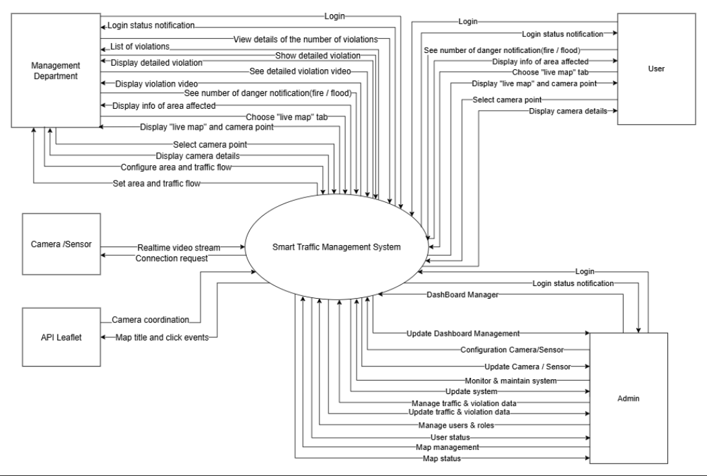

4.2 System context description
- Management Department:
  - Management Department can authenticate identity (login / logout).
  - Management Department can view details of the number of violations.
  - Management Department can show detailed violation.
  - Management Department can see detailed violation video.
  - Management Department can see number of danger notification (fire / flood).
  - Management Department can view the live map containing the camera points.
  - Management Department can select to view camera points.
  - Management Department can configure area and traffic flow.
- User:
  - User can authenticate identity (login / logout).
  - User can see number of danger notification (fire / flood).
  - User can view the live map containing the camera points.
  - User can select to view camera points.
- Admin:
  - Admin can authenticate identity (login / logout).
  - Admin can dashdoard management.
  - Admin can configuration camera/ sensor.
  - Admin can monitor and maintain system.
  - Admin can manage traffic and violation data.
  - Admin can manage users & roles.
  - Admin can map management.
- Camera /Sensor:
  - Camera /Sensor can provide a live video stream.
- API Leaflet:
  - API Leaflet can provide camera coordination functionality.

4.3 Technical Constraints Technical to develop:
- Programming language: JavaScript, Python.
- Library: OpenCV, Ultralytics YOLOv8, Django Channels, Leaflet.js.
- Technology: MVC, Object Detection (YOLO), HLS for live camera view, API Leaflet (OpenStreetMap).
- Database: PostgreSQL.
- Version Control System: GitHub.
- Team Management: Jira, Discord, Google drive
- Develop tools: Visual Studio Code, Postman
- Environments:
- Internet Connection
- Operation System: Google Chrome, Microsoft Edge, CocCoc, Firefox
- Other Constraints:
- Resource: 4 people.
- Budget: Limited.
- Time: The project must be completed within 02 months.
- These features are not available in the first version of the product.

5.Tasks and Deliverables

No. | Task name | Description
1. | Start up
1.1 | Project kick off meeting | Meeting the developer team and stakeholder to clear out the goal, defining of the base elements for the project and other project planning  activities
1.2 | Discuss about project | Brighten up the current ideal to both developer  team and stakeholder
1.3 | Create Document | Release the artifacts or schematics related to project to product owner, include Proposal, User  story, Product backlog, Project plan…
2. | Development
2.1 | Sprint Planning | A Sprint begins with a sprint planning session that  sets goals and plans details for the work to be done
2.2 | Sprint 1 | Release the first look of the product (ver1.0) with functions which have been committed in the  contract
2.3 | Sprint 2 | Release the update for ver1.0 (ver1.1) with functions which have been approved by product  owner
2.4 | Sprint 3 | The next update (ver1.2) for previous phase
3. | Project ‘s meeting | Private meeting between members to make plan what will be presented to customer in the final  release
4. | Final Release | Release the final version to product owner with  complete function

6. Project Management

6.1 Cost/Budget for Project

Full Name | Role | Salary Rate (USD/hour)
Thong, Nguyen Cao | Scrum Master | 6
Thien, Luu Vu | Team Member | 6
Bao, Nguyen Gia | Team Member | 6
Thong, Le Huu | Team Member | 6
Table 1. Cost person/hours

No | Criteria | Price | Total (USD)
1 | Working hours | 6 | 840
2 | Other cost | 100 | 400
 |  |  | 1240
Table 2. Total cost estimation

Description | Amount | Unit
Number of members | 4 | Person
Number of working hours per day | 3 | Hours
The cost per hour per member | 6 | USD
The number of working days | 58 | Days
Table 3. Description

- The explanation for the table
- Amount of working hours = 4 members * 3 hours * 90 days
- Other cost = 4 members * 100 USD

6.2Tentative Schedule

6.2.1 Master Plan

NO | Task Name | Duration | Start | Finish
1. | Initial | 8 days | 09 – Jan – 2026 | 16 – Jan – 2026
1.1 | Gathering Requirement | 2 days | 09 – Jan – 2026 | 10 – Jan – 2026
1.2 | Create Proposal Document | 1 days | 16 – Jan – 2026 | 16 – Jan – 2026
2 | Start Up | 8 days | 19 – Jan – 2026 | 26 – Jan – 2026
2.1 | Project Kick-off Meeting | 2 days | 19 – Jan – 2026 | 20 – Jan – 2026
2.2 | Create Document | 6 days | 21 – Jan – 2026 | 26 – Jan – 2026
3 | Development | 35 days | 29 – Jan – 2026 | 05 – Mar – 2026
3.1 | Sprint 1 | 18 days | 29 – Jan – 2026 | 15 – Feb – 2026
3.2 | Sprint 2 | 10 days | 16 – Feb – 2026 | 25 – Feb – 2026
3.3 | Sprint 3 | 7 days | 27 – Feb – 2026 | 05 – Mar – 2026
4 | Project’s Retrospective Meeting | 02 days | 06 – Mar – 2026 | 07 – Mar – 2026
5 | Final Release | 01 days | 07 – Mar – 2026 | 08 – Mar – 2026

6.2.2 Scrum Process

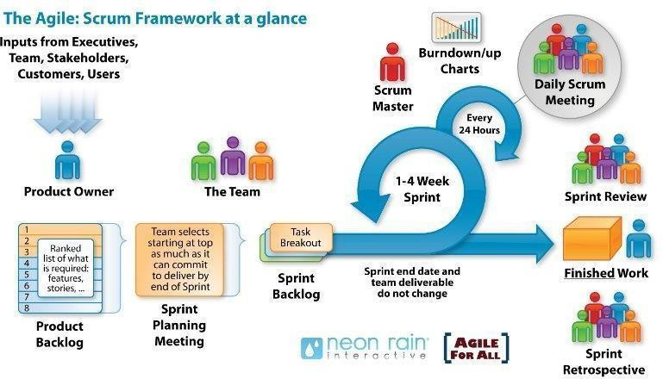

- Scrum is an iterative and incremental agile software development framework for managing software projects and product or application development.
- Scrum focuses on project management institutions where it is difficult to plan ahead.
- Mechanisms of empirical process control, where feedback loops that constitute the core management technique is used as opposed to traditional command-and
-control management.
- Its approach to planning and managing projects is by bringing decision-making authority to the level of operation properties and certainties.
- Benefit of the methodology:
  - Project can respond easily to change.
  - Problems are identified early.
  - Customers get the most beneficial work first.
  - Work done will better meet the customer’s needs.
  - Improved productivity.
  - Ability to maintain a predictable schedule for delivery.

7. Project Constraints
Constraint | Constraints Description | Guidelines for  Acceptance
Economic | - High initial cost for GPU servers and cameras.  - Ongoing maintenance and potential API fees. | Must demonstrate cost-effectiveness compared to manual surveillance and stay within the allocated budget.
Environmental | - Outdoor hardware must be weather-resistant (IP66).  - System requires 24/7 power; energy efficiency is key | Design must withstand local weather (heat/rain) and minimize energy consumption/e-waste.
Ethical | - User data and video footage must be encrypted.  - Strict access control to prevent misuse of surveillance. | Compliance with privacy laws. No sharing of sensitive data with unauthorized parties.

Public health, safety, and welfare | - Critical need for accurate real-time hazard detection (fire/flood)  - UI must be clear to avoid distracting drivers. | The system must reliably detect dangers to protect public safety and reduce accident response times.
Social and Global | - Improves traffic flow and equity for all citizens.  - Public map must be accessible on standard smartphones. | The product should be user-friendly and socially responsible, benefiting the wider community.
Cultural | - Interface must be in Vietnamese.  - AI must recognize local traffic patterns (high motorbike density). | Design must respect local language and driving behaviors distinct from Western models.
Sustainability | - Uses open-source tech (Leaflet, Python) for longevity.  - Modular architecture allows future hardware expansion. | Code must be maintainable and scalable for future teams to update or expand.

8. Conclusion
This product creates a comprehensive solution that promises to assist the Management Department and citizens in monitoring and participating in traffic safely and effectively. The system replaces manual surveillance methods with advanced AI technology, helping to detect violations, provide immediate fire/flood warnings, and minimize accident risks. The project is expected to be completed within 02 months at a cost of not more than $ 1240.

9. References
[1]. Software Development Standards for the Guidance and Control Software Project: https://sw-eng.larc.nasa.gov
[2]. General Software Coding Standards and Guidelines: https://www.nws.noaa.gov/oh/hrl/developers_docs/General_Software_Standards.pdf
[3]. Scrum and best practices: https://docs.microsoft.com/en-us/azure/devops/boards/sprints/best-practices-scrum?view=azure-devops
[4]. The Scrum Guide: https://www.scrum.org/resources/scrum-guide
[5]. The ISO/IEC & IEEE/EIA Standard 12207, IEEE standards: IEEE-829 [3], IEEE-1008 [5], IEEE-1012
[6]. Ultralytics YOLOv8 Documentation: https://docs.ultralytics.com/
[7]. Leaflet API Documentation: https://leafletjs.com/reference.html
[8]. OpenCV Library Documentation: https://docs.opencv.org/

10. Attachment

