|  |  |  |
| --- | --- | --- |
| **Category** | **Name / Version** | **Purpose / Notes** |
| .NET Version | .NET 6.0 / .NET 7.0 / .NET Framework 4.8 | Required to run/build the application |
| NuGet Package | Microsoft.EntityFrameworkCore | Entity Framework Core ORM |
| NuGet Package | Microsoft.EntityFrameworkCore.SqlServer | SQL Server provider for EF Core |
| NuGet Package | Microsoft.EntityFrameworkCore.Tools | EF Core CLI tools (for migrations, optional) |
| NuGet Package | System.Data.SqlClient *(if used)* | Direct SQL Server access (optional) |
| Database Engine | SQL Server LocalDB *(recommended for offline)* | Local, lightweight SQL Server instance |
| Database Engine | OR SQL Server Express | For multi-user or production setups |
| VS Extension | WinForms Designer | For designing WinForms UI |
| VS Extension | Entity Framework Core Tools | For managing migrations (optional) |
| Database Setup | Your SQL scripts or .mdf file | To create or copy the database |
| Config File | appsettings.json or App.config (provided in file already) | Update connection string for the new environment |

**SETUP: For this Project**

|  |  |  |
| --- | --- | --- |
| **Tool/Library** | **Version/Name (Example)** | **How to Check / Notes** |
| SQL Server Management Studio (SSMS) | 19.1.56.2 | *Help → About* in SSMS |
| SQL Server Engine | Microsoft SQL Server 2022 (16.0.1000) | Run SELECT @@VERSION; in SSMS |
| EF Core SQL Server Provider | Microsoft.EntityFrameworkCore.SqlServer | Check NuGet packages in your project |
| SQL Client Library *(if used)* | System.Data.SqlClient | Check NuGet packages in your project |

**Main Roles and Their Roles**

|  |  |
| --- | --- |
| **File** | **Purpose** |
| Program.cs | Application entry point; starts the main form. |
| Models/Book.cs | Defines the Book entity (BookId, Title, Author, etc.). |
| Models/Student.cs | Defines the Student entity (StudentId, Name, ReferenceID, etc.). |
| Models/Transaction.cs | Defines the Transaction entity (TransactionId, BookId, StudentId, BorrowDate, ReturnDate). |
| Data/LibraryDbContext.cs | Entity Framework Core context; manages database access and entity sets. |
| BLL/LibraryManager.cs | Business logic layer; handles CRUD operations and business rules for books, students, transactions. |
| Forms/MainForm.cs | Main WinForms UI; displays tabs for books, students, transactions, and handles user actions. |
| Forms/BorrowBookForm.cs | UI for borrowing a book; lets user select student and book, triggers borrow logic. |
| Forms/ReturnBookForm.cs | UI for returning a book; lets user select student and book, triggers return logic. |
| Utils/FineCalculator.cs | Utility class for calculating overdue fines. |

**Key Functions and Their Roles**

|  |  |  |
| --- | --- | --- |
| **File** | **Function** | **Purpose / How It’s Used** |
| LibraryManager.cs | GetAllBooks() | Returns a list of all books from the database. Used to populate the books grid in the UI. |
|  | GetAllStudents() | Returns a list of all students. Used to populate the students grid. |
|  | GetAllTransactions() | Returns all transactions, including book and student info. Used for the transactions grid. |
|  | BorrowBook(int bookId, int studentId) | Creates a new transaction, marks book as unavailable. Called from BorrowBookForm. |
|  | ReturnBook(int bookId, int studentId) | Marks a transaction as returned, updates book availability. Called from ReturnBookForm or MainForm. |
|  | DeleteBook(int bookId) | Deletes a book if not currently borrowed. |
|  | DeleteStudent(int studentId) | Deletes a student if they have no borrowed books. |
|  | ClearAllTransactions() | Deletes all transactions and resets book availability. |
| FineCalculator.cs | CalculateFine(DateTime borrowDate, DateTime? returnDate) | Calculates overdue fine (₱5/day after 7 days). Used when displaying or processing returns. |
| BorrowBookForm.cs | btnBorrow_Click | Handles the borrow button click: validates input, finds student, calls LibraryManager.BorrowBook. |
| MainForm.cs | LoadData() | Loads and displays all books, students, and transactions in the UI. |
|  | BtnBorrowBook_Click | Opens BorrowBookForm for the selected book. |
|  | BtnReturnBook_Click | Handles returning a book, calls LibraryManager.ReturnBook. |
|  | ExportGridToCsv | Exports data from grids to CSV files. |
|  | RestartApplication | Restarts the app, with a warning if there are unreturned books. |

**How the Code Works Together**

1. **Startup:**

* Program.cs launches MainForm.
* MainForm displays tabs for books, students, and transactions.

1. **Data Loading:**

* MainForm calls LibraryManager.GetAllBooks(), GetAllStudents(), and GetAllTransactions() to populate grids.

1. **Borrowing a Book:**

* User clicks "Borrow Book" → BorrowBookForm opens.
* User enters/selects Reference ID → btnBorrow_Click validates and calls LibraryManager.BorrowBook.
* Book is marked unavailable, transaction is created.

1. **Returning a Book:**

* User clicks "Return Book" → BtnReturnBook_Click in MainForm or ReturnBookForm is triggered.
* Calls LibraryManager.ReturnBook, which sets the return date and marks the book as available.
* Fine is calculated using FineCalculator if overdue.

1. **Managing Data:**

* Users can add/edit/delete books and students via forms.
* Transactions can be cleared, and data can be exported to CSV.

1. **Database Access:**

* All data operations go through LibraryDbContext (Entity Framework Core).
* The context manages connections to the SQL Server/LocalDB database.

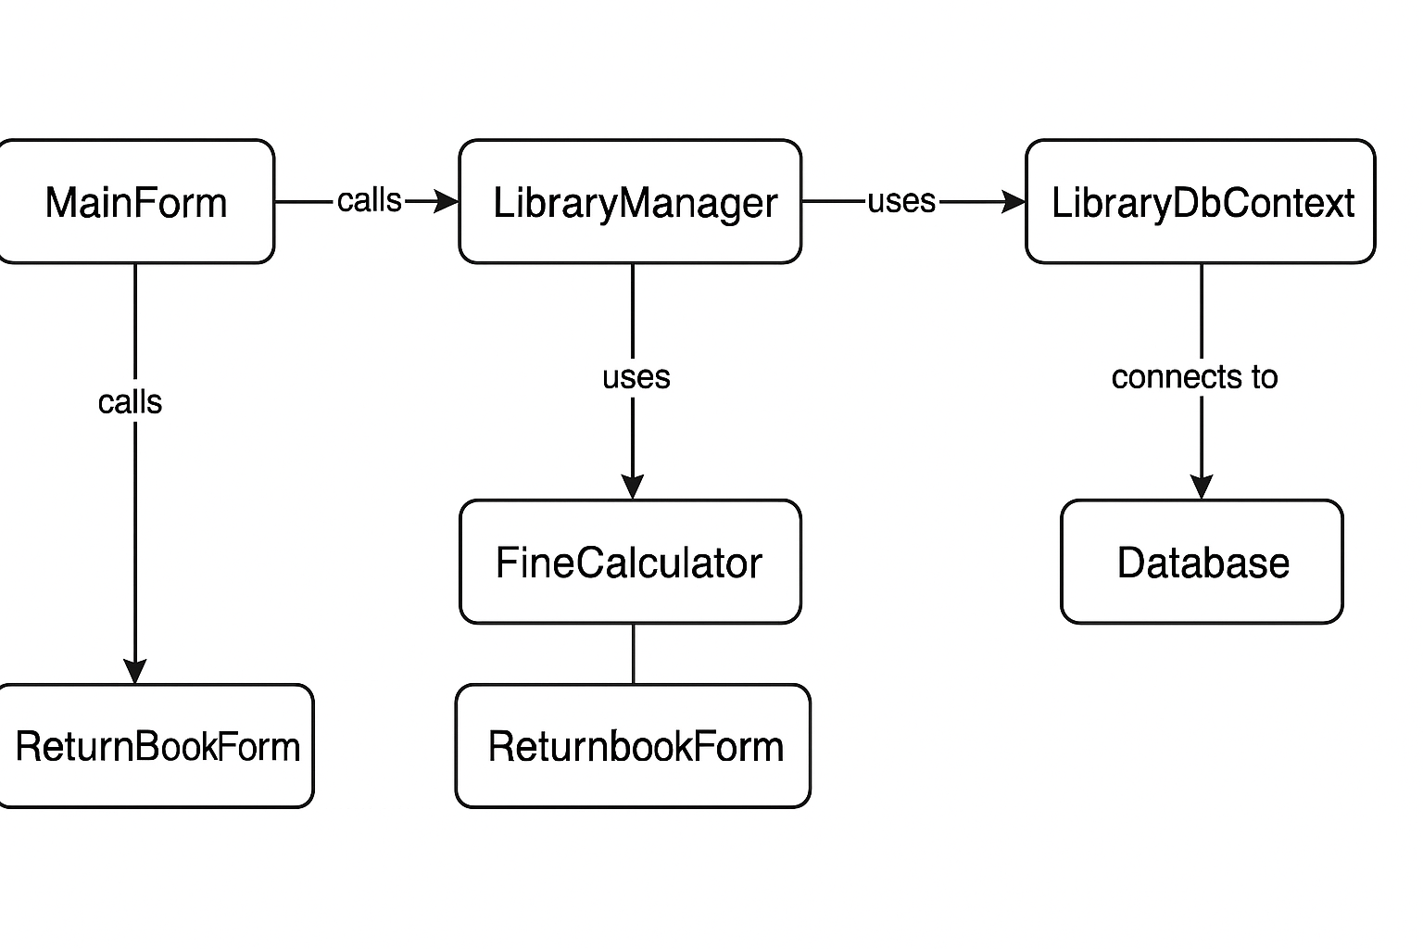

# Architecture Overview

Your project follows a **layered architecture** (sometimes called N-Tier or 3-Tier), which separates concerns into distinct layers:

1. **Presentation Layer (UI)**
2. **Business Logic Layer (BLL)**
3. **Data Access Layer (DAL) / Models**
4. **Database**

## 1. Presentation Layer (UI)

* **Files:** Forms/MainForm.cs, Forms/BorrowBookForm.cs, Forms/ReturnBookForm.cs, etc.
* **Role:**
* Handles all user interactions (buttons, forms, grids).
* Displays data to the user and collects input.
* Calls the BLL (LibraryManager) to perform actions.
* **Design:**
* Uses WinForms for a tabbed, user-friendly interface.
* Each form is responsible for a specific task (borrowing, returning, managing books/students).

## 2. Business Logic Layer (BLL)

* **File:** BLL/LibraryManager.cs
* **Role:**
* Contains all the business rules and logic (e.g., can’t borrow if already borrowed, can’t delete a student with borrowed books).
* Acts as a bridge between the UI and the database.
* Exposes methods for CRUD operations and higher-level actions (borrow, return, calculate fines).
* **Design:**
* Centralizes logic so rules are enforced consistently, no matter where the action is triggered from.

## 3. Data Access Layer (DAL) / Models

* **Files:** Models/Book.cs, Models/Student.cs, Models/Transaction.cs, Data/LibraryDbContext.cs
* **Role:**
* Defines the structure of your data (entities).
* LibraryDbContext manages database connections and entity sets using Entity Framework Core.
* Handles all communication with the SQL Server/LocalDB database.
* **Design:**
* Uses Entity Framework Core for ORM (Object-Relational Mapping), so you work with C# objects instead of raw SQL.

## 4. Database

* **Technology:** SQL Server LocalDB or SQL Server Express
* **Role:**
* Stores all persistent data (books, students, transactions).
* Enforces data integrity with primary keys, foreign keys, and constraints.

## Supporting Utilities

* **File:** Utils/FineCalculator.cs
* **Role:**
* Provides reusable logic for calculating overdue fines.
* Keeps utility code separate from business logic for maintainability.

# Design Principles Used

* **Separation of Concerns:**

Each layer has a clear responsibility, making the code easier to maintain and extend.

* **Reusability:**

Business logic and utility functions are centralized and reusable across the application.

* **Scalability:**

The architecture allows for easy addition of new features (e.g., new forms, new business rules).

* **Maintainability:**

Changes in one layer (e.g., UI) do not require changes in others (e.g., database).

# How the Layers Interact

1. **User interacts with the UI** (e.g., clicks “Borrow Book”).
2. **UI calls the BLL** (LibraryManager.BorrowBook).
3. **BLL uses the DAL/DbContext** to read/write data.
4. **DbContext communicates with the database** to persist or retrieve data.
5. **BLL may use utilities** (e.g., FineCalculator) for calculations.
6. **Results/data flow back up** to the UI for display.

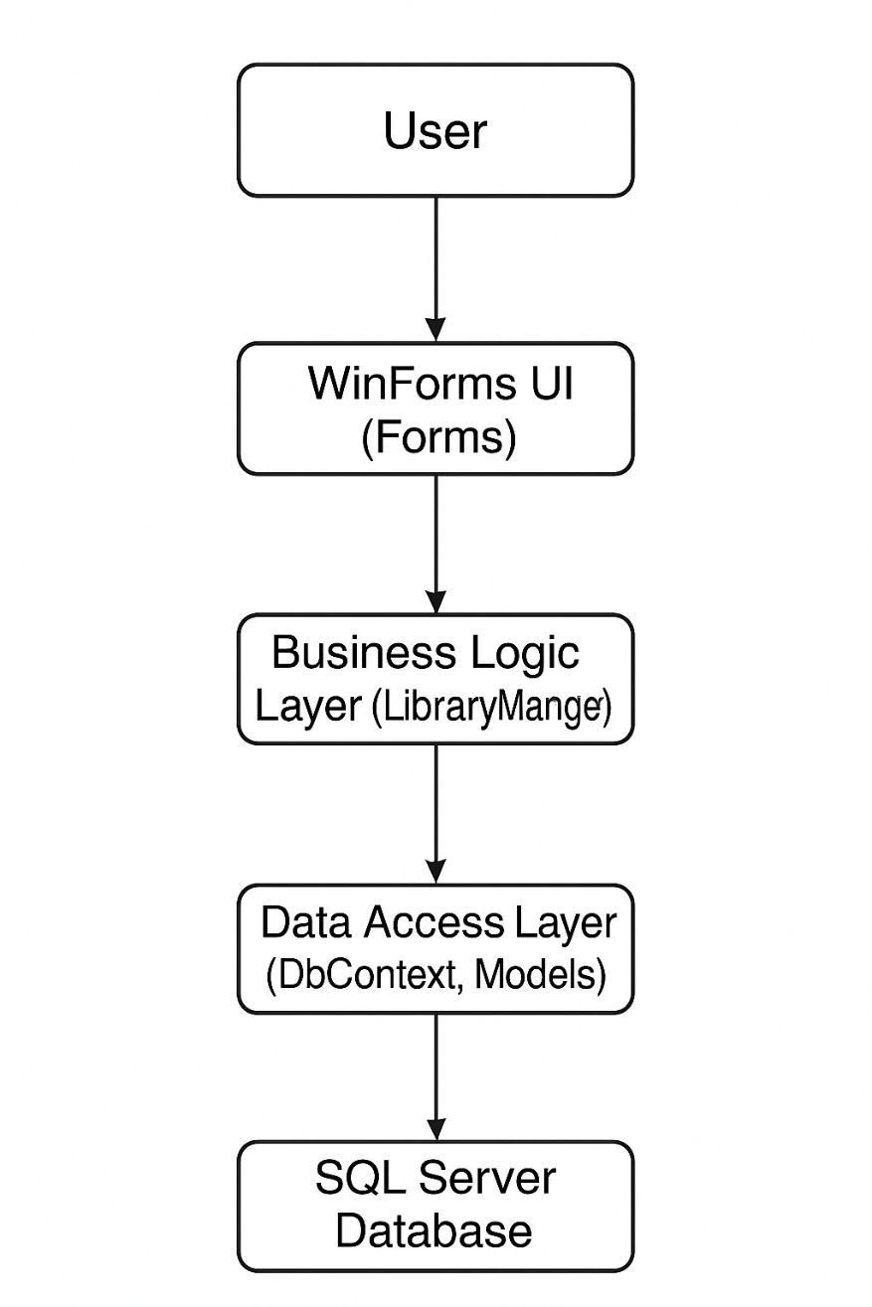

**References:**

|  |  |  |
| --- | --- | --- |
| **Term / Acronym** | **Full Form / Meaning** | **Description** |
| **.NET** | .NET Framework / .NET Core | A software framework developed by Microsoft for building and running applications on Windows. |
| **EF Core** | Entity Framework Core | A lightweight, extensible, open-source Object-Relational Mapper (ORM) for .NET applications. |
| **ORM** | Object-Relational Mapper | A tool that converts data between incompatible type systems (e.g., between SQL and C# objects). |
| **NuGet** | NuGet Package Manager | A package manager for .NET that helps install and manage libraries (packages) in a project. |
| **SQL** | Structured Query Language | A language used to interact with databases—querying, inserting, updating, and deleting data. |
| **SQL Server** | Microsoft SQL Server | A relational database management system developed by Microsoft. |
| **LocalDB** | SQL Server LocalDB | A lightweight version of SQL Server for developers; runs locally and requires minimal setup. |
| **DbContext** | Database Context | A class in EF Core that manages entity objects and database communication. |
| **BLL** | Business Logic Layer | The layer that contains application logic and rules (e.g., can a book be borrowed?). |
| **DAL** | Data Access Layer | The layer that directly interacts with the database through models and EF Core. |
| **UI** | User Interface | The visual part of the application the user interacts with, built with WinForms in this case. |
| **WinForms** | Windows Forms | A GUI class library in .NET for building desktop applications on Windows. |
| **CRUD** | Create, Read, Update, Delete | The four basic functions of persistent storage used in database operations. |
| **Migrations** | EF Core Migrations | A feature in EF Core used to update the database schema as the model changes over time. |
| **.mdf** | Microsoft Database File | The primary data file for SQL Server databases. |
| **App.config / appsettings.json** | Configuration Files | Files where application settings, such as database connection strings, are stored. |
| **CLI** | Command Line Interface | A way to interact with tools or programs using typed commands instead of a GUI. |
| **SSMS** | SQL Server Management Studio | A GUI tool used to manage and interact with SQL Server databases. |
| **Reference ID** | — | A unique identifier assigned to a student in your system. |
| **Overdue Fine** | — | A monetary penalty calculated for late return of a book. |
| **Tab (UI)** | — | A visual section of a form used to organize content (e.g., tabs for books, students). |