Als ik zo naar je hoofdvraag kijk en naast je suggestie voor een simulatie leg, dan lijkt het erop dat je je wilt richten op de afweging (voor overheden) tussen schuldhoudbaarheid en output stabilisatie. Deze afweging hangt van veel factoren af, zoals monetair beleid, r-g, de omvang van de publieke schuld, de verstrengeling van de overheid met commerciële banken, het type instrument dat de overheid gebruikt voor output stabilisatie, etc. Misschien is het een idee om die afweging nader te onderzoeken in je onderzoeksproject. Je hebt gelijk dat hier al best wel wat literatuur over bestaat, maar een overzichtelijke samenvatting kan desalniettemin uitdagend en informatief zijn. Verder lijkt het me een leuk idee als je met een klein, simpel model, deze afweging kunt illustreren voor een specifiek land, zoals Nederland, waarmee je vervolgens een beleidsaanbevelikyng kunt maken (moeten we ons meer richten op schuldhoudbaarheid of output stabilisatie? Wat zijn de risico's als we voor meer output stabilisatie kiezen?).
"Fiscal policy in times of low interest rates"
* Wat lage rentes betekenen voor schuldhoudbaarheid
* Optimaal begrotingsbeleid
* De afruil tussen schuldstabilisatie en macro-economische stabilisatie
* De coördinatie met monetair beleid (en dit alles met een specifieke blik op monetaire unies).

A scarcity of bonds from triple-A rated Germany, where supply has been low in recent years because of a budget surplus, alongside buying by the ECB for quantitative easing means there are long-term structural factors pushing yields lower.

Blanchard develops four main arguments concerning the costs of public debt when safe interest rates are low.
First, the current US situation in which safe interest rates are expected to remain below growth rates for a long time is more the historical norm than the exception. If the future is like the past, this implies that debt rollovers—that is, the issuance of debt without a subsequent increase in taxes—may well be feasible. Put bluntly, public debt may have no fiscal cost.
Second, even without fiscal costs, public debt reduces capital accumulation and may therefore have welfare costs. However, welfare costs may be smaller than typically assumed. The reason is that the safe rate is the risk-adjusted rate of return on capital. A safe rate that is lower than the growth rate indicates that the risk-adjusted rate of return to capital is in fact low. The average risky rate, i.e. the average marginal product of capital, also plays a role, however. Blanchard shows how both the average risky rate and the average safe rate determine welfare outcomes.
Third, while the measured rate of earnings has been and is still quite high, the evidence from asset markets suggests that the marginal product of capital may be lower, with the difference reflecting either mismeasurement of capital or rents. This matters for debt: The lower the marginal product, the lower the welfare cost of debt.
Fourth, Blanchard discusses a number of arguments against high public debt, and in particular the existence of multiple equilibria where investors, believing debt to be risky, require a risk premium, which increases the fiscal burden and makes debt effectively more risky. This argument, while relevant, does not have straightforward implica-tions for the appropriate level of debt.
Some of these conclusions will be controversial. But the aim of the paper is to foster a richer discussion of the costs of debt and fiscal policy than is currently the case, not to argue for more public debt, especially in the current political environment.

https://www.bis.org/publ/work794.htm
Beste Dennis,

Dag eerder dan afgesproken. Afgelopen dagen druk bezig geweest. Ik zou willen focussen op specifiek de afweging tussen macro-economische stabilisatie en schuldstabilisatie in en na COVID. Concreet zou dat iets zijn als:
“How should monetary unions balance their debts and public investments in and after the COVID-19 crisis?”
Dat voegt mijn inziens mooi jouw algemene vraagstukken samen met een relevant onderwerp. Risico hiervan is dat het, net als schulden, MMT, etc. wel al behoorlijk uitgeplozen is. Ik heb (zie link) een aantal paginas met achtergrond info / inleiding / andere artikelen alvast grofweg op papier gezet.
Aan overheidsbestedingen tijdens COVID horen o.a.:
* Increasing government expenditure (subsidy to companies) resulting from revenue shortfalls and higher expenditure. En vooral: moet dit gefinancierd worden met eigen schuld: bonds in de market (clasic/keynes) of met central bank financing? (MMT)
* calls on government guarantees (zie bijv FD artikel over de 80% garantiestelling van deze morgen)
* Preventing liquidity runs in bond markets (dat gaat dan meer naar QE/ECB dan lokaal).
Zo zijn er nog een hoop meer vraagstukken te bedenken, maar ik schrijf liever iets in-depth over één onderwerp dan een hele rits aan vragen. Dat zou denk ik de eerste zijn. Wat ik tot nu toe het moeilijkst vind, is hoe ik hier iets aan kan bijdragen. Het liefst ga ik wat verder dan een “literature study”, want over dit onderwerp is logischerwijs al erg veel geschreven. Ik ben zelf kwantitatief sterk en heb bijvoorbeeld nagedacht of we bijv. Monte Carlo simulaties (“stress tests”) zouden kunnen bouwen om enerzijds de schuldhoudbaarheid/ anderzijds de economische kwetsbaarheid te bestuderen.
Dat is natuurlijk een enorm vakgebied dat ik niet zomaar even voor elkaar krijg in 3 weken, maar misschien weet jij hier bijv een goede basis in, waar we verder mee zouden kunnen werken oid. Sta open voor ideeën en neem het graag een stapje verder…
In de bijlage zoals aangegeven een eerste opzetje aan intro’s, wat relevante papers, etc. Daarin nog niet specifiek op deze vraag gericht, maar allereerst eens algemene bespreking van government debt, interest rates, combi van fiscal en monetary policy, wat er überhaupt gebeurt met schulden in geval van hoge/lage interest rates etc.
Lijkt mij goed om hier volgende week indien mogelijk even over te spreken. Ik heb daarnaast nog een hele hoop bronnen, tekst, papers staan. Indien je dus een gedetailleerdere opzet wilt, kan ik die natuurlijk verzorgen. Ik weet niet precies hoe “diep” ik in deze beschrijving al moet gaan.
Voor nu alvast hartelijk dank,
Gr Luuk
Has this negative interest policy actually worked in other countries – has it boosted their economies and increased lending?
“The evidence from Europe does not really suggest that negative interest rates encouraged greater lending activity. In fact, lending was stagnant until the European Central Bank started its own funding for lending scheme.
“If banks are charged for holding cash reserves with the central bank, rather than being paid, then it eats into their profit margin and requires them to recoup the cost in some way.
“In theory, banks should pass on the cost to savers by giving them a negative interest rate. In reality, where negative interest rates exist, banks have been reluctant to do this, choosing instead to either increase banking fees or charges. If they cannot do this, then some banks have simply reduced lending, which may be the worst possible outcome given the policy’s intention is to stimulate business activity.”

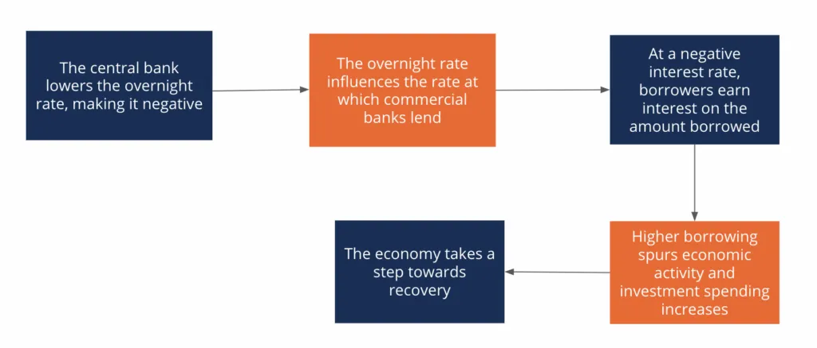
The overnight rate is the rate at which the central bank lends to commercial banks. At a negative overnight rate, commercial banks are encouraged to borrow more as they are paid interest on their borrowings.
The negative overnight rate incentivizes banks to lend more. Similarly, consumers and companies are attracted by the unusually low cost of borrowing – wherein they get paid to borrow money – resulting in higher investment and consumption spending.
Companies also borrow money to improve their cash balances at negative interest rates.
The lower interest rate also influences the exchange rate, devaluing the currency and increasing the demand for domestic goods in foreign markets, i.e., exports.
Increased borrowing and spending in the economy, in addition to higher exports, lead to an increase in aggregate demand, and the economy takes a step out of the recessionary phase.

More than two years ago the European Central Bank (ECB) adopted a negative interest rate policy (NIRP) to achieve its price stability objective. Negative interest rates have so far supported easier financial conditions and contributed to a modest expansion in credit, demonstrating that the zero lower bound is less binding than previously thought. However, interest rate cuts also weigh on bank profitability. Substantial rate cuts may at some point outweigh the benefits from higher asset values and stronger aggregate demand. Further monetary accommodation may need to rely more on credit easing and an expansion of the ECB’s balance sheet rather than substantial additional reductions in the policy rate.

Risk-free rates have been falling since the 1980s while the return on capital has not. We analyse these trends in a calibrated overlapping-generations model with recursive preferences, designed to encompass many of the "usual suspects" cited in the debate on secular stagnation. Deleveraging cannot account for the joint decline in the risk free rate and increase in the risk premium, and declining labour force and productivity growth imply only a limited decline in real interest rates. If we allow for a change in the (perceived) risk to productivity growth to fit the data, we find that the decline in the risk-free rate requires an increase in the borrowing capacity of the indebted agents in the model, consistent with the increase in the sum of public and private debt since the crisis.

Why are interest rates so low today? Many believe that the worldwide abundance of savings is due to the retirement of OECD baby-boomers and the Chinese one-child policy. Can these factors explain the fall in long-term real interest rates, from around 4.5% in 1990 to around 0% since 2015? By contrast, the return on capital, defined as profits over the stock of capital, if anything, increased from 1990 to 2000 and remained stable at around 10% until 2015. Why do investors accept such low returns on bonds while, at the same time, the return on physical capital has remained stable?

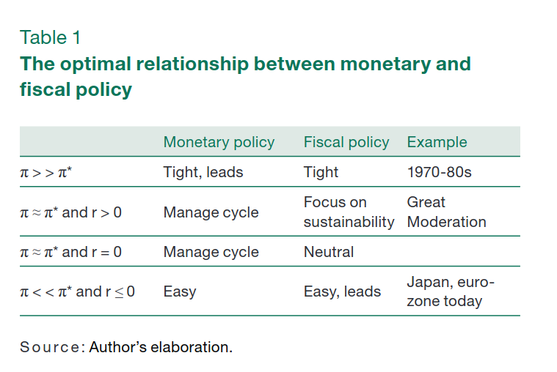
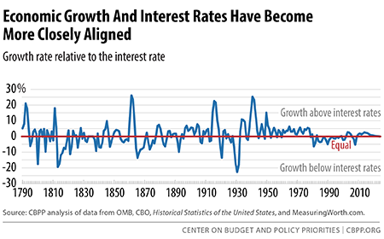

Public debt has surged during the current global economic crisis and is expected to increase further. This development has raised concerns whether public debt is starting to hit levels where it might negatively affect economic growth. Does such a tipping point in public debt exist? How severe would the impact of public debt be on growth beyond this threshold? What happens if debt stays above this threshold for an extended period of time? The present study addresses these questions with the help of threshold estimations based on a yearly dataset of 101 developing and developed economies spanning a time period from 1980 to 2008. The estimations establish a threshold of 77 percent public debt-to-GDP ratio. If debt is above this threshold, each additional percentage point of debt costs 0.017 percentage points of annual real growth. The effect is even more pronounced in emerging markets where the threshold is 64 percent debt-to-GDP ratio. In these countries, the loss in annual real growth with each additional percentage point in public debt amounts to 0.02 percentage points. The cumulative effect on real GDP could be substantial. Importantly, the estimations control for other variables that might impact growth, such as the initial level of per-capita-GDP.

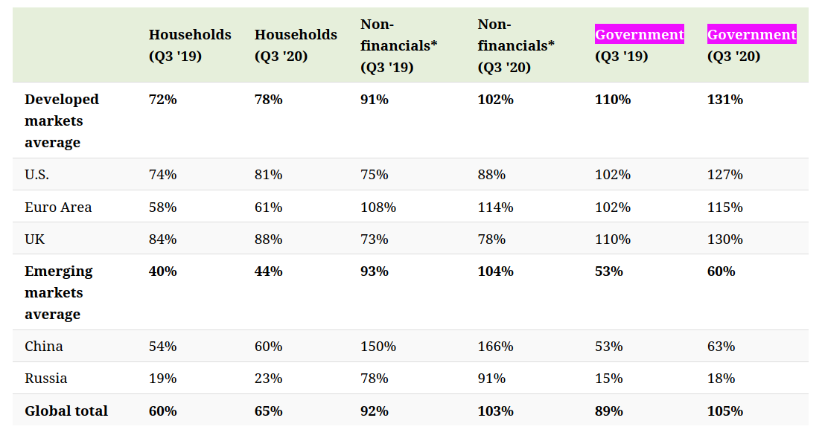
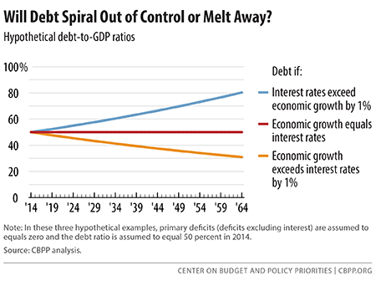

http://gouthamanbalaraman.com/blog/hull-white-simulation-quantlib-python.html
Visit here for other QuantLib Python examples. If you found these posts useful, please take a minute by providing some feedback.
The Hull-White Short Rate Model is defined as:
drt=(θ(t)−art)dt+σdWt
where a
and σ are constants, and θ(t) is chosen in order to fit the input term structure of interest rates. Here we use QuantLib to show how to simulate the Hull-White model and investigate some of the properties.

Global Debt Database
The Global Debt Database (GDD) is the result of a multiyear investigative process that started with the October 2016 Fiscal Monitor. The dataset comprises total gross debt of the (private and public) nonfinancial sector for an unbalanced panel of 190 advanced economies, emerging market economies and low-income countries, dating back to 1950. For more details on the methodology and definitions, please see the Mbaye, Moreno Badia and Chae (2018).
We rely on the feedback from users to address any problems they may encounter with the data. Notification of any omissions or supplementary sources is welcome and would be fully acknowledged. Suggestions can be sent to IMF-GDD@imf.org
Reference: Mbaye, S., Moreno-Badia, M., and K. Chae. 2018. “Global Debt Database: Methodology and Sources,” IMF Working Paper, International Monetary Fund, Washington, DC.

