ReShare: the zero-install media bridge

Sharing large media files (movies or pictures) between isolated devices specifically mobile phones, on a local network is surprisingly difficult.

1.The Problem Statement
Traditional methods require either :
- uploading the file to a cloud server… requiring an active internet connection and massive data usage
- installing third party FTP/WebDAV applications on both devices
- Using basic screen mirroring (high latency, battery drain or network freezing)

The Goal: Build a zero-install virtual file system(VFS). We want an iphone, what we shall call phone A to be able to seamlessly browse and play a movie stores on an android device, we shall calll this phone B, using only a web browser, orchestrated by a central laptop on the same local network.

2.The Evolution of the Solution
Our architecture evolves thorug three distinct phases to overcome technical limitations:
- Phase 1: WebRTC screen sharing. We initially built a peer-to-peer scrren share. The flaw: WebRTC is designed for real-time lossy communication (like video calls). Sendign a high-bitrate movie casued the stream to freeze after a few seconds due to network bottlenecks and packet drops.
- Phase 2: Centralised file hosting. We pivoted to having the python server host the files. Its Flaw: thi srequired the moves to physically live o the laptop. We wanted the files o remian on the mobile devices.
- Phase 3: The Web-Based NAS(Current). We eliminated external apps entirely. We utilised modern HTML% browse APIs to turn the mobile browser itslef into a backgorund file server, creating a custom streaming pipeline.

3.The Core Architecture
The system is divide into three distinct roles. No files are paermanently transferres or copied; everything is streamed dynamically.

Pillar I: The Hub(Laptop)
The Hub is the brain of the opertaion. It runs a python(FastAPI) server and acts as a sateless traffic director.
- Session Manager: Assigns unique Ids to connected devices and cashes their state in RAM. If a device drops pffline, the hub remenbers exactly what they were doing.
- The Signaling Room: Manages the webSocket connection, routing commands like paly, pause, send file list, stop sharing, between the devices.
- The Chunk Relay: Receives small binary pieces of the movie aformthe vault and isntantly pipes them to the stage.
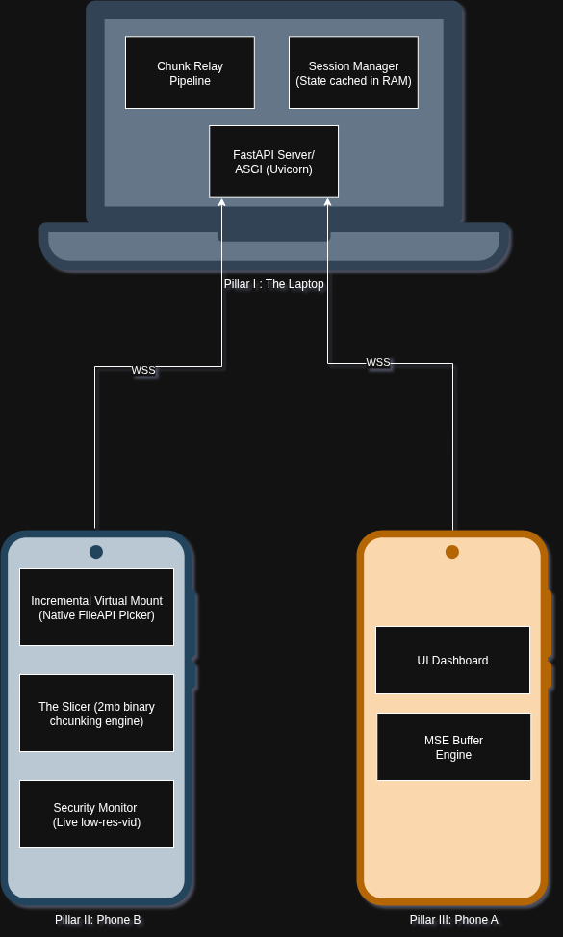

Pillar II: The Vault(Phone B)
This is the device holding the media. The user opes the web app and sets it to “Proviver mode”
- Incremental Virtual Mount: Uses the browser’s native file picker. The user explicilty grants the browser access to a specific folder (eg. /downloads). The browser maps this folder into a json file tree and sends it to the hub.
- The Slicer: When a movie is requested, the browser uses the JavaScript File API to read the movie in tiny 2mb chunks preventing the phones memory form overflowing.
- The Security Monitor (Foreground Lock): To prevent the mobile OS from killing the browser tab in the backgorund, the UI dsiplays a live low rel preview of the file currently being streames. This acts as both a visual kill switch for the owner and a hack to keep the mobile cpu awake.

Pillar III: The Stage (Phone A)
This is the device watchifnthe media. It connects to the hub and operates in consumer mode
- Medial Soource Extensions (MSE) Engine: Insteas of a standard video player, the <video> tage is fed by a custem memory buffer. The s allows the hub to pre-load chucks od the movie ahead of time.
- The UI Dashboard: Displays the JSON file tree generated by the Vault as clickable, interactive folders

4.Solving the engineeirng Bottlenecks
To make this feel like a native application, we engineered solutions for the three biggest challenges of mobile web-development:
- The 4 second freeze (network jitters)
- Problem: Standard WebRTC drops frames if the wifif fluctuates, freezing the video.
- Solution: Replace WebRTC with MSE Buffering, we decouple the download speed from the playback speed. The hub pushes 10mb of the movie into phone a’s memory before it plays. If the wifi hiccups for 3s the movie continues playing flawlessly from the buffer
- Background Execution Limits(Tab sleeping)
- Problem: iOS and Andriod aggresively freeze browser tabes whenthe user switches to another app.
- Solution: Because the vault is technically playing a video (the visualizer/ monitor) on the scrreen, the mobile operating system calssifies the browser as an active media player and refues to put it to sleep.
- Connection drops and Bookmarking(State persistence)
- Problem: If the user wals outs of disconnects form the network fro a moment, the system shosudlnt force then to restart the entire setup process.
- Solution: silent Reconnection & progree leder
- hub records the exact timestamp pf every active stream (eg device_a is at 57:16 on movie.mp4)
- if device_a drops, the hub keeps the pipeline paused.
- When device_a reconnects the browser silenty sends its ID via localStorage. The Hub recognizes it and flashes a prompt “Resume on 57:16?”

5.The User Journey
- Setup: The user runs the python script on their laptop.
- Vault Connects: The user opens the laptop’s ip address on phone B, or devices with file semir-resitriced access. They tap the share files button, select their movies/media folder, and set the phone down. The screen shows a “Sharing Active” animantion.
- Stage Connects: The user opens the same IP on phoneA or any other device. They see a beautitful file explorer showing the contents of phone B’s media folder.
- The Playback: Phone A taps “Inceptionn.mp4”
- The Magic: Behind the scenes, the hub tells phone b to start slicing inception.mp4 . The chunks fly through the hub into Phone A’s buffer. The movie begins playing in high definition on the iphone, with zero apps intalled, comlpletely offline.

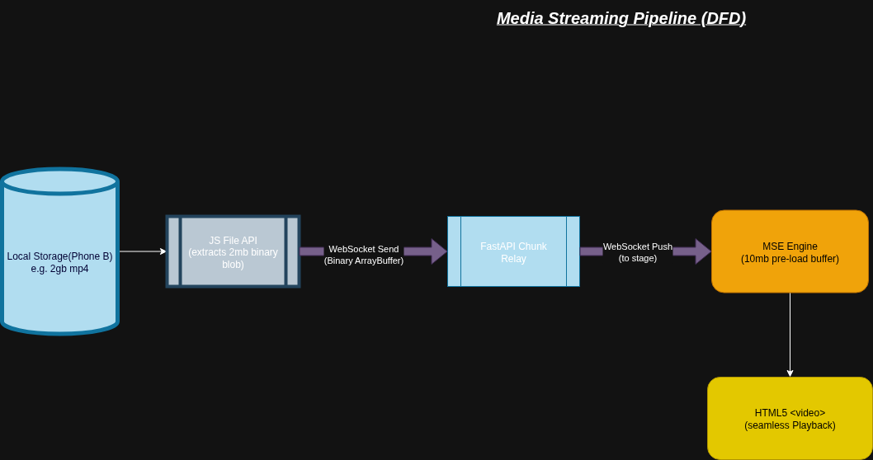

6. The Technology Stack
To keep this system lightweight, fast, and completely free of third-party app installations, we are using a Lean Stack combining a high-performance Python backend with native, modern web APIs that already exist inside mobile browsers.
- The Backend
- Lanuaguage :Python3.11+
This offers rapid development, excellent binary file manipulatoin capabilities, and native asynchronous support
- Framework: FastAPI
FastAPI is buuilt on ASGI standards, it natively handles asynchronous endpoints and WebSockets with blazing-fast performance, mathcing Node.js and Go
- ServerEngine: Uvicorn[standard]
This provides the underlying lightining-fast web server capability. The standard fflag ensures it uses uvloop and websockets for high-throughput binary data streaming
- The Frontend
Architecture: Vanilla HTML%, CSS3 and Javascript
Crucial Constraint. We intentionally avoid frontend frameworks like React, Vue or Angular. Using raw native Javascript ensures the entire app is a single, lightweight file served instantly to any mobile browser without compilation overhead.
- The Core Browser APIs
Instead od external apps, we leverage powerful, built-in browser engines:
- WebSockets API: Handles the low-latensy, bidirectional communicatio channel between the phoen and the laptop for real-time signalling ang chuck streaming.
- HTML5 file api (blob and filereader): Allows phone B to read specific byte ranges( 5mil to 7) of a local movie file directly into memory as binary slices, without loading rhe whole 2GB file.
- Media Source xtensions (MSE) api: Allows phone A’s javascript to dynamically inject those binary slices into the <video> tag’s playback buffer on the fly.
- Screen Wake Lock api and HTML5 Video Engine: Keeps the mobile CPU awake and prevents the browser tab from sleeping when phone b is running in the background
- Networking and Security Tools
Ngrok: Creates a secure temporary public https:// ad wss:// tunnel to the laptop.
Why: Modern mobile browsers (especially Safari on iOS) strictly block access to websockets, cryptography and media apis unless the connectin is fully encrypted, https. Ngrok gives us this security laeyr instantly for local testing.
