**基于pyqt5的GUI案例：**

**from PyQt5 import QtGui**

**from PyQt5.QtWidgets import QApplication, QMainWindow**

**import sys**

**from PyQt5.QtGui import QPainter, QBrush, QPen**

**from PyQt5.QtCore import Qt**

**class Window(QMainWindow):**

**def __init__(self):**

**super().__init__()**

**self.title = "PyQt5 Drawing Tutorial"**

**self.top= 150**

**self.left= 150**

**self.width = 500**

**self.height = 500**

**self.InitWindow()**

**def InitWindow(self):**

**self.setWindowTitle(self.title)**

**self.setGeometry(self.top, self.left, self.width, self.height)**

**self.show()**

**def paintEvent(self, event):**

**painter = QPainter(self)**

**painter.setPen(QPen(Qt.green, 8, Qt.DashDotLine))**

**painter.drawEllipse(40, 40, 400, 400)**

**painter.setPen(QPen(Qt.black, 5, Qt.SolidLine))**

**painter.drawRect(35, 35, 410, 410)**

**App = QApplication(sys.argv)**

**window = Window()**

**sys.exit(App.exec())**

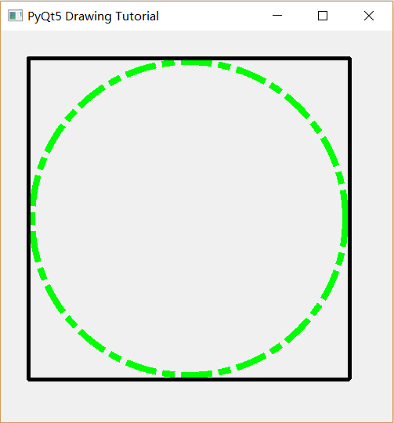

**流水灯程序：**

**import RPi.GPIO as GPIO**

**import time**

**pins=[11,12,13,23,24]**

**def setup():**

**GPIO.setmode(GPIO.BCM)**

**for pin in pins:**

**GPIO.setup(pin,GPIO.OUT)**

**GPIO.output(pin,GPIO.LOW)**

**def loop():**

**while True:**

**for i in range(0,5):**

**GPIO.output(pins[i],GPIO.HIGH)**

**time.sleep(1)**

**GPIO.output(pins[i],GPIO.LOW)**

**time.sleep(1)**

**pins.reverse()**

**def destroy():**

**for pin in pins:**

**GPIO.output(pin,GPIO.LOW)**

**GPIO.setup(pin,GPIO.IN)**

**setup()**

**loop()**

**try:**

**loop()**

**except KeyboardInterrupt:**

**destroy()**

**GPIO.cleanup()**