**Analysing and Visualizing WeRateDogs**

WeRateDogs is popular twitter account famous for its rating way for dogs images and humorous comments on them. One of its famous meme of 2016 ‘They’re good dogs Brent’, became extremely popular although through our analysis we found out that increase in favourite count was not affected by such a popular meme. The page gradually gained popularity owing to its posts and rating methodology. –

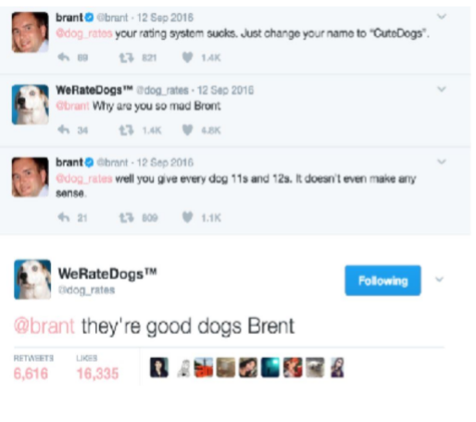

**Well you can see for yourself…why this meme is so popular.**

We rate dogs always give rating to its every dog post, which most of the times is out of 10. Surprisingly, as most of us would think that the numerator of the ratings should be 10 or less, but in reality, it is always 10 or more than that. This is because WeRateDogs believe that every dog deserves at least 10/10 rating or more than that.



Here is the reason .

This page has over 6 million followers and has received international coverage. One of the many times it received coverage was when a man who tried to humiliate this page saying its rating system is not right and screwed. He was shut up in a very humorous way by the comment ‘They’re good dogs Brent’. This post grew a lot popular and can throw anyone into laughter.



The reason for the popularity of this account is thus clearly visible from all of these posts and more.

So what do these ratings do? Which dog breed is most common in dog’s dataset? What is the favourite count of this page over time? What are the average ratings by dog types? Here we have performed some analysis of the data of this page. Let us us see our insights and visualisations and know more about this WeRateDogs.

1. **Most Rated Dogs**

We analysed about 1600 tweets of we rate dogs out of 6000+ posts of this page.

We found out that **Golden Retriever** was the most rated dog with 142 ratings. You can see it in the graph.

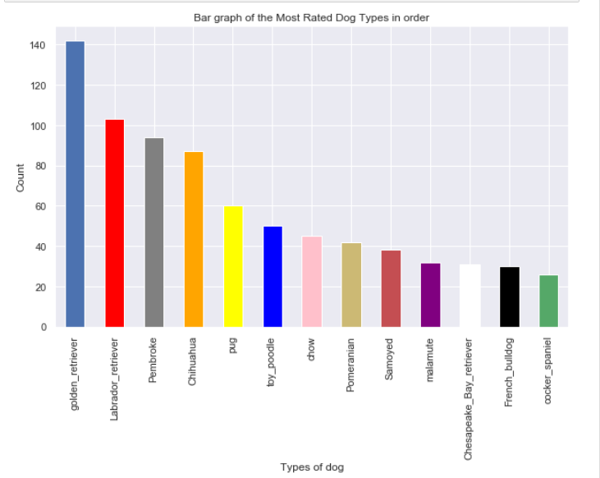

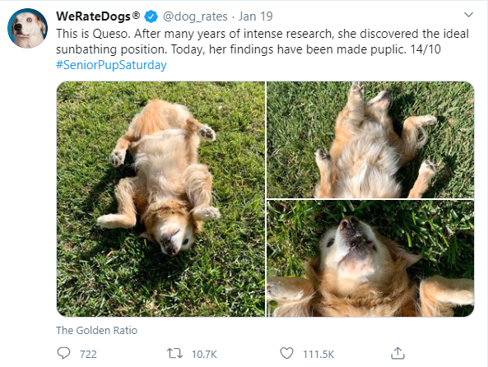

1. **Lowest Average rating among dog types**

Most of the dogs on this page have rating of 10 or above but this is an exception, Japanese spaniel has the lowest average rating of 5. It is quite interesting to know why this dog is so less rated.

Can you tell?

One of the most rated dogs is golden retriever with rating of about 11.586, you must have seen above why.

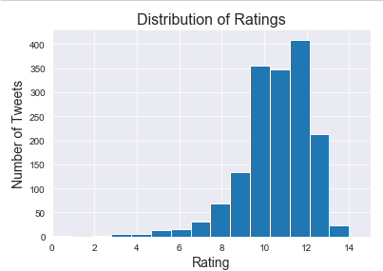

1. **Relation between retweet counts and rating**

We can notice that retweets are mostly less than 10000 for various ratings. But few posts have huge retweets few crossing more than 40000 benchmark. Overall, the relationship between ratings and retweets is not clear.

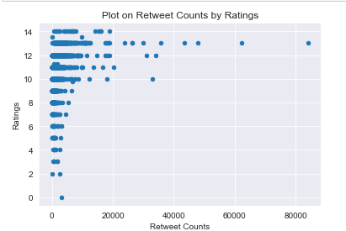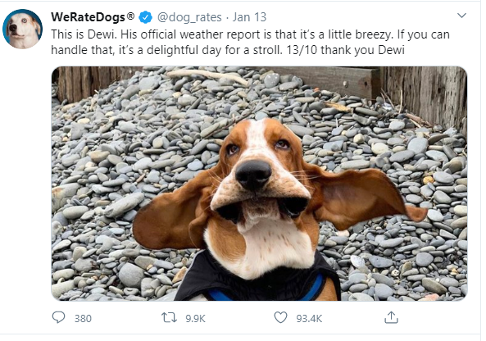

1. **Variation of favourite count with time**

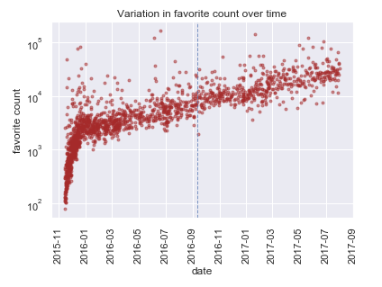

Favourite count of the tweets in the WeRateDogs page increased rapidly between November 2015 and January 2016. The page first few tweets in November had only around 100 favourite counts. By January most of the tweets would receive more than 3000 favourites. This signifies that page has gained significant popularity within this time period. Afterwards, there has been a steady increase over time. The date of origin of the "they're good dogs Brent" meme is represented by the dash line. It seems that the appearance of the meme does not really affect the rate of increase in favourite count.

1. **Variation of favourite count with time**

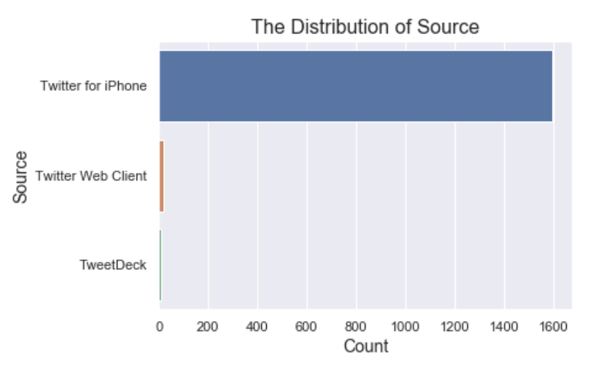

A plot was maded as showed up which tells us about the distribution of source. We can see that ,maximum no of source of tweets is from iPhone twitter app, which are about 1600 (95%) in the total. That means the twitter app for iphone is the main channel for people using to tweet, retweet, post, and others, while the TweetDeck and Twitter Web Client is pretty rare whch seems to about 10approx. only (less than 1%).