CSC-375 Final Project
Simplified C++ Group Chat System
Spring 2026 | Morehouse College | Operating Systems

1. Project Scope
This simplified version keeps the required folder layout and focuses on a working text-based group chat. The server supports multiple clients, active groups, group switching, recent message history, a thread pool, and a scheduling simulation. Optional audio/video is kept as a separate placeholder so the main project remains manageable.

2. Folder Layout
GroupChat/
├── client/
├── server/
├── shared/
├── tests/
├── logs/
├── diagrams/
├── README.md
├── CMakeLists.txt
└── final_report.docx

3. Required Features Covered
- Clients can join or create groups using /join <group>.
- Messages are broadcast to everyone in the same group.
- Messages include timestamp, sender ID, and group name.
- The server can manage multiple active groups.
- A client can switch groups by joining a different group.
- The /list command shows active groups.
- Each group stores recent history in a fixed-size circular cache.
- The server uses a thread pool with Round Robin or SJF task selection.

4. OS Concepts

Threads and Synchronization
The server accepts network clients and submits message work into a fixed thread pool. Shared group state is protected using std::mutex. The thread pool uses std::condition_variable, which lets worker threads sleep while the task queue is empty.

Scheduling
Round Robin mode uses FIFO order. SJF mode prioritizes shorter messages first by using message length as an estimated cost. This is an application-level scheduling simulation; the real operating system still schedules the actual CPU threads.

Caching and Memory Limits
Each group owns a fixed-size circular message cache. When the cache is full, the oldest message is evicted. This models limited memory and gives new group members recent history without reading from disk.

5. How to Build and Run
mkdir build
cd build
cmake ..
make
./groupchat_server 5555 rr
./groupchat_client 127.0.0.1 5555

6. Diagrams
Thread architecture
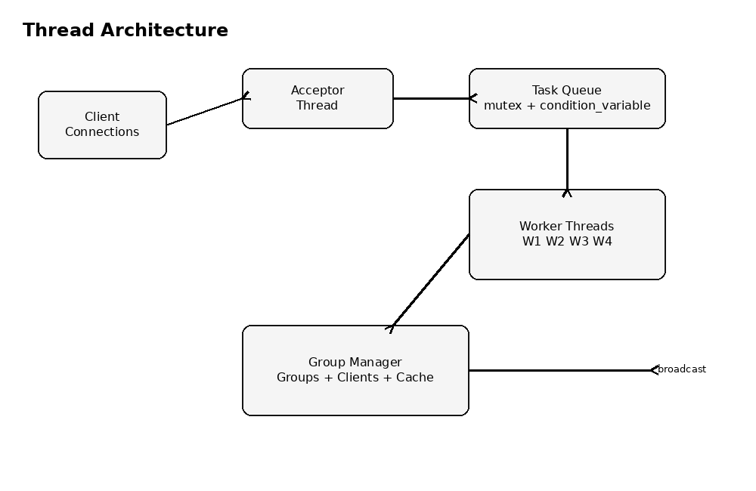
Message flow
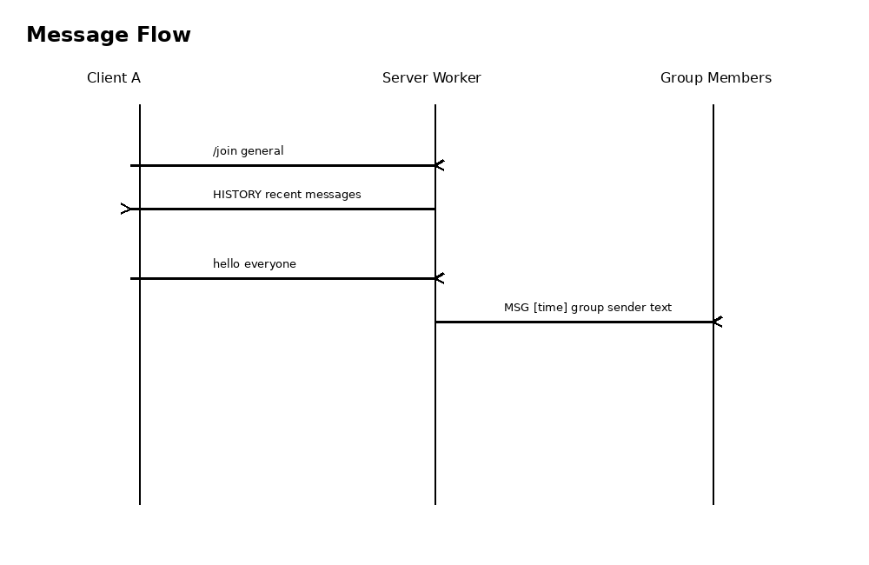
Virtual memory / cache simulation
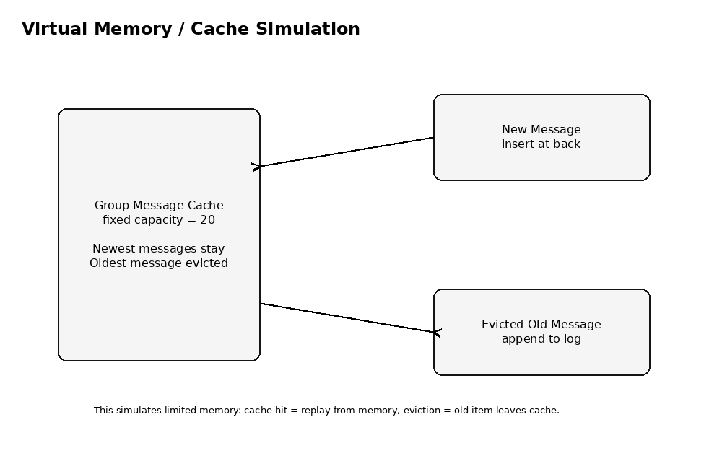
Task queue scheduling
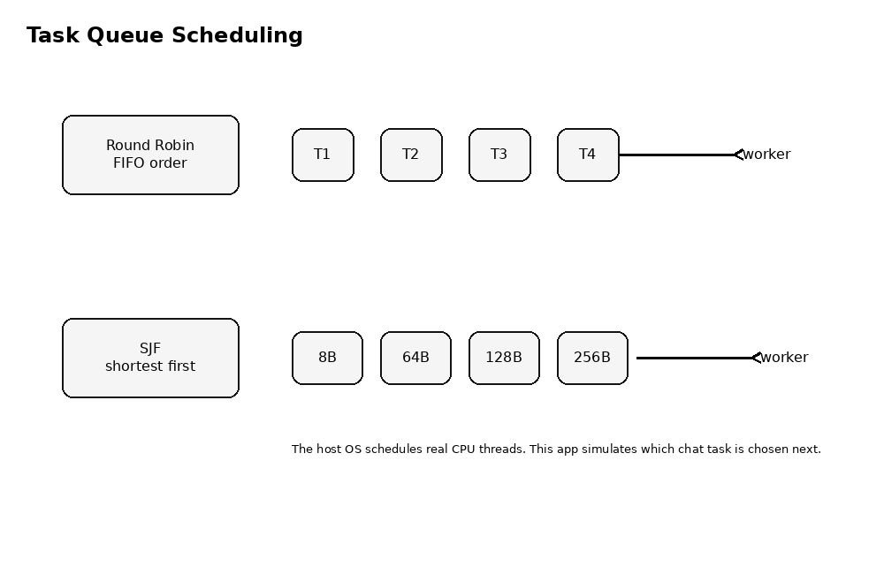

7. Simplification Decisions
The biggest simplification is using readable text commands instead of a fixed binary packet format. This makes debugging much easier while still demonstrating sockets, threads, synchronization, scheduling, and caching. The optional audio/video feature is represented by a stub file that can later be upgraded to send simulated binary chunks.

