Question 1
Data dictionary management defines data, ensuring data quality. This function is important because it ensures the data in the database management system is placed properly
Question 2
Q.2.1 UML Notion
Q.2.2 Many to many relationships, many students can have a seat, and many seats are available to many students.
Question 3
Q.3.1 Normalization is the process where data in table form is simplified to be stored in the database. The objective of normalization is to take real world data and translate it into a database showing the dependencies that exist in a database.
Q.3.2 It is when it is displayed in a dependency diagram, showing transitive dependencies, showing partial dependencies
Q.3.3 when all the transitive dependencies are removed and displayed in separate tables.
Q.3.4 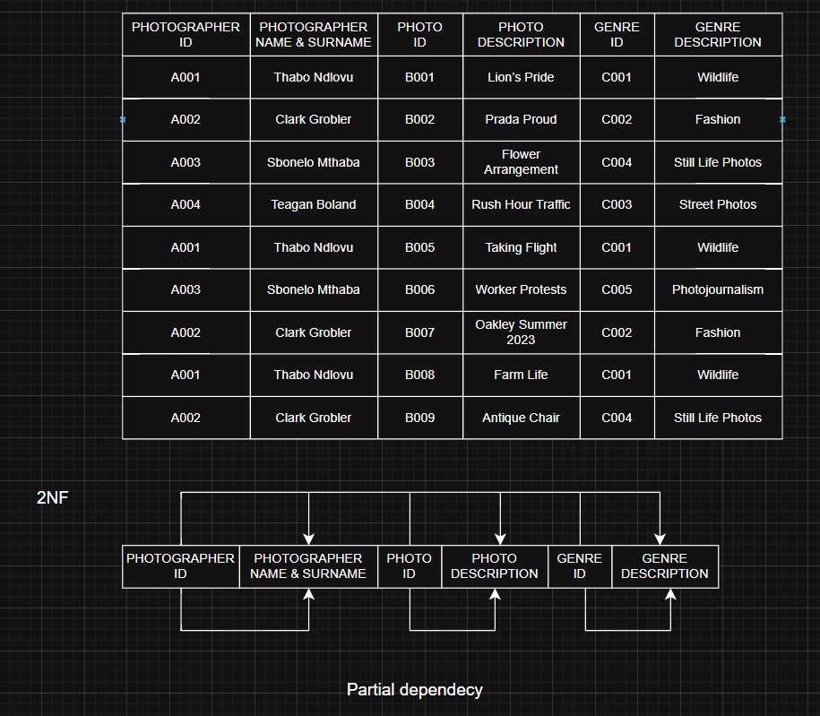

Q.3.5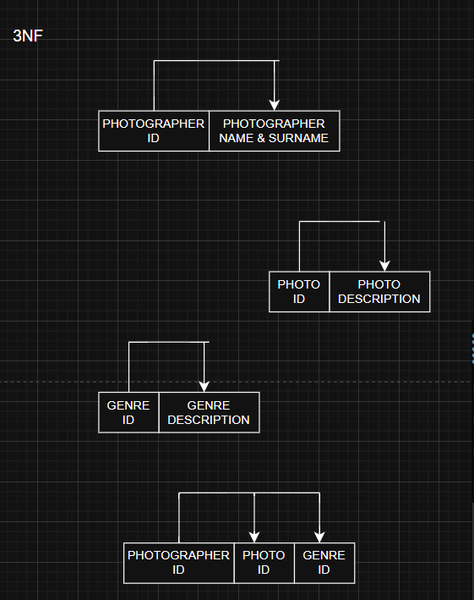

Question 4

