Question 1

Q.1.1 data is the raw details that do not make sense all together. However, information is made up of data to make decisions about the business.
Q.1.2 One advantage of implementing a database management system is that it organizes data. It helps improve productivity. It helps businesses make better decisions. It helps the business to access data quickly.
Q.1.3 Database access language is the code that is used to access data. The language inserts, changes, deletes data. An example of such a language is Structured query Language (SQL).

Question 2

Q.2.1 one and only one owner owns one and only one pet. A pet can have the many owners.
One pet can be many breeds. One and only one breed belongs to a pet.
A bread can belong to many species. One and only one species is a bread.
One and only one pet can create an entry. One entry can include many pets.

Q.2.2.1 One to one relationship because one only one person owns a car and one and only one car can be owned by a person. The multiplicity shows 1..1 on both sides.
Q.2.2.2 one to many relationships. It is because one driver can drive many trucks, one truck can be drive by many drivers.
Q.2.2.3 One to many relationships. One province belongs in one country. One country has many provinces.
Question 3
Q.3.1 ClassID
Q.3.2 Doctor and medication have a many to many relationships resolved by prescription entity. One and only one doctor can Write one prescription. A prescription belongs to many doctors. One prescription is prescribed many medications. One and only one medication can be prescribed in one prescription. One prescription can be for many patients one and only one patient can get one prescription.
Q.3.3.1 No, primary Keys must be unique and Modise is repeated.
Q,3.3.2 No. like primary keys, secondary keys must be unique, and Johannesburg is repeated.

Question 4
Q.4.1 Binary Relationship diagram has 2 entities; unary relationship involves one entity.

Q.4.2 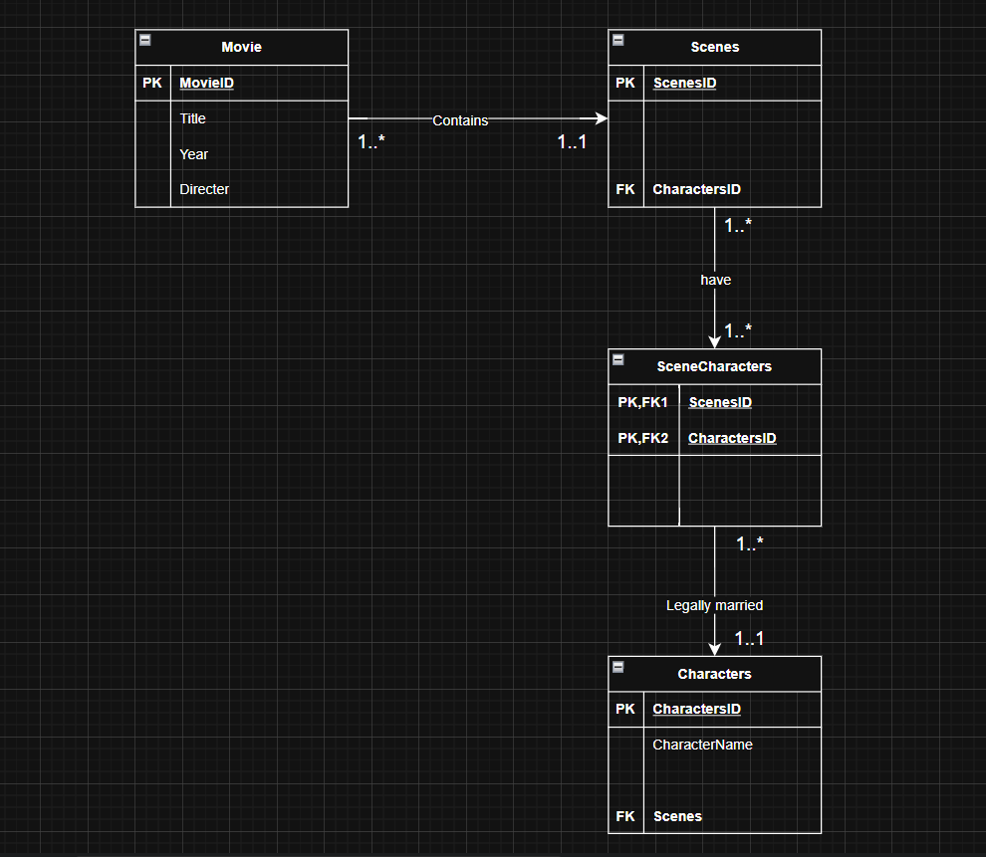
Question 5

Q.5.1 Second normal form takes real world data and normalise data done by creating dependency diagrams. identifying transitive dependencies, partial dependencies between tables and relationships and resolved partial dependencies. Third normal form removes transitive dependencies and separates tables.
Q.5.2.1 unnormalised, it is in UML and not displayed in a dependency diagram. It should be in a table form to create the dependency diagrams.
Q.5.2.2 Second normal form, because it is displayed as a dependency diagram. Showing partial and transitive dependencies. It can be normalized further which makes it second normal form.
Q.5.2.3 First normal form, it is in table form and is not in dependency diagram, there are 2 more steps to be normalized to third normal form. No dependencies are identified and showed.
Q.5.3 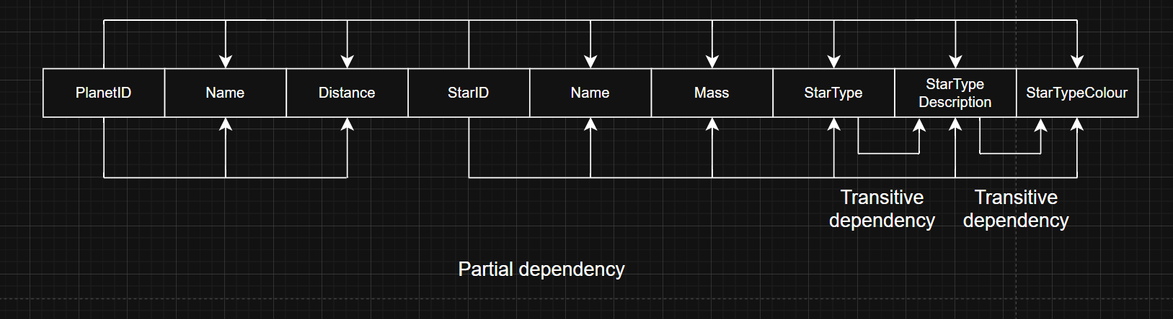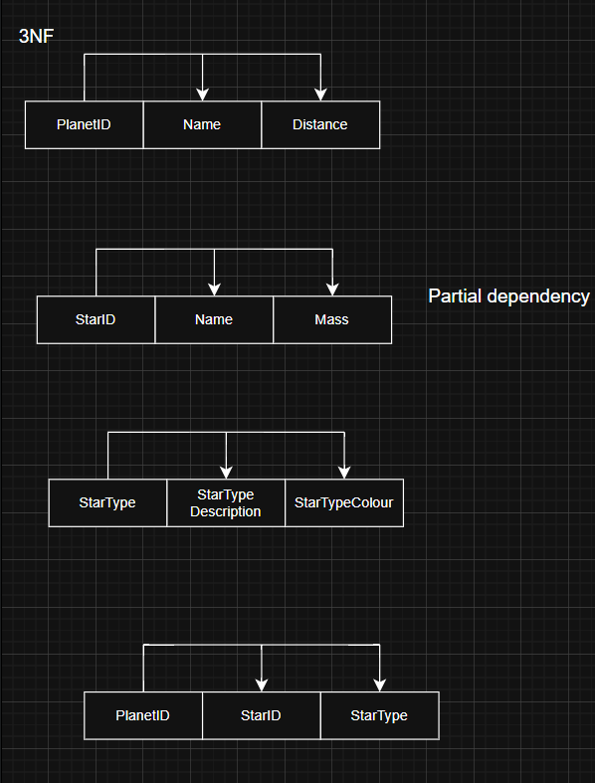

Q.5.4
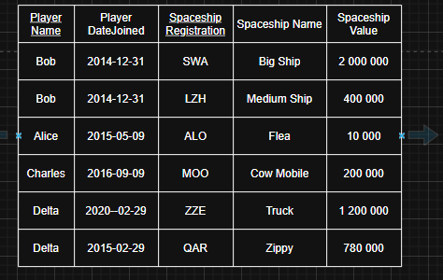
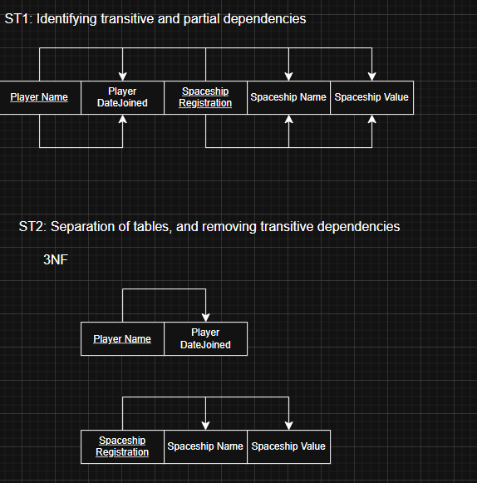
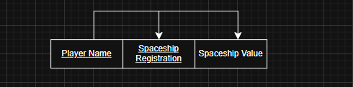

Question 6
Q.6.1.1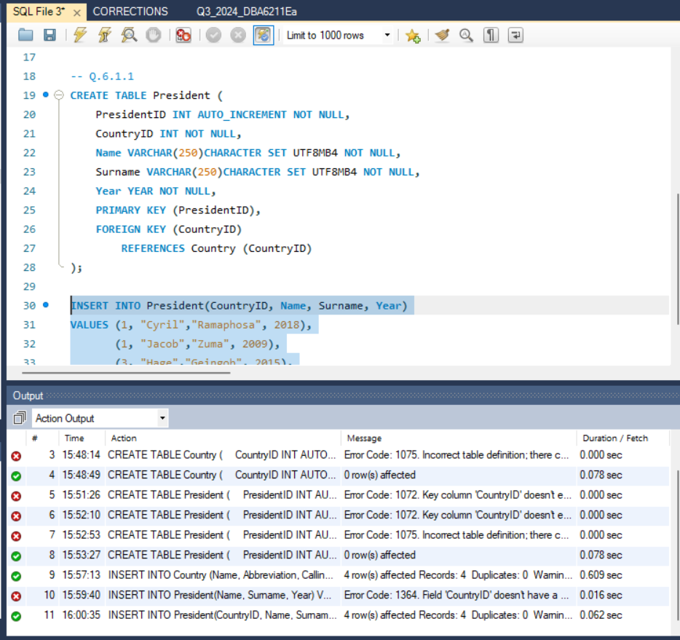

Q.6.1.2
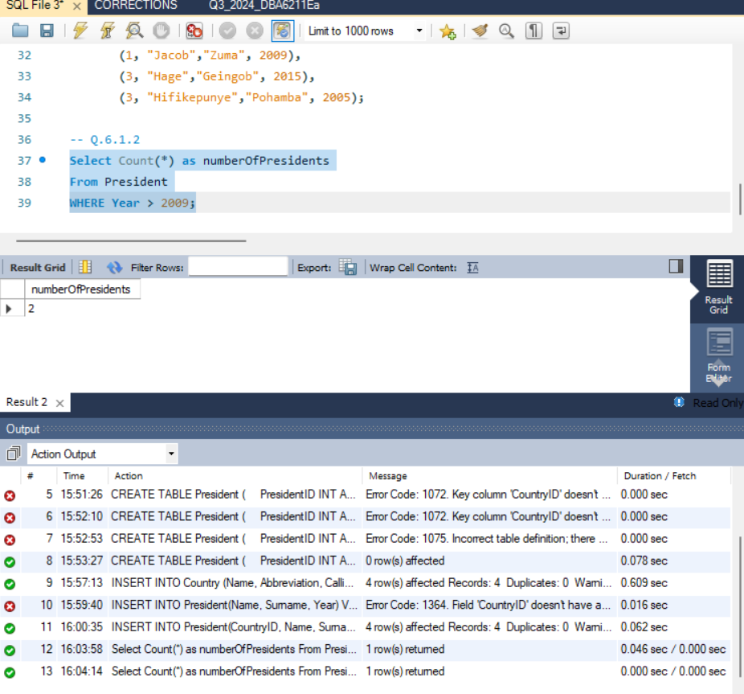

Q.6.1.3
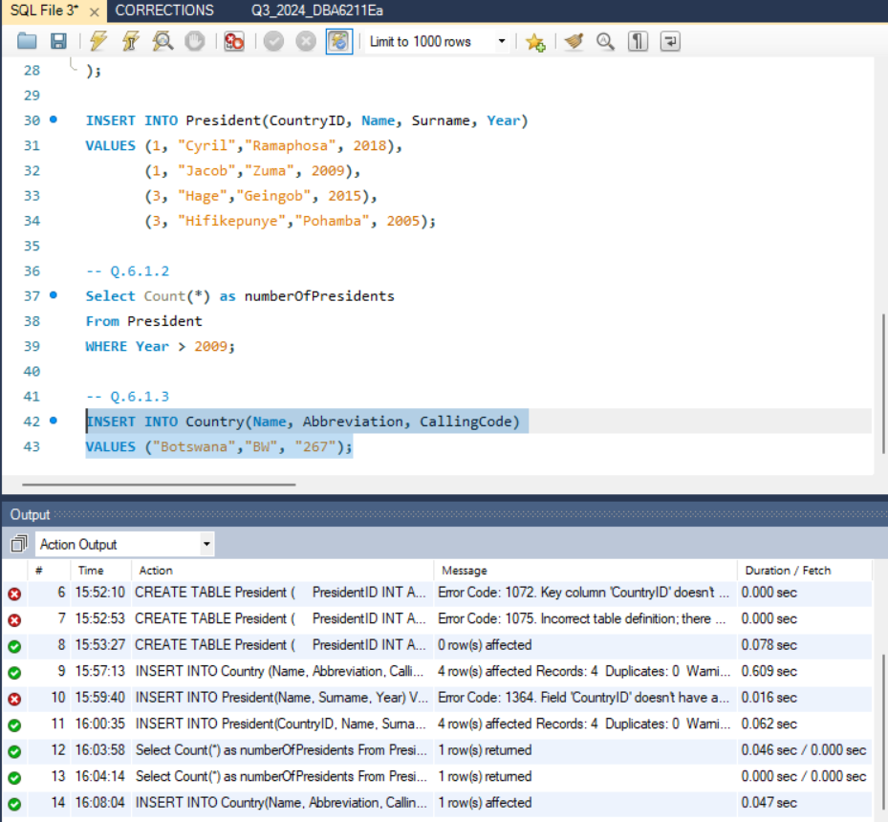

Q.6.1.4
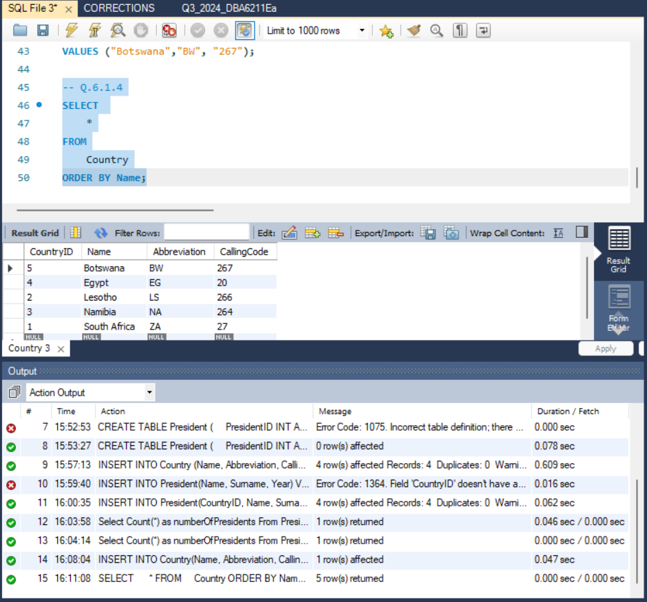

Q.6.1.5
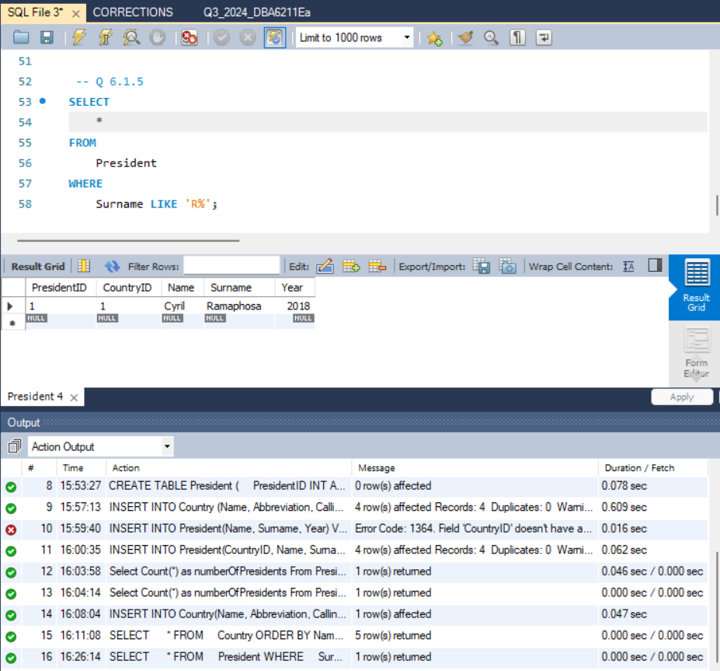

Q.6.1.6
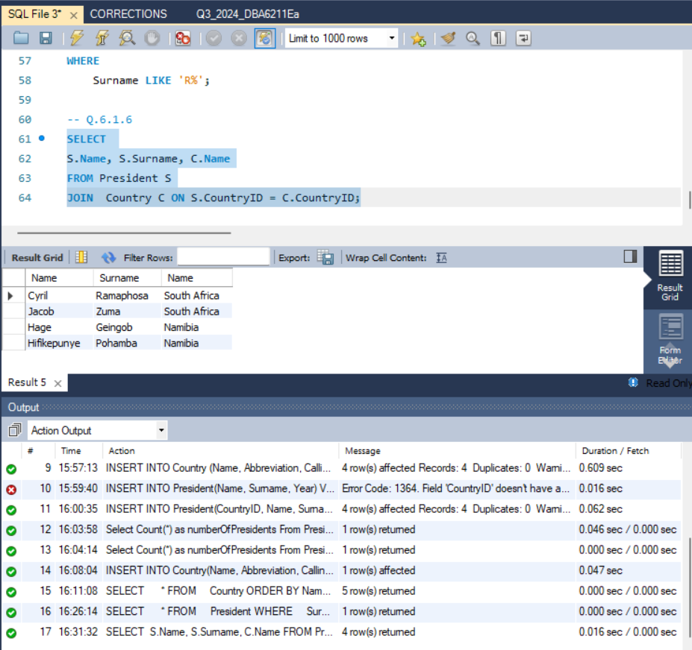

Q.6.2 The WHERE clauses help to give a list with specific data, with limits
Where having checks for data that has data of a specific datatype.

Q.6.3 An index of a SQL database is to list data in categories

Q.6.4.1 It would put Name into the Judge table with a value of Abe
Q.6.4.2 It shows all the columns from judge, the count of cases from the courtcase table being grouped by judgeID, with the number of cases that’s more than or equal to 2.
Q.6.4.3 deletes the table Judge

