Question 1
Q.1.1 Data governance is the ethical use and working with data. Follow guidelines to ensure that data is not illegally shared. While data quality refers to keeping the data secure, consistent. It means
Q.2.2
Question 2
Q.2.1 business rules are the things that guide how data is stored in a database. In the design process it helps to ensure the data is logically stored and makes it easier to acquire data quickly. It is essential to have robust and good databases that help the businesses solve problems and assist with decision making.
Q.2.2 a) one Medication belongs to a category. Each category belongs to a medication
b) A book can have multiple Book numbers. A unique book number is assigned to each book.
Q.2.3 software independence improves fault tolerance.

Question 3
Q.3.1 data models help define and structure the database.
Q.3.2 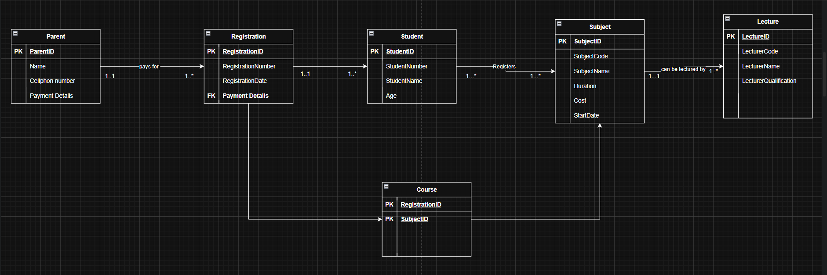

Question 4
Q.4.1
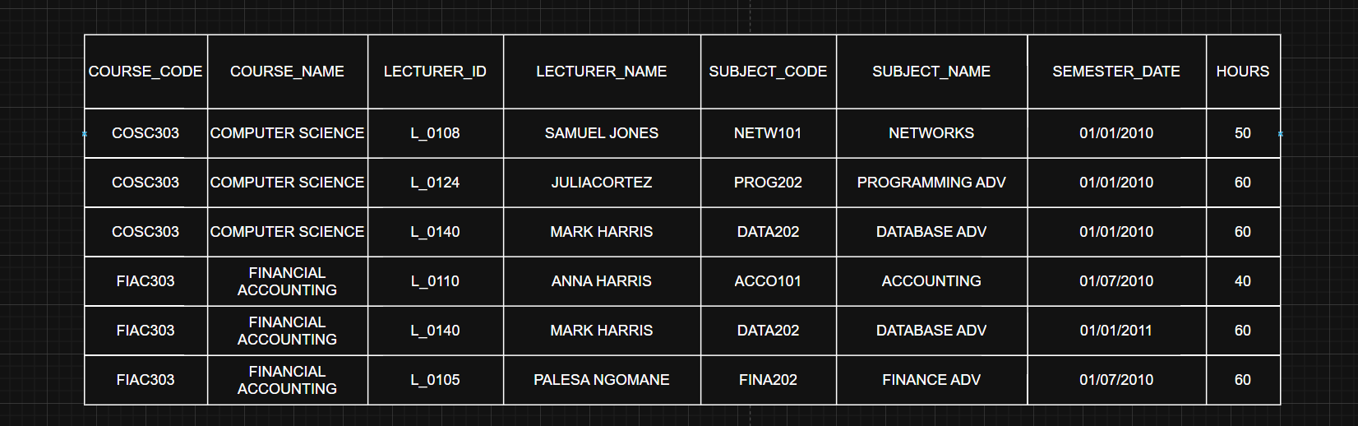
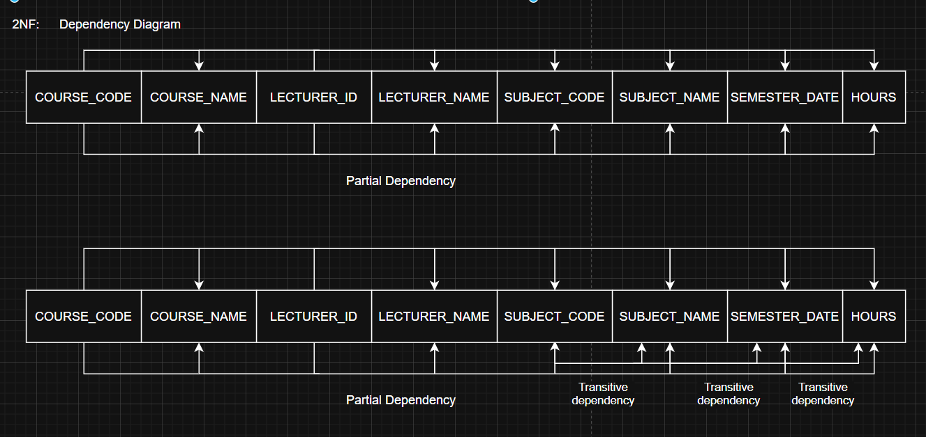
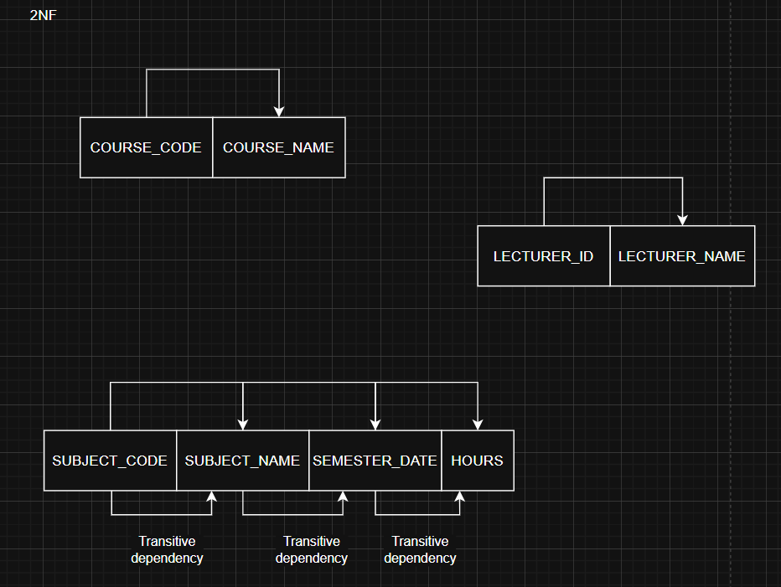
Q.4.2 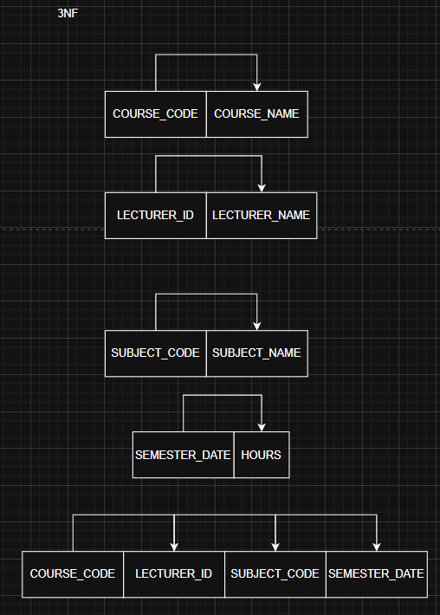
Question 5
Q.5.1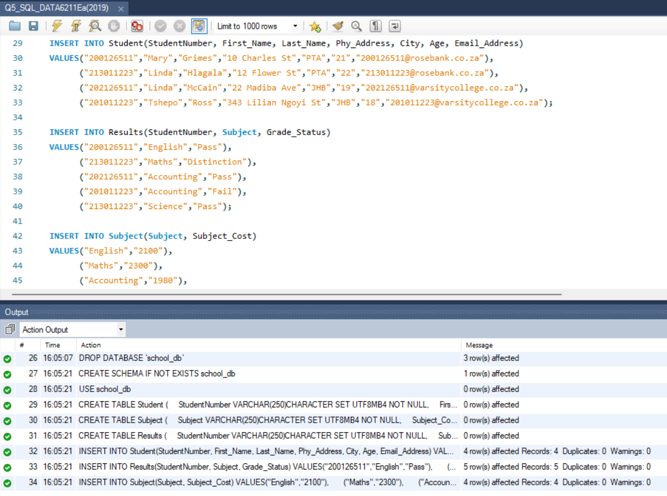
Q.5.2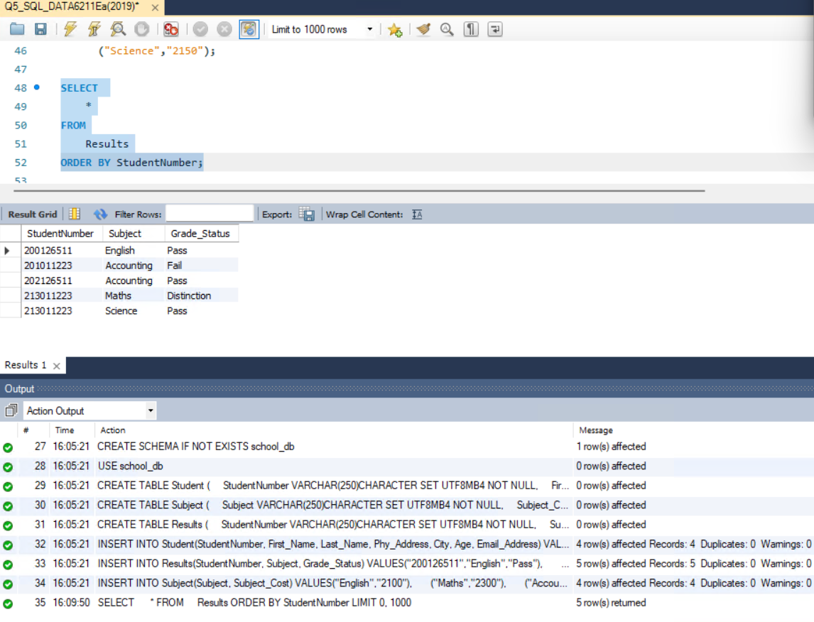
Q.5.3 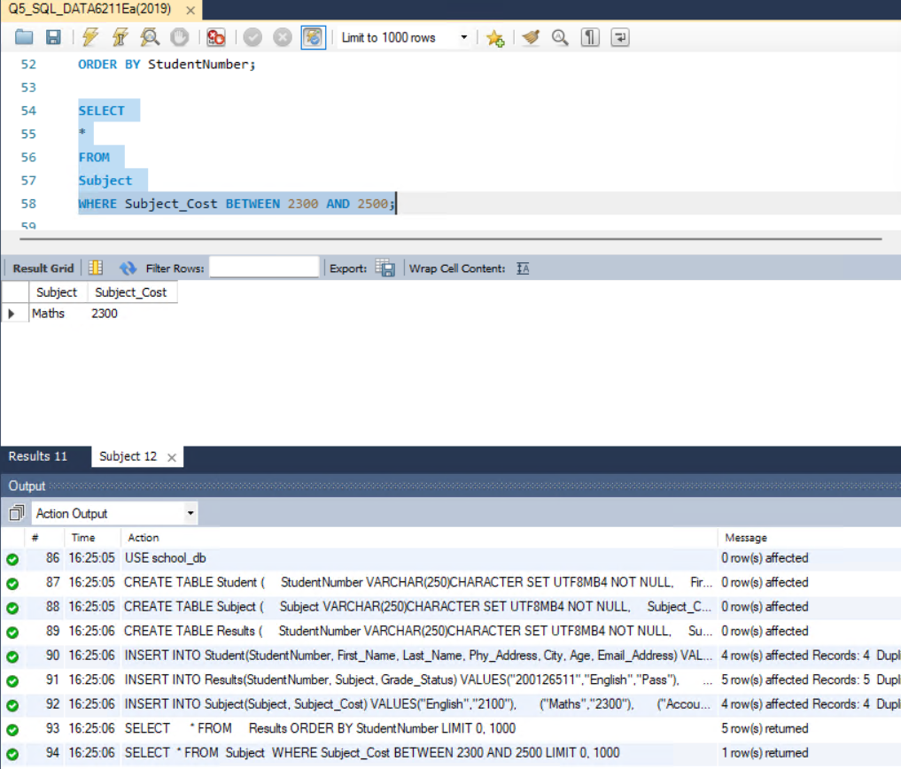
Q.5.4 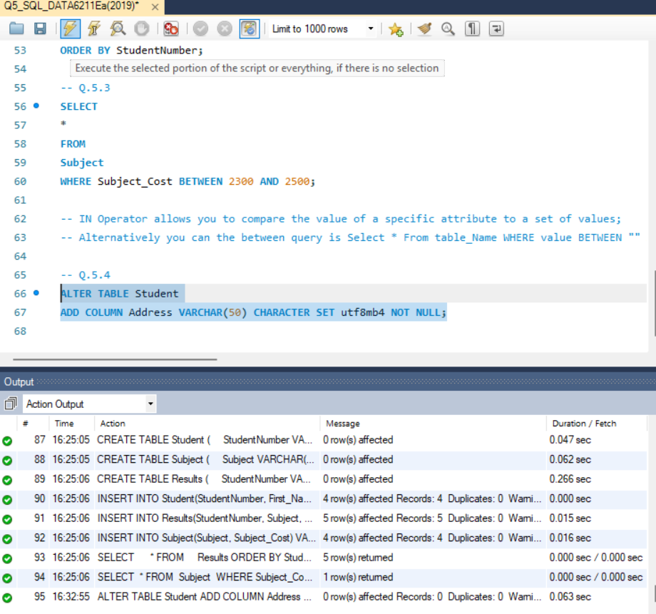
Q.5.5 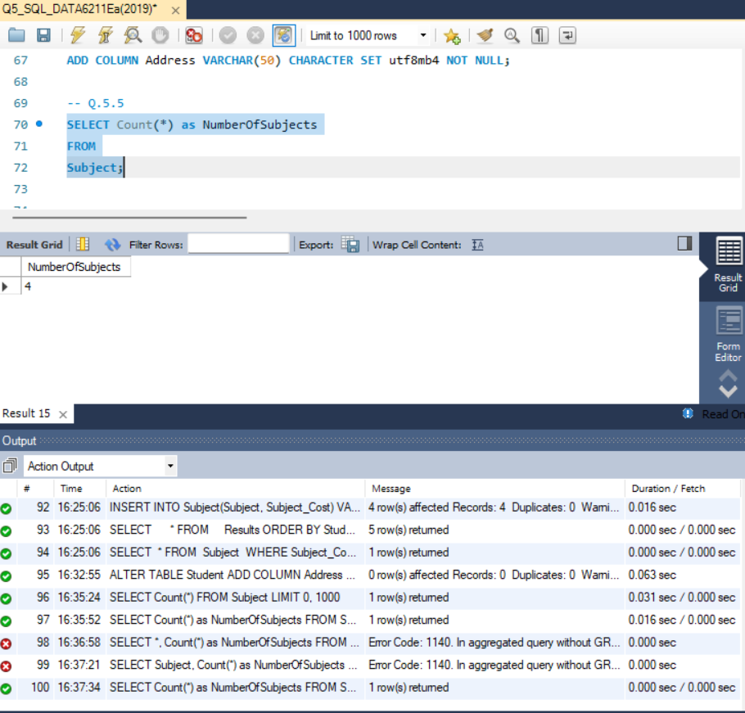
Q.5.6 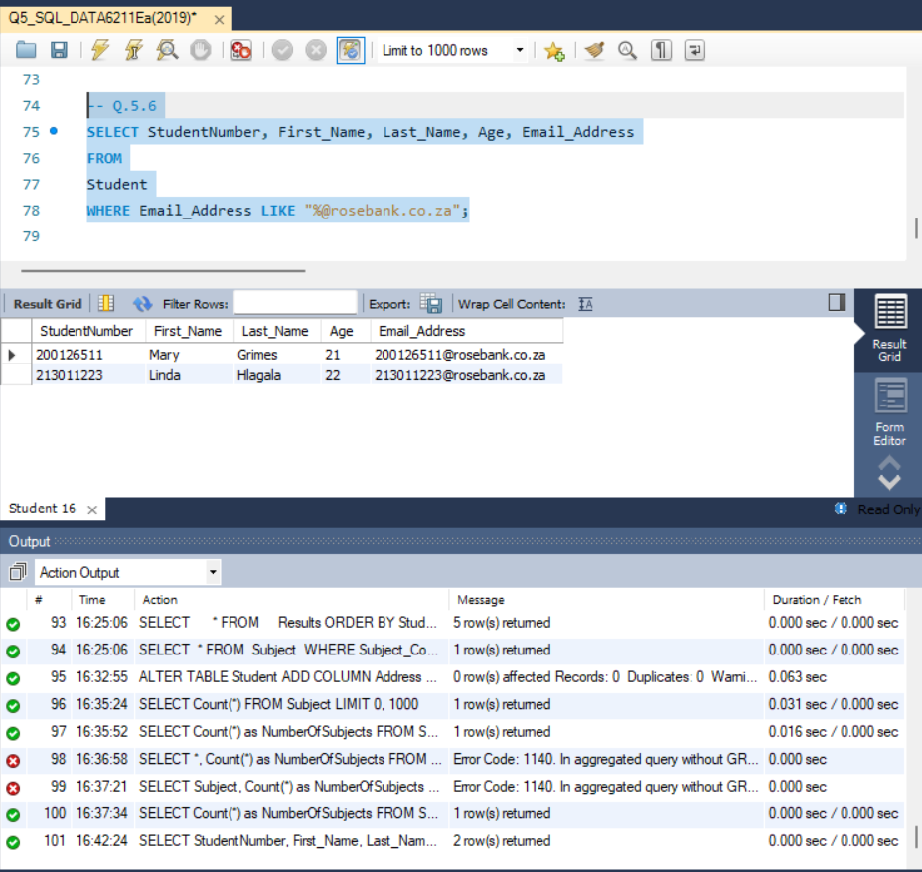
Q.5.7 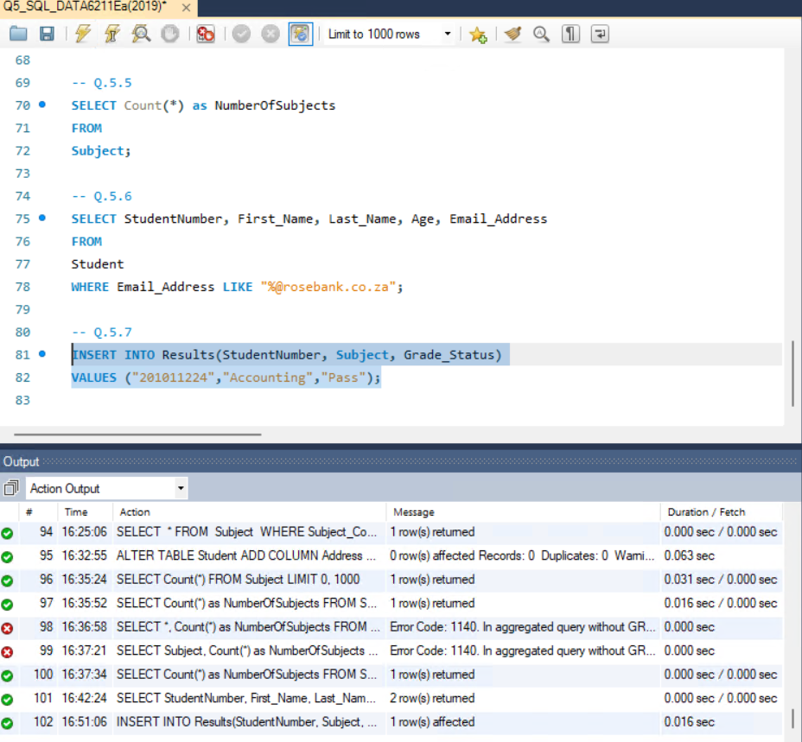
Q.5.8 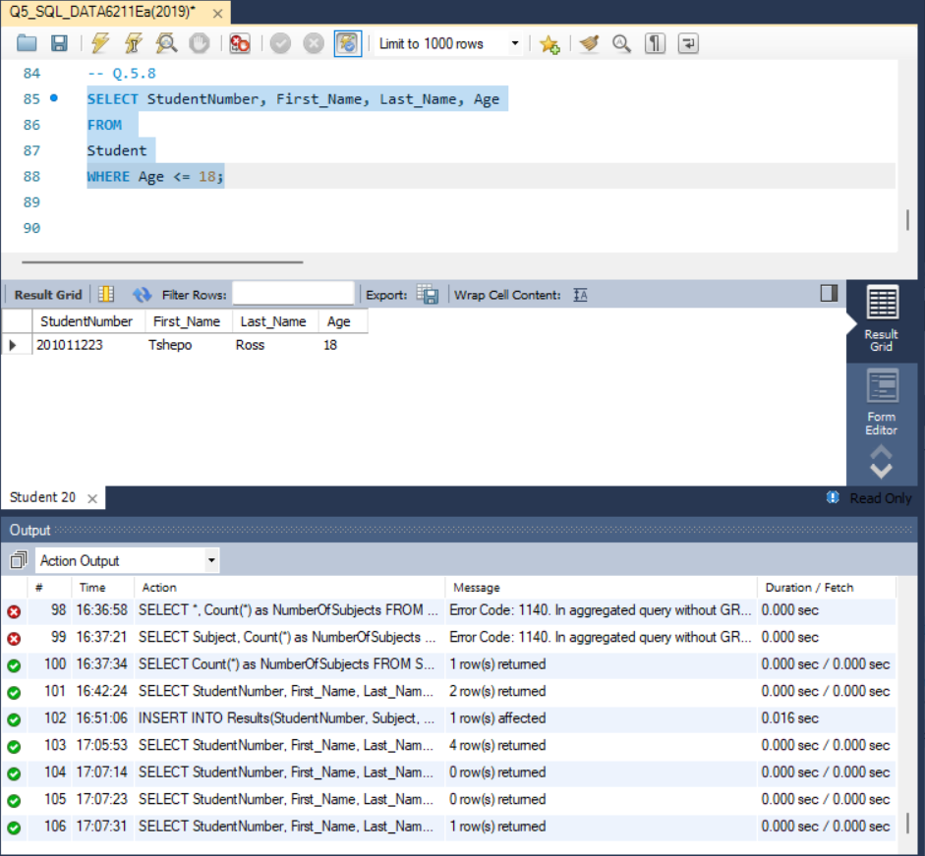
Q.5.9 