Complexity of Single-Trial EEG Responses Distinguishes Reported from Unreported Near-Threshold Visual Stimuli
An exploratory analysis of a public EEG dataset (OpenNeuro ds005273)
Author: Luvneet Kahlon | August 2026

Abstract
Whether conscious perception is associated with more ordered, more random, or more complex neural activity is a long-standing open question in consciousness research. This project used a public EEG dataset (OpenNeuro ds005273; Rodriguez-San Esteban et al.) in which participants viewed near-threshold visual stimuli (Gabor patches) and reported whether they consciously perceived them, alongside catch trials with no stimulus and separate suprathreshold localizer trials. After reverse-engineering undocumented event codes and validating a full preprocessing and trial-labeling pipeline against the original published behavioral results, permutation entropy and Lempel-Ziv (LZ) complexity were computed for single-trial EEG, comparing physically identical, consciously reported (“Seen”) trials against unreported (“Unseen”) trials of the same near-threshold stimulus. In a 300–600ms post-stimulus window, LZ complexity was significantly lower for Seen than Unseen trials across all 11 subjects tested (Wilcoxon signed-rank, W = 0, p = 0.00098; FDR-corrected p = 0.00195), an effect that survived statistical control for trial-level signal amplitude. Permutation entropy showed no consistent difference between conditions. Extending the comparison to suprathreshold localizer trials revealed a temporal pattern rather than a simple monotonic relationship: obvious, easily-detected stimuli showed their own low-complexity signature earlier (0–400ms), while near-threshold stimuli that were ultimately reported showed a distinct low-complexity signature later (300–600ms), with no group differing significantly after 600ms. These results suggest that conscious detection of a stimulus is associated with a time-limited, stereotyped local neural response whose timing depends on stimulus strength or difficulty, not a generic or fixed increase in disorder, and that this effect is distinct from, and should not be conflated with, complexity differences associated with global consciousness state (e.g. anesthesia, sleep).

1. Background and Motivation
A recurring question in consciousness research is whether subjective conscious experience corresponds to a distinctive statistical signature in neural activity, and if so, whether that signature reflects greater order, greater randomness, or greater complexity (a related but distinct property from either). These are not interchangeable: a purely random signal can have high entropy while containing no meaningful structure, and a highly patterned, low-entropy signal can still be described as complex if it reflects rich underlying organization. Distinguishing between these possibilities requires a dataset in which conscious perception is manipulated while holding the physical stimulus constant.
This project used a within-subject, trial-level design well suited to that question: participants viewed brief, faint Gabor patches individually calibrated to be detected on roughly half of trials, then reported both the stimulus orientation and whether they subjectively saw it at all. Because the physical stimulus is the same near-threshold intensity across “Seen” and “Unseen” trials, differences in neural activity between the two conditions can be attributed to whether the stimulus reached conscious report, rather than to differences in the stimulus itself.
This is an important scoping point: this design manipulates awareness of a single, brief sensory event, not global consciousness level. Participants were awake and conscious throughout, aware of the screen, the fixation cross, and the response buttons, in both conditions. The comparison is therefore local and event-specific, not a comparison between conscious and unconscious brain states in the sense used in anesthesia or sleep research. This distinction matters for interpreting the results (see Section 6.1).

2. Dataset
Data were drawn from OpenNeuro dataset ds005273, “Neural representation of consciously seen and unseen information” (Rodriguez-San Esteban et al., Scientific Reports, 2025), 63-channel EEG recorded at 1000Hz from subjects performing a near-threshold Gabor detection task (https://openneuro.org/datasets/ds005273/versions/1.0.0).
Each trial consisted of a brief (50ms) Gabor stimulus or no stimulus, followed by a pattern mask and a response phase in which participants reported (1) the perceived orientation of the Gabor and (2) whether they subjectively saw it (“Visto”/“No visto”). Blocks were of two types: localizer blocks (suprathreshold, easily visible stimuli, included as a validation check) and experimental blocks (individually titrated near-threshold stimuli, targeting ~50% detection rate). Each experimental block contained 40 present and 20 absent trials.
The dataset's public metadata (README, event descriptions) did not document the meaning of its raw trigger codes. These were reconstructed using the original authors' own published preprocessing code and cross-referenced against the raw trigger stream from one subject's data before any trial-level analysis was attempted.

3. Methods

3.1 Preprocessing
EEG data were processed in Python using MNE-Python. For each subject: EOG artifact reduction via regression, notch filtering at 50/100/150Hz (line noise and harmonics), automated bad-channel detection (RANSAC, pyprep), spherical-spline interpolation of bad channels, and average referencing. Data were epoched from –2.0s to +2.0s around stimulus onset, baseline-corrected (–200 to 0ms), and resampled to 256Hz. One channel (the online reference electrode) had no usable scalp position in the dataset's electrode coordinate file and was excluded from spatial interpolation and subsequent analysis.
Raw trigger codes were decoded into trial-level labels (stimulus present/absent × reported seen/unseen × perceived tilt direction) using logic adapted from the original authors' published recoding function.

3.2 Phase 1 Validation
Before any neural analysis, the recovered trial labels were validated against the original paper's reported behavioral statistics across 11 subjects (excluding subjects the original authors flagged as unusable, and one additional subject excluded for an atypically high false-alarm rate; see Section 3.4).
Metric | This analysis (n=11) | Published
Localizer, Present, % reported seen | 93–100% (range) | ~97.4%
Localizer, Absent, % false alarm | 0–3% | ~1.9%
Experimental, Present, % reported seen | 17.5–65.8% (range, mean ~48%) | ~49% (SD ~13.5%)
Experimental, Absent, % false alarm | 0.5–13.1% | ~7.2%
Localizer-block detection rates closely matched published values across all subjects, confirming correct event decoding and epoch labeling. Experimental-block detection rates varied across subjects as expected given individually titrated, near-threshold stimulus intensities, and averaged close to the published sample mean.

3.3 Entropy and Complexity Measures
Two single-trial measures were computed per channel and averaged across channels for each trial:
Permutation entropy: quantifies the unpredictability of the ordinal pattern of the signal (order=3, delay=1, normalized). Captures general signal unpredictability without regard to compressibility or structure.
Lempel-Ziv complexity: quantifies the compressibility of the signal after median binarization (normalized). Lower values indicate a more repetitive, structured, compressible signal; higher values indicate a less structured, more effectively random signal.
Both measures were computed using the antropy Python package on experimental-block, stimulus-present trials only (excluding absent trials, which do not permit a Seen/Unseen comparison on identical physical input), comparing Seen against Unseen trials.

3.4 Subject Selection
Eleven subjects were analyzed (subject IDs 10, 12–16, 19–23), excluding subjects previously flagged as unusable by the original authors (11, 24, 26, 38) and one additional subject (18) excluded here due to an atypically high experimental-block false-alarm rate (30.8%, versus 0–13% for all other subjects and ~7.2% published average), suggesting possible task disengagement or a response-mapping problem.

4. Results

4.1 Time Window Selection
Rather than selecting a single post-stimulus window, three windows were tested: an early window (0–300ms, dominated by low-level feedforward visual processing common to both conditions), a mid window (300–600ms, overlapping the timing of the P3 component classically associated with conscious access in near-threshold detection paradigms), and a late window (600–1000ms, overlapping motor-preparation and response-related activity).

4.2 Lempel-Ziv Complexity: Seen vs. Unseen
Window | LZ–variance r | Seen vs. Unseen (residualized) | p-value
0–300ms | –0.23 (weak) | Not sig. (6/11 negative) | 0.966
300–600ms | –0.17 (weak) | Significant (10/11 negative) | 0.00195
600–1000ms | –0.41 (moderate) | Not sig. (7/11 negative) | 0.102
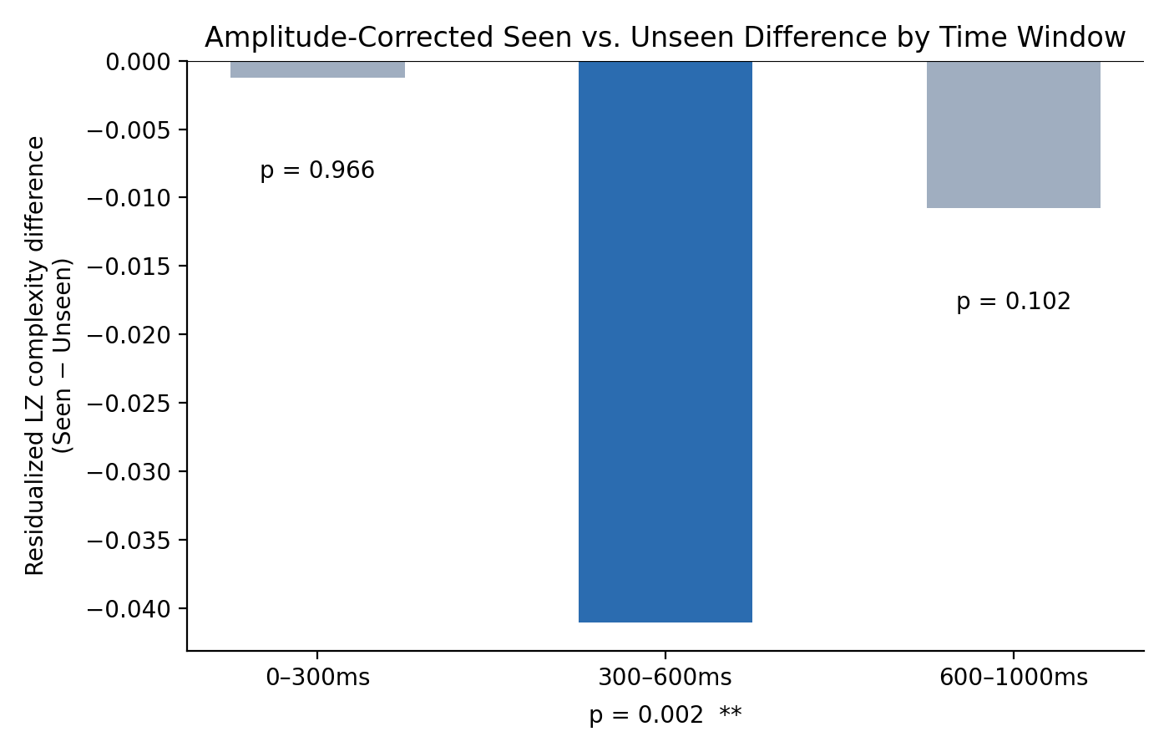
Figure 1. Amplitude-corrected (residualized) Seen minus Unseen difference in LZ complexity, by time window. The effect is significant only in the 300–600ms window (p = 0.002), overlapping the classic timing of the P3 component.
In the 300–600ms window, LZ complexity was significantly lower for Seen than Unseen trials (mean Seen = 0.834, mean Unseen = 0.870; Wilcoxon signed-rank on the full, non-residualized comparison: W = 0, p = 0.00098, FDR-corrected p = 0.00195 across the two measures tested). Every one of the 11 subjects showed the same direction of effect (Unseen > Seen), the maximally consistent result possible for a sample of this size under this test.
This effect was not attributable to a simple amplitude difference between conditions. Although trial-level signal variance was also modestly higher in Seen trials (Wilcoxon p = 0.024), the direct trial-level correlation between LZ complexity and variance was weak (r = –0.148 to –0.230 across windows, explaining roughly 2–5% of variance in LZ). After statistically removing the portion of LZ complexity explainable by trial-level variance (per-subject linear residualization), the Seen/Unseen difference in the 300–600ms window remained significant (10/11 subjects, p = 0.00195), while the same procedure eliminated the (non-significant) apparent differences in the early and late windows.
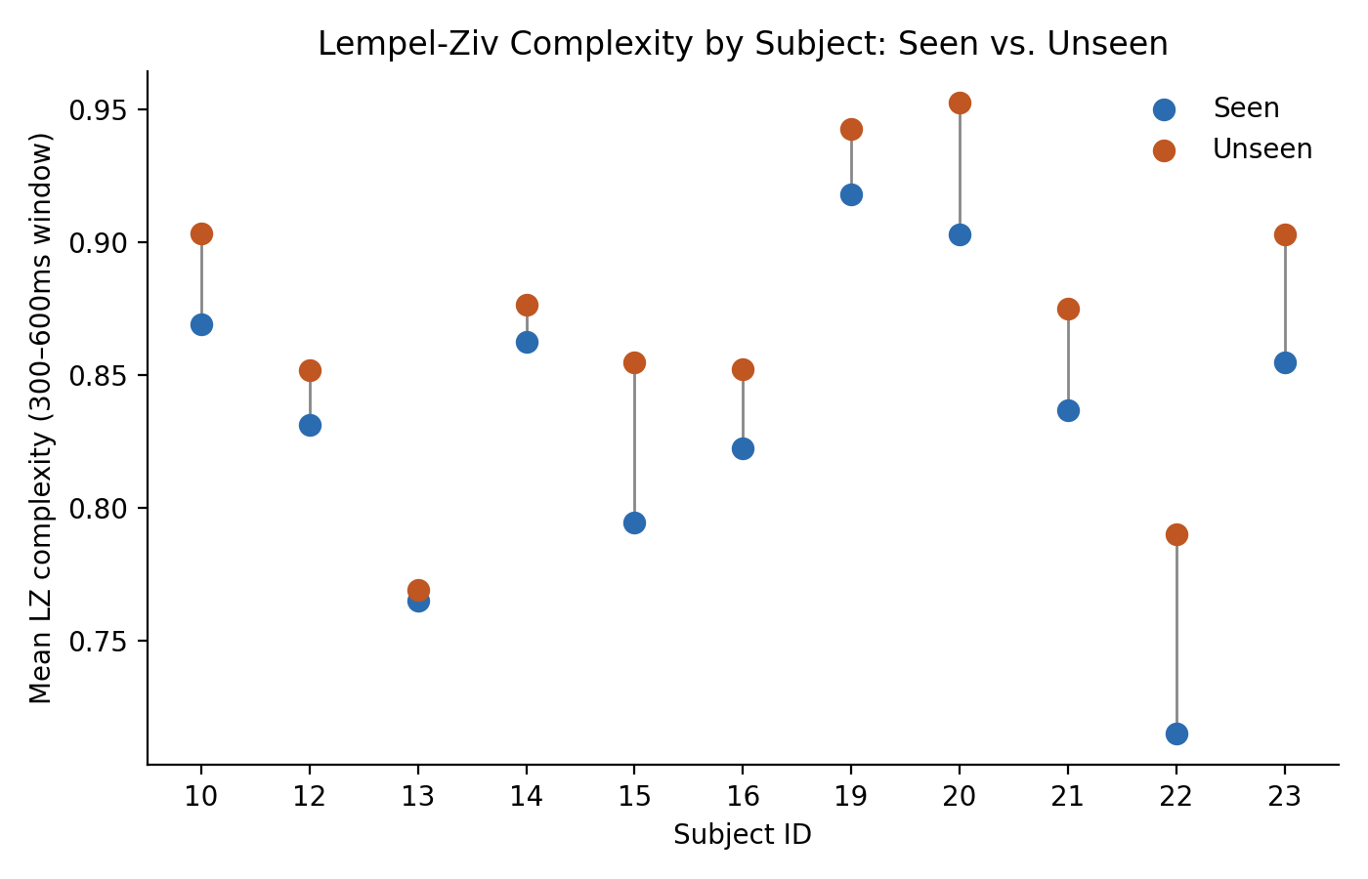
Figure 2. Mean Lempel-Ziv complexity (300–600ms window) for each of the 11 subjects, Seen versus Unseen. Every subject shows the same direction of effect (Unseen > Seen), the maximally consistent result possible under a Wilcoxon signed-rank test at this sample size.

4.3 Permutation Entropy: Seen vs. Unseen
Permutation entropy showed no consistent difference between Seen and Unseen trials: subject-level differences were small (range: –0.0025 to +0.0047) and inconsistent in direction across the sample (6 of 11 subjects positive, 5 negative), with no evidence of a systematic effect.

5. Extension: Comparing Against Obvious (Localizer) Stimuli
A natural question is whether the Seen/Unseen complexity effect generalizes beyond the near-threshold experimental condition: does an obvious, confidently perceived stimulus (localizer block, suprathreshold contrast) show an even lower complexity signature than a near-threshold but consciously reported stimulus? A monotonic prediction would be: Localizer Seen < Experimental Seen < Experimental Unseen, with complexity decreasing as detection becomes more certain.
This prediction could not be tested as a simple Localizer Seen vs. Localizer Unseen comparison, because localizer miss trials (stimulus present but not reported) are rare (often 0-3 per subject, since localizer stimuli are suprathreshold and detected 93-99.5% of the time), too few for a reliable per-subject average. Comparing Localizer Present trials against Absent trials was also avoided, since this would confound awareness with stimulus presence. Instead, three groups sharing a Present, physically-real stimulus were compared: Localizer Present+Seen, Experimental Present+Seen, and Experimental Present+Unseen.

5.1 Single-Window Result (300-600ms)
In the original 300-600ms window, a Friedman test confirmed the three groups differ overall (chi-squared = 8.91, p = 0.012). Pairwise comparisons showed a result contrary to the monotonic prediction: Experimental Seen, not Localizer Seen, had the lowest complexity (mean = 0.892, vs. Localizer Seen mean = 0.909, vs. Experimental Unseen mean = 0.937). Localizer Seen vs. Experimental Seen was not significant on its own (p = 0.206) and trended in the opposite direction from the generalized prediction, while both Experimental Seen vs. Unseen (p = 0.00195) and Localizer Seen vs. Experimental Unseen (p = 0.024) were significant in the predicted direction.

5.2 Temporal Map: Where Does Each Group's Signature Emerge?
To understand this result, the three-group comparison was repeated across eight time windows spanning 0-1000ms post-stimulus, testing whether each condition's complexity signature emerges at a different time rather than assuming a single fixed window.
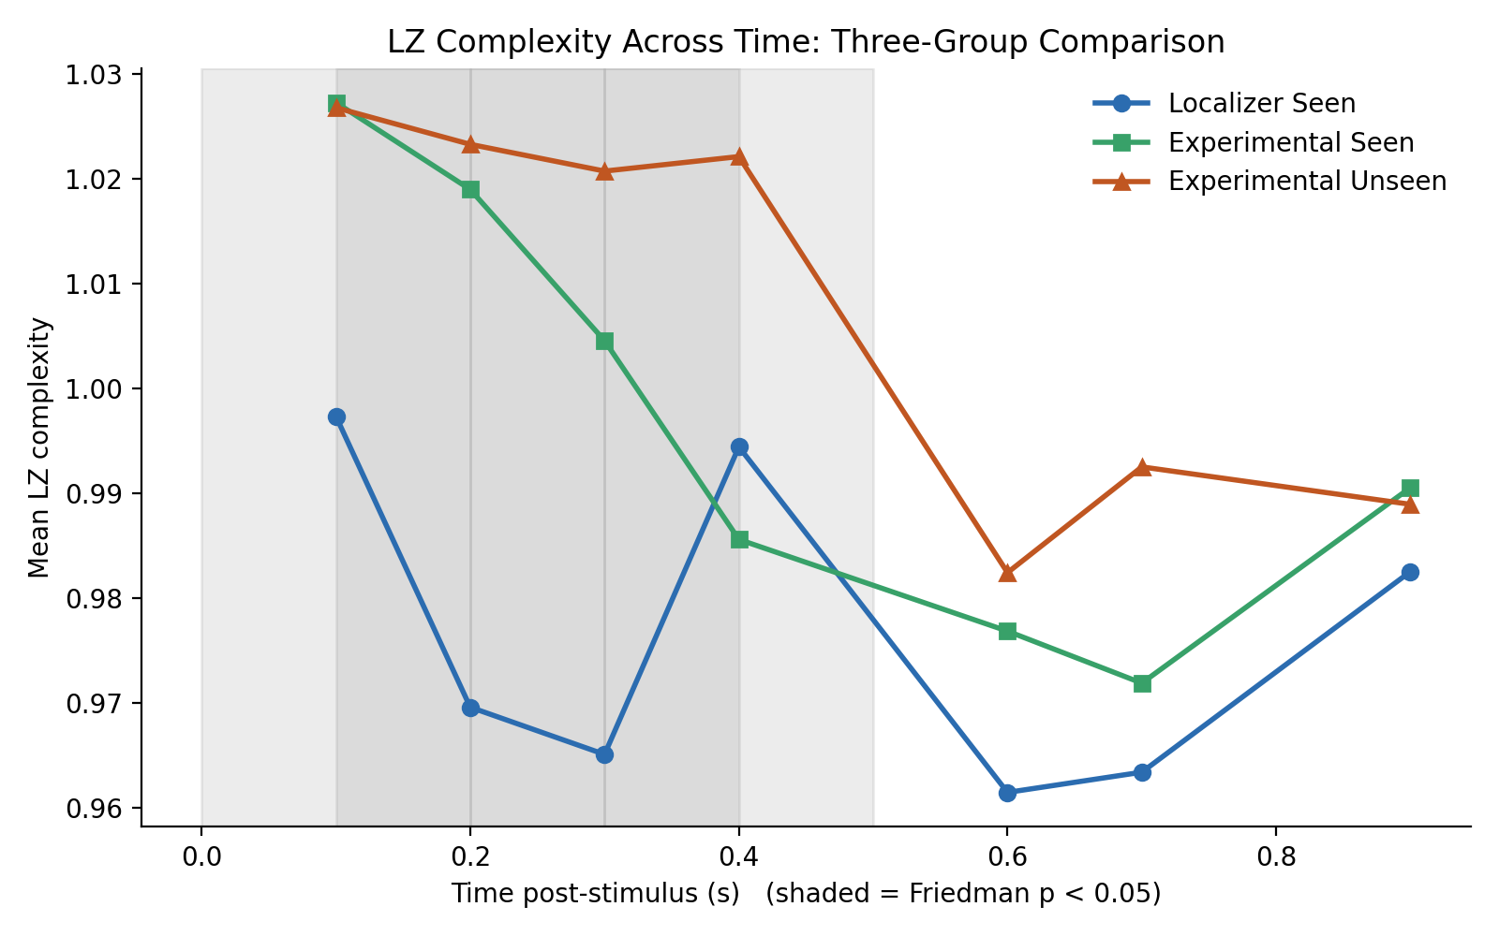
Figure 3. Mean LZ complexity for all three groups across sequential time windows post-stimulus. Shaded regions indicate windows where the three groups differ significantly overall (Friedman p < 0.05). Localizer Seen shows the lowest complexity early (0-400ms); Experimental Seen and Localizer seen converge and cross specifically around 300-500ms, after which no group is significantly differentiated.
The temporal map reveals a clear, orderly pattern. In every window from 0-400ms, Localizer Seen has the lowest complexity of the three groups, consistent with an easy, high-contrast, suprathreshold stimulus producing a fast, stereotyped early response. Experimental Seen and Experimental Unseen remain close together and elevated relative to Localizer Seen through this same early period. Between roughly 300-500ms, Experimental Seen's complexity drops sharply, crossing below both other groups and becoming the lowest of the three, coinciding with the window in which the original Seen/Unseen effect was found. After 600ms, none of the three groups differ significantly.
This pattern is consistent with obvious, suprathreshold stimuli being resolved quickly (producing an early, low-complexity signature that near-threshold stimuli, seen or unseen, do not yet show), while near-threshold stimuli that are ultimately consciously reported take longer to resolve into a comparably structured neural response, arriving roughly 100-200ms later. This offers a partial revision to the account in Section 5.1: the low-complexity signature is not simply a marker of conscious detection in general, but appears to track the point in time at which a stimulus, easy or difficult, is resolved into a stereotyped response, with that timing depending on stimulus strength or difficulty.

5.3 Note on Window Length
An attempt to narrow these windows further (to 100ms) was made to localize the effect more precisely, but produced noisier, less consistent results, with several previously significant windows falling below threshold and the pattern becoming less orderly. This is consistent with a known property of Lempel-Ziv complexity: the measure requires a long sample to produce a stable estimate, and windows below roughly 200ms (around 25-50 samples at the 256Hz resampled rate used here) appear to introduce enough estimation noise to obscure an otherwise real effect. This is a measurement stability limitation rather than evidence against the effect itself; the 200-300ms windows used for the primary temporal map (Section 5.2) represent a reasonable balance between temporal resolution and estimate stability. Whether a larger subject sample would recover a stable narrow-window signal is an open question for future work: more subjects would reduce between-subject noise in the group-level comparison, but would not directly reduce the trial-level estimation noise inherent to computing LZ complexity on a very short sequence.

6. Discussion

6.1 What This Finding Does and Does Not Show
The central result, lower LZ complexity for consciously reported than unreported near-threshold stimuli, specifically in a 300–600ms window and independent of amplitude, should be interpreted narrowly. This is a within-subject, trial-level, single-event comparison: participants were awake and conscious throughout the experiment, in both conditions. The manipulation was whether one brief, faint stimulus reached conscious report, not whether the participant was globally conscious or unconscious.
This distinction matters because a substantial body of prior work, particularly the Perturbational Complexity Index (PCI) literature (Casali et al., 2013, and related work), finds the opposite relationship at the level of global consciousness state: LZ complexity is consistently lower during anesthesia, deep sleep, and disorders of consciousness, and higher during wakefulness. Other work has similarly found greater EEG signal diversity associated with more meaningful, richly perceived stimuli. The present finding should not be read as contradicting that literature, because it addresses a different question: not “is the brain in a conscious state,” but “does a specific stimulus that reaches conscious report produce a different local, event-related complexity signature than one that does not.” Conflating these two levels of comparison would be a misreading of these results.

6.2 A Plausible Mechanistic Account
One interpretation consistent with the temporal specificity of this effect (present at 300–600ms, a window overlapping the classic P3 component, but absent earlier and later) is that consciously reported stimuli are associated with a more stereotyped, reproducible neural event, broadly consistent with “ignition” accounts of conscious access (e.g. Dehaene and colleagues), in which a stimulus crossing into conscious report triggers a distinctive, comparatively uniform neural response, while a stimulus that does not reach report fails to trigger this event and the surrounding activity more closely resembles unstructured ongoing background activity. Under this account, lower LZ complexity for Seen trials reflects the presence of a consistent, repeatable response component, not a general reduction in brain “randomness.” This account is offered as the most parsimonious explanation consistent with the observed timing, not as an established conclusion. Section 5 refines this account further using the localizer comparison and temporal map.

6.3 Limitations
Several limitations should temper interpretation. First, the sample size (11 subjects) is modest; while the effect was maximally consistent in direction (11/11 subjects for the primary result), a larger sample would allow more precise effect-size estimation and subgroup analysis. Second, complexity and entropy measures were averaged across all 62 channels, which may obscure spatially specific effects (e.g. posterior/occipital versus frontal channels); channel- or region-resolved analysis is a natural extension. Third, only one complexity measure (LZ) and one entropy measure (permutation entropy) were tested; other measures (e.g. sample entropy, multiscale entropy, fractal dimension) may behave differently and were outside the scope of this analysis. Fourth, the residualization approach used to address the amplitude confound is a simple linear correction; more sophisticated approaches (e.g. explicitly modeling evoked-response amplitude as a covariate in a mixed-effects framework) could provide a more rigorous test.

7. Future Directions
Several extensions follow naturally from this analysis:
Channel/region-resolved analysis: testing whether the complexity effect is spatially localized (e.g. posterior visual regions versus frontal regions), which would further support or constrain the “ignition” interpretation.
Additional complexity/entropy measures: extending to sample entropy, multiscale entropy, and fractal measures to test whether the pattern generalizes across different formalizations of “complexity.”
Larger sample: extending analysis to the full available subject pool (up to ~29 usable subjects in the source dataset) to increase power and enable more granular subgroup comparisons (e.g. by orientation-report accuracy, splitting “unseen” trials into correct and incorrect orientation judgments), and to test whether a larger sample recovers a stable signal at narrower time windows (see Section 5.3).
Surprise / prediction-error paradigms: a natural next test of the “ignition” account is whether the complexity signature associated with conscious detection is specific to awareness, or is better explained by the strength/stereotypy of the evoked response regardless of awareness. A dataset manipulating expectation or surprise (independent of awareness) alongside conscious report would help disentangle these possibilities. If a consciously perceived but fully expected stimulus shows the same low-complexity signature as a surprising one, this would support an awareness-general account; if surprising stimuli show a distinct signature, it would suggest the effect is partly driven by prediction-error processing rather than awareness per se.

8. Data and Code Availability
All analysis code is available at [GitHub link]. Raw and derivative EEG data are not redistributed here; the source dataset is publicly available at https://openneuro.org/datasets/ds005273/versions/1.0.0 under its original OpenNeuro license terms.
Event-code recoding logic was adapted from the original authors' publicly released preprocessing code (Rodriguez-San Esteban et al., GitHub repository accompanying the associated publication). This project's preprocessing pipeline, trial-table construction, entropy/complexity computation, and statistical analysis were independently written and are not part of the original authors' published analyses.

9. References
Rodriguez-San Esteban, P. et al. Neural representation of consciously seen and unseen information. Scientific Reports (2025).
Casali, A. G. et al. A theoretically based index of consciousness independent of sensory processing and behavior. Science Translational Medicine (2013).
Dehaene, S. & Changeux, J.-P. Experimental and theoretical approaches to conscious processing. Neuron (2011).

