**git init**

**git status and .gitignore**

**git add**

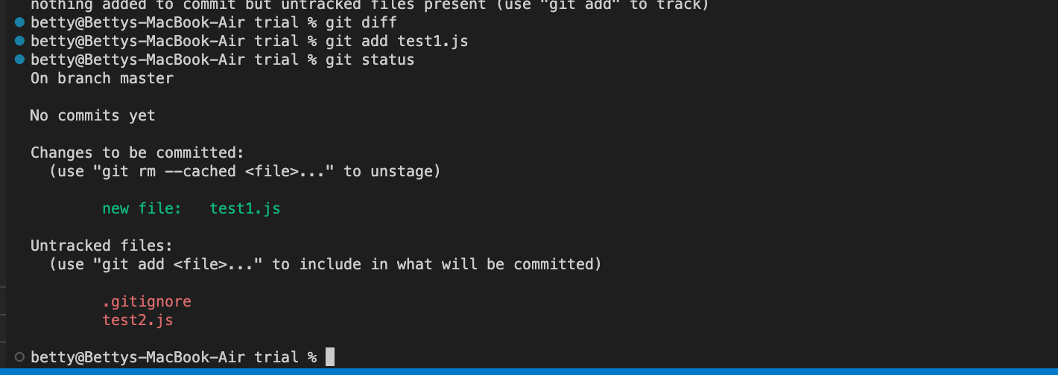

**“git add** .” : adding all files to staging area

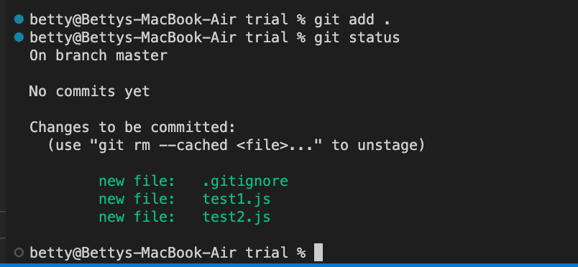

**git diff**

**git commit -m**

**git commit –amend :** changes the last commit message

**git log**

**git config alias status**

**git tag**

**git branch**

**git checkout**

**git merge**

**git merge:** with conflict

**merge conflict**

**fixing the merge**

**git revert**

**git branch -d**

**git reset**

