SSC 441

GROUP12(Ciao) Lab 01

Group Member: Wangpeng Xie; Yueling Zhang; Qiting Guan; Luwei Jiang

***Exercise 1:***

The scatterplot between engine size and fuel efficiency shows that as the fuel efficiency increase the engine size decrease. Therefore, it shows an intuitive relation between the fuel efficiency and engine size.

The scatterplot between class and drv is a useless chart, due to both of these variables are types, we could not see the relation between these two variables in the chart.

**Displ & Hwy Class & Drv**

***Exercise 1b:***

Base on the different class of each cars we can find out the main distribution for them. In the other hand, we can find the relation between these three elements and give a reasonable analyze.

In conclusion, for people with different needs, they can use this form to determine which one is more suitable for them.

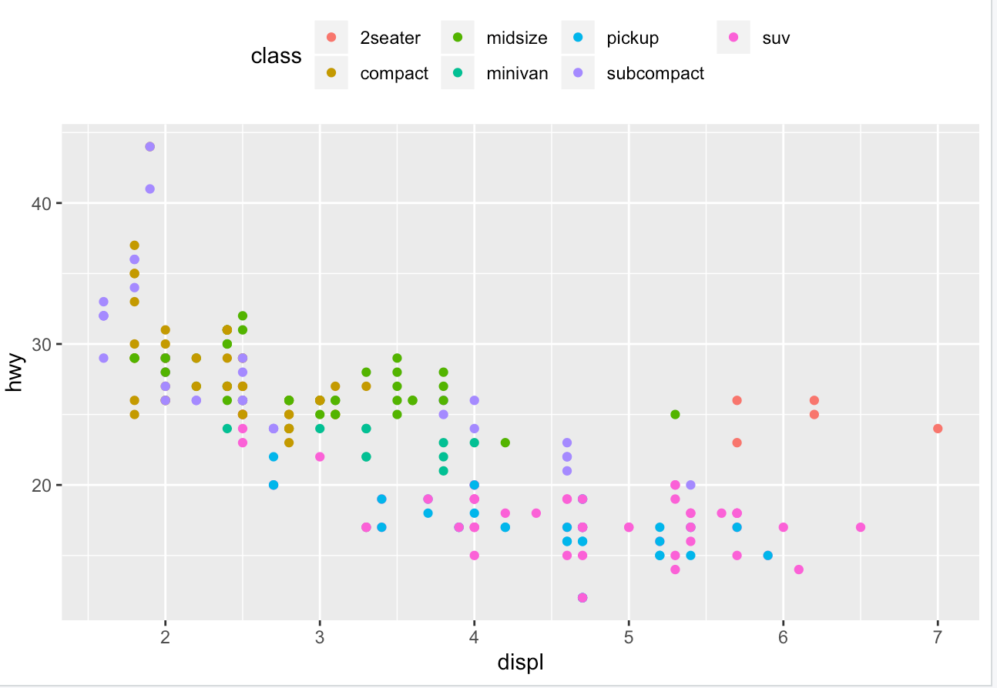

**Engine size & Fuel Efficiency & Class**

***Exercise 2:***

This graph shows if people gets loan or not in different jobs.

1. Data shows entrepreneur is the major group who is going to loan for their business.
2. Student become the smallest group in loan.
3. From the data, I can analyze that entrepreneur will loan to expand their business size. People who does not want loan should in jobs with stable income and does not need to worry about income resource(who does not have a business).

This graph shows the housing status of people who have different jobs.

1. First, we can find retired people and people who are blue-collar are two major groups having house.
2. Also, retired workers also is the major group does not have house.
3. Housing sales should more targeting in retired workers and blue-collar. Technician should also be the target to become a house owner.