Comic WorkStation — Multi-Agent Story and Illustration Workshop

Main Agents:

1. ScriptWriterAgent: Use Deepseek-chat model to draft story segments with explicit image markers to guide illustrations.
2. RefinerAgent: Compresses each prompt to ~10–12 high-signal keywords; applies
CharacterMemory + SceneMemory for identity and setting consistency; normalizes style tokens.
3. ImageGeneratorAgent: Locally uses diffusers.StableDiffusionPipeline with ogkalu/Comic-Diffusion-v2(a famous diffusion model); sequential generation; consolidated negative prompts to suppress blur, extra fingers, text/watermarks, logos; supports seed control and identity-weighting.

Implementation Highlights:

· Short English prompts with identity tokens for character consistency across panels.
· Unified negative prompt policy to reduce common diffusion artifacts.
· Sequential image generation for stability and reproducibility; quality modes tuned with higher steps/CFG by default.

Results (screenshot from three different novels):
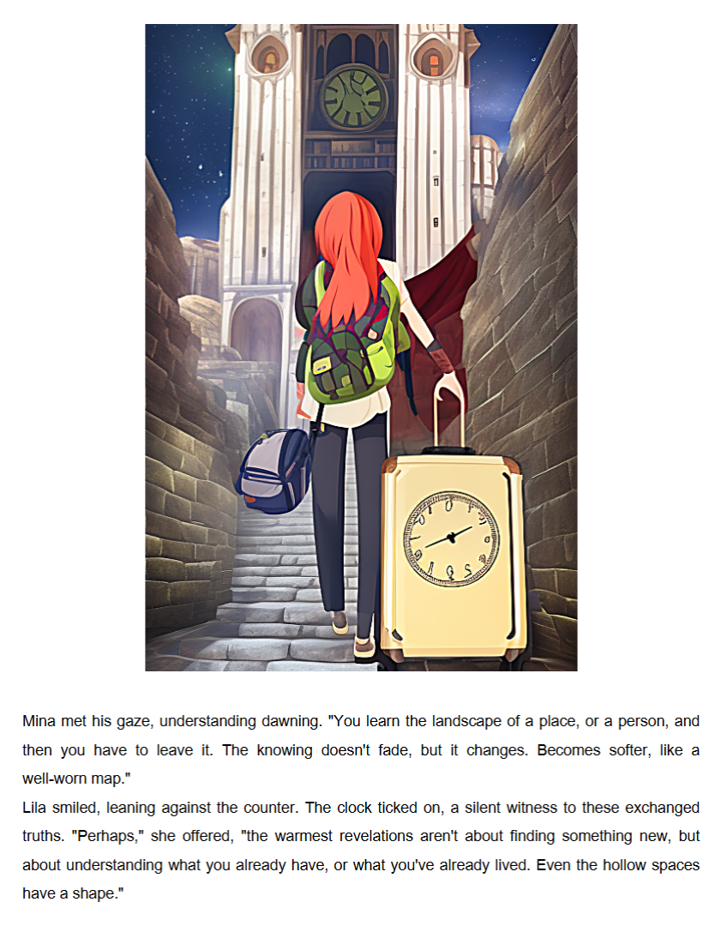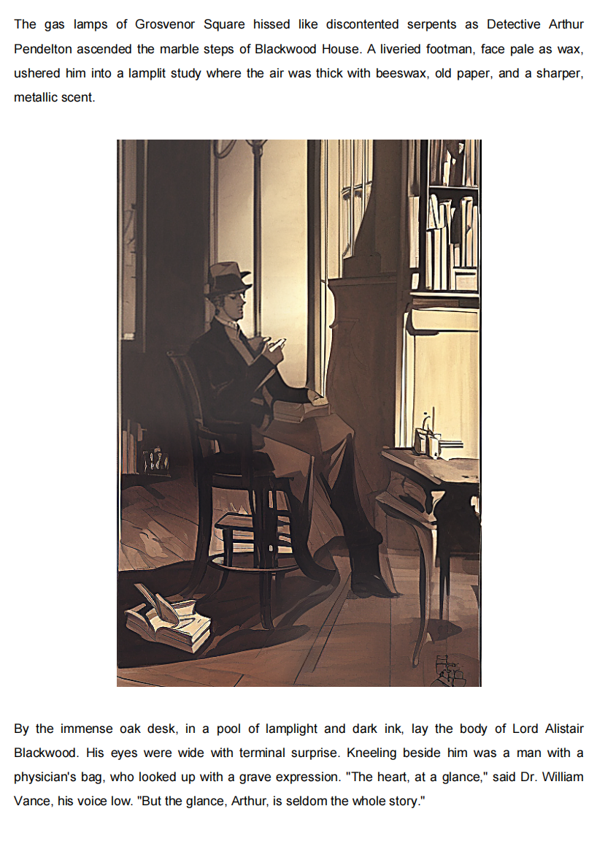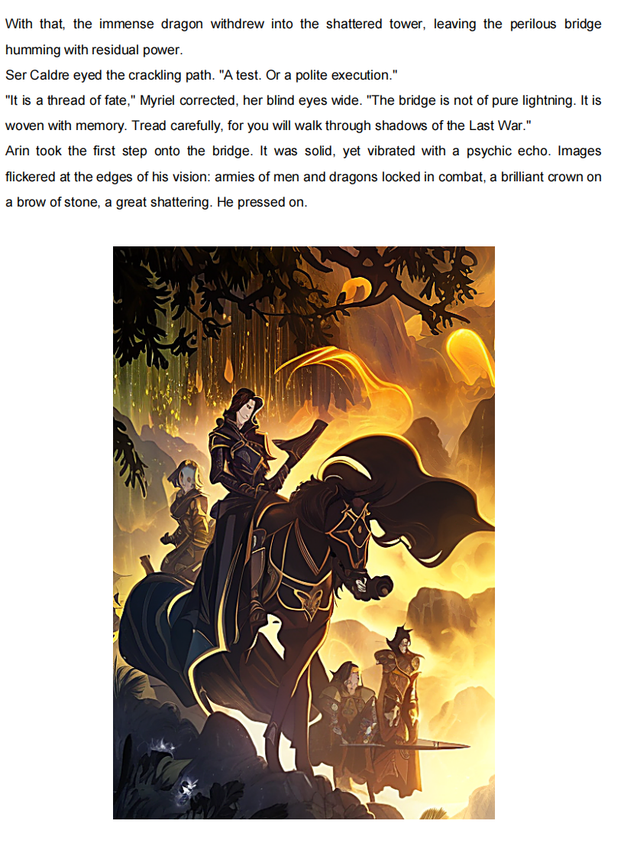

Github repository: https://github.com/Lux-Jason/Comic_WorkStation

