

SWD-LB itS Project

Ticketing (Soccer)

Informationstechnik und System-Management / Wirtschaftsinformatik
Fachhochschule Salzburg GmbH

vorgelegt von
Susanne Lastowicka
Alexander Lux

Puch/Salzburg, November 2026

Inhaltsverzeichnis

1 Project Description 2
1.1 Project Setting 2
1.1.1 Current situation 2
1.1.2 Project goals 3
1.1.3 No Project goals 4
1.1.4 List of Stakeholder 4
1.2 Context Diagram 5
1.3 Requirements 6
1.3.1 Functional requirements 6
1.3.2 Non-functional requirements 7
2 Behavior 9
2.1 Overview Use Case Diagram 9
2.2 Use Case 1 (4.1) 9
2.2.1 Activity Diagram 10
2.3 Use Case 2 (4.2) 11
2.3.1 Activity Diagram 13
3 Architecture 14
3.1 Component Diagram 14
4 Implementation 15
4.1 Class Diagrams 15
4.2 Sequence Diagrams 15
5 Conclusion 16

Project Description

Project Setting
The goal of this project is a ticketing system for FC Red Bull Salzburg (RB Salzburg). The club wants to sell tickets for its home matches to its customers online as well as on site, and to extend ticket sales from domestic league matches to European fixtures such as the UEFA Champions League. Customers can pay in cash (at staffed ticket counters only) or by credit card, either online or at a point of sale.
The system is designed as an extensible, server-centric ticket shop. A central server manages stadiums, matches, seats, tickets, prices and statistics. Several independent clients – point-of-sale terminals at the ticket counters, the web shop, self-service kiosks, a mobile app and the entry gates – communicate with this server.

Current situation
RB Salzburg operates an all-seater stadium with a capacity of 32,000 seats. This season the club has qualified for the UEFA Champions League for the first time in its history. Ticket sales therefore have to cover domestic league matches and European fixtures, with different ticket types, customer groups and prices. A large number of spectators must also be admitted to the stadium quickly and reliably.
The stadium is divided into eight seating sections (A–H) with the following capacities and price categories. Prices depend on the section and on the type of competition (league vs. European fixture) and are set at domain-typical levels; children under 16 and persons with disabilities pay half price.
Section | Capacity | Price category
A | 8,000 | Category 1
B | 8,000 | Category 1
C | 4,000 | Fan sector (FC ITS Fan Club members only)
D | 4,000 | Category 2
E | 2,000 | Category 3
F | 2,000 | Category 3
G | 2,000 | Category 3
H | 2,000 | Category 3
Total | 32,000
Table 1: Stadium sections, capacities and price categories
The system will first be built as a prototype for this single stadium with 32,000 seats. In a later stage it shall support several stadiums – one for every club of the Austrian Bundesliga – so the capacity model must scale up to the largest stadium in Austria.

Project goals
The project pursues the following goals:
- Single-match ticket sale (Use Case 1): customers select an upcoming match, a sector and an available seat, see the price and buy the ticket (max. 4 tickets per person). Concurrency control prevents the same seat from being sold twice.
- Access control (Use Case 2): spectators enter the stadium by presenting their ticket number. Entry is granted only if the ticket is valid for the currently active match (single-match ticket) or for its competition/series (season ticket) and has not already been used. Entries and exits are logged, so a spectator who leaves can re-enter with the same ticket number; repeated entry attempts with the same number notify the stadium staff.
- Ticket and customer types: regular, season, Champions League and fan tickets; regular customers, reduced-price customers (half price) and FC ITS Fan Club members (fan sector C only).
- Reservation and cancellation: season ticket holders can reserve up to 4 tickets per match; customers or authorised staff can cancel reserved tickets.
- Payment: cash at staffed ticket counters, credit card online or at the point of sale; anonymous single-match sales at the ticket counter.
- Real-time seat status: free, reserved or sold per match and sector, available to all clients.
- Statistics: tickets sold, tickets used and occupancy per conducted match, cumulative statistics per competition/series and utilisation over a selectable period (match, season, winter/spring season, Champions League).
- Extensibility: start with one stadium as a prototype and extend later to several stadiums of the Austrian Bundesliga.
- Quality: a working web application for customers, a lightweight HTML page simulating the entry gate, and automated unit tests for the critical paths.

No Project goals
The following points are explicitly not part of this project:
- No season ticket sale: Use Case 3 (Season Ticket Sale) is intended for teams of three and is not implemented by our team of two. Season tickets are provided as seed data.
- No explicit customer types and prices: the system will not explicitly model customer types (regular, reduced-price, and fan club member). Therefore, prices will not be calculated based on the customer type.
- No ticket resale: the platform offers no resale or secondary-market function, and dedicated protection mechanisms against resale (anti-scalping) are not implemented.
- No stadiums above 100,000 seats: the system is not designed for capacities beyond 100,000 seats per stadium.
- No premium pricing: premium tickets in the range of €200–500 (e.g. VIP or hospitality packages) are not offered; prices remain at domain-typical levels.
- No master-data administration UI: stadiums, sectors, seats, teams, competitions and matches are loaded via seed data or migration scripts.
- No real hardware or payment integration: entry gates are simulated by an HTML page, and payments are simulated instead of connected to a real payment provider.

List of Stakeholder
The following stakeholders are involved in or affected by the system:
Stakeholder | Role / interest
FC Red Bull Salzburg (client) | Commissions the system; wants reliable ticket sales for league and European matches, revenue and an extensible solution.
Spectators / customers | Buy tickets online, at kiosks or at the counter; regular and reduced-price customers (children under 16, persons with disabilities).
Season ticket holders | Hold a fixed seat for all home league matches of a season; reserve additional tickets (max. 4).
FC ITS Fan Club and its members | Members buy discounted fan tickets for sector C; membership is verified at purchase and entry.
Ticket counter staff | Sell tickets (also anonymously and for cash), handle reservations and cancellations.
Stadium entry and security staff | Operate access control; are notified when the same ticket number is used repeatedly.
Club management / marketing | Use match and season statistics and link ticket usage to customers for marketing.
Competition organisers (Austrian Bundesliga, UEFA) | Define competitions, fixtures and rules, e.g. for Champions League tickets.
Other Austrian Bundesliga clubs | Future users of the system once several stadiums are supported.
Development team | Analyse, design, implement and test the system.
Table 2: Stakeholders

Context Diagram
The context diagram shows the ticketing system as a black box and the external actors and systems that exchange information with it.
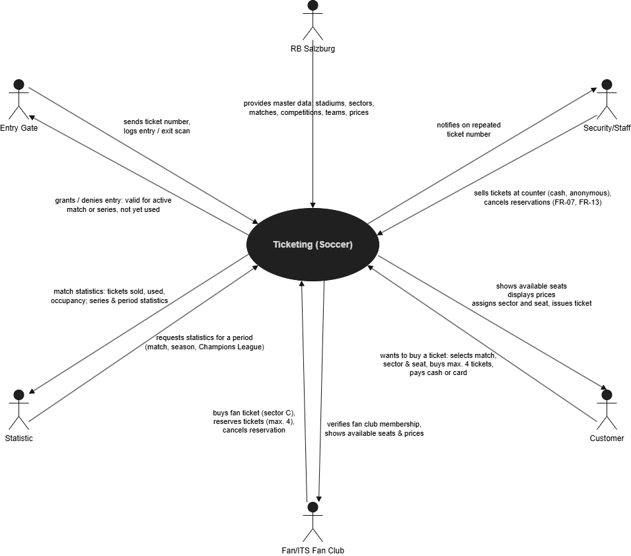
Figure 1: Context diagram of the ticketing system
Customers, season ticket holders and ticket counter staff query available seats and buy, reserve or cancel tickets via their clients (web shop, app, kiosk, POS). The payment provider handles credit card payments, and the FC ITS Fan Club data is used to verify membership for fan tickets. The entry gates send ticket numbers and entry/exit scans and receive a grant or deny decision; if a ticket number is used repeatedly, stadium staff are alerted. Club management and marketing receive utilisation and match statistics.

Requirements

Functional requirements
The project requirements document (Ticketing (Soccer), FH Salzburg, 2025) already describes the functional requirements in detail. The most important ones for our project are summarised below; FR-01 to FR-07 belong to Use Case 1 and FR-08 to FR-12 to Use Case 2.
ID | Requirement
FR-01 | The system shall allow a customer to select one of the upcoming matches for purchasing a ticket.
FR-02 | The system shall allow the customer to choose a sector and a seat.
FR-03 | The system shall display only available seats, i.e. seats without a sold single-match ticket for the match and without an assigned season ticket for the competition/series.
FR-04 | The system shall display the ticket price, determined by sector and competition type, during the purchase flow.
FR-05 | The system shall prevent double-selling of a seat by concurrency control.
FR-06 | The system shall limit purchases and reservations to a maximum of 4 tickets per person.
FR-07 | The system shall support payment in cash (staffed counters only) and by credit card (online or POS) and allow anonymous single-match sales at the counter.
FR-08 | The system shall allow a spectator to attempt entry by presenting a ticket number.
FR-09 | The system shall grant entry only if the ticket is valid for the currently active match (single-match ticket) or its competition/series (season ticket) and has not already been used for entry.
FR-10 | The system shall permit entry only when the match status is active (statuses: planned, active, conducted, cancelled).
FR-11 | The system shall log every entry and exit scan, so that a spectator who has left can re-enter with the same ticket number.
FR-12 | The system shall notify stadium staff when the same ticket number is presented repeatedly for entry.
FR-13 | The system shall allow season ticket holders to reserve tickets and customers or authorised staff to cancel reservations.
FR-14 | The system shall provide the real-time status of seats (free, reserved, sold) per match and sector.
FR-15 | The system shall maintain statistics per conducted match (tickets sold, tickets used, occupancy) and add them to the cumulative competition/series statistics.
FR-16 | The system shall provide utilisation statistics over a selectable period (match, season, winter/spring season, Champions League).
FR-17 | The system shall represent stadiums (name, address), sectors with capacities, competitions/series and matches with kickoff time, stadium and exactly two teams.
Table 3: Functional requirements

Non-functional requirements

Quality requirements
The following quality requirements act as architecture drivers:
ID | Quality attribute | Requirement
QR-01 | Data integrity / concurrency | A seat can never be sold or assigned twice, even with many simultaneous requests from different clients; capacity limits and pricing rules are always enforced.
QR-02 | Performance | Seat availability is shown in real time; seat queries and entry checks respond within about 2 seconds, so that spectators can enter the stadium without long queues.
QR-03 | Availability | The server remains available during sales peaks (e.g. start of Champions League sales) and while the stadium is being filled before kickoff.
QR-04 | Scalability / extensibility | The system can be extended from one stadium (32,000 seats) to several stadiums of the Austrian Bundesliga and to new clients and competitions without major changes.
QR-05 | Security and privacy | Personal customer data and ticket usage are processed according to the GDPR; payment data is protected; only authorised staff can cancel tickets.
QR-06 | Traceability | Every entry and exit scan is recorded so that ticket usage can be analysed and misuse (repeated ticket numbers) detected.
QR-07 | Usability | The purchase flow in the web application is simple and shows sectors, available seats and prices clearly.
QR-08 | Testability / maintainability | Critical paths are covered by automated unit tests (isolation, Arrange–Act–Assert, mocks/stubs, boundary and error cases); the code follows a clear, layered structure.
Table 4: Quality requirements

Constraints
The project is subject to the following constraints:
- Server-centric architecture: all clients (POS, web, kiosk, app, entry gate) communicate with one central server.
- The starter project and technology stack provided by the lecturers are used and extended.
- Team of two: exactly two use cases are implemented – Single-Match Ticket Sale and Access Control.
- A web application for customers and a lightweight HTML page simulating the entry gate are required.
- Master data is provided by seed data, fixtures or migration scripts; no CRUD interface is required.
- Business rules from the requirements: max. 4 tickets per person, cash only at staffed counters, every ticket bound to exactly one fixed seat, season tickets require a customer account, reduced price for children under 16 and persons with disabilities, fan sector C only for FC ITS Fan Club members.
- Legal: personal data must be handled in compliance with the GDPR.

Behavior

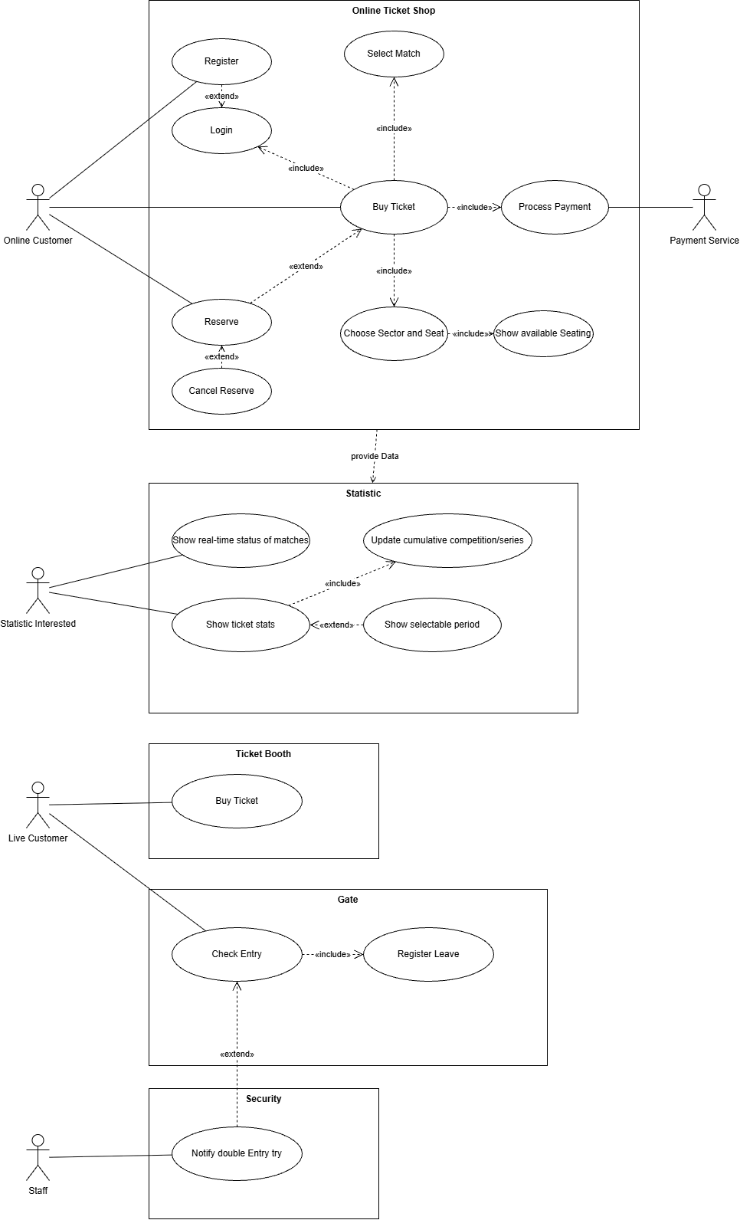
Overview Use Case Diagram

Figure 2: Overview use case diagram (part 1 of 2)

Figure 3: Overview use case diagram (part 2 of 2)

Use Case 1 (4.1)
Use Case ID | 4.1
Use Case Name | Single-Match Ticket Sale
Created By | L | Last Updated By | Lux Alexander
Date Created | October 14, 2026 | Date Last Updated | October 14, 2026
Actors | Customer, Authorized Staff
Description | The system allows a customer to select an upcoming match, choose a specific sector and seat, and purchase a single-match ticket valid for that specific fixture.
Trigger | A customer or staff member selects one of the upcoming matches to initiate a ticket purchase via a client interface (web or ticket booth).
Pre-Conditions | 1. Upcoming matches are scheduled and their initial status is set to 'planned' or 'active'.  2. The purchasing customer has not exceeded the maximum limit of 4 tickets per person.
Post-Conditions | 1. The single-match ticket is successfully sold and bound to a fixed, pre-defined seat.  2. The server is notified, and the real-time status of the specific seat is updated to 'sold' for that match.  3. Concurrency control has been successfully enforced, preventing the seat from being double-sold.  4. The statistics are updated with the new information.  5. Payment has been received.
Normal Flow | 1. The customer selects one of the upcoming matches for purchasing a ticket.  2. The client queries the server for available seats within a specified sector/section.  3. The system displays only available seats (ensuring no single-match ticket or season ticket is already assigned for that seat).  4. The customer chooses a sector and a seat.  5. The system displays the ticket price at the appropriate step.  6. The customer requests billing information and completes payment via cash (at staffed counters only) or credit card.  7. The client notifies the central server that the ticket/seat is sold.
Alternative Flows | 4.1.1 Fan Sector Purchase: If the customer selects Section C (Fan sector), the system requires membership verification for the FC ITS Fan Club before allowing the purchase.  4.1.2 Reduced-Price Purchase: If the customer belongs to an eligible group (children under 16 or persons with disabilities), the system applies a half-price discount across all sections.  4.1.3 If the Payment/Process fails (Incorrect billing information, lack of money, Termination, Error), nothing will be sold/bound (if needed Rollback).
Exceptions | 4.1.0.E.1 Concurrency Conflict: If another user attempts to purchase the same seat simultaneously, the system's concurrency control rejects the second request to prevent double-selling.  4.1.0.E.2 Ticket Limit Exceeded: If a customer attempts to purchase more than 4 tickets, the system denies the transaction.
Includes | None explicitly required for anonymous sales, though customer registration is required for season tickets, not single-match tickets.
Priority | High (Core System Functionality)
Frequency of Use | High (Multiple concurrent users per fixture)
Business Rules | 1. Customers are limited to a maximum of 4 tickets per person.  2. Single-match tickets can be sold anonymously at staffed ticket counters.  3. Ticket pricing must be dynamically determined by the sector/section and the competition/series type.
Special Requirements | 1. Each client must operate independently while communicating with a central server.  2. The server must provide real-time status updates for seats (free, reserved, sold).
Assumptions | Relevant master data (stadiums, sectors, capacities, match details) is already populated in the system.
Notes and Issues

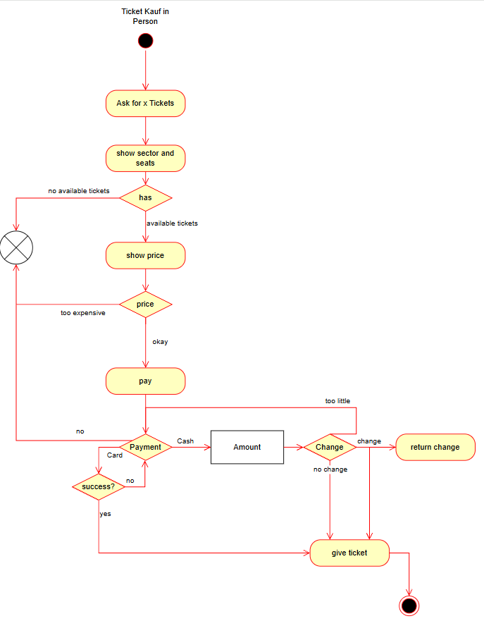
Activity Diagrams

Figure 4: Activity diagram of Use Case 1: ticket purchase in person
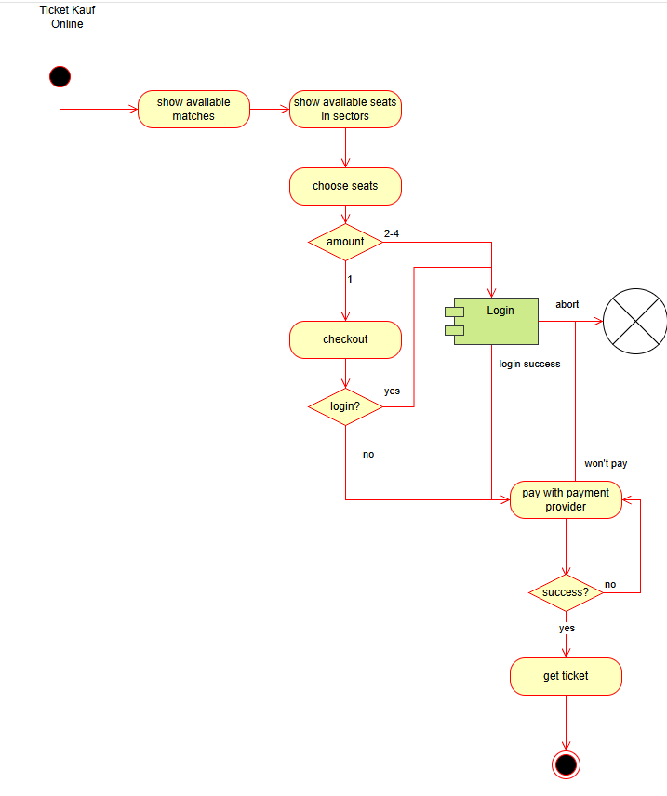
Figure 5: Activity diagram of Use Case 1: ticket purchase online

Use Case 2 (4.2)

Use Case ID: | 4.2
Use Case Name: | Access Control (Check Stadium Entry)
Created By: | Susanne Lastowicka | Last Updated By: | Susanne Lastowicka
Date Created: | 14.10.2026 | Date Last Updated: | 14.10.2026

Actors: | Primary actor: Live Customer (ticket holder presenting a ticket number at the gate)  Supporting actors: Gate (entry terminal / entry scan), Security and Staff (notified of double entry attempts)
Description: | A Live Customer attempts to enter the stadium by presenting a ticket number at a gate. The system checks that the ticket is valid for the currently active match and has not already been used for entry to this match. If so, entry is granted and logged; otherwise entry is denied. Customers are also logged when they leave the stadium, so that the same ticket number can be used to re-enter. Attempts to enter with a ticket that is already inside are denied, logged and reported to Security/Staff.
Trigger: | The Live Customer presents a ticket number at a gate to attempt entry (ticket scan or manual entry of the ticket number).
Pre-Conditions: | - The match is created and its status is “active” (entry is only permitted for active matches).  - The ticket (single-match or season ticket) has been sold and is stored in the system, bound to exactly one fixed seat.  - The gate is connected to the central server.
Post-Conditions: | - On granted entry: the entry (ticket number, match, gate, timestamp) is logged and the ticket is marked as “inside”; if the ticket is linked to a customer account, the entry is associated with that customer identity.  - The match statistics (number of tickets used / entries, occupancy) are updated.  - On denied entry: no entry is granted, the ticket status remains unchanged and the attempt is logged.  - On a double entry attempt: Security/Staff have been notified.
Normal Flow: | - Live Customer: presents the ticket number at the gate.  - System: loads the ticket and the currently active match.  - System: checks that the ticket is valid for the active match: it is either a single-match ticket for exactly this match, or a season ticket for the competition/series of this match.  - System: checks that the ticket has not already been used for entry to this match (no entry without a subsequent leave).  - System: logs the entry (ticket number, match, gate, timestamp) and links it to the customer identity, if known.  - System: updates the match statistics and grants entry (gate opens, success is displayed).  - Live Customer: enters the stadium.
Alternative Flows: | 4.2.1 Leave stadium (Register Leave): The Live Customer presents the ticket number when leaving. The system checks that the ticket is currently marked as “inside”, logs the leave (ticket number, match, gate, timestamp) and marks the ticket as “outside”. The same ticket number may then be used to enter again.  4.2.2 Re-entry: The Live Customer returns with a ticket whose leave has been logged. The flow continues as in 4.2.0 (the check “not already used” succeeds because the leave was logged); the new entry is logged as well.  4.2.3 Season ticket: The ticket is a season ticket. In step 3 of 4.2.0 the system validates it against the competition/series of the active match instead of a single match. The remaining steps are identical.
Exceptions: | 4.2.0.E.1 Unknown ticket number: The ticket number does not exist. The system denies entry, displays an error message and logs the attempt. No state change.  4.2.0.E.2 No active match: The match status is planned, conducted or cancelled. The system denies entry and displays an error message. No state change.  4.2.0.E.3 Ticket not valid for this match: The ticket is a single-match ticket for another match, or a season ticket for a different competition/series. The system denies entry and logs the attempt.  4.2.0.E.4 Ticket already used (double entry attempt): The ticket is already marked as “inside”. The system denies entry, logs the attempt with the ticket number and notifies Security/Staff (Notify double entry attempt). If the same ticket number is presented repeatedly, the notification is marked as a repeated attempt. The original entry stays valid.  4.2.0.E.5 Server not reachable / system error: The system cannot process the request. Entry is not granted automatically, an error is displayed and Staff handles the case manually. The log and ticket status are left unchanged (the transaction is rolled back).  4.2.1.E.1 Leave without entry: On leaving, the ticket is not marked as “inside”. The system rejects the leave and logs the event. No state change.
Includes: | Register Leave (4.2.1)  Notify Double Entry Attempt (4.2.0.E.4)
Priority: | High (core function on match day; without it no controlled stadium access is possible).
Frequency of Use: | Once per ticket holder per match, plus one leave and re-entry per customer who leaves in between: up to 32,000 entries per home match (stadium capacity), concentrated in the 60–90 minutes before kickoff.
Business Rules: | Entry is permitted only if the match status is “active”.  A single-match ticket is valid only for exactly one match; a season ticket is valid for all matches of its competition/series.  A ticket is bound to one fixed seat and may not be used for entry to the same match a second time unless a leave has been logged in between.  Every entry (and leave) is logged for marketing purposes and linked to the customer identity where possible; anonymously sold tickets are logged without identity.  Entry counts feed the match statistics (tickets used, occupancy); series statistics are updated only after the match status is “conducted”.
Special Requirements: | Concurrency: entry checks and logging must be atomic, so the same ticket cannot be admitted twice when scanned simultaneously at different gates.  Performance: the entry decision should be returned within about one second, also at peak load.  Server-centric: all checks run on the central server; gates (or the HTML gate simulation page) are only clients.  Traceability: all entries, leaves and denied attempts are stored permanently.  Testability: critical paths (valid/invalid ticket, double entry, concurrent requests) are covered by automated unit tests.
Assumptions: | The ticket number uniquely identifies exactly one ticket.  Only one match is active at a time per stadium.  Every gate can be used for entry and for leaving and is permanently connected to the server.  Each ticket is counted only once in the entry statistics, even if the customer re-enters.  Staff are notified via a notification in the system (e.g., a message at the staff terminal).
Notes and Issues:

Architecture

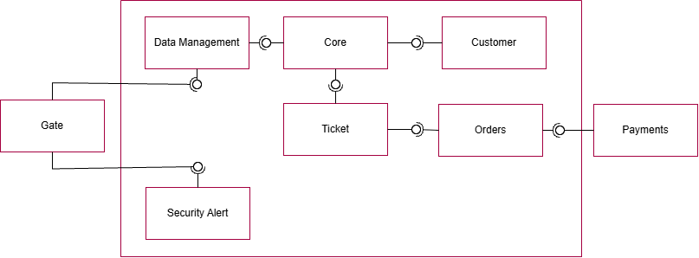
Component Diagram

Figure 6: Component diagram of the ticketing system

The system is a ticketing platform made up of six internal components: Data Management, Core, Customer, Ticket, Orders and Security Alert. Core sits at the center, using Data Management for stored data and linking to Customer and Ticket. Orders connects to Ticket and handles the purchase side, passing payment requests to the external Payments service. The external Gate component talks to Data Management and Security Alert, which lets it exchange data with the system and receive security alerts.

Implementation

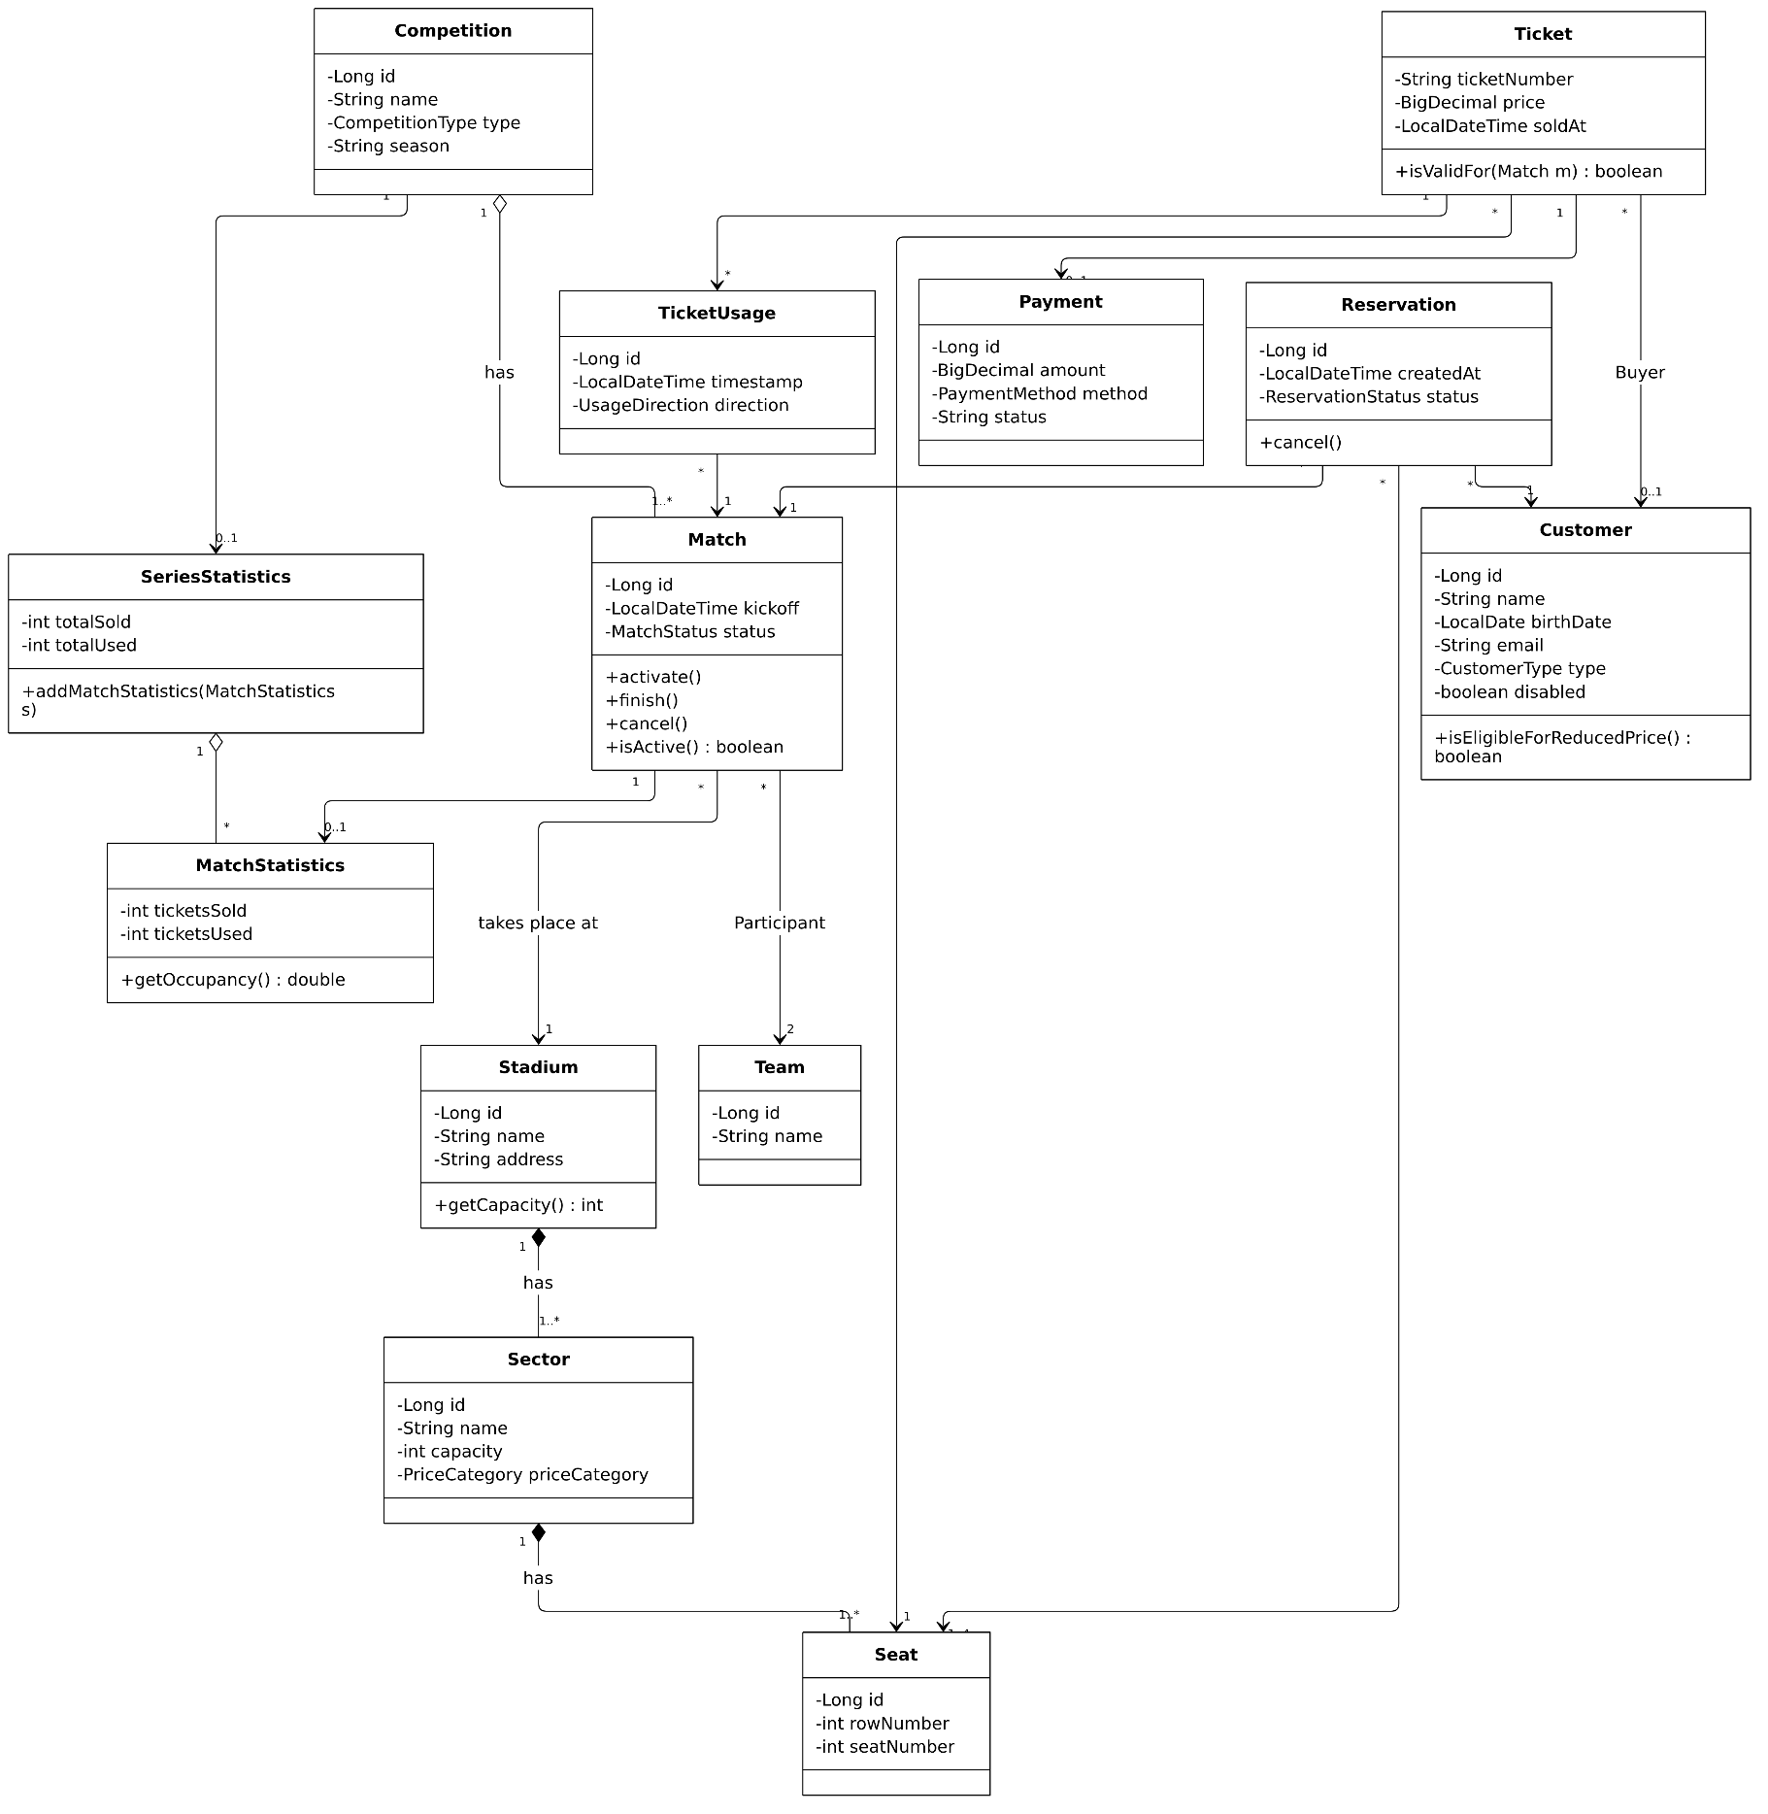
Class Diagrams

Figure 7: Class Diagram Master
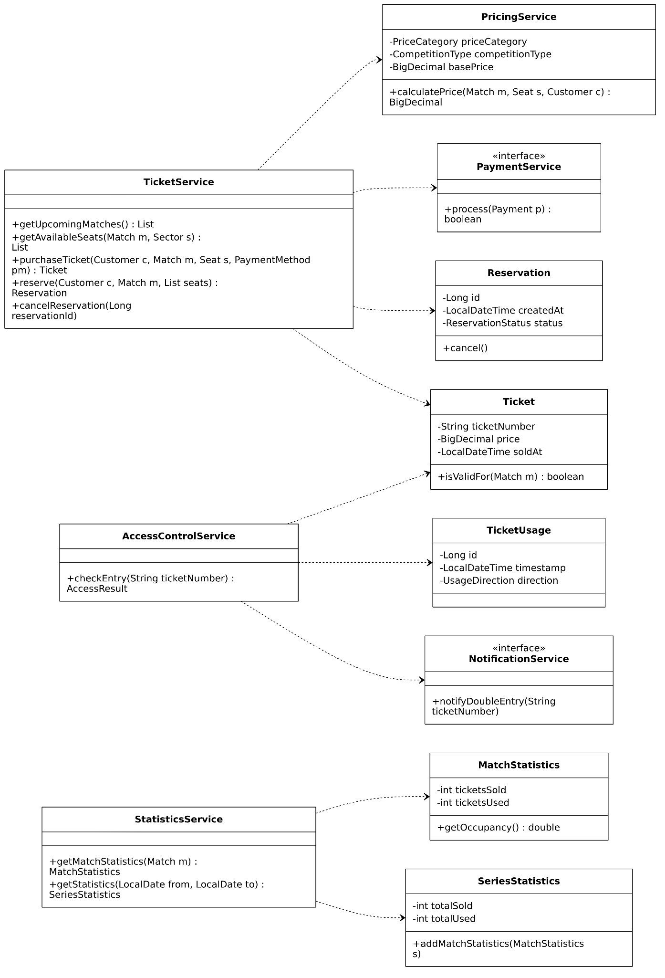
Figure 8: Class Diagram Services
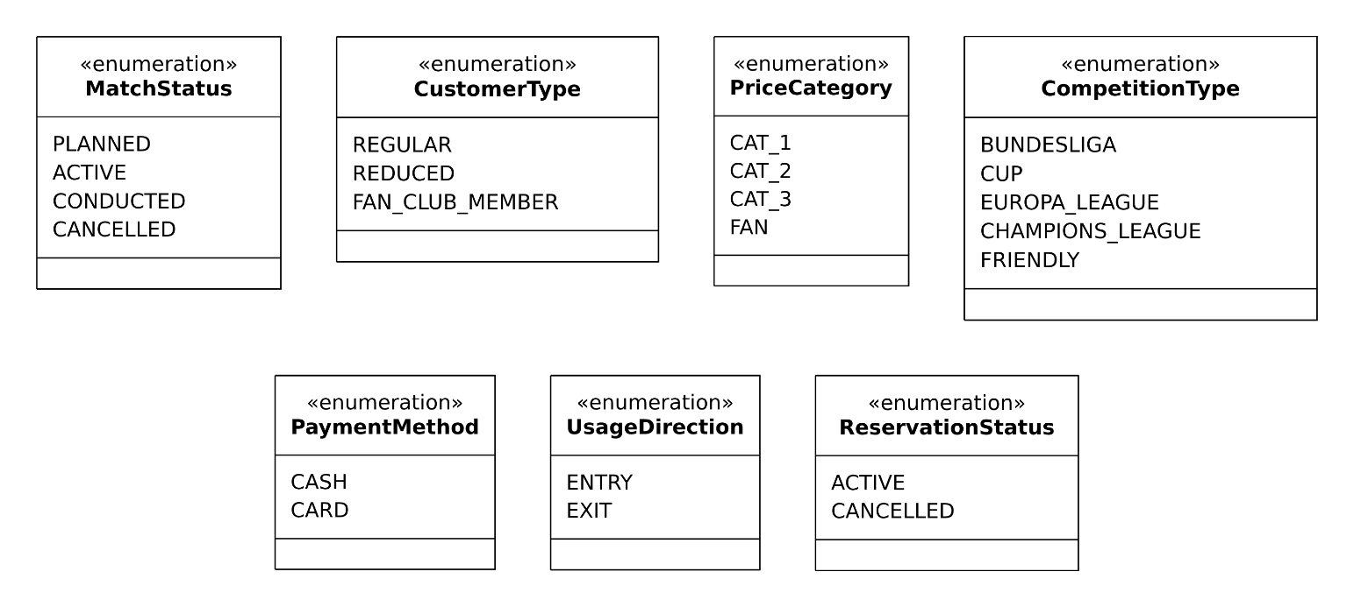
Figure 9: Class Diagram Enumerations

Sequence Diagrams
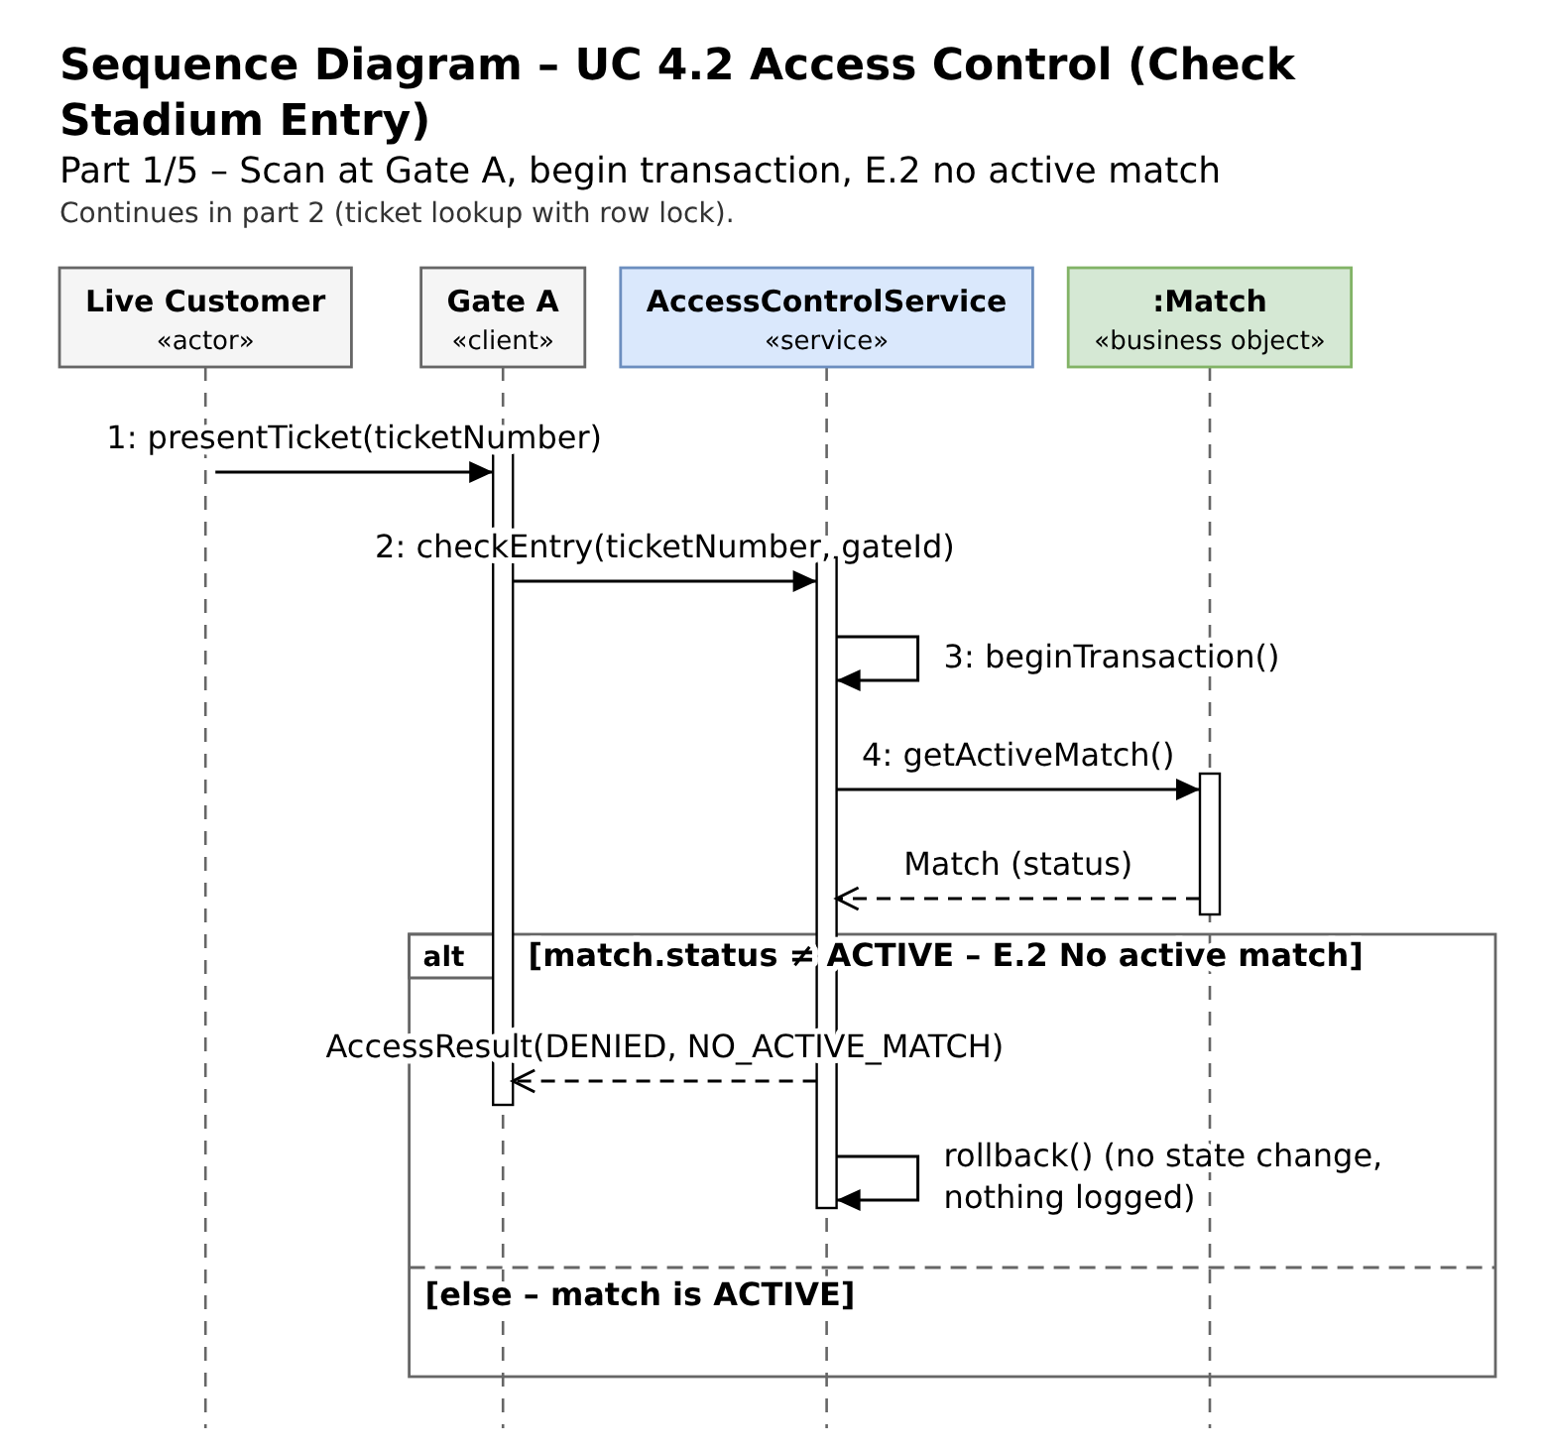
Figure 10: Sequence Diagram Part 1
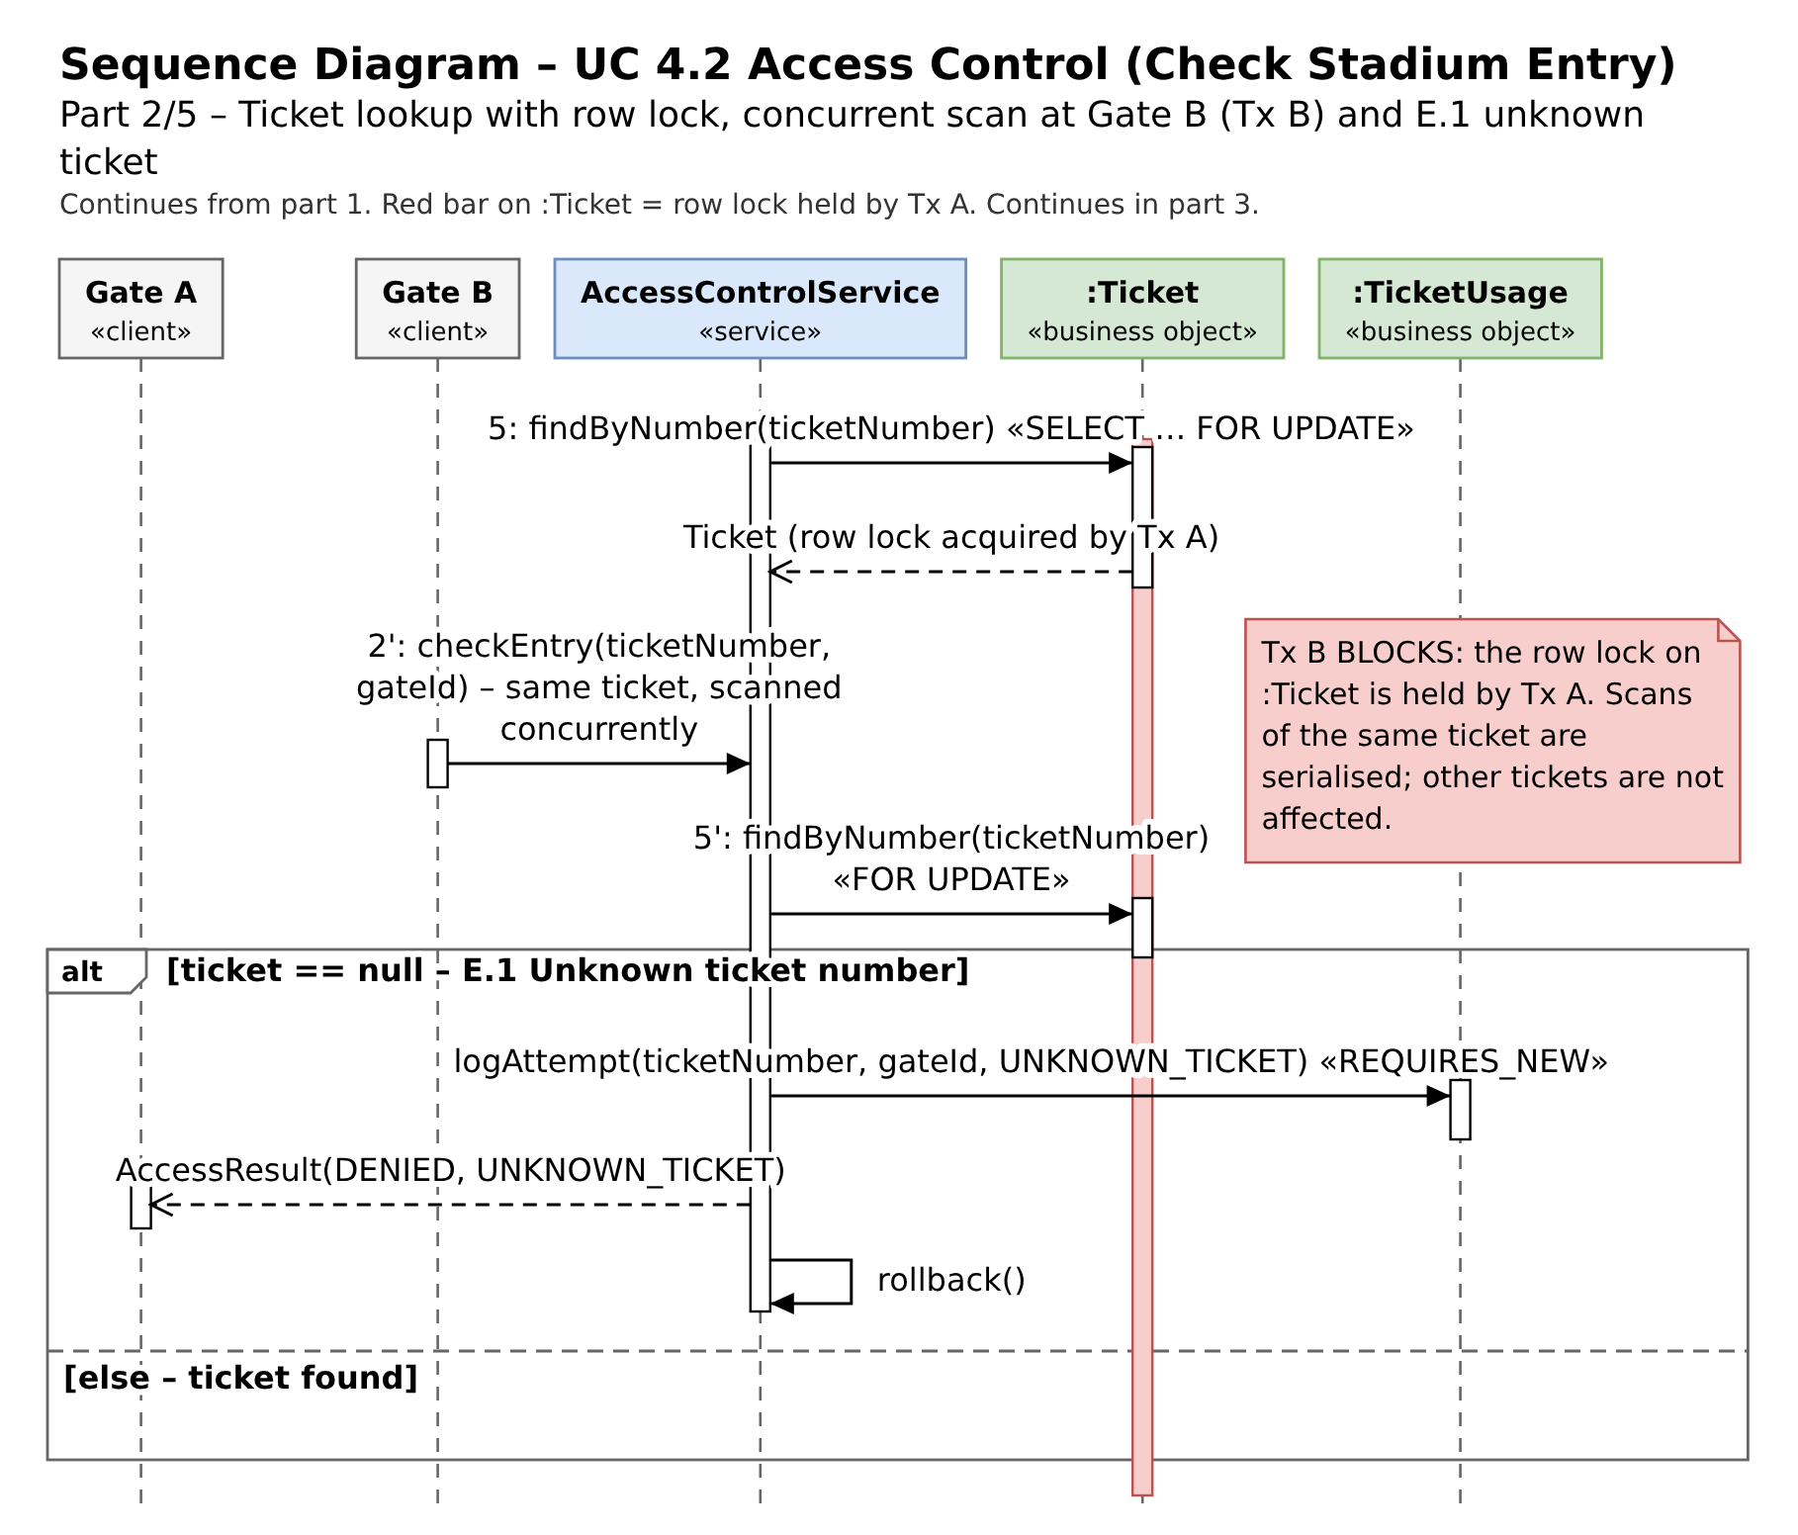
Figure 11: Sequence Diagram Part 2
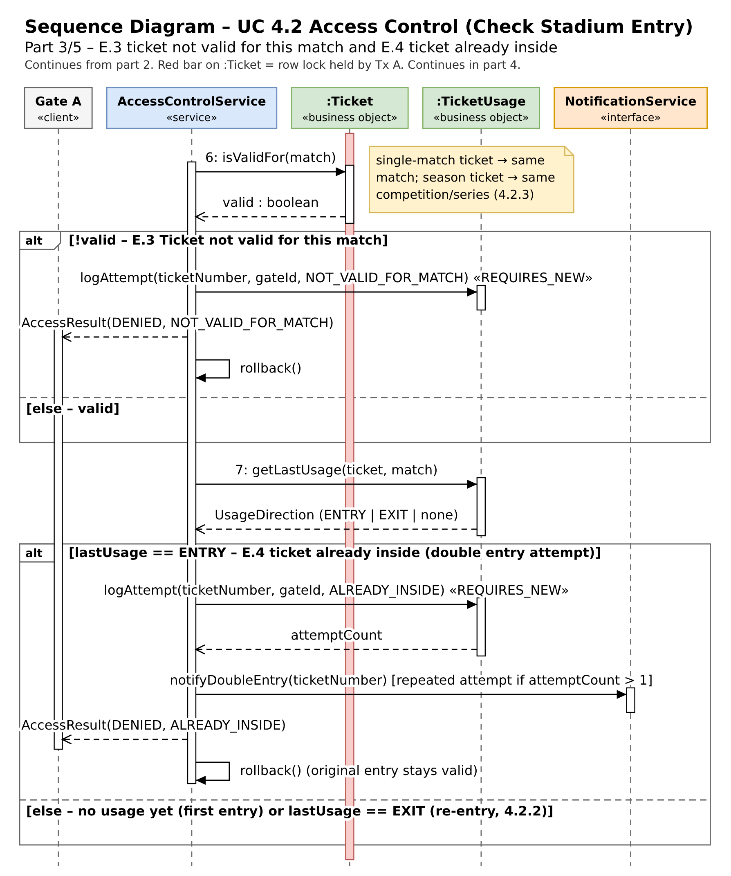
Figure 12: Sequence Diagram Part 3
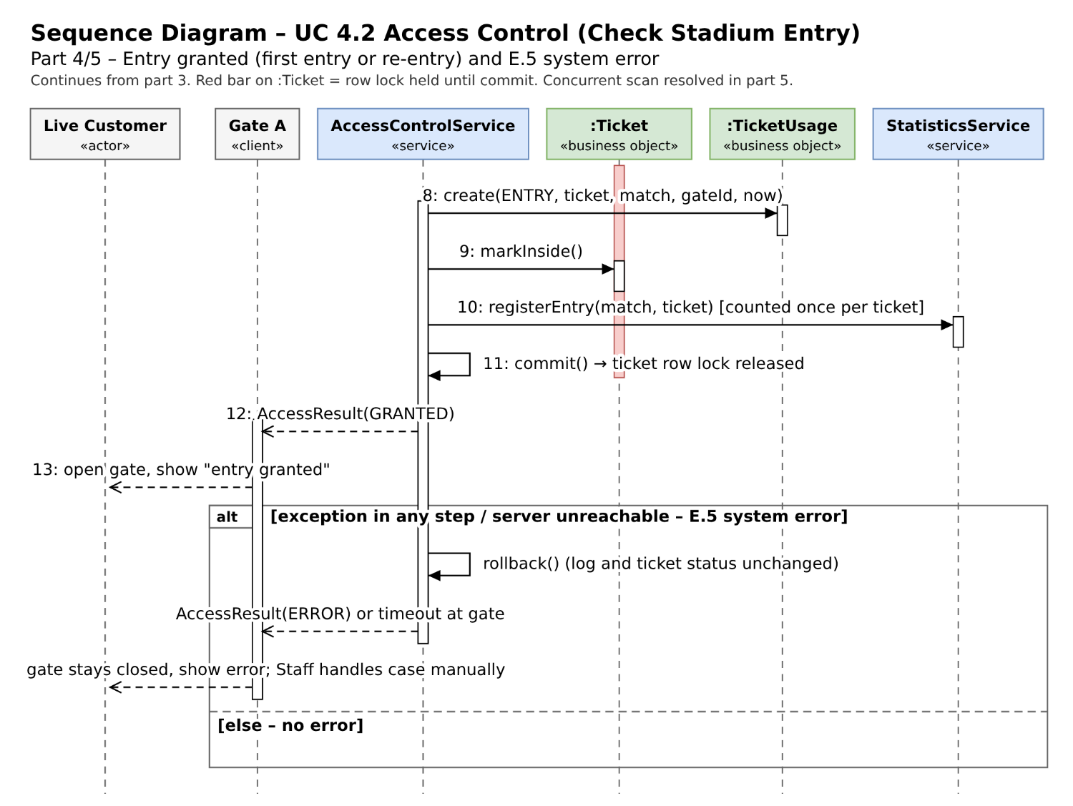
Figure 13: Sequence Diagram Part 4
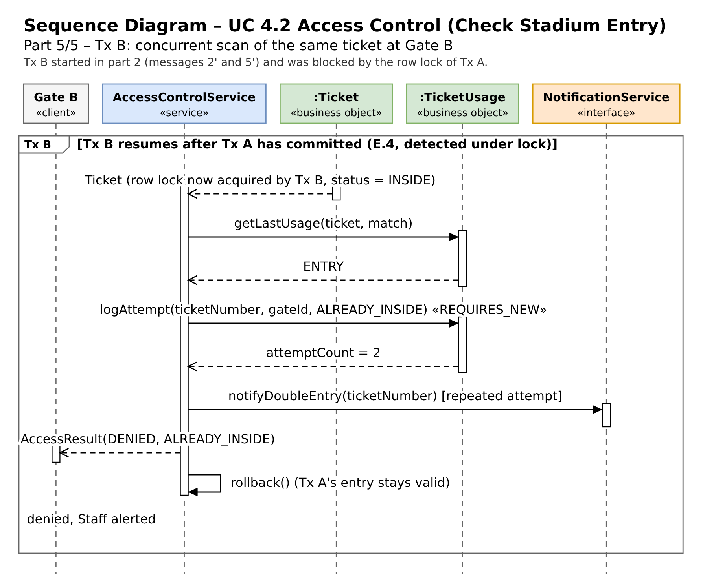
Figure 14: Sequence Diagram Part 5
Measures for concurrent users / consistency
One transaction per check (steps 3–11): validity check, usage log, ticket status and statistics are committed together or rolled back together (E.5).
Pessimistic row lock on :Ticket (SELECT … FOR UPDATE, step 5) serialises simultaneous scans of the same ticket at different gates; the second scan sees status INSIDE and is denied (E.4). Scans of different tickets run in parallel (up to 32,000 entries, peak 60–90 min before kickoff).
Safety net: @Version (optimistic lock) on :Ticket and a unique constraint “max. one open ENTRY per ticket and match” in :TicketUsage – a lost race can never admit the same ticket twice.
Denied attempts are logged in a separate transaction («REQUIRES_NEW») so that the audit trail survives the rollback (traceability, QR-06) and attemptCount / “repeated attempt” is reliable.
Statistics are updated atomically inside the same transaction (UPDATE … SET used = used + 1) and only for the first entry of a ticket; fixed lock order Match → Ticket → TicketUsage → Statistics avoids deadlocks; lock wait timeout → ERROR (E.5).

User Stories
As a customer I want to be able to see the matches, sectors and seats, so that I can choose where I will sit and buy a ticket.
As a customer I want to buy a ticket, so that I can watch the match.
As a manager I want to be able to see the statistics of matches and tickets, so that I have an overview of the current situation and can plan ahead.
As a returning customer I want to be able to have my own profile (register/login), so that I can manage my tickets in my account.
As a security guard I want to be notified of a double entry, so that I can sort out the situation.
As a customer I want to be able to exit the stadium and re-enter, so that if I have to leave the stadium during the match, I won’t be locked out.

Conclusion
In this project we analysed and designed a server-centric ticketing system for FC Red Bull Salzburg. It sells tickets for domestic league matches and for UEFA Champions League fixtures and controls access to the stadium. Starting from the project setting, the stakeholders, and the functional and quality requirements, we worked out the behaviour, the architecture and the structure of the system for the two use cases assigned to our team of two: Single-Match Ticket Sale (4.1) and Access Control (4.2).
The behavioural models show how customers and staff select a match, a sector and a seat and pay for the ticket, and how spectators are admitted, may leave and re-enter, and trigger an alert when the same ticket number is used repeatedly. The component diagram divides the system into six components (Data Management, Core, Customer, Ticket, Orders and Security Alert) with the Payments service and the entry gates as external partners. All clients talk to one central server, so new clients and further stadiums can be added (QR-04). The class and sequence diagrams refine this into services, entities and enumerations and describe the complete entry check, including its exceptional flows.
The measures for concurrent use follow from the requirements for data integrity (QR-01) and traceability (QR-06). A seat must never be sold twice and a ticket must never admit two spectators at the same time, even when many requests arrive at once. Each entry check runs in one transaction. A pessimistic row lock on the ticket serialises simultaneous scans, and an optimistic version check and a unique constraint act as a safety net. Denied attempts are logged in a separate transaction, so the audit trail survives a rollback.

