Debugging:
Using build make Debug on custom Targets
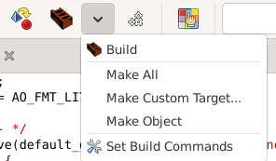

Since the pluggin in Geany doesn’t seem to give me a compiler tab, I’m using the CLI
gdb ./AK04a.exe
run or r
We can break at functions, such as: break main
Or on lines: break a.c:42
Continue or c
Print variable
Or memory with print &variable
Exit

