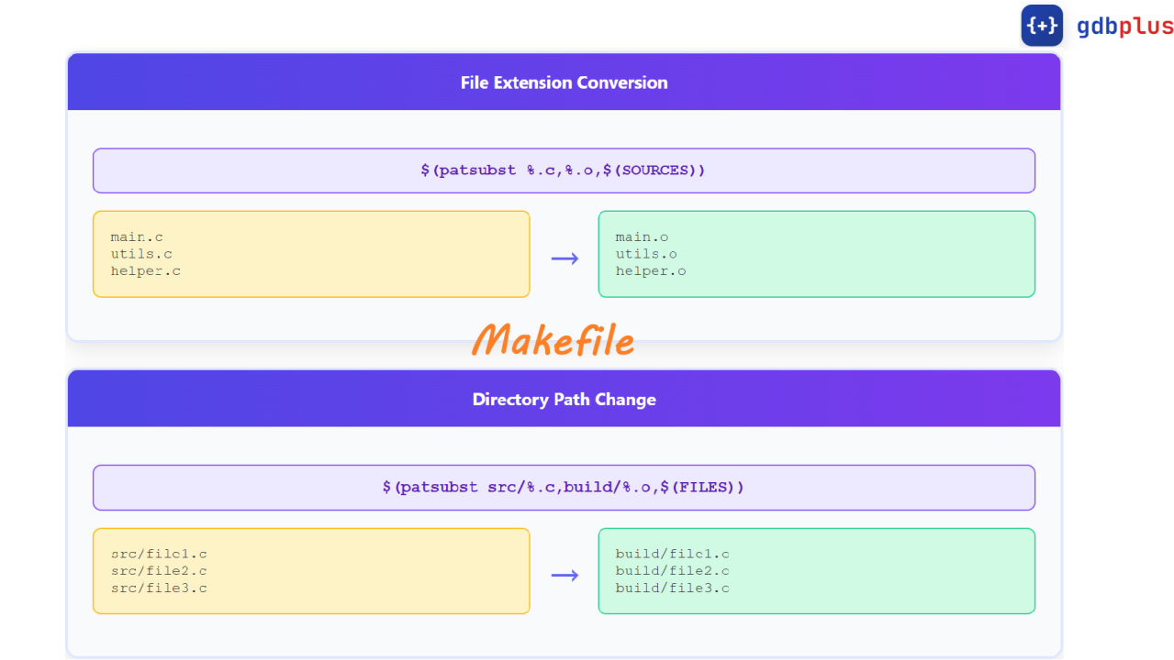
https://stackoverflow.com/questions/67995335/using-wildcard-with-ifneq-in-makefile

ifneq ($(wildcard $(CURDIR)/libs/),)
check if there is a lib folder in the path, if not it’s probably onestep outside
https://askubuntu.com/questions/210210/pkg-config-path-environment-variable

PKG_CONFIG_PATH := $(LOCAL_LIBS_DIR)/lib/pkgconfig:$(PKG_CONFIG_PATH):/usr/lib/pkgconfig:/usr/lib/x86_64-linux-gnu/pkgconfig
Search Lokal Lib Folder -> Search environment terminal variables -> system-wide installed libraries

LDFLAGS += -L$(LOCAL_LIBS_DIR)/lib -lx264 $(shell pkg-config --libs libavformat libavcodec libavutil || echo "-lavformat -lavcodec -lavutil") -lm -lpthread

1.search your custom local library directory for binaries
2. Links the H.264 video encoding library
Either Finds libavformat, codec util through pkg config or fallsnack on lavformat… (it’s echo since it’s inside $shell block, making it a string not an execute)
Adds -lm – lpthread

runtime dynamic linking (for: undefined reference to `x264_encoder_open_164')
LDFLAGS += -Wl,-rpath,'$$ORIGIN/../libs/lib':'$$ORIGIN/libs/lib'
-Wl, pass it directly down to the linker
-rpath, Run path, directory paths
absolute folder path where your executable is currently sitting

$@, for each variable
$<, input variable (z.b a.o, b.o, c.o)

