

SWD-LB itS Project

Ticketing (Soccer)

Informationstechnik und System-Management / Wirtschaftsinformatik
Fachhochschule Salzburg GmbH

vorgelegt von
Susanne Lastowicka
Alexander Lux

Puch/Salzburg, Oktober 2026

Inhaltsverzeichnis

1 Project Description 2
1.1 Project Setting 2
1.1.1 Current situation 2
1.1.2 Project goals 2
1.1.3 No Project goals 2
1.1.4 List of Stakeholder 2
1.2 Context Diagram 2
1.3 Requirements 2
1.3.1 Functional requirements 2
1.3.2 Non-functional requirements 2
2 Behavior 3
2.1 Overview Use Case Diagram 3
2.2 Use Case 1 xxx 3
2.2.1 Use Case Description 3
2.2.2 Activity Diagram 3
2.3 Use Case 2 xxx 3
2.3.1 Use Case Description 3
2.3.2 Activity Diagram 3
3 Architecture 4
3.1 Component Diagram 4
4 Implementation 5
4.1 Class Diagrams 5
4.2 Sequence Diagrams 5
5 Conclusion 6

Project Description

Project Setting
The goal of this project is a ticketing system for FC Red Bull Salzburg (RB Salzburg). The club wants to sell tickets for its home matches to its customers online as well as on site, and to extend ticket sales from domestic league matches to European fixtures such as the UEFA Champions League. Customers can pay in cash (at staffed ticket counters only) or by credit card, either online or at a point of sale.
The system is designed as an extensible, server-centric ticket shop. A central server manages stadiums, matches, seats, tickets, prices and statistics. Several independent clients – point-of-sale terminals at the ticket counters, the web shop, self-service kiosks, a mobile app and the entry gates – communicate with this server.

Current situation
RB Salzburg operates an all-seater stadium with a capacity of 32,000 seats. This season the club has qualified for the UEFA Champions League for the first time in its history. Ticket sales therefore have to cover domestic league matches as well as European fixtures, with different ticket types, customer groups and prices, and a large number of spectators have to be admitted to the stadium quickly and reliably.
The stadium is divided into eight seating sections (A–H) with the following capacities and price categories. Prices depend on the section and on the type of competition (league vs. European fixture) and are set at domain-typical levels; children under 16 and persons with disabilities pay half price.
Section | Capacity | Price category
A | 8,000 | Category 1
B | 8,000 | Category 1
C | 4,000 | Fan sector (FC ITS Fan Club members only)
D | 4,000 | Category 2
E | 2,000 | Category 3
F | 2,000 | Category 3
G | 2,000 | Category 3
H | 2,000 | Category 3
Total | 32,000
Table 1: Stadium sections, capacities and price categories
The system will first be built as a prototype for this single stadium with 32,000 seats. In a later stage it shall support several stadiums – one for every club of the Austrian Bundesliga – so the capacity model must scale up to the largest stadium in Austria.

Project goals
The project pursues the following goals:
- Single-match ticket sale (Use Case 1): customers select an upcoming match, a sector and an available seat, see the price and buy the ticket (max. 4 tickets per person). Concurrency control prevents the same seat from being sold twice.
- Access control (Use Case 2): spectators enter the stadium by presenting their ticket number. Entry is granted only if the ticket is valid for the currently active match (single-match ticket) or for its competition/series (season ticket) and has not already been used. Entries and exits are logged, so a spectator who leaves can re-enter with the same ticket number; repeated entry attempts with the same number notify the stadium staff.
- Ticket and customer types: regular, season, Champions League and fan tickets; regular customers, reduced-price customers (half price) and FC ITS Fan Club members (fan sector C only).
- Reservation and cancellation: season ticket holders can reserve up to 4 tickets per match; customers or authorised staff can cancel reserved tickets.
- Payment: cash at staffed ticket counters, credit card online or at the point of sale; anonymous single-match sales at the ticket counter.
- Real-time seat status: free, reserved or sold per match and sector, available to all clients.
- Statistics: tickets sold, tickets used and occupancy per conducted match, cumulative statistics per competition/series and utilisation over a selectable period (match, season, winter/spring season, Champions League).
- Extensibility: start with one stadium as a prototype and extend later to several stadiums of the Austrian Bundesliga.
- Quality: a working web application for customers, a lightweight HTML page simulating the entry gate, and automated unit tests for the critical paths.

No Project goals
The following points are explicitly not part of this project:
- No ticket resale: the platform offers no resale or secondary-market function, and dedicated protection mechanisms against resale (anti-scalping) are not implemented.
- No stadiums above 100,000 seats: the system is not designed for capacities beyond 100,000 seats per stadium.
- No premium pricing: premium tickets in the range of €200–500 (e.g. VIP or hospitality packages) are not offered; prices remain at domain-typical levels.
- No season ticket sale: Use Case 3 (Season Ticket Sale) is intended for teams of three and is not implemented by our team of two. Season tickets are provided as seed data.
- No master-data administration UI: stadiums, sectors, seats, teams, competitions and matches are loaded via seed data or migration scripts.
- No real hardware or payment integration: entry gates are simulated by an HTML page, and payments are simulated instead of connected to a real payment provider.

List of Stakeholder
The following stakeholders are involved in or affected by the system:
Stakeholder | Role / interest
FC Red Bull Salzburg (client) | Commissions the system; wants reliable ticket sales for league and European matches, revenue and an extensible solution.
Spectators / customers | Buy tickets online, at kiosks or at the counter; regular and reduced-price customers (children under 16, persons with disabilities).
Season ticket holders | Hold a fixed seat for all home league matches of a season; reserve additional tickets (max. 4).
FC ITS Fan Club and its members | Members buy discounted fan tickets for sector C; membership is verified at purchase and entry.
Ticket counter staff | Sell tickets (also anonymously and for cash), handle reservations and cancellations.
Stadium entry and security staff | Operate access control; are notified when the same ticket number is used repeatedly.
Club management / marketing | Use match and season statistics and link ticket usage to customers for marketing.
Competition organisers (Austrian Bundesliga, UEFA) | Define competitions, fixtures and rules, e.g. for Champions League tickets.
Other Austrian Bundesliga clubs | Future users of the system once several stadiums are supported.
Development team | Analyse, design, implement and test the system.
Table 2: Stakeholders

Context Diagram
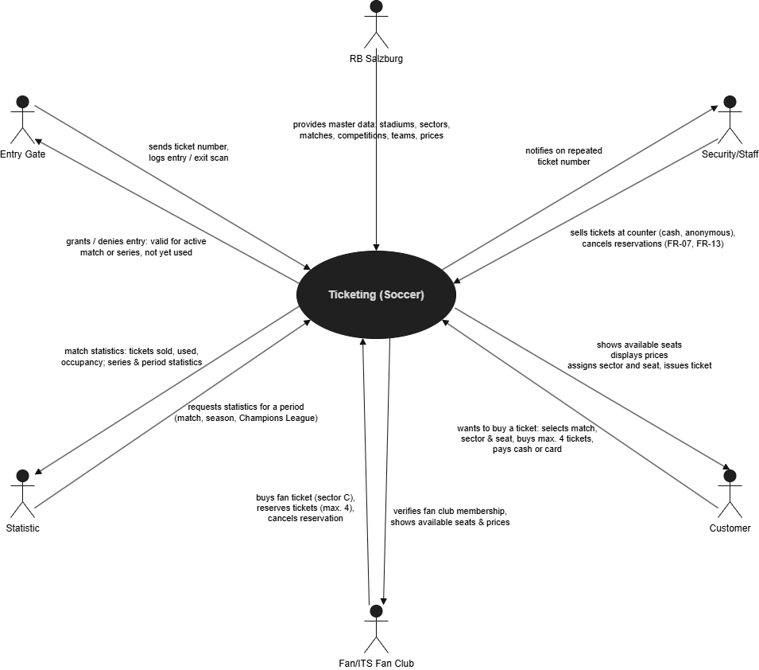
The context diagram shows the ticketing system as a black box and the external actors and systems that exchange information with it.
Figure 1: Context diagram of the ticketing system
Customers, season ticket holders and ticket counter staff query available seats and buy, reserve or cancel tickets via their clients (web shop, app, kiosk, POS). The payment provider handles credit card payments, and the FC ITS Fan Club data is used to verify membership for fan tickets. The entry gates send ticket numbers and entry/exit scans and receive a grant or deny decision; if a ticket number is used repeatedly, stadium staff are alerted. Club management and marketing receive utilisation and match statistics.

Requirements

Functional requirements
The project requirements document (Ticketing (Soccer), FH Salzburg, 2025) already describes the functional requirements in detail. The most important ones for our project are summarised below; FR-01 to FR-07 belong to Use Case 1 and FR-08 to FR-12 to Use Case 2.
ID | Requirement
FR-01 | The system shall allow a customer to select one of the upcoming matches for purchasing a ticket.
FR-02 | The system shall allow the customer to choose a sector and a seat.
FR-03 | The system shall display only available seats, i.e. seats without a sold single-match ticket for the match and without an assigned season ticket for the competition/series.
FR-04 | The system shall display the ticket price, determined by sector and competition type, during the purchase flow.
FR-05 | The system shall prevent double-selling of a seat by concurrency control.
FR-06 | The system shall limit purchases and reservations to a maximum of 4 tickets per person.
FR-07 | The system shall support payment in cash (staffed counters only) and by credit card (online or POS) and allow anonymous single-match sales at the counter.
FR-08 | The system shall allow a spectator to attempt entry by presenting a ticket number.
FR-09 | The system shall grant entry only if the ticket is valid for the currently active match (single-match ticket) or its competition/series (season ticket) and has not already been used for entry.
FR-10 | The system shall permit entry only when the match status is active (statuses: planned, active, conducted, cancelled).
FR-11 | The system shall log every entry and exit scan, so that a spectator who has left can re-enter with the same ticket number.
FR-12 | The system shall notify stadium staff when the same ticket number is presented repeatedly for entry.
FR-13 | The system shall allow season ticket holders to reserve tickets and customers or authorised staff to cancel reservations.
FR-14 | The system shall provide the real-time status of seats (free, reserved, sold) per match and sector.
FR-15 | The system shall maintain statistics per conducted match (tickets sold, tickets used, occupancy) and add them to the cumulative competition/series statistics.
FR-16 | The system shall provide utilisation statistics over a selectable period (match, season, winter/spring season, Champions League).
FR-17 | The system shall represent stadiums (name, address), sectors with capacities, competitions/series and matches with kickoff time, stadium and exactly two teams.
Table 3: Functional requirements

Non-functional requirements

Quality requirements
The following quality requirements act as architecture drivers:
ID | Quality attribute | Requirement
QR-01 | Data integrity / concurrency | A seat can never be sold or assigned twice, even with many simultaneous requests from different clients; capacity limits and pricing rules are always enforced.
QR-02 | Performance | Seat availability is shown in real time; seat queries and entry checks respond within about 2 seconds, so that spectators can enter the stadium without long queues.
QR-03 | Availability | The server remains available during sales peaks (e.g. start of Champions League sales) and while the stadium is being filled before kickoff.
QR-04 | Scalability / extensibility | The system can be extended from one stadium (32,000 seats) to several stadiums of the Austrian Bundesliga and to new clients and competitions without major changes.
QR-05 | Security and privacy | Personal customer data and ticket usage are processed according to the GDPR; payment data is protected; only authorised staff can cancel tickets.
QR-06 | Traceability | Every entry and exit scan is recorded so that ticket usage can be analysed and misuse (repeated ticket numbers) detected.
QR-07 | Usability | The purchase flow in the web application is simple and shows sectors, available seats and prices clearly.
QR-08 | Testability / maintainability | Critical paths are covered by automated unit tests (isolation, Arrange–Act–Assert, mocks/stubs, boundary and error cases); the code follows a clear, layered structure.
Table 4: Quality requirements

Constraints
The project is subject to the following constraints:
- Server-centric architecture: all clients (POS, web, kiosk, app, entry gate) communicate with one central server.
- The starter project and technology stack provided by the lecturers are used and extended.
- Team of two: exactly two use cases are implemented – Single-Match Ticket Sale and Access Control.
- A web application for customers and a lightweight HTML page simulating the entry gate are required.
- Master data is provided by seed data, fixtures or migration scripts; no CRUD interface is required.
- Business rules from the requirements: max. 4 tickets per person, cash only at staffed counters, every ticket bound to exactly one fixed seat, season tickets require a customer account, reduced price for children under 16 and persons with disabilities, fan sector C only for FC ITS Fan Club members.
- Legal: personal data must be handled in compliance with the GDPR.

Behavior

Overview Use Case Diagram

Use Case 1 xxx

Use Case Description

Activity Diagram

Use Case 2 xxx

Use Case Description

Activity Diagram

Architecture

Component Diagram

Implementation

Class Diagrams

Sequence Diagrams

Conclusion

