Coltin Lux

Computer Graphics

6 Oct 2016

1. Describe the difference between the Gouraud shading and Phong shading models. Include screen shots from your application to help strengthen your discussion.

The individual polygons can be seen using the Gouraud shading model. This is due to how the color is computed. Gouraud shading computes lighting values per vertex and interpolates them over a polygon. For example, the color values from the vertices are interpolated for each fragment on the polygon. This is why we see defined polygons.

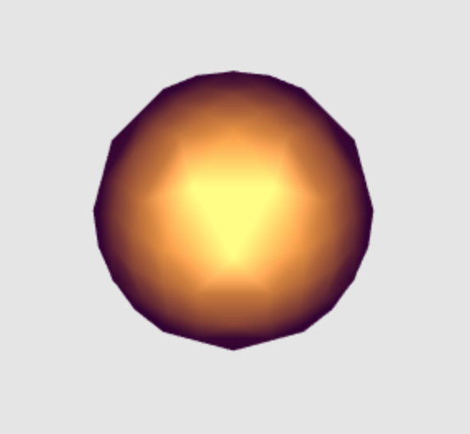

To help eliminate this visible polygon effect, we could try using the Phong shading model. This model helps to eliminate that effect because it interpolates the lighting matrix values across the polygon and computes the lighting per fragment. That is, per fragment as opposed to per vertex like the Gouraud model.

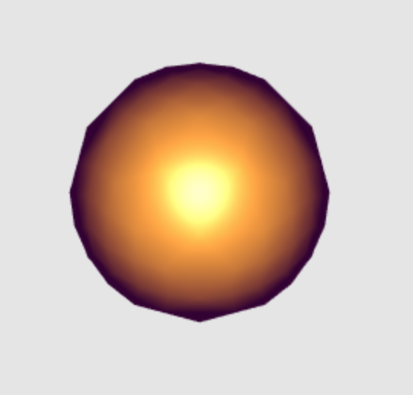

1. The Phong reflection model includes several non-physical (non-realistic) components in the model. List and describe these components that are not realistic and describe why they are made.
   1. The distance term, the distance term is used for if the light was moved closer.
   2. Global ambient term, this is for the ambient light that exists regardless of the ambient light from the light source we are calculating.
   3. Global specular term, this is for the specular light that exists regardless of the specular light from light source we are calculating.