1.
number of connection increases automatically
period:5min
tps:88

outgoing network:
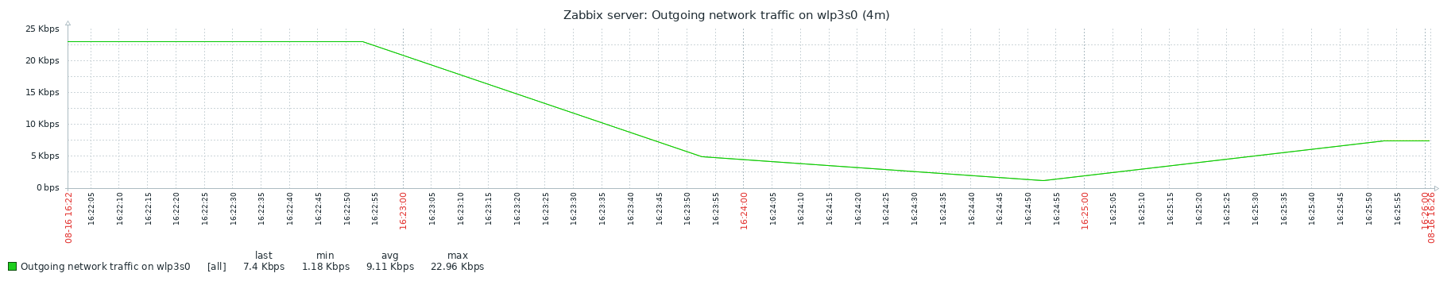
incoming network:
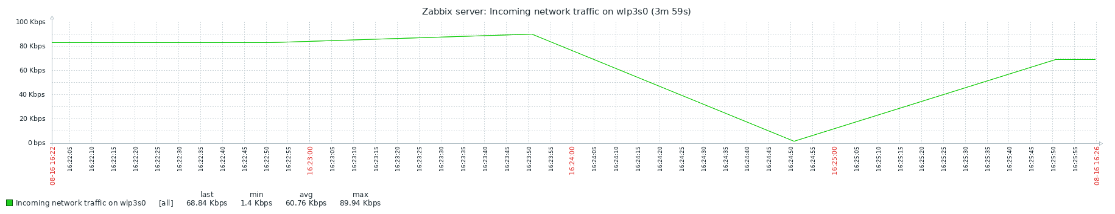
cpu load:
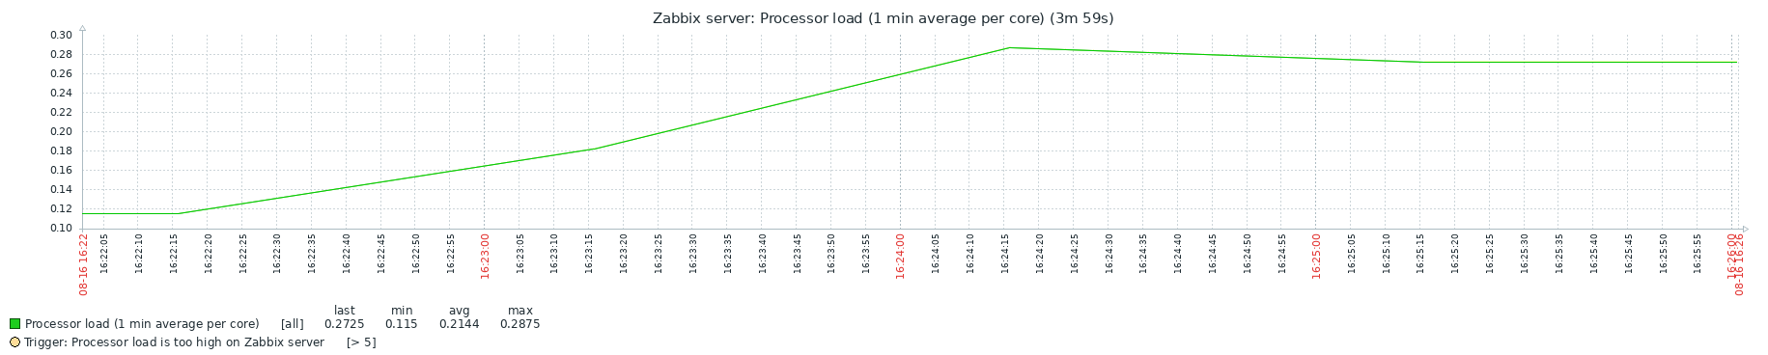
available memory:
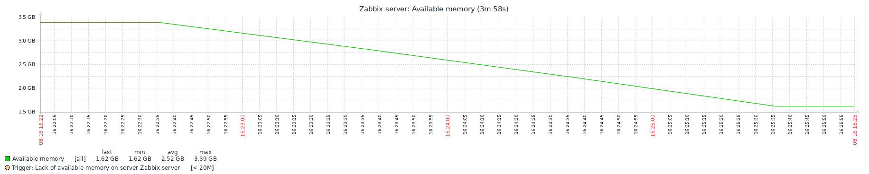
conclusion:low tps may caused by lacking of request

2.
same condition as above,except server and client is on same computer
tps:87

outgoing network:
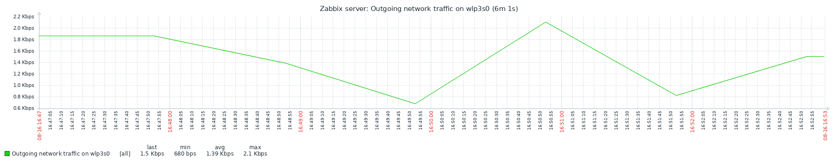
incoming network:
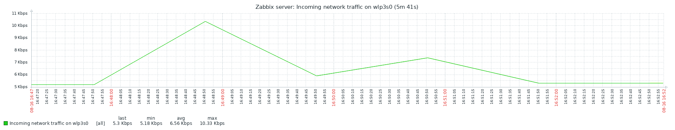
cpu load(average per 1 second):
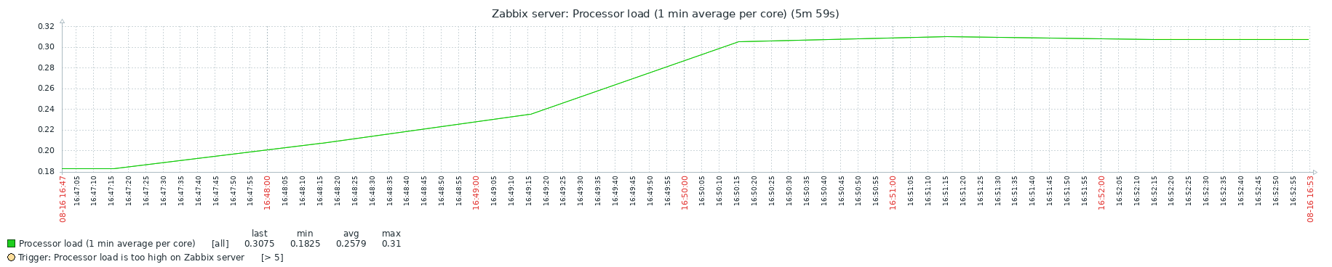
available memory:
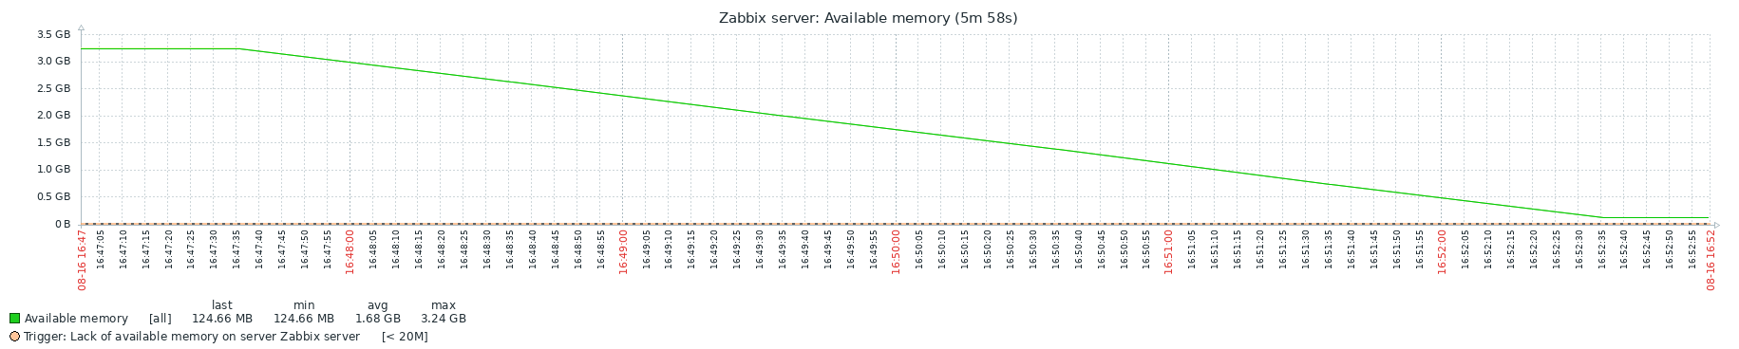
conclusion:due to lack of memory,running both side on same computer is meaningless

3.
some discoveries:due to unknown reason,client sends message to server discontinuously

4.
noticed that open too much connections leads to lack of memory of server,try to use 1 connection instead

5.
open two computer as client,each has 1 connection,then tps raised to 26k

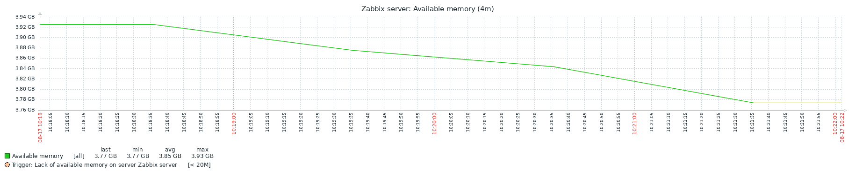
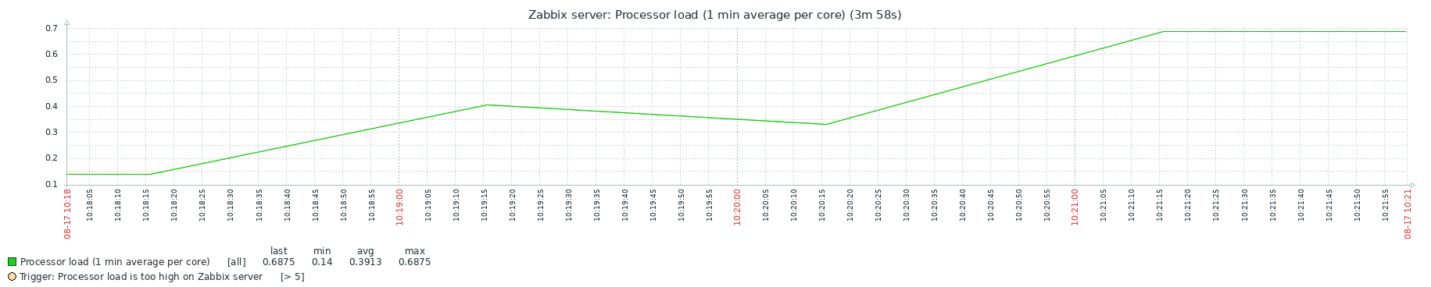
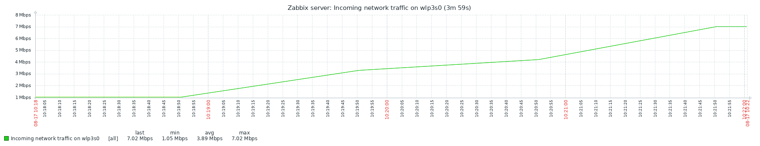
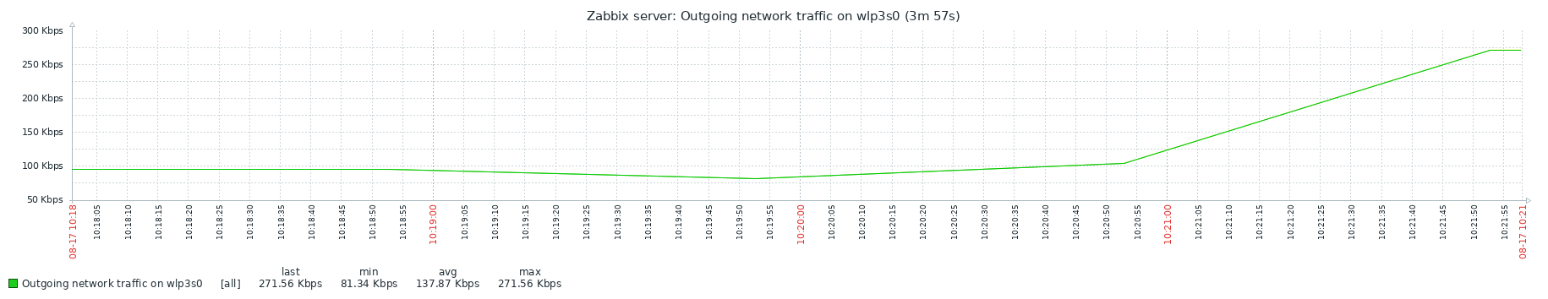
6.
test 5 didn’t always transmit message,this test transmit message continuously,server transmit every message received to every user in chat room,so outgoing network bps should be much more higher than incoming network bps,but test show opposite result,so low tps may caused by low speed of processing data
