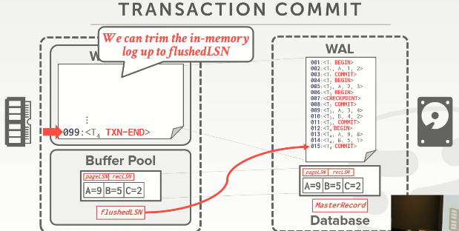
20:01 - 20:05
we could just trim the log and and reclaim this memory and reuse it
我们会截断这段日志，回收并复用这段内存
20:05 - 20:09
and that's that sort that ping pong effect I thought when we talked about last class when we did group commit
这就是我们上节课讨论group commit时所提到的那种乒乓效应（知秋注：使用两个buffer pool来做来回的gc操作）
20:09 - 20:11
once I know this log buffer is empty
一旦我知道这个log buffer是空的之后
20.11-20.12
because I flushed everything out
因为我将里面所有的内容都刷出去了
20.12-20.14
then I can use that to fill it up again
那么，我可以再次使用这个log buffer，并往里面添加数据
20:14 - 20:16
And then I read out the other buffer
接着，我再去读取其他的buffer
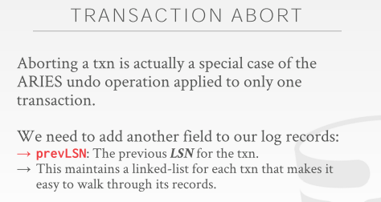
20:18 - 20:20
so for abort
So，对于事务中止来说
20.20-20.22
this is the me different than we did before, question
这和我们之前做的不同，有问题吗？
20:28 - 20:29
No
No
20.29-20.33
txn-end just as an internal marker for the recovery algorithm
TXN-END其实是恢复算法中的一个内部标记
20:33 - 20:36
that's to say that you will never see this transaction ever again
通过它你将永远不会再看到这个事务
20:39 - 20:43
you will never see any additional log records for this transaction
你永远不会看到与该事务有关的任何额外日志记录
20:44 - 20:47
because we've seen abort it'll make more sense when we do abort
当我们讨论事务中止的时候，你们会更能感受到它的作用
20:47 - 20:48
because there's stuff that you do after aborts
因为当事务中止后，你还要做些其他事情
20.48-
that be the outside world doesn't see, it's not like a query you executed
外界无法看到这些东西，它并不像是你所执行的那些查询
20:52 - 20:54
but it's stuff we have to do to reverse the changes
但我们需要做些处理来撤销这些修改
20.54-20.56
it'll yeah give me a few more slides, yes
我会在之后的幻灯片中讲这些内容，请讲
21:03 - 21:05
Disk write so what
磁盘写入方面有什么问题吗？
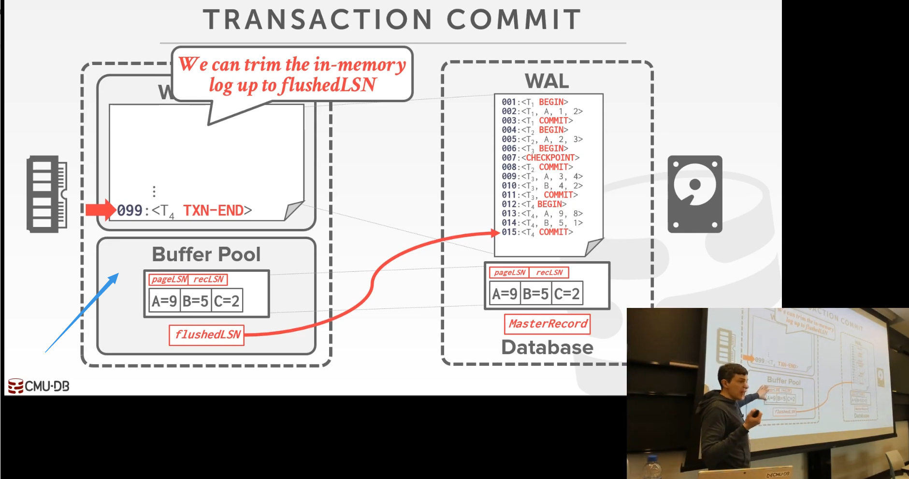

21:09- 21:12
right so at this point here when does it get flushed out
So，在此处，当这个page被刷出去的时候
21:13 - 21:16
and it's the buffer pool replacement policy, right
你问的是buffer pool的替换策略吧
21:17 - 21:18
what 2 wayit's right ,
两种方式
21.18-21.21
so one is you need to free up space
So，其中一种是，当你需要释放空间时
21.21-21.24
you have to evict to page its mark dirty you flush it out
你需要将那些标记为dirty的page刷出去
21:24 - 21:26
the other one could be the background writer
另一种方式则是使用background writer
21.26-21.27
which I think we talked about it briefly
我觉得我们之前有简单讨论过
21:28 - 21:34
and some database systems they'll just be a separate you have a separate process or thread in the background
有些数据库系统在后台会有一个独立进程或者线程
21:34- 21:38
that occasionally walks through the buffer pool finds all the dirty pages
它们偶尔会去遍历下buffer pool，然后找到所有的dirty page
21:38 - 21:40
and then just write them out ahead of time,
然后，提前将这些dirty page写出到磁盘
21.40-21.42
it doesn't a victim it says, hey let me write you out
它表示，我会将这个page写出到磁盘
24.42-21.44
and then I flip your bit to say you're not dirty anymore
接着，我会翻转你的bit，以此来表示这个page不再是dirty page了
21:44 - 21:46
so that way when the buffer pool replacement policy runs
So，当buffer pool的替换策略执行的时候
21:47 - 21:48
and it wants to evict a page
它想去移除buffer pool中的某个page
21.48-21.52
,hey I got one that's marked clean, I can just drop it not have to write it out
它表示：hey。我看到一个标记为clean的page，我可以将这个page移除，而不是将这个page写出到磁盘
21:55 - 21:56
but that's independent of what we're talking about here
但这和我们这里所讨论的东西无关
21:57 - 21.58
right that's again in some ways
某种意义上来讲
21.58-22.00
that's the beauty of the write-ahead log is that
预写式日志的魅力在于
22:00 - 22:07
we can separate the policy other than what we have we have big things other we making sure, we don't have big things that there's no log record out the disk or
在确保我们没有什么大问题（即没有将日志记录写出到磁盘）外，我们可以将策略分离，
22:08 - 22:12
we can separate that decision process from the write-ahead log part
我们可以将决策过程与预写日志部分分开
22:15 - 22:15
yes sorry
请讲
22:20 - 22:20
Correct
说的没错
22.20-22.21
so the statement is
So，他所说的是
22.21-22.23
if the flushedLSN is less than the pageLSN
如果flushedLSN小于pageLSN
22:23 - 22:25
then you can't evict that page
那么，你就无法移除这个page
22.25-22.31
, because you know that whatever this thing the last log record you wrote out is prior to this one
因为你写出的最后一条日志记录（flushedLSN）是在这个日志记录（pageLSN）之前
22:31 - 22:32
so therefore
因此
22.32-22.35
the log records that modify this page is not out on disk yet
修改这个page的日志记录并未落地到磁盘
22:41 - 22:42
so this question is
So，他的问题是
22.42-22.45
if your victim policy is running
如果你的Victim policy（受害者策略）执行的时候
22:45 - 22:45
you say
你会说
22.45-22.53
oh my flushedLSN is is less than all the pageLSN all the dirty pages in my log
我的flushedLSN要比我日志中所有dirty page相对应的pageLSN都要小
22:53 - 22.55
sorry your data pages in my buffer pool,
抱歉，你的data page都是在我的buffer pool中
22.55-22.58
all my pages my buffer pool are dirty
我buffer pool中的所有page都是dirty的
22.58-22.59
what do I do
我该做什么呢？
22.59-23.00
you have to stall
我们需要停下来
23:00 - 23:01
you have to write up a disk
你需要将这些page写出磁盘
23.01-23.03
you can't there's nothing else you could do
除此以外，你啥也做不了
23:05 - 23:08
and that's what the background writer supposed to be it's sort of like
这就是background writer所试着做的事情
23:08 - 23:10
if I know I have some idle IO cycles
如果我有一些闲置的I/O cycle
23.10-23.12
I could write this things out ahead of time
那么，我就可以将这些东西提前写出到磁盘
23:12 - 23:13
so I don't have to stall
So，我无须进行等待
23.13-23.15
I'm not on the critical path as I execute transactions
在我执行事务时，我并没有在关键路径上（指的是这样做，不会影响我们前台所做的事情）
这些事情并不会影响我正在执行的事务
23:16 - 23:18
right again the worst thing you could do is
你所能做的最糟糕的事情是
23.18-23.19
I'm running a transaction
当我执行一个事务时
23.19-23.21
it acquires a bunch of locks
它会去获取一堆lock
23:21 - 23:22
then I have to do a bunch of disk i/o
那么，我就需要去做一大堆磁盘I/O
23.22-23.26
because now that just the backs everybody up and everything it's slower
因为它会将所有数据进行备份，这样它们的速度就会变得更慢
23:26 - 23:28
so they if I can do some things in the background
So，如果我可以在后台做一些事情
23:28 - 23:32
now it's not on the critical path while I'm holding locks and transactions can complete more quickly
现在，它就不会影响前台性能，当我拿着lock时，事务可以以更快的速度完成
now，它就不会影响食物事务的执行，当我拿着lock的时候，事务可以以更快的速度完成
23:33 - 23:39
and but how you balance that between like flushing this ,flushing the the log ,flush flushing the background stuff
我们该如何在刷出这个表数据、刷出日志、后台进程刷出操作这几者间取得平衡呢？
23:39 - 23:41
that's the tricky thing that database systems have to figure out
这是数据库系统必须解决的一个棘手问题
23:42 - 23:43
we don't let the OS do it for us
我们不会让OS来为我们处理这些
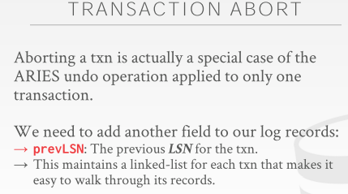
23:45 - 23:46
okay

23.46-23.48
so for aborts
So，我们来讲下事务中止
23.48-23.54 ！！！！
aborts are gonna be serve a special case we're gonna have under ARIES
事务中止其实是ARIES下我们所遇到的一种特殊案例
23.54-23.58
, where we're gonna reverse changes for transactions
我们会去撤销这些事务所做的修改
23:59 - 24:07
but we're actually going to end up adding log records to keep track of that we will we have reversed those changes
但实际上，我们会通过添加日志记录来跟踪我们撤销了哪些修改
24:08 - 24:10
this is way different than we talked about so far
这和我们之前讨论的不同
24.10-24.13
like every time we said oh we abort a transaction rollback its changes
比如，每当我们中止一个事务，我们就会去回滚它所做的修改
24:13 - 24:15
we just assume that we can undo some stuff in memory
我们假设我们可以撤销内存中的某些东西
24:16 - 24:21
right now we need to keep track of everything that we're doing as we reverse transactions
当我们撤销事务所做的修改时，我们需要去跟踪我们所做的所有事情
24:22 - 24:27
so we're gonna add an additional field to our our log records called the prevLSN
So，我们会往我们的日志记录中添加一个额外字段，即prevLSN
24:28 - 24:29
and this is not required
它不是必须的
24.29-24.32
but this is just gonna make your life easier at runtime
但这会让你在运行时处理起来更为容易
24:32 - 24:36！！！！！！！
because now you can know how to jump back to find the next thing you need to reverse for a given transaction
因为通过它，你就可以知道该如何往回跳找到你需要用来撤销一个给定事务的东西
24:37 - 24:39
I to avoid have a sort of scanning everything
以此避免去扫描所有的日志记录
24:39 - 24:39
essentially
本质上来讲
24.39-24.40
you think of this as like
你可以这样想
24.40-24.42
for every transaction you're generating a linked list to say,
对于每个事务来说，它们会去生成一个链表
24.42-24.44
for every aborted transaction
对于每个被中止的事务来说
24.44-24.46
, here's the linked list up, here's all the changes I need to reverse
这里有一个链表，链表中保存了我需要撤销的所有修改
24:46 - 24:50
so I need to I know how to walk back in one by one and reverse them
So，我需要知道我该如何回过头去逐个撤销这些修改
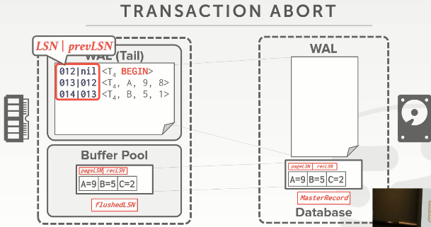
24:52 - 24:54
so we have our simple transaction like this
So，这里我们有一个简单事务
24.54-24.57
again now we have the LSN and prevLSN
现在，我们有LSN和prevLSN
24:58 - 25:03
and so for the first LSN for the first log record for this transaction t4
对于事务T4的第一条日志记录来说
25.03-25.07
,since there's no prevLSN at the begin statement
因为在BEGIN语句中，并没有prevLSN
25:07 - 25:10
we just set the prevLSN to nil
我们只需将这个prevLSN设置为nil
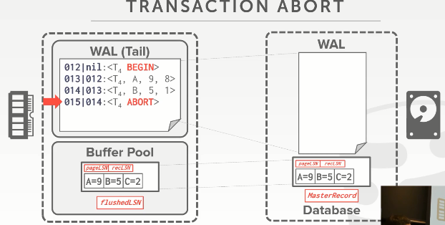
25:11 - 25:12
so this transaction runs
So，这个事务开始执行
25.12-25.13
it makes some changes
它做了一些修改
25.13-25.15
but then it aborts
但接着，T4被中止了
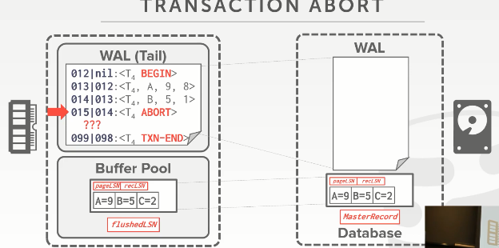
25:15 - 25:19
so now what we need to do is reverse those changes
So，现在我们需要做的就是撤销这些修改
25:19 - 25:21
I'm going to add log entries for these
我要为这些操作添加日志记录
25:22 - 25:26
and then once we know all those log entries have been are durable out in a disk
接着，一旦我们知道所有的日志条目都被持久化到磁盘后
25:27 - 25:29
we can then add the txn-end message
那么，我们就可以往log buffer中添加TXN-END消息
25:29 - 25:30
again this is what I was saying
这就是我之前所说的
25.30-25.35
this is saying that the transaction MS is denoting
这条事务消息表示
25:35 - 25:38
that there's nothing else that it could ever come about this transaction later on
这条消息之后不会再出现与该事务相关的日志记录
25:38 - 25:42
we've reversed I've done everything we've needed to do
我们已经撤销了我们需要撤销的所有东西
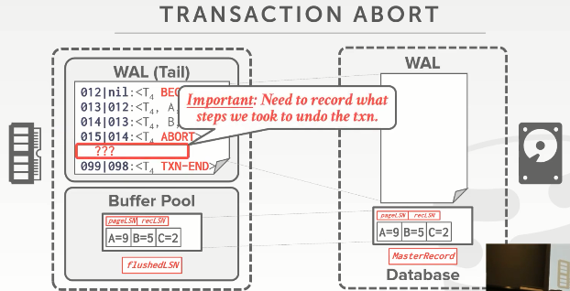
25:43 - 25:44
so for this part here
So，对于这部分来说
25.44-25.50
when you're talk about know how we actually record the changes, that were reversing as we go along
当我们撤销这些修改时，我们该如何记录这些撤销动作呢？
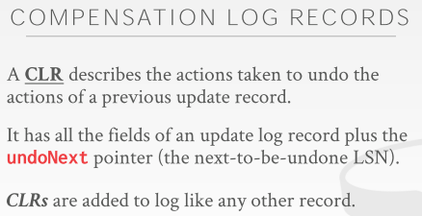
25:50 - 25:54
so these are called compensation log records or CLRS
So，这被叫做补偿日志记录（Compensation Log Record）或者称之为CLR
25:54 - 25:57
so CLR is just it's like an update record
So，CLR就像是一条更新记录
25:57 - 26:01
but it's reversing the change of a an actual update record when the transaction actually ran
但它会去撤销事务执行时所写入的更新记录
26.01-26.02
yes
请讲
26:04 - 26:04
yes
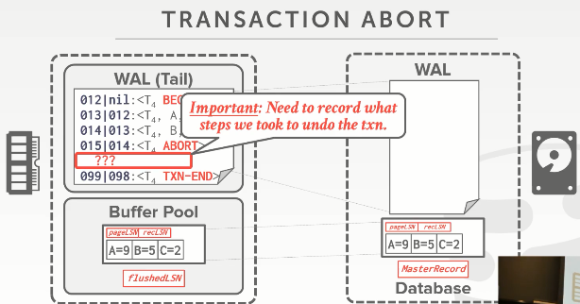
26:13 - 26:14
so your question is
So，你的问题是
26.14-26.15
why do we even have the prevLSN,
我们为什么需要这个prevLSN
26.15-26.17
what is this actually buying us
它为我们实际做了哪些事
26:21 - 26:24
yeah her question your statement is
So，她所说的是
26.24-26.27
could you just check for this simple example just find all the things that are t4
在这个简单例子中，我们是否能找到与T4相关的所有东西
26:28 - 26:30
and then just figure out those things I need reverse
并弄清楚我需要撤销哪些东西
26.30-26.31
, yes
没错，是这样的
26:31 - 26:35
but what if I'm running like a high-end system is doing a million transactions a second
但就拿高端的数据库系统来说，每秒钟它可以处理一百万个事务
26:36 - 26:36
and I crash
接着，系统发生了崩溃
26.36-26.39
now I have at any given time ,when I crashed
在任意给定时间点，如果我发生了崩溃
26.39-26.42
I could have maybe a hundred thousand transactions in flight
在运行时，我可能这10万个事务出现了问题
26:42 - 26:46
so to avoid having to scan everything over and over again to find ,you know exactly what I need to reverse
So，为了避免通过反复扫描日志来弄清楚我需要撤销哪些操作
26:47 - 26:48
this is just a helper to get us there
prevLSN对我们的帮助很大
26:49 - 26:52
so it's not required for correctness， it's could use it for convenience
So，对于正确性来说，它不是必需品，但通过它，我们处理起来会很方便
26:55 - 26:55
yes
请问
26:58 - 26:59
why do we need to reverse
我们为什么需要撤销？
27:02 - 27:03
so for this example no
So，在这个例子，答案是No
27:05 - 27:09
but how do you know in real life in real system
但在真正的系统中，这是怎么样的呢？

27:09 - 27:10
what did I say, I said
我说过
27.10-27.13
we we don't know we're not logging what pages we write to disk
我们并没有记录我们往磁盘中写入了哪些page
27:13 - 27:15
we don't know anything about what we've got written to disk
我们不清楚我们已经往磁盘中写入了哪些东西
27:15 - 27:18
because the eviction policy is doing its own thing
因为移除策略自己在做自己的事情
27:18 - 27:21
that's why we're gonna play it safe I'm just reverse everything
这就是为什么我将所有修改撤销是安全的原因所在了
这就是为什么我要保证安全的玩耍的原因所在，我就是要撤销那些需要撤销的修改。
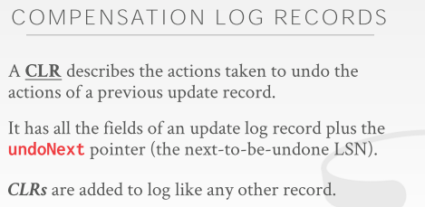
27:24 - 27:27
so the CLR again it's gonna be like an update log record
So，CLR就像是一条更新日志记录
27.27-27.31
, where it's gonna have before and after value
它里面会存放一个before value以及一个after value
27:31 - 27:36
but it's gonna be tied to an update record that actually occurred during the transactions regular life time
但每条CLR会和事务正常执行时已经执行的每条更新记录相对应

27:37 - 27:38
and then we're gonna have this undo next pointer
接着，我们会有这个undoNext指针
27.38-27.40
which again just for convenience
出于方便起见
27.40-27.42
who can tell us what's the next LSN that we need to reverse
它可以告诉我们需要撤销的下一个LSN是什么
27:43 - 27:48
so that we know you know for every given transaction
对于每个给定事务来说

27:48 - 27:52
we would know whether we've actually processed all the ones ,we need we need the process to reverse all this changes
通过它，我们会知道我们是否已经处理了我们所需要撤销的所有修改
27:53 - 27:56
so the CLR is gonna be added to the log just like any other log record
So，就和其他日志记录一样，CLR会被添加到日志中
27:56 - 28:00
but they're gonna be added after the transaction gets aborted
但它们会在事务被中止之后添加到日志中
28:01 - 28:05
and then once we went through reverse everything then we add the txn-end
接着，一旦我们撤销了该事务所做的所有修改，那么，我们就会往日志中添加TXN-END
28:05 - 28:06
so unlike commit
So，和COMMIT不同
28.06-28.07
with commit
如果是COMMIT
28.07-28.12
I have to flush all the log records to disk, before I tell the outside world I've committed
在我告诉外界该事务已经被提交前，我必须将所有的日志记录刷出到磁盘
28:12 - 28:13
if a transaction gets aborted
如果一个事务被中止了
28.13-28.16
,we immediately go back to the applications that you were aborted
我们会立刻回过头去告诉应用程序，这个事务被中止了
28:16 - 28:19
they don't need to wait around to to write anything up the disk
它们无须去等待将任何东西写入到磁盘
28.19-28.20
, because who cares
因为没人会去注意这些被中止的事务
28:21 - 28:26
right they try to go read that their changes not real to do that, as long as we're running with the concurrency control protocol
只要我们使用并发控制协议，他们就会尝试读取它们的更改不是真的更改了
28:27 - 28:30
so the CLR just get logged any other record
So，就像其他记录一样，CLR会被记录到日志中
28.30-28.33
and then they just get flushed out ,you know eventually it's at some point
接着，最终在某个时候，它们会被刷出到磁盘
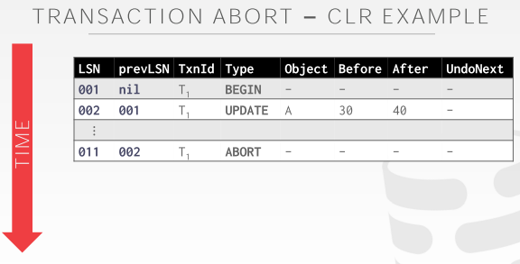
28:35 - 28:36
so let's look an example
So，我们来看个例子
28.36-28.37
how we're gonna use CLRS
我们该如何使用CLR
28.37-28.40
and so because I'm running out of space on the slide
因为我幻灯片上的空间不够了
28:40 - 28:42
because we have so many so many metadata fields
因为我们其实有很多元数据字段能展示
28.42-28.44
I'm now going to show this in a tabular form
我现在以这种表格的方式向你们展示
28:44 - 28:46
so here we have one transaction t1
So，这里我们有一个事务T1
28.46-28.47
it just does an update on A
它对A进行更新
28:48 - 28:49
all right, and then it aborts
接着，该事务被中止了
28:49 - 28:51
we don't care how how it aborted
我们不会去关心该事务是怎么被中止的
28.51-28.56
whether the the transaction application said to abort, or the database systems concurrency control protocol said to abort it
不管是应用程序中止了该事务，还是数据库系统的并发控制协议中止了该事务
28:56 - 28:57
we don't care
我们并不在意这些
28.57-28.57
it's all the same
结果都是一样的，那就是这个事务被中止了

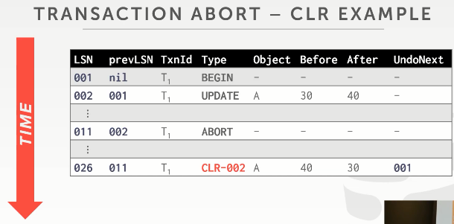
28:58 - 29:00
so now when we want to start undoing its change
So，现在当我们想开始撤销它所做的修改时
29.00-29.03
right this is during the regular execution time
这是在正常执行时处理的
这个动作发生在我们平常正常的程序执行过程中
29:03 - 29:04
this is not during recovery
而不是在数据库恢复时处理
29.04-29.06
this as we're as processing transactions
即当我们处理事务的时候去撤销这个被中止事务所做的修改
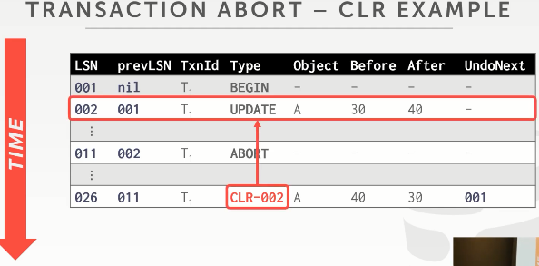
29:06 - 29:08
we're gonna create a CLR entry
我们会去创建一个CLR条目(知秋注：注意Type)
29.08-29.12
,that's gonna be tied to the the update bet it did
它会和该事务所执行的一个更新操作相关联
29:12 - 29:14
and again it looks exactly like the first one
它和第一条记录看起来很像
29.14-29.16
it's just that the before and after values were reversed
只是before value和after value的值互相换了一下
29:17 - 29:20
so before the value was 30 and then after the update was 40
So，在第一条记录中before value的值是30，after value的值是40
29:20 - 29:25
so now what we're doing in a reversal or setting the the old value back to 30
So，我们所做的就是将A变为老值，即30
29:27 - 29:27
right
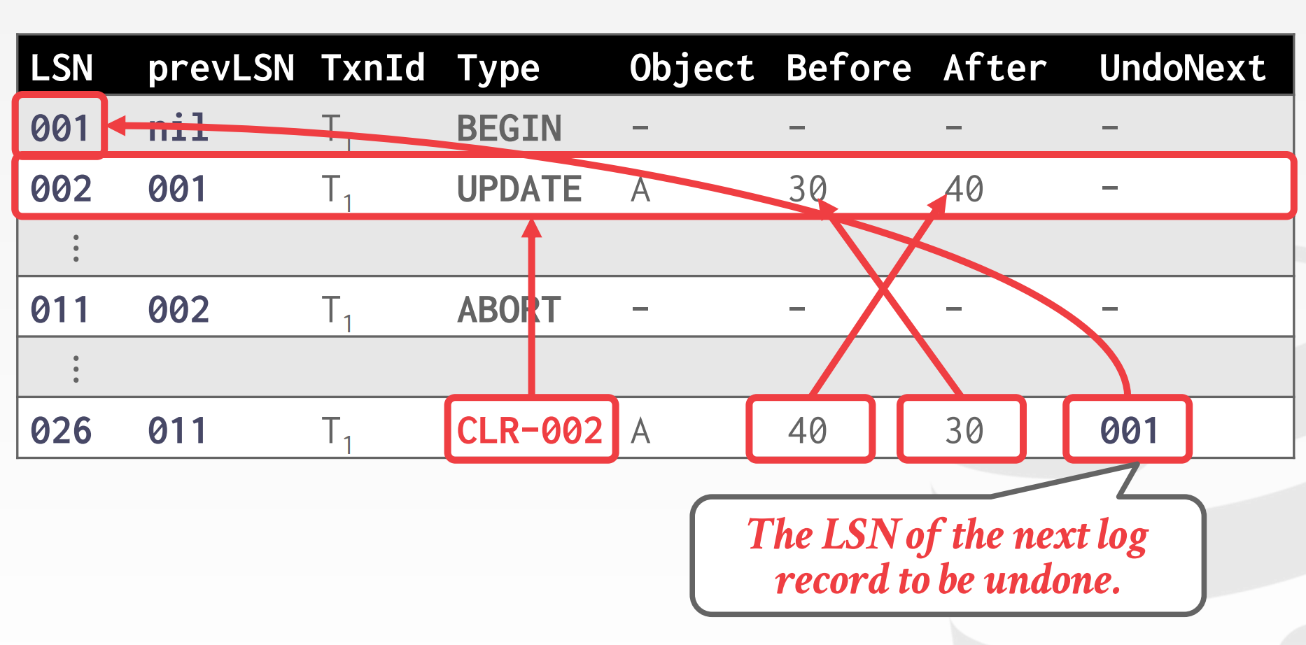

29:28 - 29:30
and then we had this UndoNext record
接着，我们有这个UndoNext记录
29.30-29.32
that LSN that says
这个LSN表示的是
29.32-29.2
what's the next thing we need to undo to completely reverse this transaction
我们需要去撤销的下一个目标修改条目，以此来完全撤销该事务所做的修改
29:35 - 29:37
but in this particular example here
但在这个例子中
29.37-29.40
the undoLSN goes to the begin statement
这个undoLSN指向的是这条BEGIN语句
29:40 - 29:43
so we know there's nothing else for us to reverse for this transaction
So，我们知道我们无须再去做任何事情来撤销这个事务
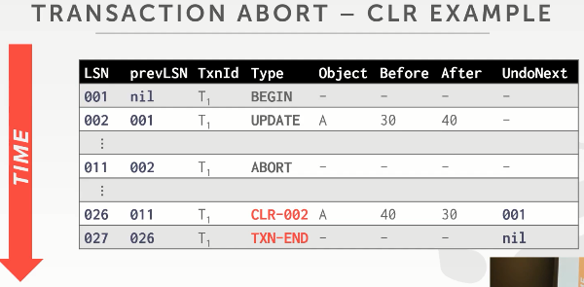
29:43 - 29:46
so we can go ahead and add our txn-end record
So，我们可以去添加我们的TXN-END记录
29:48 - 29:48
yes
请问
29:58 - 29.58
this question is
他的问题是
29.58-30.04
did I say that when you abort, you can immediately go back to the application and say your transaction aborted
我说过，当你中止该事务，你就会立刻回过头去告诉应用程序，你的事务被中止了
30:04 - 30:07
and that you don't have to write flush any of these things out to disk
并且你无须往磁盘中写入任何数据
30.07-30.08
correct
说的没错
30.08-30.08
yes
请问
30:17 - 30:18
His statement is
他说的是
30.18-30.19
I said that
我之前说过
30.19-30.21
if you really tell the outside world you aborted
假设你告诉外界你的事务已经被中止了
30:22 - 30:25
but then you create these log records
但接着，你创建了这些日志记录
30.25-30.26
you reverse the changes
你撤消了这些修改
30:26 - 30:27
But then you crash
但接着，你崩溃了
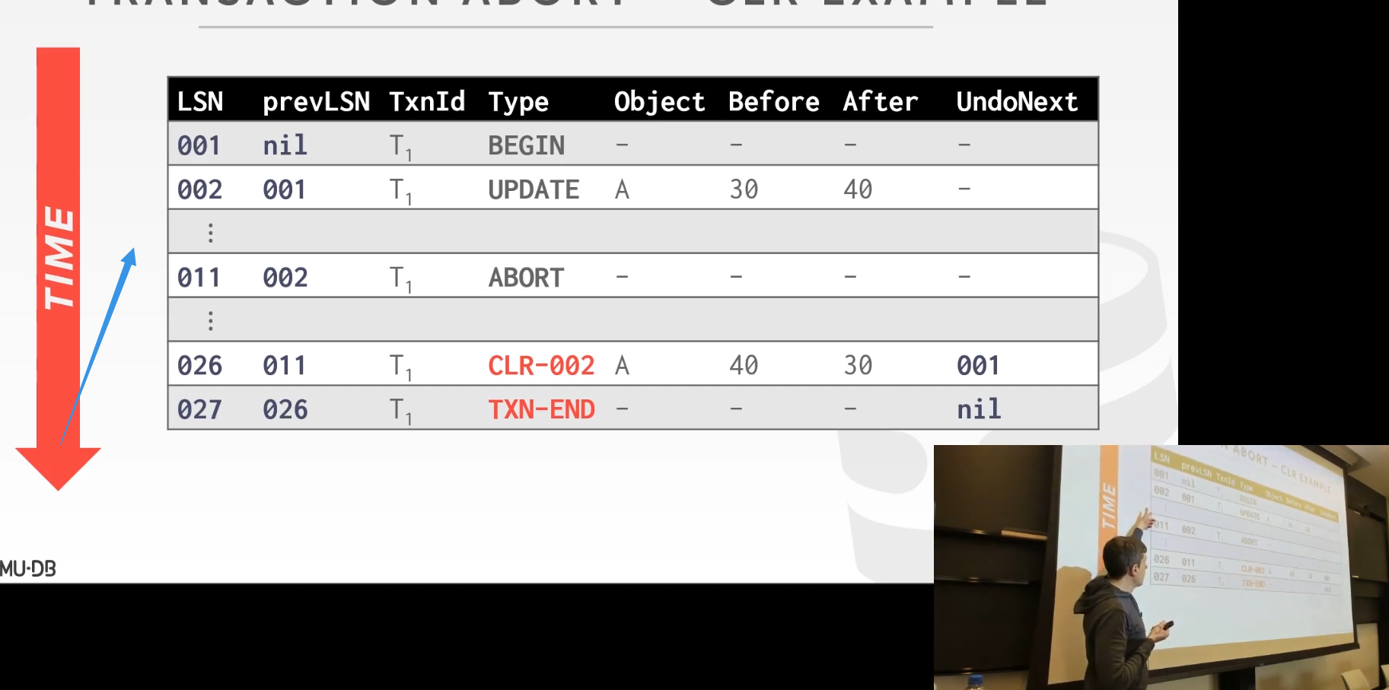

30:30 -30:31
up here
你在这个位置发生了崩溃
30:34 - 30:34
you're right
你说的没错
30.34-30.36
so you yeah you can lose these
So，你会丢失这部分数据
30.36-30.37
do we care
我们在意这些吗？
30:40 - 30:41
he's shaking his head no why
这位同学摇了摇他的头，看来他说的是No，能讲下原因吗
30:45 - 30:47
well yes you're gonna abort it
没错，你中止了这个事务
30.47-30.49
but like something more fundamental
但我想要的是更为基础的回答
30:52 - 30:52
correct
没错
30.52-30.57
so the the page that got modified ,but this transaction is not on disk
So，修改该page的事务并未落地到磁盘
30:57 - 30:58
so who cares
So，没人会在意这点
31:03 - 31:04
half of what sorry
一半的什么？能重复下么
31:09 - 31:09
yes
Yes
31:11 - 31:12
who cares
谁会去在意这些东西呢？
31:19 - 31:20
can you undo it
你能撤销它们吗？
31.20-31.21
because they didn't commit right
因为它们并没有被提交
31:23 - 31:25
so again we'll see this when we do a for example
So，我们会在演示例子的时候，再次看到你说的这些东西
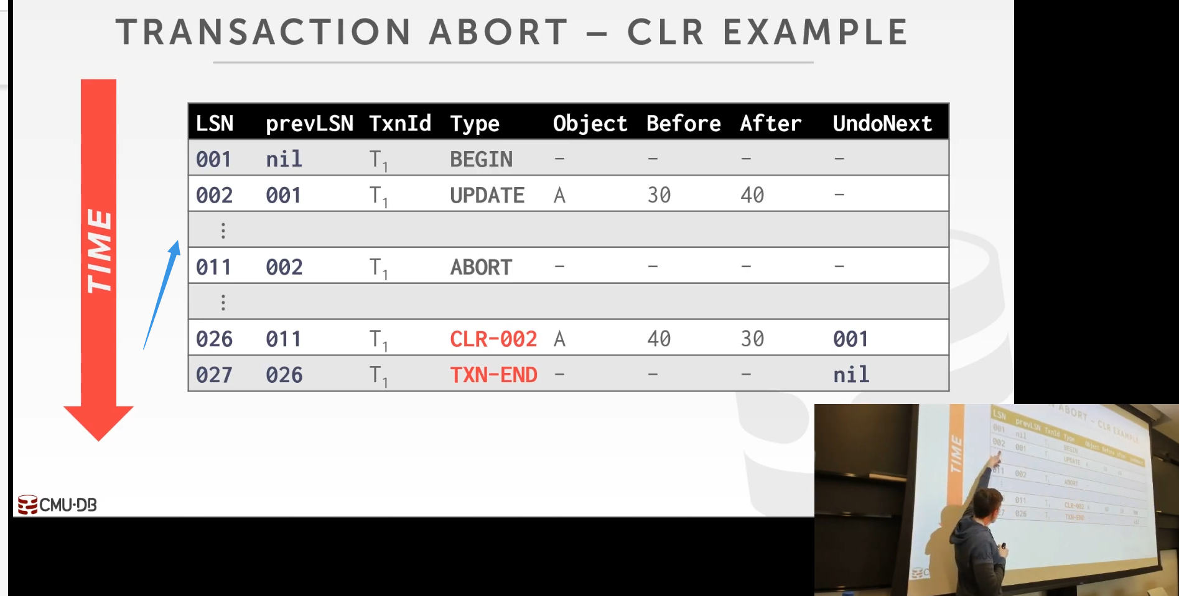

31:25 - 31:27 ！！！！！！
if I don't see if I crash here
如果我在这个位置崩溃
31:28 - 31:32
and I don't see what was the final determination of the transaction where the committed aborted
我就不会知道这个事务最终是被提交还是被中止了
31:32 - 31:34
it aborted right
这里它是被中止了
31:35 - 31:36
that's the beauty of the write-ahead log
这就是预写式日志的魅力所在
31.36-31.41
this is a single source location to tell us, what was the final outcome of what happened in the transaction
即这个单一来源位置会告诉我们该事务最后发生的事情是什么
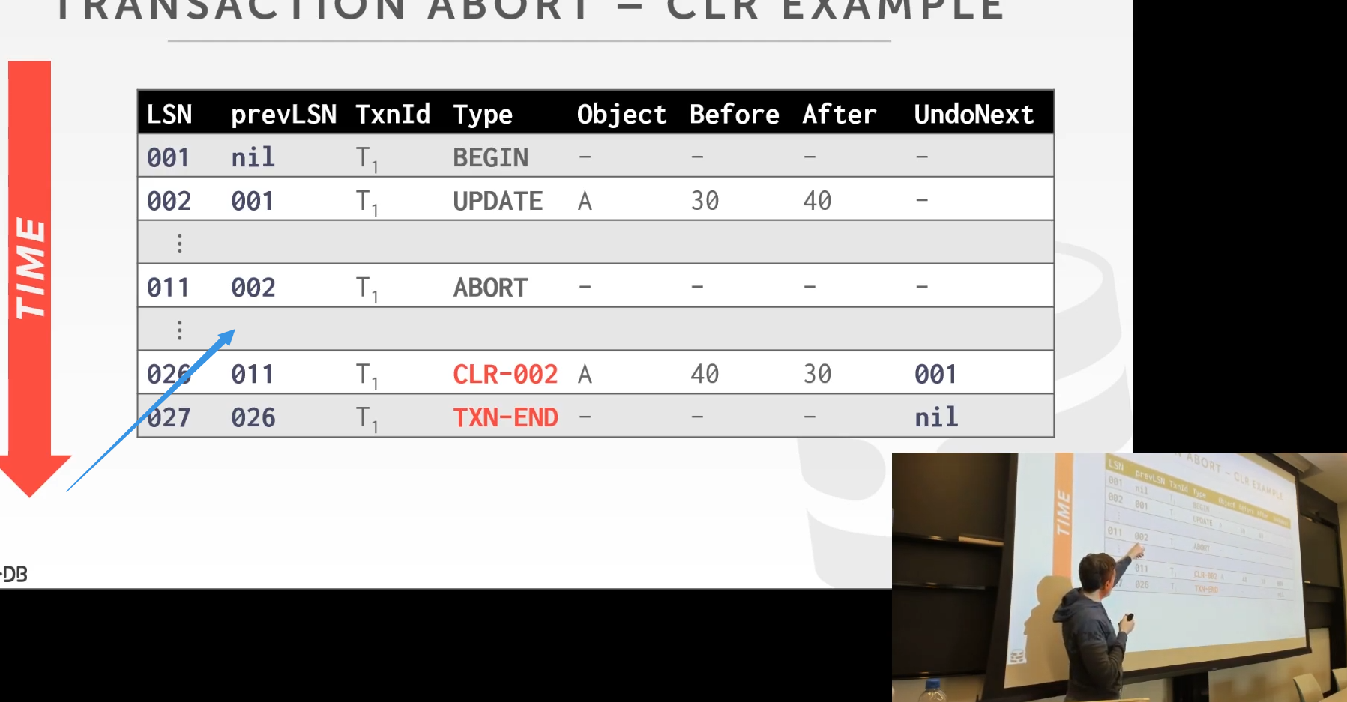

31:41 - 31:43
so we got here, say we got here
So，假设我们到了这里
31:44 - 31:45
and we aborted
然后，我们中止了这个事务
31.45-31.46
we tell the WAL we aborted
我们告诉WAL，我们中止了这个事务
31:48 - 31:50
we crash before we do all this stuff
在我们做这些事情之前，我们发生了崩溃
31.50-31.51
who cares
谁会去在意这种事情呢？
31:51 - 31:52
because the transaction got aborted .
因为该事务被中止了
31.52-31.55
,we don't have to guarantee anything's durable
我们不需要去保证与该事务有关的东西被持久化
31:55 - 31.57
we come back and it wasn't there
当系统恢复正常的时候，这些东西就不见了
31.57-31.59
because we'll reverse any changes that could have gotten written up to disk
因为我们会去撤销所有可能已经被写入到磁盘的修改
32:03 - 32:04
correct
说的没错
32.04-32.06
so if the page got written to disk
So，如果该page被写入到磁盘
32.06-32.09
you would have seen you have to see all these things anyway
你就会看到所有这些东西
32:09 - 32:12
so we know how to put it back in the correct state if necessary,
So，如果有必要的话，我们知道该如何将这些东西回归正轨
32.12-32.14
yes
请问
32:22 - 32:24
here yes so so say

32:26 - 32:30
all right so say they said they told us roll back from the terminal from from the application
So，假设Terminal或者应用程序告诉我们，它们要回滚这个事务
32:30 - 32:36
then we could append this log record into the write-ahead log in memory,
那么，我们可以将这个日志记录追加到内存中的预写式日志里面去
32.36-32.39
go back and immediately tell them that it aborted
回过头去，并立刻告诉它们，这个事务已经被中止了
32:39 - 32:41
and then now start cleaning up all its internal changes
接着，现在开始去清理该事务内部所做的修改
32:42 - 32:48
right so we don't have to wait to do any clean up all the things that it modified
So，我们无须去等待清理这些东西的工作完成
32:48 - 32:49
we can tell them it abort it right away
我们可以直接告诉它们，我们中止了该事务
32:55 - 32:58
I commit again commit says I have commit it

32:58 - 33:01
if the DBMS tell you you committed
如果DBMS告诉你这个事务已经被提交了
33.01-33.03
,it has to guarantee that everything's durable
它需要去保证所有东西被持久化了
33:03 - 33:11
so it has to be ready any log record ,that that corresponds to the changes that it made has to be written a disk upon the commit
So，当事务提交的时候，它需要确保与这些修改相关的日志记录已经落地到磁盘
33:11 - 33:13
we don't care about txn-end
我们不会去在意这个TXN-END
33.13-33.14
that's internal for us
这是我们内部的东西，与外界无关
33:17 - 33:18
immediately come back yes
每次，我们会立刻回过头去这么做
33.18-33.20
,I think about why like who cares that I aborted
我觉得，谁会去在意我这个事务中止了呢？
33.20-33.24
why do I care that you're gonna go do much I stopped to clean things up
为什么我要去停下来等你清理完这些修改呢？
33:24 - 33:25
why should I wait for that
我为什么需要等待这种事情完成呢？
33:33 - 33:34
so this question is,
So，他的问题是
33.34-33.41！！！！！！！！
for any if any transaction wants to modify the same page that got modified by abort of transaction
如果任意一个事务想要对一个page进行修改，该page已经被中止事务所修改
33:41 - 33:50
do they need to wait until the the log record that modified it got written out the disk
它们是否需要等待，直到修改该page的那些日志记录被写出到磁盘？
33:51 -33:51
no
答案是No
33:53 - 33:58
right because if I like say I abort here I say this is in a page A
假设我中止了对该page中对象A的操作
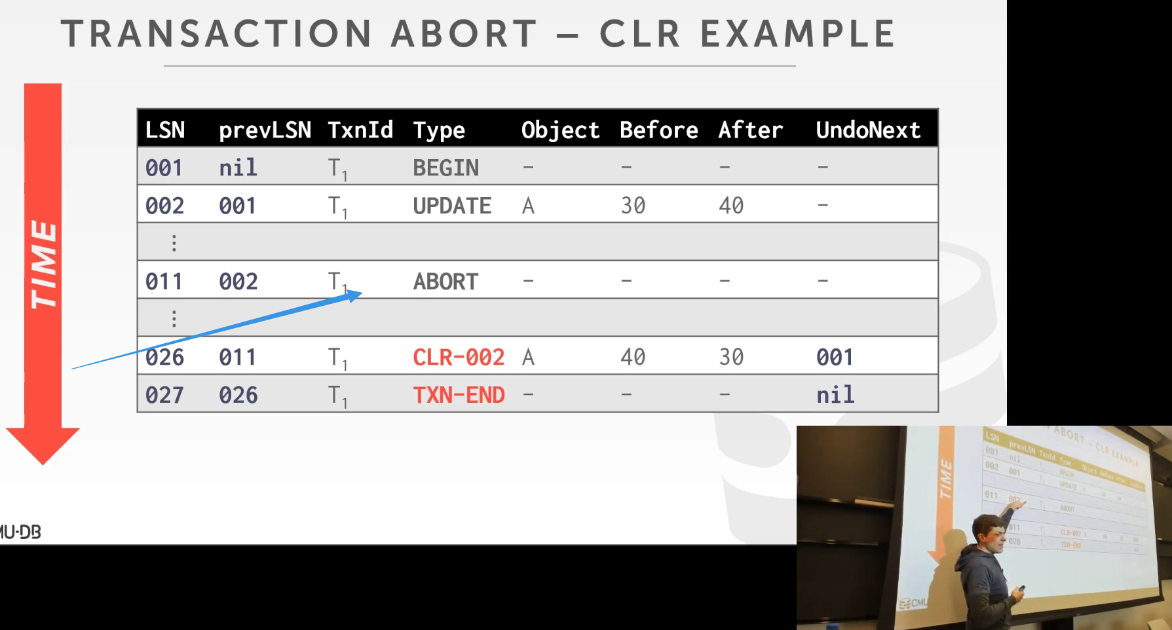

33:59 - 34:00
I abort here
我在这里中止
34.00-34.05
I can immediately release what it can to assuming today's locking, I release the write lock I have on that page
假设我可以立刻释放该page上的这个lock
34:05 - 34:08
any now other transaction can come along start modifying it
那么，其他事务就可以开始对该page进行修改
34:09 - 34:10
so they start modifying
So，它们会开始修改这个page
34.10-34.11
what is that going to do,
它们会做什么呢
34.11-34.13
that's gonna create new log records
它们会去创建新的日志记录
34.13-34.15
bump up the pageLSN for my page
并撞上这个page的pageLSN
34:16 - 34:17
and therefore
因此
34.17-34.23
that page can't be written out the disk until my new log records now written out to the disk
直到我的新日志记录被写出到磁盘，该page才能被写出到磁盘
34:23 - 34:26
so who cares this is of the transaction modify
So，谁会去在意这个被中止的事务所做的修改呢？
34:38 - 34:40
Yeah,you you correct
你说的没错
34:41 - 34:49
if I try to read the the change may from an aborted transaction
如果我试着去读取一个被中止的事务所做的修改
34:49 - 34:52
I have to reverse them，yes before I'm allowed to read
在我被允许去读取这些数据前，我就需要撤销这些修改

34:58 - 35:00
when we say written a disk of written a memory
你说的是写出到磁盘还是写入内存
35:01 - 35:04
yeah sure yes, you have to yes you'd have to reverse that
没错，你需要撤销这些东西
35.04-35.06
I mean that's true always
我的意思是，这种说法永远是对的
35:11 - 35:14
if it's single version yes, multi version no
如果这里是单版本，答案就是Yes，如果是多版本，那答案就是No
35:14 - 35:17
Because multi versioning right who cares
因为如果是多版本的话，没人会去在意这个
35:17 - 35:19
because you now you just have a version that doesn't exist anymore
因为你现在拥有的是一个不再存在的数据版本
35:21 - 35:21
you ignore it
你将它忽略
35:25 - 35:26
yes in single version yes
在单版本中是这样的
35.26-35.27
you'd had to reverse these things yes
你需要撤销这些东西
35:29 - 35:29
yes
请问
35:49 - 35:50
Yeah statement is
他的说法是
35.50-35.52
let's say I have a transaction
假设我有一个事务
35.52-35.54
that makes a lot of updates
它对数据库进行了大量更新
35.54-35.59
have the updates get you you apply all the updates
并且你提交了所有更新
35:59 - 36:03
but half of them got written out to disk
但只有一半更新被落地到磁盘
36:04 - 36:07
how do I reverse those changes now they're out on disk
我该如何撤销这些已经落地到磁盘的修改呢？
36:07 - 36:08
and it because it's the steal policy
因为我们使用的是Steal策略
36.08-
I'm a lot of commits, right ，I'm rather flush out dirty pages, yes
我有很多提交，right ，我会有刷出dirty pages
36:12 - 36:15
you'd have to bring them back in and reverse them
你需要将它们放回来，并撤销这些修改
36:16 - 36:17
when you actually do that
当你实际做这件事的时候
36.17-36.18
whether you do that immediately on abort
你是否要在事务中止的第一时间来做撤销这件事
36.18- 36:26
or whether you do that you know lazily like oh when somebody the next time someone goes to reads it then I'll reverse it
或者你可以之后再做，就好比当有人在未来某个时间去读这块的数据时，我再去撤销此处的修改

36:28 - 36:28
yes
请问
36:31 - 36:31
I love this question
我很喜欢这个问题
36.31-36.40
there is some dude on YouTube complain like, like professor Pablo, I like your class, I like the material
有些老兄在Youtube上表示，我喜欢你的课，我喜欢你提供的材料
36:40 - 36:43
but all those pesky students keep interrupting me asking questions bad dude right
但总有些讨厌的学生会一直打断我，问我各种问题，这帮人太坏了
36:45 - 36:46
let him begin to CMU and come ask questions
让他们自己来CMU，来问我问题吧
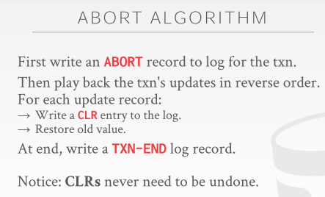
36:47 - 36:50
all right

36.50-36.52
so now for our abort algorithm we've already said this
So，我们已经讨论过我们的中止算法了
36:52 - 36:55
we're gonna write a abort record to the log for the transaction
我们会为事务写一个ABORT记录，并添加到日志中
36:55 - 37:00
and then we're gonna play back the transaction updates in reverse order for the transaction
然后，我们会以相反的顺序去执行事务的操作
37:00 - 37:03
and then for everything in that we're going to reverse
接着，对于我们要去撤销的所有东西来说
37:03 - 37:04
we add a CLR entry to the log,
我们会往日志中添加一条CLR条目
37.04-37.07
it's tied to the original update that occurred during normal operation
它会与正常操作期间所执行的更新语句所绑定
37:08 - 37:09
and then we restore the version of value
接着，我们恢复该数值的版本
37:09 - 37:17
and then once we complete all these transaction these CLRS ,once we've done them all they need to do for this transaction
一旦我们添加完该事务中这些对应的CLR记录
37:17 - 37:19
then we can add the txn-end message
那么，我们就可以添加这条TXN-END消息
37:20 - 37:22
so CLRS will never need to be undone
So，我们永远不需要去撤销CLR
37:25 - 37:29
well we could only redo them during recovery
Well，我们只有在恢复过程中才会去重新执行它们
37:30 - 37:32
because it's like a one-way update
因为它就像是某种单向更新
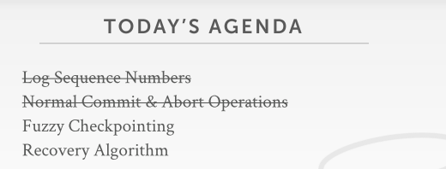
37:35 - 37:35
okay

37.35-37.38
so now right so what have you covered so far, now we know we have log sequence numbers
So，这就是目前我们今天已经介绍的东西，我们已经介绍了日志序列号
37:39 - 37:40
we have these CLRS
我们拥有这些CLR
37.40-37.45
,and we know do how to keep track of the LSN's at various locations for us to figure out ,what has been written out the disk or not
我们知道该如何跟踪这些不同位置处的LSN来弄清楚哪些东西被落地到磁盘
37:46 - 37:51
so now let's talk about,how we're going to bring along some additional metadata to figure out ,what was running at the system at the time
So，现在我们来讨论下如何通过一些额外的元数据来弄清楚系统此时在做什么
37:51 - 37:54
and use it a better checkpointing scheme
并使用一个更好的checkpoint方案
37:54 - 37.56
so in last class I said that
So，在上节课的时候，我说过
37.56-38.03
checkpoints are necessary for us to be able to figure out at ,what point can we figure out at, what point can we start recovering the database
checkpoint对于我们来说是必要的，我们可以通过它来弄清楚我们从日志中哪个位置来开始恢复数据库
38:03 - 38:04
because without checkpoints
因为如果没有checkpoint
38.04-38.07
we potentially have to go look through the entire log
我们可能就得去查看整个日志
38:07 - 38:09
if we have one year's worth a log with no checkpoints
如果我们的日志是一年份的，并且它里面没有checkpoint
38:10 - 38:12
we may have the potential replay one year's worth for the log
我们可能就需要重新执行这一年份的日志
38.12-38.15
, which could take a long time
这很花时间
38:15 - 38:17
so let's look at two bad ways to take checkpoints
So，我们来看下制作checkpoint的两种糟糕做法
38:18 - 38:20
and we'll see why fuzzy checkpoints are the better way
并且我们会去看看为什么fuzzy checkpoint是一种更好的方法
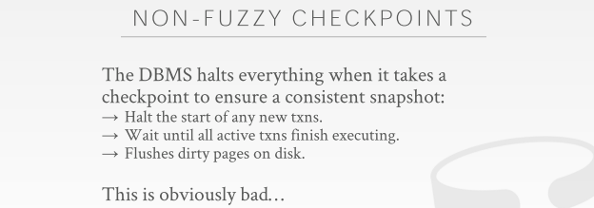
38:20 - 38:23
so I discuss one of these bad ways last class
So，我在上节课的时候讨论过其中一种糟糕的方法
38:24 - 38:24
and I said
我说过
38.24-38.35
the technique we were going to use was to just halt the execution of of any new transaction and then take the checkpoint
我们所使用的技术会让所有的新事务（知秋注：新事务，重点！！）停止执行，接着，再去制作checkpoint

38:35 - 38:41
and this will guarantee that my pages they're written out the disk, as part of that checkpoint are are consistent
这能保证我们要写出磁盘的page，从checkpoint 角度来说，具备了一致性
38:41 - 38:45
there's no torn updates from a transaction that was running halfway through right
在制作checkpoint的过程中并不会发生事务更新修改操作
38:45 - 38:49
so basically what happens is on the on the front end on the network network layer
So，简单来讲，这里所发生的是，在前端和网络层处
38:49 - 38:51
we halt the execution of any new transaction
我们停止了任何新事务的执行
38:51 - 38:56
and then we just wait for all our workers to finish executing any transaction that's already running
接着，我们等待所有已经在执行事务完成它们手上的工作
38:57 - 38.58
so this is obviously bad
So，显然，这很糟糕

,because we we have to wait until everybody ,you know to all its transaction to finish
因为，我不得不等待，直到所有这些已有的事务结束
39:04 - 39:05
we can't start executing anything new
我们无法开始任何新事务的执行
39:05 - 39:08
so we have one transaction it's gonna take five hours to run
so 如果这个过程中，我们有一个事务，它会消耗5个小时来执行
39:09 - 39:13
they've made the wait for the five hours to finish wait for it to finish ,before we go ahead and take our checkpoint
那在我们执行新事务之前，就要等它5个小时，直到它结束位置，并得到我们的checkpoint
39:13 - 39:16
and then during that time we can't execute any other transaction
这期间，我们无法执行任何其他的新事务
39:16 - 39:19
so our system looks completely unresponsive
so 我们的系统看起来就像一个完全无响应的服务器一样
39:19 - 39:22
from a recovery standpoint ,this is this is this is great
从恢复（recovery）的角来看，这种方式是极好不过的
39:22 - 39:25
because the the checkpoint is consistent as I said
就像我说的，因为checkpoint 具备一致性的特性
39:25 - 39:31
there's no intermediate updates it's exactly as it was ,when you know it only contains changes from committed transactions
这里没有发生中间更新 ，确切的说，它只包含那些已提交事务的修改
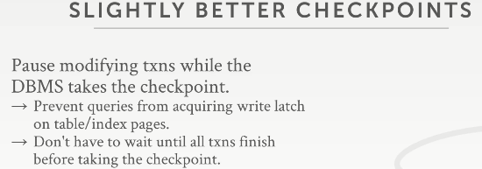
39:32 - 39:41
so a slightly better way to do this would be to pause transactions while they're running while we take the checkpoint
so 稍好一点的方法是当我们要得到checkpoint时，在事务运行时暂停事务

39:42 - 39:47
so we're going to mean what this is any transaction has a query that's modifying the database
so 意思就是任何要修改数据库的查询事务
39:48 - 39:52
we just pause it,any time they try to acquire a write latch on a page
我们就是要暂停它，每当他们尝试获取某个page上的写锁时
39:52 - 39:54
we don't we prevent that and they have to stall
我们不阻止，但他们必须得等
39:56 - 40:00
any read-only transaction can still run ,they can read whatever they want ,because that doesn't interfere with that checkpoint
那些只读事务依然可以运行，它们可以读任何它们想读的，因为这不会干扰该checkpoint的制作

