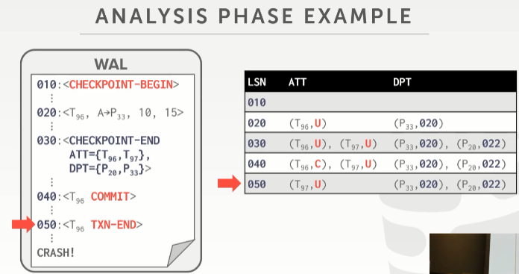
01:00:00 - 01:00:02
and actually you would just sort of see that because it would be nothing
其实你可以想下，因为它会说空的，什么也没有
01:00:04 - 01:00:05
yeah if it's empty
如果它是空的话
1.00.05-1.00.07
then you know there's nothing everything it made it out yes
然后，你知道，不会有任何东西写出的
01:00:18 - 01:00:19
your question is
你的问题是
1.00.19-
if during the in between the checkpoint is do I am I not write dirty pages out to disk
如果在这两个checkpoint 标签期间，我并没有将 dirty pages写出到磁盘
01:00:26 - 01:00:28
the buffer pool write out to disk
并没有将buffer pool中数据写出到磁盘，，，，，，
01:00:34 - 01:00:37
yes I don't I think yes but I actually don't know the answer that
我觉得这是对的，但我实际并不清楚答案是什么
01:00:38 - 01:00:39
I think yes
我觉得是对的
1.00.39-
because like why would the buffer pool manager ever need to write out dirty pages
因为为什么 buffer pool管理器需要写出dirty pages
01:00:43 - 01:00:46
why I need to evict some stuff to make space when the checkpoint essentially is just doing that
为什么在checkpoint做这些事时，我要移除一些东西来腾出空间，
01:00:55 - 01:00:55
correct
没错
1.00.55-1.00.58
yeah I I think the answer is yes
我觉得答案是Yes
1.00.58-1.00.59
,but I should double-check that
但我应该会去再次确认下
01:01:00 - 01:01:00
so his statement is
So，他所说的是
1.01.00-1.01.02
that during the checkpoint
在checkpoint期间
1.01.02-1.01.07
the buffer pool manager is not allowed to write out dirty pages to disk
buffer pool manager是不允许将dirty pages写出到磁盘的
01:01:09 - 01:01:14
because you may not missing the term hey, feel like answer is yes, but I actually don't know
因为你可能会丢失一些东西，感觉他讲的没问题，但我实际并不清楚
1.01.13-1.01.14
I mean you think about that
我的意思是，你们可以自行去思考下答案
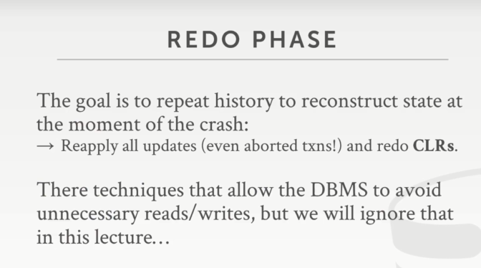

01:01:17 - 01:01:17
all right

1.01.17-1.01.19
so again after the analysis phase,
So，当经历过分析阶段后
1.01.19-1.01.21
we have ATT and DPT
我们拿到了ATT和DPT
1.01.21-1.01.23
that's telling us what was going on at the time of the crash
通过它们我们可以知道在当系统遇上崩溃的时候，系统里有什么
01:01:24 - 01:01:26
so now in the redo phase
So，在Redo阶段中
1.01.26-1.01.27
we want to repeat history
我们想重复执行下以前的操作
01:01:27 - 01:01:32
so we're gonna apply all the changes from some point in the log
So，我们会从日志中的某处位置开始重新执行操作
1.01.32-1.01.34
,where we know that there was a dirty page
假设这里有一个dirty page
1.01.34-1.01.37
,that was modified that was potentially not made about to disk
我们对该page进行了修改，但它并未被写出到磁盘
01:01:37 - 01:01:41
so we're gonna reapply all these changes for even the aborted transactions
So，即使是那些被中止的事务，我们也要重新执行它所做的修改
01:01:41 - 01:01:45
and any CLR we see from an aborted transaction ,we're gonna redo them as well
对于由中止事务所得到的CLR（Compensation Log Record 补偿日志记录）来说，我们也要重新执行它们
01:01:47 - 01:01:49
so this as I said before
So，就如我之前所讲
1.01.49-51.51
this is gonna seem very expensive
这样做的成本非常昂贵
01:01:52 - 01:01:57
because we're gonna be reapplying changes we may technically need may not need have to reapply
因为这些我要重新执行的修改，从技术上来说，我可能没有必要去重新执行它们
01:01:59 - 01:01.59
you know for example
举个例子
1.01.59-1.02.02
for a transaction, we know it's gonna aborted
我们知道这里有一个事务被中止了
01:02:02 - 01:02:08
who cares about you know bringing a page in making doing update ,and then reversing in the CLRS
谁会关心说，他在进行更新时要先引入该page，然后在CLRS中反转撤销？
01:02:08 - 01:02:11
and then you know if that was the only transaction that modified that page
那么，如果只有该事务对该page进行了修改
1.02.11-1.02.13
I could just skip that transaction
我就可以跳过这个事务
01:02:14 - 01:02:16
so there are optimizations like that you can do
So，你可以做一系列类似于这种的优化
01:02:16 - 01:02:18
but again we're just going to ignore that
但现在我们将它忽略
我们仅需要将这个事务的修改忽略即可
1.02.18-1.02.21
because you want to make sure that everything is is sort of clean and correct
因为我们想确保这一切都是干净且正确的
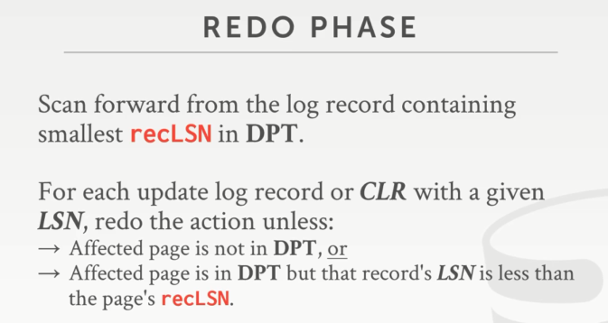

01:02:23 - 01:02:25
so as we do the redo phase
So，当我们在经历Redo阶段的时候
1.02.25-1.02.30
then we start from the log record containing the smallest recLSN in the DPT
我们会从DPT所包含page的最小recLSN 所指的那条log记录开始
01:02:30 - 01:02:37
because again that's the that's the first log record ,that modified a page that dirtied it up, that we may not have made it out to disk
因为这是修改该page的第一条日志记录，我们可能并没有将它对应的表数据写出到磁盘
01:02:37 - 01:02:40
then as we scan through for every single log record of CLR
然后我们会扫描CLR的每条日志记录
01:02:40 - 01:02:46
we look at all LSN ,and we're gonna redo the action, unless the page is not in the dirty page table
我们会查看所有的LSN，我们会重新执行这些动作，除非目标page并不在DPT中
01:02:46 - 01:02:53
in which case we know that our modifications are flushed out the disk at some point
只要目标page并不在DPT中，也就意味着我们的修改已经在某个时刻刷出到磁盘中了
01:02:54 - 01:02:56
or if it is in our dirty page table
或者，如果目标page在我们的DPT中
01:02:56 - 01:03:02
but our LSN is is less than the pages recLSN
但我们的LSN小于目标page的recLSN
01:03:02 - 01:03:08
and that would mean that we made some change to the page, then the page got written out the disk
这也就意味着，我们对目标page做了些修改，并将它写出到磁盘了
01:03:08 - 01:03:12
but then some other transaction made you know maybe that made it change of the same page
然后，其他一些事务对该page进行了别的修改
01:03:12 - 01:03:15
and then that second change didn't write out the disk
第二次修改并没有写出到磁盘
01:03:15 - 01:03:19
and so that's why again we if we record the recLSN write out the disk
so 这就是为什么我们要将recLSN 写出到磁盘的原因
01:03:19 - 01:03:23
we can recognize what actually got you know what changes actually got modified
通过它，我们可以知道哪些修改真正落地了
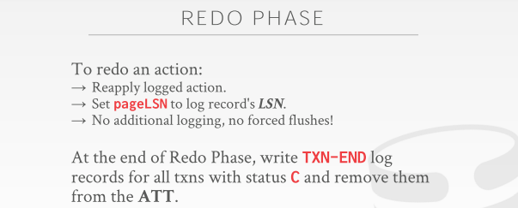
01:03:27 - 01:03:30
so to redo an action we just reapply the change
对于redo这个操作，我们就是重新执行这些修改
01:03:31 - 01:03:34
and we set the pageLSN to the recLSN
我们将pageLSN设定到recLSN
01:03:34 - 01:03:40
it's just as we would normally do during regular execution of you know the transaction
这就像在transaction的常规执行过程中通常要做的一样
01:03:41 - 01:03:43
but during the normal operation we're not doing any additional logging
但在正常操作期间，我们不会进行任何其他日志记录
01:03:44 - 01:03:46
we don't worry about flushing it and you anything extra, right
我们无须担心要去刷出日志记录等其他额外的事情
01:03:46 - 01:03:48
we can sort of do everything asynchronously
我们可以异步完成所有工作
01:03:49 - 01:03:56
so then when we get to the txn-end message, we'll just go ahead and and remove it from the ATT
so 当我们得到 TXN-END 消息后，我们就要将该事务从ATT中移除
01:03:56 - 01:04:00
and if we want to be super careful we could flush everything at that point
如果我们想要极度细致，我们可以在这个点将所有东西刷出到磁盘
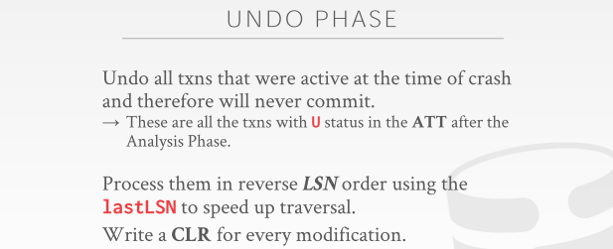
01:04:03 - 01:04:04
So now the last phase is the undo
so 现在，最后一个阶段就是undo
01:04:05 - 01:04:13
so this is just undoing all the transactions that we saw at the ATT after the analysis phase, that are hanging out with the the undo flag or undo Canada flag
so，在analysis 阶段之后，undo要做的就是撤销所有我们在ATT中事务所做的修改
01:04:14 - 01:04:21
so we're gonna go back and reverse order in in we're going to reverse their changes in log sequence order
so 我们按照log记录的顺序,由后往前来撤销它们的修改
01:04:22 - 01:04:28
see even though transaction t1 ran before t1 aborted then t3 aborted
若我们看到T1中止了，然后T3中止
01:04:28 - 01:04:34
if we see the look the log records for T3 first ,well we will reverse them first before we get to t1
接着，我们会先看到T3的log记录，我们会在看到T1的记录前翻转它们
01:04:36 - 01:04:38
and every single time we reverse a change
每次我们只翻转一个修改
01:04:39 - 01:04:43
we're gonna add a CLR message, this is the allows to recover database
同时，我们会添加一条CLR信息，通过它我们可以来恢复数据库
01:04:43 - 01:04:46
if we're crashed and recovery ， we know what we actually reversed
如果我们的服务器发送崩溃，并恢复，我们知道我们该如何去恢复
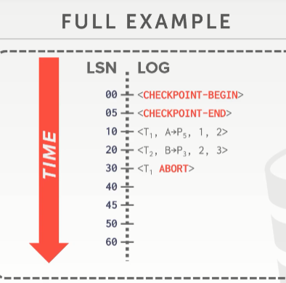
01:04:47 - 01:04:52
so this gives a lot of hand waving a lot of text look, let's look walk through a simple example here
so ，我们已经看了很多理论了，让我们通过一个简单的例子看看
01:04:53 - 01:04:56
so here we have now a write ahead log going forward in time
so 这里，我们有一个预写日志，按时间线从上到下
01:04:57 - 01:04:59
and we see that we did a checkpoint and it finished
你可以看到，我们做了一个checkpoint 并完毕
01:04:59 - 01:05:05
and then we have t1 did a modification on page 5, t2 to modification page 3
然后，我们有一个事务T1对Page5进行了一个修改，T2对Page3进行了修改
01:05:05 - 01:05:06
but then t1 aborts
然后T1中止了
01:05:07 - 01:05:10
so during the normal execution what do we do to abort this
so 在正常的执行过程中，发生中止后，我们要做些什么
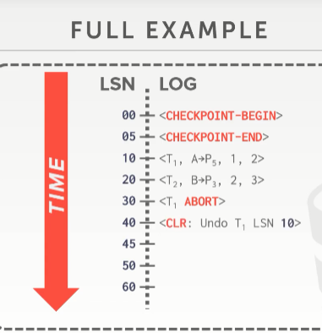
01:05:11 - 01:05:15
we create the CLR that says we want to undo the change from this this one here
我们会创建CLR，以此来说，我们想要从这里开始撤销T1的修改（undo）
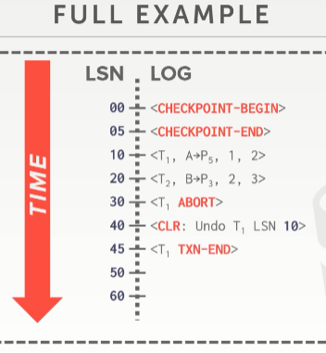
01:05:16 - 01:05:23
and then once we know that that's been applied,then we go ahead and add our transaction and message to say ,that this transaction is fully done
然后，一旦我们搞定这些，然后我们继续往前，为这个事务添加一条TXN-END消息，以此表示这个事务已经完全结束了
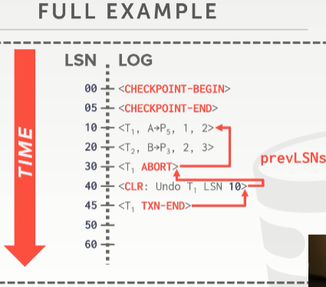
01:05:24 - 01:05:27
so now I'm also now showing the prevLSN
so now,我也会给大家展示下这个prevLSN
01:05:27 - 01:05:33
but that you can think of that this is a linked list to tell you for a given transaction , how to walk back through its updates and be able to reverse them
您可以将之想象成一个链表，通过它，对于给定的事务，我们知道该如何回滚修改
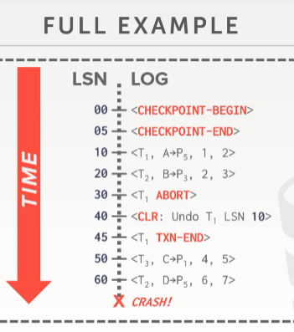
01:05:34 - 01:05:40
so now let's say at here ,we do a bunch of changes for t3 and t2 ,but then we crash
so now，我们来看这里，T3和T2做了很多修改，然后我们的服务器崩溃了
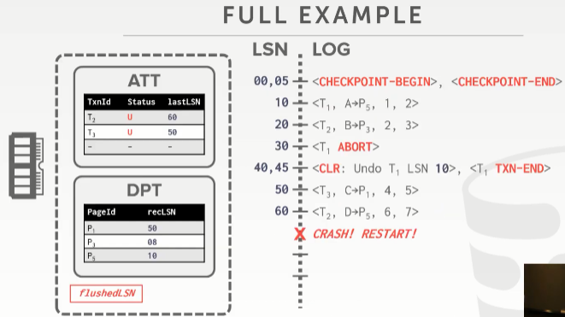
01:05:42 - 01:05:47
so in the analysis phase we would come back and populate the ATT and DPT
so 在分析阶段，我们需要回看并将对应的信息填充到ATT和DPT中
01:05:48 - 01:05:51
so this is somebody at space ,so this is a truncated version of a log
so 这是它们在内存里的样子，so，这是一个log中的某一段
01:05:51 - 01:05:57
so for example here I had 40 45 inches upper lines now 40 45 on one line
so 对于这里的例子来说，现在，我在40 ，45这一行
01:05:57 - 01:06:01
right and there's there is the CLR followed by the transaction and message
这里有一条CLR和一条T1结束的信息（TXN-END）
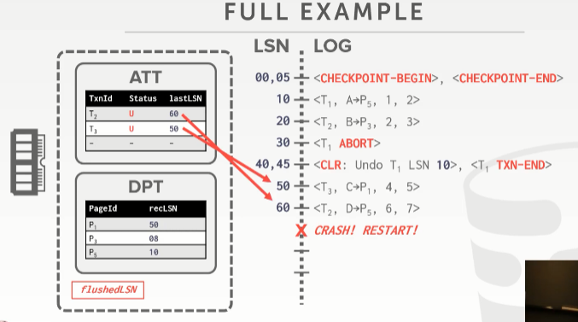
01:06:02 - 01:06:07
so let me come back are you ATT tells us that we had two active transactions t2 and t3
so 我可以回头通过ATT来告诉我们，我们有两个活动事务T2和T3
01:06:07 - 01:06:13
and then we have the lastLSN that point to the last modification that they made
然后，我们有lastLSN 可以知道这所操作的目标page最后修改的LSN处
01:06:13 - 01:06:23
so we're going to look at the transaction that has the be the greatest than recLSN to start doing undo
so 我们会去看这俩事务目标page大于recLSN 的LSN中最大的那个，从该LSN处开始进行undo操作
01:06:23 - 01:06:26
so assuming we've already we've already done everything right
so 假设我们已经完成了所有工作
01:06:26 - 01:06:31
and now we're going to undo this thing, and we're to add new log entries to reverse these changes
now 我们要去对这个事情进行undo操作，那我们就要添加一些新的log条目去翻转这些修改
01:06:31 - 01:06:32
because these transactions aren't allowed to commit
因为这些事务是不允许被提交的
01:06:33 - 01:06:38
so we look at this and say t2 is lastLSN ,it's 60 ,t3 lastLSN is 50
so 我们来这里，T2的lastLSN是60，T3的lastLSN是50
01:06:38 - 01:06:42
so we're going to we want to reverse the LSN 60 first
so，我们会想要先翻转这个LSN60的记录
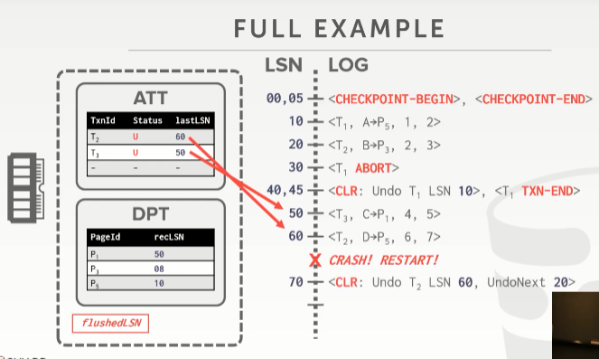
01:06:43 - 01:06:45
so we go ahead and create the the CLR
so 我们就要先创建CLR
01:06:46 - 01:06:48
Right this to reverse this change
并通过这条日志来翻转LSN 60这个修改
01:06:48 - 01:06:56
and then we add this UndoNext LSN, the point to that the next LSN, we would need to reverse for this transaction here
然后，我们添加这个UndoNext，并将数值指向下一个要进行翻转撤销操作的LSN
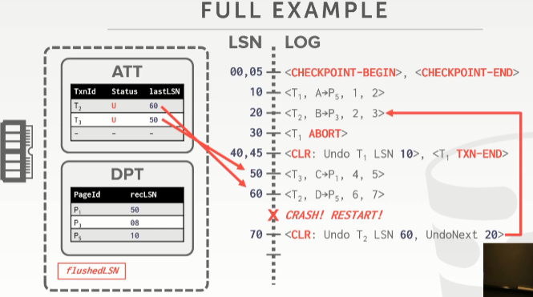
01:06:56 - 01:07:01
right and again the thing is a logical pointer for convenience to tell us where we need to jump to next
这其实可以看作是一个逻辑指针，方便我们找到下一个要跳到并进行撤销操作的地方
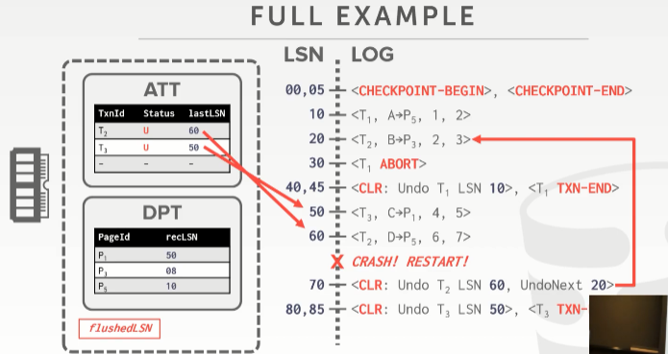
01:07:02 - 01:07:06
then maybe we add the CLR for transaction t3
然后，我们要为T3添加一条CLR
01:07:08 -01:07:10
right and this is the last thing we actually need to undo for this transaction
实际上，这是我们对该事务进行undo操作所要做的最后一件事
01:07:11 - 01:07:13
so therefore we can go ahead and create the txn-end message right away
因此，我们会为之创建一条txn-end消息
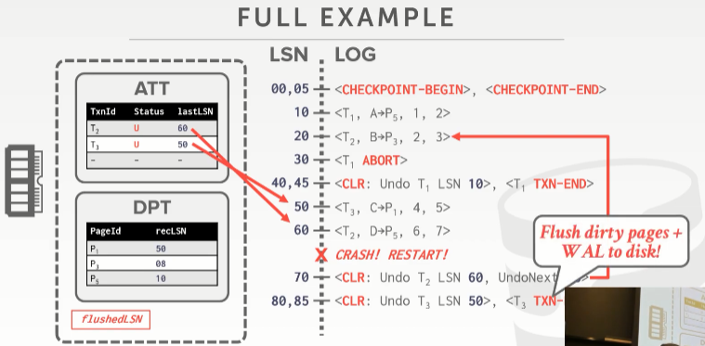
01:07:14 - 01:07:21
right and at that point we're going to flush all the dirty pages,that this shows actually modified ,and the write ahead log to disk
在此时，我们可以将所有的dirty pages刷出到磁盘，要知道，所有的修改信息都已经写入到我们预写日志中并已刷出到磁盘了
01:07:21 - 01:07:27
so at this point we know that we never need to recover or undo this transaction ever again to reverse anything
在此时上，我们知道我们不再需要恢复或撤消该事务以撤消任何事情
01:07:27 - 01:07:31
because the log already contains everything you need you to reverse it
因为日志已经包含了所有你可以用来撤销的信息
01:07:31 - 01:07:35
so we'll redo it if we crash again,but we want to undo it anything
so，如果服务器崩溃了，我们可以进行redo操作，但我们想要去undo一些东西
01:07:37 - 01:07:43
so now I say we crash here right ,we're doing recovery, we're in the undo phase ,we crashed and restart
so 比如说我在这里发生了服务器崩溃，我要去做恢复，我们进入了undo阶段，我们崩溃和重启了
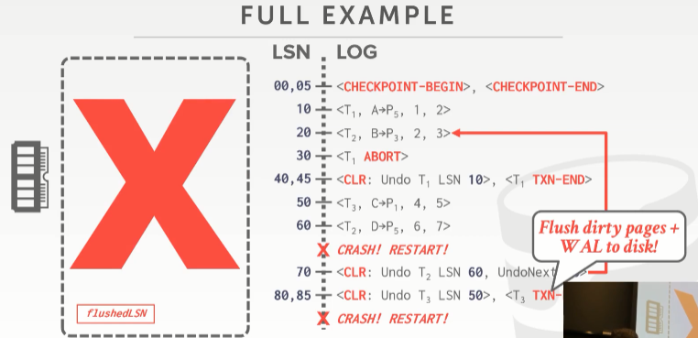
01:07:43 - 01:07:46
all this gets blown away ,because this is just hanging out in memory
所有这些全没了，因为它们只是暂驻在内存中
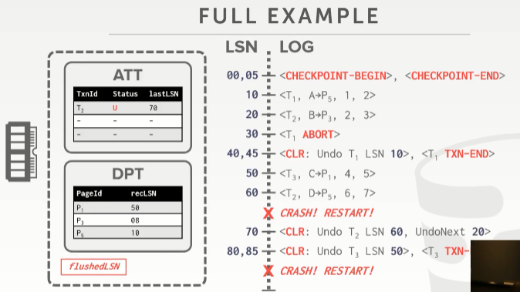
01:07:46 - 01:07:48
so when we come back
so 当我们回过头来
01:07:48 - 01:07:53
we and our ATT would say well we only have t2 sitting around at the end , we make sure we need to reverse that
我们知道，在最后，我们的ATT中只有一个T2，我们确定，我们需要去撤销T2的修改
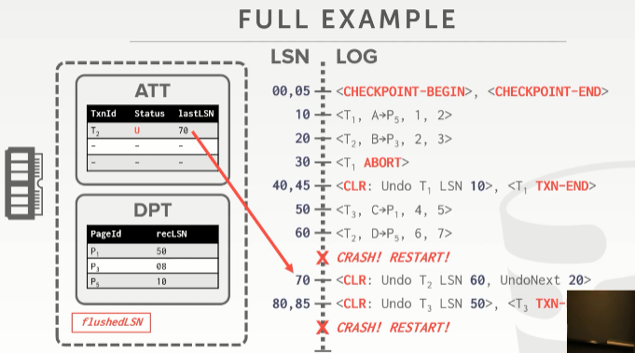
01:07:53 -01:07:58
so and the next thing we need to reverse the starting point for our reversal is here
so下一个事情就是我们要从这里（LSN 70）开始进行撤销
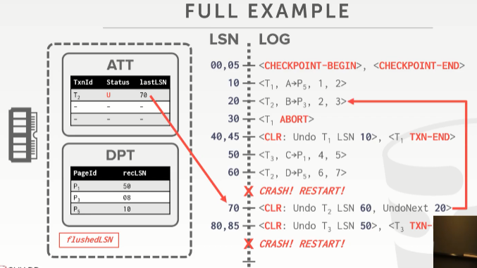
01:07:58 - 01:08:02
so for this we just we've already applied it during the undo phase
对此，我们只会在undo阶段进行该操作
01:08:02 - 01:08:05
so there's nothing to undo, because you can't undo an undo
so，这里没东西让你去undo，你无法undo之后紧接undo（知秋注：因为前面服务器崩溃了，内存中没东西让你undo，得先redo之后才有信息给你undo）
01:08:05 - 01:08:09
you just redo them ,so you redo undos ,but you don't undo undo, okay
你要做的是对它们进行redo，so，你要先redo，后undo，不能undo，undo
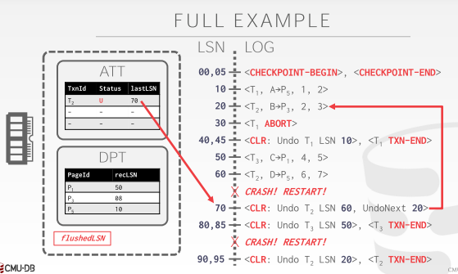
01:08:10 - 01:08:13
so the undoNext tells us the next thing we need reverses up here at 20
so 这个undoNext 告诉我们下一个要撤销修改的地方在LSN 20
01:08:13 - 01:08:18
so we add CLR for that, then we have our txn-end message ,because it's the last thing we need to do
so 我们为此增加一条CLR，然后我们给它添加一条txn-end消息，因为它到此结束了
01:08:18 - 01:08:20
we flush the log and then we're done
我们将日志刷出，然后我们就结束了
01:08:21 - 01:08:24
at this point here after this has been flushed that your dirty pages been flush
在此处，在此刷出之后，你的dirty pages可以被刷出了
01:08:24 - 01:08:32
we know at the database is in a consistent state, as it existed at the moment of the first crash with no partial effects from any aborted transactions
我们知道，这在数据库中是一个一致性的状态，因为它在第一次崩溃时就存在，而并没有对任何中止的事务产生什么其他影响（知秋注：要知道，在崩溃后，你能读取到这段日志：lsn60之前的日志，说明它落盘了，那就是一致性的状态，根据这段日志来进行相应的回滚操作）
01:08:33 - 01:08:33
yes
请讲
01:08:37 - 01:08:41
this question is would it be worth doing a checkpoint at the redo phase
这个问题是在redo阶段去做一个checkpoint 是不是有价值的，
01:08:44 - 01:08:52
that would so that would make it so, you would do that if you assume you're gonna crash very soon in the near future again
如果你假设你在redo时，不到一会，就又发生了服务器崩溃，那你可以这么做
01:08:53 - 01:08:55
otherwise it's just excessive disk writes
否则，它就是一个多余的磁盘写操作
01:08:55 - 01:08:57
so nobody does that
没人会那么做
01:08:58 - 01:09:03
if it's 1970s porto rico and you don't have power, yes you do that
如果是在1970年代，经常断电，yes，你会那么做
01:09:06 - 01:09:06
Okay

01:09:14 - 01:09:20
the question is is it we required to do this flush here ,no, that's an optimization become amid that yes,yeah
他的问题是这里我们是不是需要做刷盘操作，no
01:09:22 - 01:09:23
well next slide
下一张幻灯片
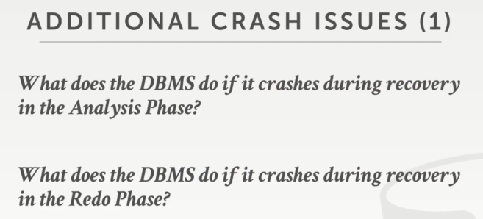

01:09:25 - 01:09:28
alright so I in this example here, I showed what happens if you crash during undo
通过这里的这个Demo，我向大家展示了，如果在undo期间发生服务器崩溃，会发生哪些事情
01:09:29 - 01:09:35
if we crash during the analysis phase what do we have to do, what`s that
如果在analysis 阶段发生了崩溃，我们该做点什么
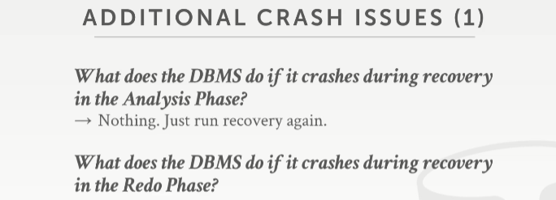
01:09:36 - 01:09:40
nothing right there's nothing to do, because it's already of just breathing log we just come back log again
什么也不做，因为我们只是从log中获取一些信息而已，我们只需要重启重新来过，重新分析即可
01:09:40 - 01:09:43
it all over again if we crash during redo ,what do we have to do
如果是在redo期间发生了崩溃，我们要做些什么呢
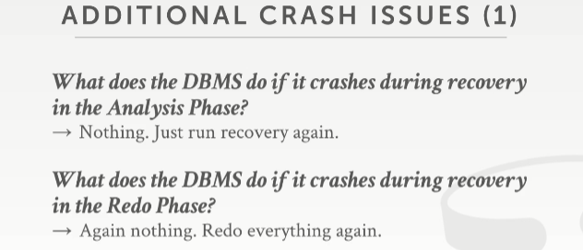
01:09:48 - 01:09:54
in the back nothing exactly yes, right, because you just come back again redo it all over again
确切的说什么也不做，因为你只需要重新来过，再对它重新进行一次redo即可
01:09:54 - 01:09:58
including the CLRS that you generated from if you undo things previously
包括你先前redo操作时生成的CLRS（如果日志落地了，那依据前面的信息，继续后面添加就是，又不影响）
01:09:59 - 01:10:04
so it's only on the undo phase where you potentially have to go figure out what was I undoing at this given time
so 仅在undo 阶段，你可能需要弄清楚在给定的时间我该去撤消什么
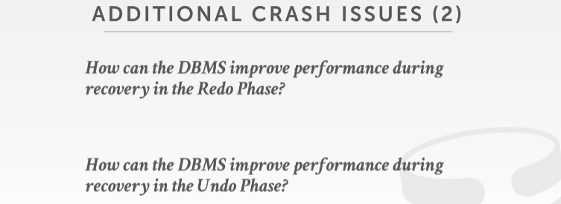
01:10:06 - 01:10:16
so related his question is is there a way to avoid all those extra disk flush every single time we have a txn-end
有一种方法可以避免每次我们有一个txn-end时都会进行一次额外的磁盘刷出
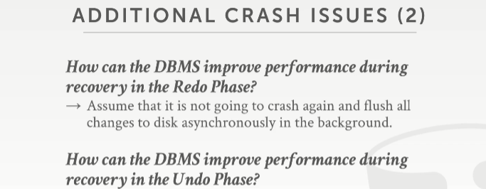
01:10:16 - 01:10:18
right and it sort of related his question as well
这个也和他刚才的问题相关
01:10:18 - 01:10:21
right you just assume that you're not going to crash during recovery
我们可以假设，我们并不会在恢复期间发生崩溃
01:10:21 - 01:10:30
and there or you're just gonna flush the changes in the dirty pages, use an asynchronously flush them out the disk
然后我们可以通过异步刷盘的方式，将我们dirty pages刷出到磁盘中
01:10:31 - 01:10:36
when I think you finally say the DBMS online ready to start processing new transactions
最后我们会说DBMS线上已经准备好开始处理新的事务了
01:10:38 - 01:10:41
I think most systems would do take another checkpoint then
我认为大多数系统都会进行另一个checkpoint
01:10:41 - 01:10:44
but you don't have to correctness reasons you don't have to
但你不需要去考虑的
01:10:45 - 01:10:49
so how can we another way to produce improve performance during the undo phase
so 我们如何在undo阶段中通过其他方式提高性能
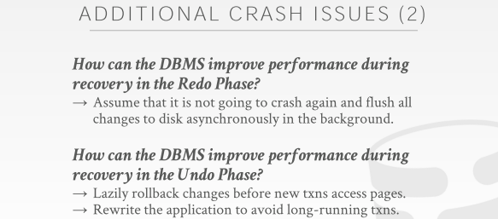
01:10:49 - 01:10:51
well we've already talked about a couple of these
我们已经讨论过这两个了
01:10:51 - 01:10:56
we talked about you know figuring out that, this transaction aborted it's the only thing that modified this page
我们有讨论指出，若该事务中止了，这是修改此page的唯一内容
01:10:56 - 01:10:58
therefore I don't need to reverse any changes on that page
因此，我不需要撤消该页面上的任何修改
01:11:00 - 01:11:10
another approach would be to actually lazily apply the rollbacks for transactions, oh at runtime
另一种方式是在实际运行中对事务延迟回滚，
01:11:11 - 01:11:18
so you do the analysis, you do the redo, then you figure out what you need to undo for every single page
so，你进行了分析，你进行了redo，然后，你会指出哪些是你需要去对每一个单独的page进行undo操作的
01:11:18 - 01:11:23
but then rather than applying those changes, you just sort of keeping them around somewhere in memory
但，比起立马去undo这些修改，不如你就把这些修改先放在内存中的某个地方
01:11:23 - 01:11:29
and then anytime a new transaction comes along and it wants to read that page
然后，在后面，只要有一个新的事务过来想要读这些page
01:11:29 - 01:11:31
then you go ahead apply the log
然后，你就去执行log上的undo操作
01:11:32 - 01:11:35
so the idea here is like you must have like instant recovery
so 这里的思路就像，你必须对dbms服务器进行即时恢复
01:11:35 - 01:11:40
that you say , alright I'm back online even though my DBMS is not in an incorrect State
接着，你说了，虽然我的DBMS处于不正确的状态
01:11:41 - 01:11:45
no transaction can read those pages that have not been rollback yet correctly
当前没有事务会去读取尚未回滚的page
01:11:45 - 01:11:48
and only when you go ahead and read them then you actually apply them
只有当你去读这些page的时候，你再去真正的回滚它们
01:11:49 - 01:11:51
the idea there is like if you have a large database
如果你有一个很大的数据库
01:11:52 - 01:11:58
and the undo the you'll for the undo phase you only modify a small portion of it
在undo阶段，你只需要修改它其中很小一部分数据
01:11:58 - 01:12:03
rather than blocking access to the entire database ,why you undo this small number of pages
就为了去undo这小一部分的page，而去阻塞整个数据库的访问，你觉得值么？
01:12:03 - 01:12:06
you merely come back right away and let anybody read whatever they want
你仅需要启动到位，然后让大家畅通访问即可
01:12:06 - 01:12:09
it's just you block them when they try to read things you haven't rollback yet
当有人要访问这些尚未回滚的内容时，你阻塞并回滚就好咯
01:12:10 - 01:12:13
I don't think anybody actually does this optimization
我认为没有人真正进行此优化
01:12:13 - 01:12:20
and then the last one would be just the rewrite your application so you don't have long-running transactions
最后一个就是要求重写你的应用程序，以避免那种慢查询事务
01:12:20 - 01:12:25
as you minimize how far back on the log after the last checkpoint you have to go and then replay that
你要最简化执行你的日志，即找到日志中的最后那一个checkpoint ，去重演里面的操作
01:12:25 - 01:12:29
if you can cut that back down then the redo phase and undo phase is will much faster
如果你可以将日志削减，那么redo阶段和undo阶段将会更快
01:12:32 - 01:12:32
okay

01:12:34 - 01:12:39
everyone you know ready to kill me or fall asleep or what, or go out and build your own database
听我课的每个人是不是都受不了我了或睡着了或什么，出去构建自己的数据库吧
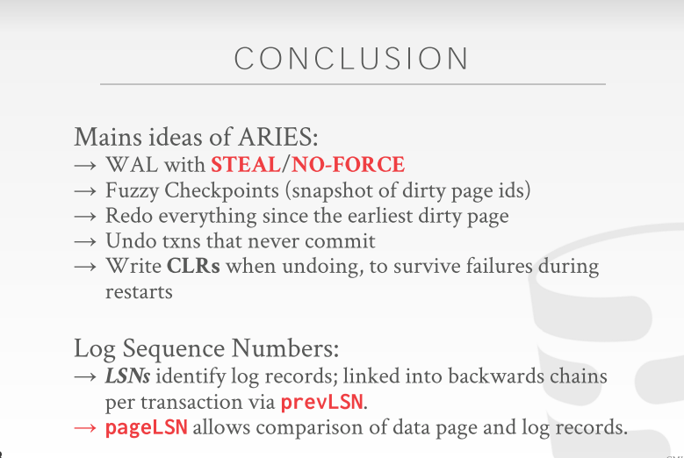

01:12:40 - 01:12:41
all right so

01:12:42 - 01:12:51
the main idea is for aries we covered our against write ahead log using steel no force with fuzzy checkpoints, which is essentially just taking a snapshot of all the dirty page IDs
ARIES主要涵盖了几个方面：WAL(write ahead log)使用了steel /no-force策略，fuzzy checkpoints实际上就是对所有dirty page ids进行的快照
01:12:52 - 01:12:53
so we think we know which one's got modified
so 通过它，我们可以知道哪个page被修改了
01:12:54 - 01:12:59
and then we're gonna redo everything since the earliest dirty page we had in our write ahead log
我们将redo所有操作，因为我们在预写日志中设定有最早的dirty page
01:12:59 - 01:13:04
and then we undo the transactions that did not end up committing,before the write-ahead log finished
在预写日志完成之前，我们撤消那些最终并未提交的事务
01:13:04 - 01:13:10
and then we add these CLR, so make sure we record all the undo operations were doing for updates to the database
然后，我们添加这些CLR，确保我们记录所有undo操作
01:13:11 - 01:13:19
and the log sequence numbers are the way we're going to use to figure out ,whether the log record that modified a page has been successfully written to disk or not
对于 LSNs来说，通过它我们可以确定修改页面的日志记录是否已成功写入磁盘
01:13:22 -01:13:27
all right, we have like three minutes, let's just do a quick demo to show you that this actually does work
距离下课，我们还有三分钟左右，让我们来快速做一个Demo来给大家演示下这些东西
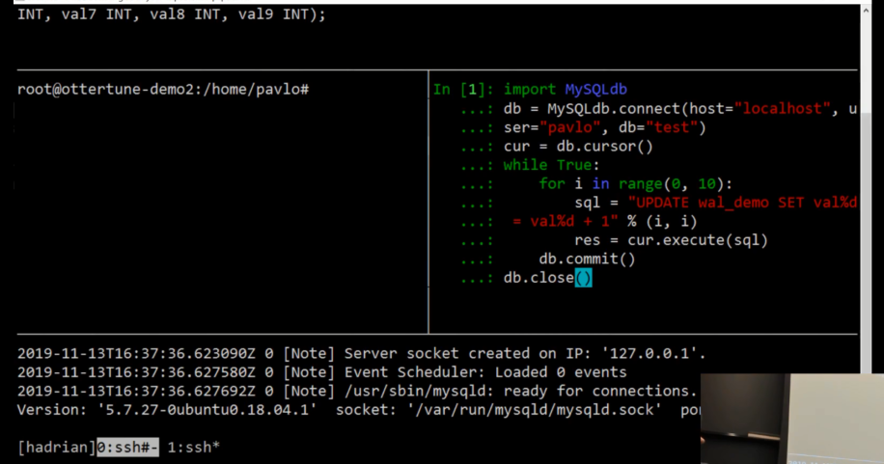

01:13:28 - 01:13:30
so there's gonna be MySQL
这是MysqL
01:13:31 - 01:13:32
and we're gonna have one table
我们创建一个table
01:13:34 - 01:13:44
let me turn this off too ,so sorry let's suck
真扯淡！
01:13:48 - 01:13:49
so we're gonna have one table
so 我们创建一个table
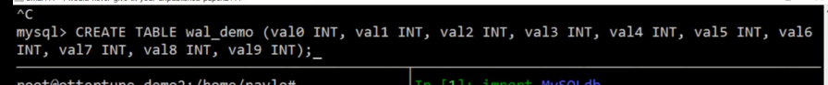

01:13:51 - 01:13:58
that just has a single row that has ten columns
插入一行数据，总共十列
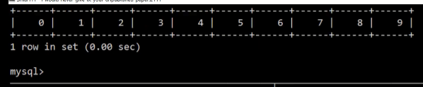
01:14:04 - 01:14:0401:14:08
right 123456789
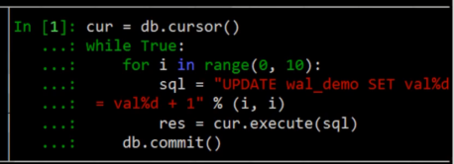

01:14:08 - 01:14:16
and then we're gonna have a simple Python program, that is in a single transaction, it's gonna take the first column
我们将有一个简单的Python程序，表示在一个事务中，它将取第一列
01:14:16 - 01:14:18
and just slide it over to the next one
一个接一个遍历获取
01:14:19 - 01:14:21
and then you know it's gonna increment every column by one
它会使每一列增加一
01:14:22 - 01:14:24
And so we're gonna let this run
我们将这个程序跑起来
01:14:27 - 01:14:27
oh
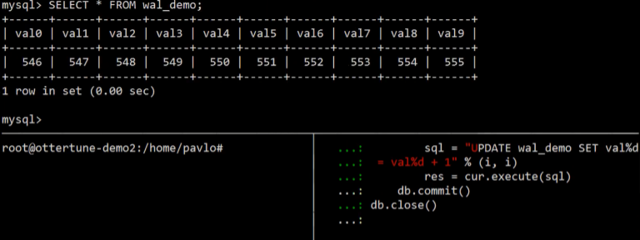
01:14:31 - 01:14:33
right and just to prove that it's actually working ,we go select again
为了证明它真的运行了，我们再次查询下
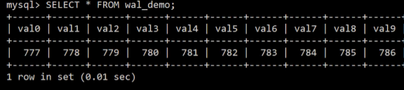
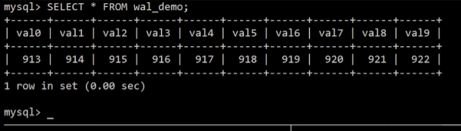
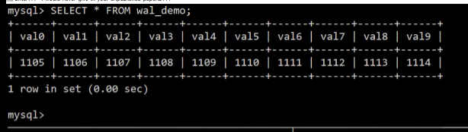
01:14:33 - 01:14:36
right we see it's incrementing one by one all right
我们有看到，它每一列增加一
01:14:36 - 01:14:39
so our transact it's running in an infinite loop
so 我们在一个无限循环中跑我的事务
01:14:39 - 01:14:43
I mean down here we have the log message the log from MySQL to tell us that it is actually running
我们有来自MySQL的日志消息，告诉我们它实际上正在运行
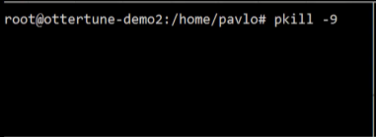
01:14:44 - 01:14:49
so what we're gonna do is a hard kill ,on MySQL kill -9
我们要做的就是强行终止，pkill -9 mysql
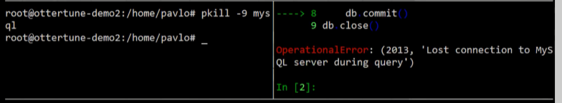
01:14:50 -01:14:52
all right that's going to kill everything
all right 一切都被干掉了，整个世界都清净了
01:14:52 - 01:14:56
and behold you see that the log actually got tripped it says that we crash
看你看到日志报错了，它说我们崩溃了
01:14:56 - 01:15:01
and then this is running Ubuntu, it has a service that says if like MySQL crashes it automatically restarts it for you
这里正在运行的是Ubuntu，它有一项服务，该服务说如果MySQL崩溃，它将自动为你重启
01:15:01 - 01:15:05
but you can see we got disconnected up here, and then our Python code got disconnected here
但是你可以看到我们在这里断开了连接，然后我们的Python代码在这里断开了连接
01:15:05 - 01:15:08
so this proves that when I did the kill -9 that like it killed everything
so 这证明了当我执行kill -9时，它kill掉了所有东西
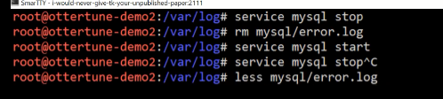
01:15:09 - 01:15:11
so let's actually go look in the log and see what it says
让我们来看看日志，看看它说了什么
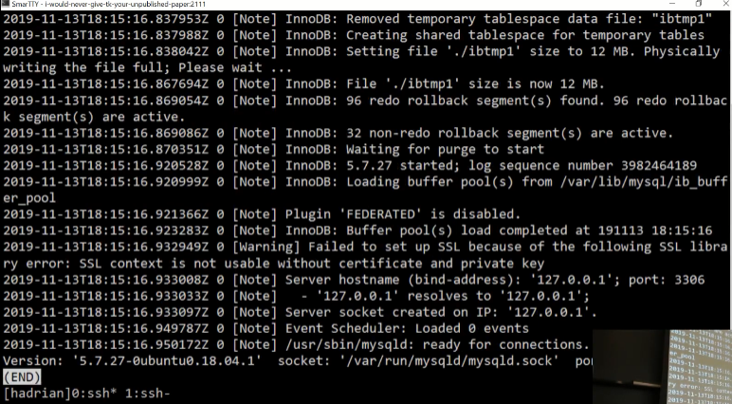
01:15:18 - 01:15:21
the details all this doesn't matter, but Lona holed up in here
所有这些细节都无关紧要，但是我们要关注的在这里
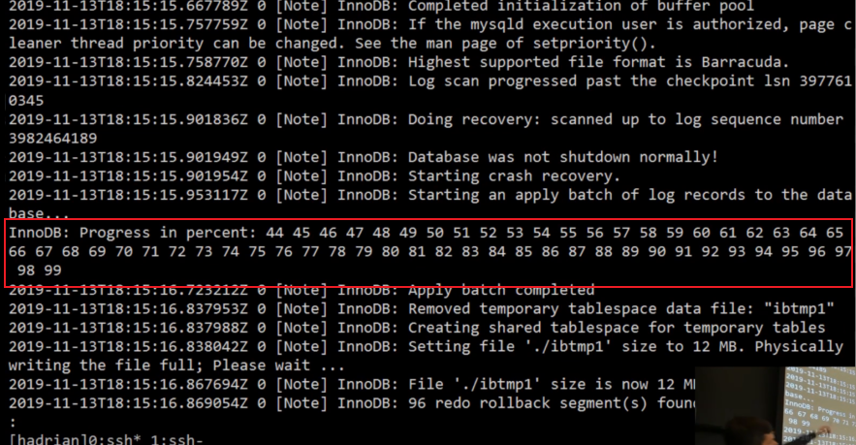

01:15:22 - 01:15:28
says database was not shut down normally, starting crash recovery, start apply a batch old walk records in the data
这里表示数据库未正常关闭，启动崩溃恢复，开始在数据中应用一批旧的行记录
01:15:28 - 01:15:30
so these are just percentages
这些只是百分比
01:15:30 - 01:15:36
so this is doing Aries, this is saying like hey and they go look a log figure out what's running, and go ahead and replay them
这是在做ARIES，这就是说嘿，他们去查看日志，找出正在运行的内容，然后重演它们
01:15:37 - 01:15:39
so now when we go back and look inside of our database
现在，当我们回头查看数据库内部时
01:15:40 - 01:15:45
we connect it to prove that, we don't have any torn updates for our transactions
我们连接上数据库，此处证明了，我们的事务没有任何残缺不全的更新
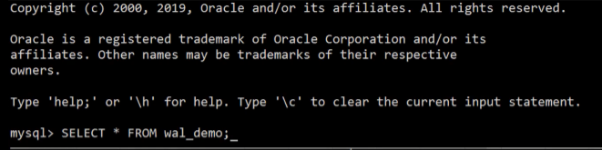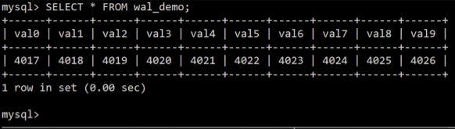
01:15:45 - 01:15:49
we should be guaranteed that every column is one more greater than the previous column
我们应该保证每一列都比上一列大一
01:15:50 - 01:15:52
right and behold in this case it is
在这种情况下是正确的
01:15:55 - 01:15:56
MySQL works okay
MySQL一切工作正常
01:15:57 - 01:16:01
I don't know what other way to show you a demo of the database crash other than that
我不知道还有什么其他方式通过一个Demo来向你展示数据库崩溃
01:16:03 - 01:16:05
it's the best I could come up with ,okay ,yes
这是我能想出的最好的办法
01:16:10 - 01:16:14
like what when I killed it why did they recover right away ,that's a Ubuntu thing
当我kill掉它时，为什么他们立即恢复，那是Ubuntu的事情
01:16:15 - 01:16:18
it's Ubuntu has a service it says this if this thing crashes it'll restart it
这是Ubuntu的服务，它会说，如果mysql崩溃，它将重新启动它
01:16:18 - 01:16:21
yeah it's not special to MySQL it's the operating system doing that
这并不是特别针对MySQL来说的，它是由操作系统来完成的
01:16:22 - 01:16:24
yeah okay all right

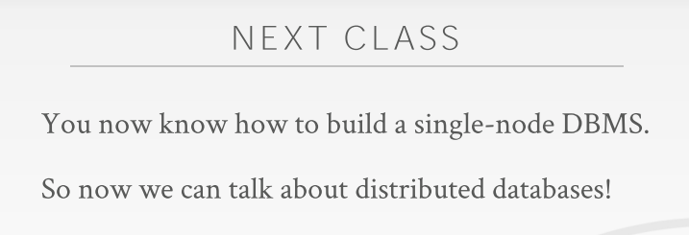
01:16:26 - 01:16:31
so this point, you can say you know you could quit CMU
So，现在，你就可以说，你可以离开CMU了
01:16:31 - 01:16:36
you have enough information in your brain to go out and build a reliable transactional DBMS
你脑子中已经有足够的知识去构建一个可靠的事务型DBMS
01:16:37 - 01:16:41
because you knew recovering new transactions, you knew query optimization, you can do database storage
因为你知道如何恢复事务，对查询进行优化，以及数据库存储方面的知识
01:16:42 - 01:16:45
right this is what I've at this point in the semester
这就是我在这学期所教的东西
1.16.45-1.16.49
these are the core things you need to know of what a database does
这些都是你需要知道的核心知识，以此来弄清楚数据库所做的是什么
01:16:49 - 01:16:50
so starting next week on Monday
So，从下周一开始
1.16.50-1.16.53
,now start talking my distributed databases
我们会开始讨论分布式数据库
01:16:54 - 01:17:02
all the same concepts that we talked about so far the semester ,still still have the same problems the same same issues, that we think account for in distributed database
在我们讨论分布式数据库时，依然会存在着与我们之前讨论过的概念相同的问题
01:17:02 - 01:17:04
just now we have to account for the network which can be slightly more tricky
并且，我们也需要网络上的问题放到一起考虑，这其实有点棘手
01:17:04 - 01:17:06
ok

1.17.06-1.17.07
so again at this point
So，在此时
1.17.07-1.17.12
even though like say, oh I won a distributed databases, you need to unchain the single-node databases first
可以这么说，我想要拿下分布式数据库，你需要先拿下单体数据库的东西
01:17:12 - 01:17:16
and this is the point you know what they're actually doing
然后你就知道他们实际上在做什么了
01:17:17 - 01:17:18
ok guys

