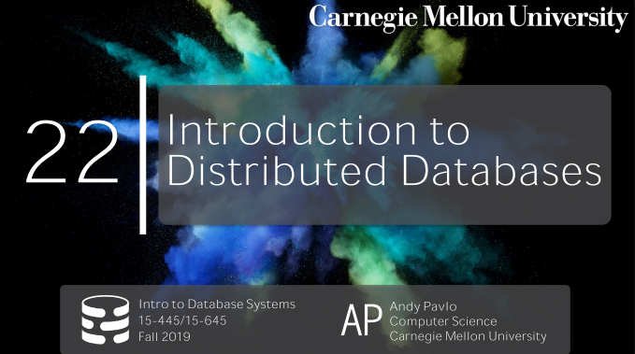
00:14 - 00:16
alright let's get started
好了，我们开始吧
00:16 - 00:20
alright DJ drop tables as back,thank you
我们的DJ Drop Table总算回来了
00:22 - 00:24
did you solve all your problems
你解决你的问题了吗
00:24 - 00:25
yeah most of them
emmm，算是解决了大部分问题
0.33-0.38
okay you know you don't want to be in that boat it's awful ,yeah
你不想脚踏两条船是吧
00:38 - 00:39
Everything else okay
其他事情一切顺利吗？
00:40 - 00:43
I mean you still gonna have three girlfriends or you try to come back
我的意思是，你现在依然有3个女朋友，还是说你只是跑路回来了
00:47 - 00:48
one and a half, what's the half
一个半，那半个女朋友是什么鬼？
00:50 - 00:53
Okay,alright alright alright
好了，不说了
00:53 - 00:56
so we have a lot I think a lot of things to talk about today
So，我们今天要讨论的内容有很多
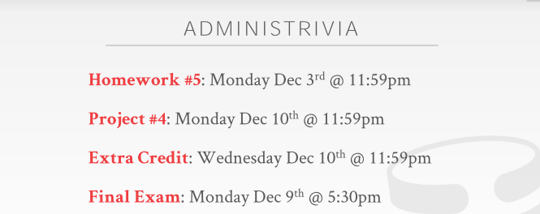
00:57 - 01:01
so real quickly before we get into the course the the topic for the lecture today
So，我们来快速看下今天要讲的内容
01:01 - 01:06
so this is the final docket for everyone this semester
So，对于你们来说，这是这学期你们最后要面对的东西了
01:06 - 01:08
this is everything that that you have to finish up
你需要完成这一切
这就是你必须完成的一切
1.08-1.10
project 3 obviously was due last night
很明显，Project 3昨晚就截止了
01:10 - 01:13
homework 5 should go out today ish
Homework 5今天会放出来
01:13 - 01:17
and that'll be due in two weeks on December 3rd
它会在两周后截止
1.17-1.19
project 4 will go out went out this weekend
Project 4会在这周四放出
01:20 - 01:21
and that'll be due on December 10th
它的截止日期是12月10号
1.21-1.24
,the extra credit is due on December 10th as well
额外加分也是在12月10号结束
01:24 - 01:27
and then we'll have the checkpoint which I'll talk about next slide
我会在下张幻灯片的时候讲下关于额外加分的时间点检查事宜
01:28 - 01:33
and then the final exam is on Monday December 9th at 5:30 p.m.
期末考试是在12月9号下午5点半
1.33-1.34
not in this room
考试的地点不是这个房间
1.34-1.35
, I don't know what room they'll put us in
我不知道他们把我们的考试地点安排在哪
01:37 - 01:40
but it's sort of a shitty time
但这有点糟糕
01:40 - 01:45
so maybe we'll do is that new candy maybe a new pizza or something like that something better okay
So，我们可能会带点糖果，披萨或者其他更好的东西
01:46 - 01:47
so any question about any of these things
So，对于我讲的这些东西，你们有任何问题吗？
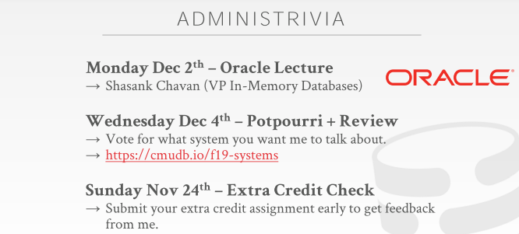
01:50 - 01:50
all right

1.50-1.52
and then some other things that are floating around
然后，我们来讲下其他相关事情
01:54 - 01.57
we have three more sort of I'm Convio lectures ,
我们会有额外的三节课
1.57-2.05
but like course topic lectures on material that's this week and then one one class next week
这是这周以及下周课上要讲的主题

02:05 - 02:10
and then when we come back from effort the Thanksgiving break on Monday December 2nd
当我们结束感恩节假期的时候
02:10 - 02:15
our friends at Oracle will be coming giving a talk about the the stuff that they're working on
我们在Oracle的朋友会给我们做场演讲，主题与他们的工作方向有关
02:16 - 02:17
and again this is not like a

02:19 - 02:23
it's not like a lecture where there you know instead of me talking about the material, they're gonna talk about the same material
那堂课不是我去上，而是他们给你们上，讲的内容和我讲的是一样的
02:24 - 02:27
they're actually gonna talk about what they're been building in in their group
实际上，他们会讨论下他们组里所构建的东西
02:28 - 02:31
and you'll see how it ties in together all the things various things we talked about through the entire semester
你们会看到他们是如何将我们这整个学期所讲的内容都串联在一起的
02:32 - 02:35
the other thing that for the second class in the next week
在下周第二节课的时候
02:36 - 02:37
I do two things
我会做两件事
2.37-2.39
one we'll do a final system review
一件事情是，我们会对系统进行审查
2.39-2.42
and the second one will be what I'll call systems potpourri
第二件事情就是，我们会去看下一个叫做Potpourri的系统
02:43 - 02:50
where if there's any system you want me to talk about for like 10 or 15 minutes to teach you about ,what it is, how it works ,and why it's interesting
如果你们想让我花10到15分钟给你们讲下任何你们想了解的系统，它的工作原理以及它令我们感兴趣的地方
02:51 - 02:54
you know and using the vernacular that we talked about through the entire semester
我会去使用我们这整个学期所讨论的那些专业术语
02:55 - 02:59
we'll have a vote online at this URL, it's just a Google form
你们可以去点击这个链接，投下票
02:59 - 03:03
and you go select whatever system that you want me to cover for 10 or 15 minutes
你们可以去选下你们想让我花时间讲的那个系统
03:03 - 03:03
okay

3.03-3.06
so we usually have time to do three or four of them
So，按照正常情况来看，我们应该是有时间能讲3到4个DBMS
03:07 - 03:11
so the list that I'm showing here is the when you go to the Google Form
当你去填写这个谷歌表格的时候
03:11 - 03:18
it's the systems on the DBDB.io website
你们可以看到列表中展示了dbdb.io上的那些DBMS
3.18-3.20
,that have had the most views for the last two months
它上面列出了近两个月越来浏览数最多的那些DBMS
03:22 - 03:23
so that they're in that order
So，它们是按照这个顺序排序的
3.23-3.25
but you don't necessarily have to you know follow that
但你们不一定需要根据这个顺序来
03:25 - 03:32！！！！！！
but and also there's another one that's on DBDB.io that we want to cover that that's not on that list, just you know that you can even type it in ,okay
但如果有其他不在dbdb.io上的DBMS，而你想让我去讲这个系统的话，那你就手动输入它
03:33 - 03:36
and you can go back last year and see what I cover
你们可以去回看下去年我所介绍的那些DBMS
3.36-3.38
but I encourage you not to do that before you vote
但在你们投票前，我不建议你们这样做
03:38 - 03:43
you don't want to sort of take your bias to you just do whatever people did last year
我不建议你们让我去讲去年已经讲过的那些DBMS
03:43 - 03:46
because I'm always curious to see what you guys are just about
因为我始终好奇你们这帮人会想听什么内容
3.46-3.49
like, yeah we've covered Postgres a little bit, we covered MySQL Oracle and SQLite a little bit
比如：我们已经介绍了PostgreSQL、MySQL、Oracle以及SQLite中的一些内容
03:50 - 03:56
easier to see what you guys are seeing on the internet or what you want to do it in your job or on a hobby project
我想知道你们在网上看到了这方面的哪些内容，或者你们在工作中想做哪些事情
03:56 - 04:00
we know what system you've been thing about maybe using, and I can come teach you about what it is and how it works
你们可以让我讲下你们正在使用的那些数据库系统，以及它的工作原理
04:02 - 04:02
okay

04:03 - 04:06
all right and then the extra credit feedback
接着，就是关于Extra Credit的反馈
4.06-4.12
again you can submit your extra credit article this Sunday on November 24th
你们可以在这周日的时候提交你们的文章到dbdb.io上
04:12 - 04:15
and then the myself and the TA will give you feedback
然后，我和助教就会给你们一些反馈
4.15-417
and say, what you're doing correctly,what you're not doing correctly
并告诉你们，你们哪些地方做得没问题，哪些地方没有做到位
04:18 - 04:21
and that way you can fix it up in time for this submission
这样你就可以在你提交前及时修复这些问题
04:21 - 04:22
so they did get full credit
这样的话，你就能拿到满分
04:23 - 04:23
okay

04:24 - 04:25
and the questions about any of these things
对于这些东西你们有疑问吗？
04:26 - 04:28
so I'll put a deadline for when you should go vote right
So，我会设置一个投票截止日志
04:28 - 04:32
if like you obviously can't vote the day before the lecture ,because then I don't have time that you prepare it
你们千万不要在我上那节课之前再投票，因为我根本没时间去准备
很明显是为了避免你们在我上那节课之前才投票，因为我根本没时间去准备
04:32 - 04:35
certainly or maybe the week of Thanksgiving deadline for this
投票的截止时间我可能会设置为感恩节那周
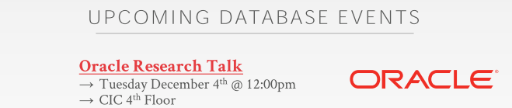
04:36 - 04:40
okay and the last thing is that
最后要讲的事情是
4.40-4.51
in addition to giving an in-class lecture on that should be December third on the Tuesday December third
在12月3号，也就是周二的时候，我们课上会有一堂讲座

04:51 - 04:56
Oracle also be giving a graduate level research talk over in the CIC building
Oracle会在CIC楼那里给我们做一场研究生级别的演讲
04:56 - 05:01
I think they're also giving an undergrad talk Monday and Monday afternoon as well
我觉得他们也会在周一下午的时候给我们做一场本科生层面的演讲
05:01 - 05:03
so there's me three Oracle talks in two days
So，这两天Oracle会为我们做3场演讲
5.03-5.06
and you know one of them you'll require to come to or not required
我要求你们来参加其中一场
05:06 - 05:09
but you'll get extra credit for the final if you come to that
但如果你们来的话，你在期末的时候会有额外加分
5.09-5.11
,and then these ones are optional okay
其他两场你可来可不来
05:13 - 05:14
Any questions
还有问题吗？
05:15 - 05:16
we're almost done
我们基本讲完了我们的规划
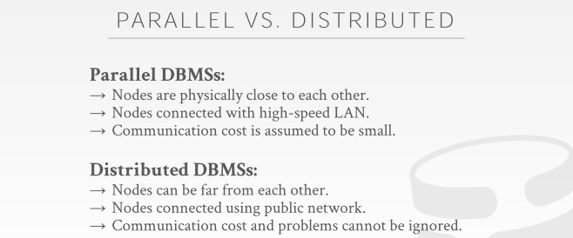
05:17 - 05:22
all right so today's class is now
So，今天要讲的东西是
05:23 - 05:26
the beginning of our discussion on distributed databases
我们要开始讨论分布式数据库
05:26 - 05:27
and as I said last class
正如我上节课所讲
5.27-5.32
, we can't actually ,you know before we just ,you know jump immediately into distributing databases
在我们讲分布式数据库之前
05:32 - 05:39
we had to spend however weeks we've gone and so far in this semester to understand, how a single node database system works
我们在这学期需要花好几周的时间去理解一个单节点数据库系统是如何工作的
05:39 - 05:41
because when now we start going distributed
因为现在我们要开始讲分布式数据库方面的东西了
05:42 - 05:44
you know just because we have more machines or more hardware,
因为我们现在拥有了更多的机器或硬件
5.44-5.48
doesn't magically make our system easier to build or better
这并不会让我们的系统构建起来更加容易或者性能更好
05:49 - 05:54
all the things that we had to talk about for a single node system，we have to still solve them in a distributed system
所有我们在单节点数据库系统中讨论的问题，我们依然需要在分布式数据库系统中解决它们
05:54- 05:55
and actually they're even harder
实际上，这些问题会变得更难
5.55-5.57
, because now you have to account for the network
因为现在我们需要考虑网络这方面的事情
05:57 - 06:00
so we've already talked about this before
So，我们之前已经讨论过这些东西了
6.006.06
, when we talked about query executes, this contrast between a parallel DBMS and a distributed DBMS
当我们讨论查询执行的时候，我们对并行DBMS和分布式DBMS进行了对比
06:06 - 06:08
and when I talk about parallel database system
当我讨论并行数据库系统时
06:08 - 06:12
we were just assuming that the the DBMS was running on a single box
我们假设DBMS是在单机环境下运行
6.12-6.15
that could have multiple cores and multiple CPUs
该环境下，我们拥有多个CPU核心
06:15 - 06:21
and then we assumed that the the workers that were executing the queries could communicate very quickly with each other
接着，我们假设执行这些查询的worker它们之间可以快速通信
6.21-6.23
and that communication was reliable
并且该通信是可靠的
06:23 - 06:26
because if you're running on the same physical machine
因为如果你在同一台物理机器上运行你的DBMS
06:26 - 06:29
you're sending things over the interconnect between CPU sockets
你会通过CPU Socket间的interconnect来发送数据
6.29-6.30
that's super fast
它的速度超级快
06:31 - 06:32
but now under distributed DBMS
但如果是分布式DBMS
6.32-6.37
we still have to you know there's still the things we care about how to do parallel execution
我们在意的依然是如何并行执行
06:37 - 06:41
but now we're doing this potentially across multiple machines
但现在，我们是通过多台机器来并行执行
06:41 - 06:50
and so now we actually need to be mindful on what the cost is and the reliability of one worker communicating with another worker
So，实际上，我们现在需要注意的是一个worker和另一个worker进行通信的成本和可靠性
06:50 - 06:52
because it's going over the network
因为这是通过网络进行通信
6.52-6.54
that you know that other worker might not be in the same data center right
你知道的，其他worker可能并不在同一个数据中心
06:55 - 06:57
might be on the same continent
它们可能是在同一个大陆上
06:58 - 07:03
and so now we can't assume that you know we send a message there guarantee to get that
So，我们无法保证我们发送一条信息就能进行通信
07:03 - 07:07
and that's gonna come from the problem when we start talking about transactions and other things
当我们开始讨论事务和其他事情时，这就会出现问题
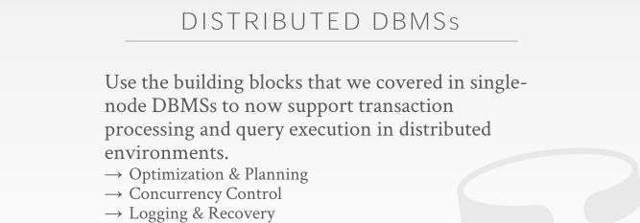
07:09 - 07:10
so as I said
So，正如我说的
7.10-7.13
the for the distributed DBMS, we could talk about starting today
对于我们今天开始讨论的分布式DBMS来说
07:13 - 07:16
it's it's building on all the things we've already talked about
它是建立在我们已经讨论过的东西之上
07:17 - 07:18
so we still have to do logging
So，我们依然需要做日志
7.18-7.22
,we stuff to do a concurrency Control ,query optimization
我们需要并发控制，查询优化
07:22 - 07:25
we have to do query execution，to do joins potentially
我们需要进行查询优化，进行join操作
07:25 - 07:28
all those things we still have to do in distributed DBMS
这些都是我们需要在分布式DBMS中要做的事情
7.28-7.31
, and now they're just everything is more expensive， everything is harder
做这些东西的成本就变得更为昂贵，问题也变得更为复杂
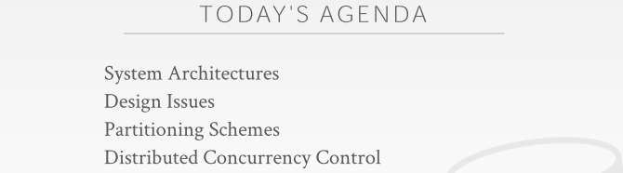
07:33 - 07:38
so for today's lecture as I said today's sort of introduction to distributed databases
So，正如我说的，今天这节课上我要向你们介绍下分布式数据库
7.38-7.47
just to understand you know what they actually look like， the different designs of them, one of the implications of those designs
为了让你们理解它们实际是怎么样的，它们中有哪些不同的设计，这些设计有哪些影响
07:47 - 07:49
and then we'll talk about how to do the partitioning,
接着，我们会去讨论如何进行分区
7.49-7.57
which is the key way we're gonna divide up our database across multiple resources to get the parallelism, we want in a distributed environment
这是我们在分布式环境下将数据库拆分到多个资源上以获得并行性的关键方式
07:57 - 08:03
and then we'll finish up briefly touching on how distribute concurrency control is
接着，我们会简单讲下分布式并发控制是怎么做的
08:04 - 08:09
and then that'll segue into Wednesday's class, where we'll spend the entire day talking about how we actually do this
接着，在周三的时候，我们会花一整天去讨论我们实际该如何做
08:10 - 08:12
and again like we're still going to do 2PL potentially
比如：我们依然会使用两阶段锁
08:12 - 08:13
we're still gonna do timestamp ordering
我们依然会去使用Timestamp Ordering
8.13-8.16
all those things we did on a single DBMS still apply here
我们在单个DBMS上做的这些所有事情都会应用在分布式DBMS上
8.16-8.17
just now it's distributed
我们现在就是将这些东西应用在了分布式上
8.17-8.18
so it's even harder
So，这样就变得更难了
08:18 - 08:18
okay

08:20 - 08:22 ！！！！！！！
and again stop and ask questions as we go along
如果遇上问题，随时打断我，我会为你解答
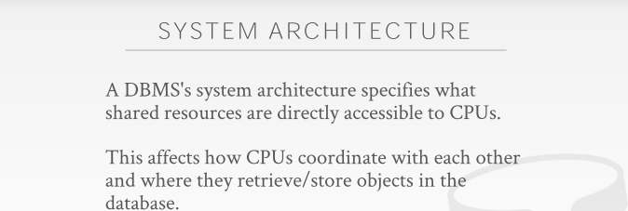
08:24 - 08:26
so the first thing we need to discuss is
So，我们需要讨论的第一件事情是
8.26-8.28
what is the system architecture of the database system
这种数据库系统的系统架构是什么
08:29 - 08:32
so as I said before when we talk to parallel systems
So，正如我之前在讨论并行系统的时候，我说过
08:32 - 08:37
we talked about there being these workers
我们讨论了这些worker
08:37 - 08:41
that are typically tied to either a process or a thread that are running on the CPU
这些worker通常是和CPU上所运行的进程和线程绑定在一起
08:42 - 08:46
and they're gonna access shared resources like disk and memory
它们会去访问诸如磁盘和内存这样的共享资源
08:47 - 08:54
and so the design of our database system in an distributed environment depending what our architecture is
So，分布式环境下我们数据库系统的设计取决于我们的架构是什么
08:54 -09:04
right the variations of these architectures are going to differ in how you actually can coordinate the CPUs and communicate with each other, as you're running queries or transactions in parallel
当你执行查询或者并行执行事务的时候，这些不同架构会以不同的方式去协调CPU并让它们彼此进行通信
09:05 - 09:10
and where is the memory and where is the disk located in contacts to the CPUs
它们的内存在哪里，磁盘又在那里，它们是如何与CPU进行联系的
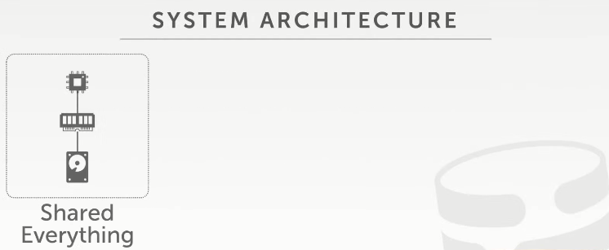
09:11 - 09:16
so what we talked about so far the entire semester is what is known as a shared everything system
So，我们这整个学期中，目前为止所讨论是一种叫做shared-everything的系统
09:16 - 09:19
assume this is a single box, a single rack unit
假设这是一个单机
09:19 - 09:21
that has CPU
它拥有CPU
9.21-9.25
and CPU has local memory and you know there's a local disk that you can read and write to
本地内存，以及一个你可以进行读写的磁盘
09:25 - 09:29
right now any time I want to access something in the binomial architecture, that we're based on,
在任意给定时刻，当我想去访问（我们所使用的）这种架构下的某些东西时
9.29-9.31
anyhow I'm gonna get something from disk
当我从磁盘中获取数据时
09:31 - 09:33
I got to bring it to my buffer pool into memory
我需要将这些数据放入内存中buffer pool里面
09:34 - 09:40
and then my worker up above running on my CPU can read and write to things, read write to pages, and then I let you write them out the disk
那么，我CPU上运行着的worker就可以对这些东西进行读写，对这些page进行读写，然后我将修改过的page写出到磁盘
09:41 - 09:47
again most DBMS that every database system that's not distributed is using this approach
所有非分布式DBMS使用的都是这种方案
9.47-9.48
it`s shared everything system
即shared-everything系统
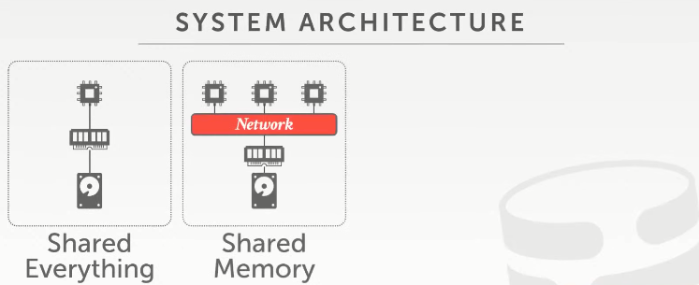
09:50 - 09:55
so an alternative in a distribute environment is one alternatives called shared memory
So，在分布式环境下另一种备选方案叫做shared-memory
09:55 - 9.57
and the idea here is that
它的思路是
9.57-*9.58
you'll have multiple CPU resources
你有多个CPU资源
9.58-10.01
, that are potentially running on different machines
它们可能是来自于不同的机器
10:02 - 10:09
but there's a communication layer that allows them to have a unified memory view across all those machines
但这里会有一个通信层，这使得它们在跨机器的情况下拥有一块统一的内存
10:10 - 10:11
all right

10.11-10.14
assume this is some kind of high speed interconnect like InfiniBand or TCP/IP
假设这是某种类似InfiniBand或者TCP/IP之类的高速interconnect
10.14-10.15
it doesn't matter
这都没关系
10.15-10.17
the high level architecture is still the same
它们高级层面的架构依然是相同的
10:17 - 10:22
and then there's still going to be some local or sorry, some shared disk that everybody's reading writing to
接着，这里面依然存在着一些所有人都能进行读写的共享磁盘
10:24 - 10:31
I said typically the spoiler be this is actually not, actually I don't know of any database of them actually, that's commercially or open source that actually uses this
实际上，我并不清楚有任何商业数据库系统或者开源数据库系统使用这种方案
10:31 - 10:36
this kind of architecture is mostly seen in the HPC or high-performance computing world
这种架构最常见于高性能计算领域
10:36 - 10:39
like the people running on supercomputers at like the big National Labs
就比如，人们在国家实验室中的超级计算机上运行这种东西
10:40 - 10:43
they build software and assuming this model
他们构建软件时会使用这种模型
10.43-10.45
for databases is there isn't that much
对于数据库来说，并不需要这样
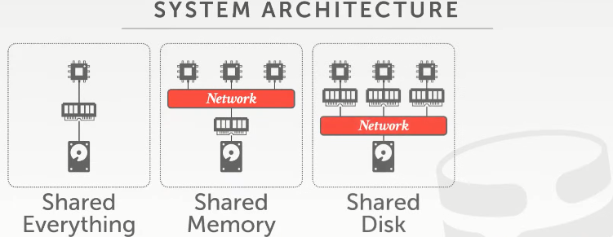
10:46 - 10:48
another approach is do shared disk
另一种方案则是shared disk
10:49 - 10:50
and the idea here is that
这里的思路是
10.50-10.56
the CPU workers are the workers running on the CPU, they have local memory
这些运行在CPU上的worker有它们自己的本地内存
10:57 - 11:04
but the disk where we have maintained a persistent state of the database, that's some scrum shared architecture shared device
但我们用来维护数据库持久化状态的磁盘是一种共享设备
11:05 - 11:07
that all these CPUs can read and write in to
所有的CPU都可以对其进行读写
11:09 - 11:09
right to think of this
思考下这个
11.09-11.12
if you're running on Amazon
如果你使用的是Amazon的服务
11.12.-11.16
, this is something like s3 or EBS or HDFS and kind of distributed file system
这其实就像是和S3、EBS、HDFS之类的分布式文件系统
11:17 - 11:20
so all the CPUs are still seeing the same disk
So，所有的CPU看到的依然是同一个磁盘
11:21 - 11:23
but in order for them to communicate with each other
但为了让它们彼此间进行通信
11.23-11.25
they have to maybe send messages back and forth between them
它们之间可能必须来回发送信息
11:26 - 11:29
right because this CPU can't read the memory of this CPU
你知道的，因为这个CPU无法读取另一个CPU的内存（知秋注：共享的是磁盘存储，具体可以参考MIT6.824第一集内容）
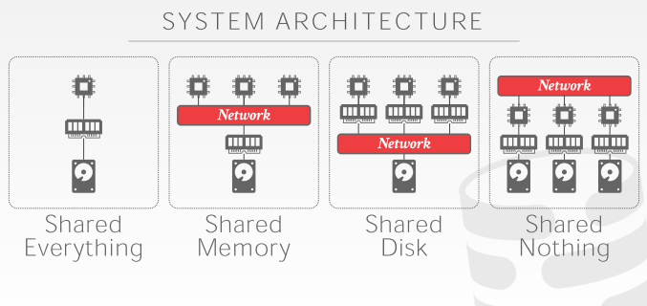
11:31 - 11:37
the last architecture is what most people think of when they think of distributed database, just what is going to shared-nothing
最后一种架构，其实也是大部分人在思考分布式数据库时所考虑的架构，即shared-nothing
11:38 - 11:43
meaning every single worker is running on a sort of island by itself
即每个worker都是在一个“孤岛”上干活（即自己干自己的事情）
11:44 - 11:46
it has its own local memory has its own local disk
每个worker都有自己的本地内存和本地磁盘
11:46 - 11:56
and the only wave to coordinate between different workers it to go up above and communicate by using some kind of messages fabric on the top
协调这些worker的唯一办法就是在它们上面通过某种message fabric来进行通信

11:57 - 12:04
so again this CPU worker here can't read the memory or disk from and any its neighbors or friends in the cluster
So，这些CPU worker无法读取集群内其他worker内存或磁盘中的数据
12:06 - 12:08
so again we'll go through each of these one by one
So，我们会逐个来看这些系统架构
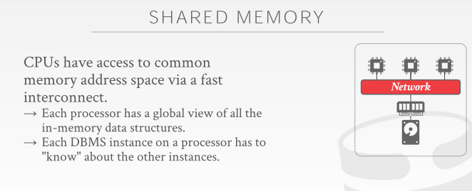
12:10 - 12:11
so again under shared memory
So，在shared memory这种架构下
12.11-12.12
as I said
正如我说的
12.12-12.15
this is not that common in databases
在数据库中，这种架构并不常见
12:15 - 12:19
I'm not aware of any system that's actually people are using that's based on this
我并不知道有哪个数据库系统使用了这种架构
12:21 - 12:22
and the basic idea is that
它的基本思路是
12.22-12.26
the database system is running on these different CPUs
数据库系统运行在这些不同CPU之上
12:27 - 12:29
it's running in the same operating system instance
它会运行在同一个操作系统实例
12:29 - 12:34
Right and assumes it has a single global address space
假设，它有一个全局地址空间
12.34-12.36
,that maybe just aggregated across different machines
这可能只是将不同的机器聚合在一起
12:38 - 12:42
and then there's some networking layer that allows them to pass messages back and forth to make make this work
接着，通过某种网络层来让它们之间来回发送信息，以此来让这种架构工作
12:42 - 12:45
right so again this could be InfiniBand ,this could be TCP/IP
So，它用的可能是InfiniBand，也可能是TCP/IP
12:45 - 12:47
this could be intel's OmniPath
也可能用的是intel的Omni-Path
12.47-12.50 ！！！
,alright some fast interconnect between them
总之是用于这些机器之间通信的高速interconnect
12:51 - 12:53
so in this world
So，在这种架构中
12.53-12.56
the database instance running on one CPU
数据库实例是在一个CPU上运行的
12.56-12.59
it like the worker is aware of other workers
某个worker会注意到其他worker
12:59 - 13:01
and so if they want to communicate between each other
So，如果这些worker彼此之间想互相通信
13:01 - 13:03
they can just do what you would normally do in a shared everything system
它们可以做那些shared-everything系统下所做的事情
13:03 - 13:09
you can write something into a global data structure or send a message over an IPC
你可以往一个全局数据结构中写入数据，或者通过IPC发送一条消息
13:10 - 13:15
and you know the other process of the other worker running on on the other another machine would see that
运行在其他机器上的worker会看到这些东西
13:16 - 13:18
right again in the context of a shared everything system
在这种shared-everything系统下
13.18-13.18-
when we were doing 2PL
当我们使用两阶段锁时
13:20 - 13:25
if we wanted to tell another worker that, hey I hold the lock for this tuple
如果我们想告诉另一个worker：Hey，我拿着这个tuple对应的锁
13:25 - 13:29
I add an entry to my lock table that's sitting in memory
我就会往内存中的lock table里添加一个条目
13:29 - 13:30
so same thing here
So，这里也是一样的
13.30-13.33
if one worker wants to acquire lock on a tuple
如果一个worker想去获取某个tuple对应的锁
13.33-13.35
just updates the global lock table
它只需去更新下这个全局lock table
13:36 - 13:41
and then the messaging fabric is guarantee to make sure everything's coherent across all those workers
接着，Messaging Fabric是用来保证确保所有worker的接触的所有东西都是一致的
13:43 - 13:44
okay as I said
Ok，正如我说的
13.44-13.45
this is not that common
这种并不常见
13.45-13.49
,I don't know if anybody actually does this
我不清楚是否有人真这样做了
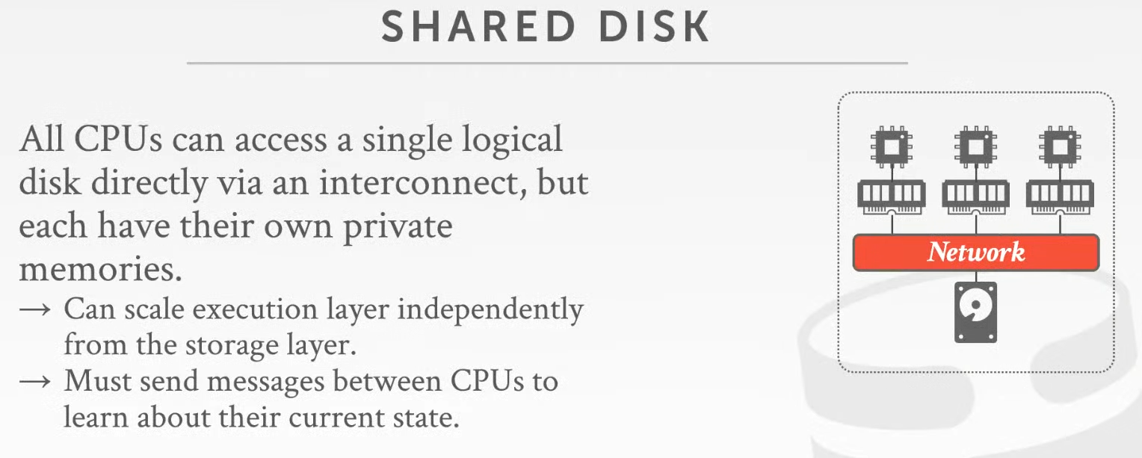

13:49 - 13:51
the more common one is share disk
更常见的架构则是这种shared disk
13.51-13.53
and again the idea here is that
它的思路是
13.53-1354
we have these compute nodes
我们有多个计算节点
13.54-3.57
that have their own local memory
每个节点都有它们自己的本地内存
13:57 - 13.59
they can have a disk up there as well
每个节点里面也可以有一个自己的磁盘
13.59-14.05
but that's not the final storage location of any kind of data in the database
但这并不是数据库中数据所保存的最终位置
14:05 - 14:06
you can just use it for caching
你可以将这些磁盘用于缓存
14.06-14.08
in case you need to spill the disk on your local machine
以便根据你的需要，将数据溢出到你本地机器的磁盘中
14:09 - 14:12
but the database the final resting location is down here
但数据库真正存储数据的地方则是在下面这个磁盘中（知秋注：比如hdfs）
14:13 - 14:18
so if I say I bring a page into my buffer pool in my local memory say I modify it
So，假设如果我要将一个page放入我本地内存中的buffer pool中，并对其进行修改
14:18 - 14:19
and then I'm gonna write it out
然后，我将它写出
14.19-14.20
because it's dirty
因为它变成了dirty page
14.20-14.21
,I would write it down here to the shared disk
我就会将这个page写出到下面的共享磁盘中（比如写到hdfs中）
14:22 - 14:25
and now potentially any other worker can see my change
现在，可能其他的worker都能看到我所做的这个修改
14:26 - 14:30
how you coordinate that will make sure that they're told about that change will get to later
关于我们如何协调这些worker以让它们看到这些修改，这个我们之后会讲
14:32 - 14:33
so as I said
So，正如我说的
14.33-14.37
this is the present architecture in today's cloud environment
这是当下云环境中所使用的架构
14:38 - 14:42
because the disk is going to be you know something Amazon provides like s3 EBS
因为这里的磁盘会是Amazon所提供的S3或者EBS之类的东西
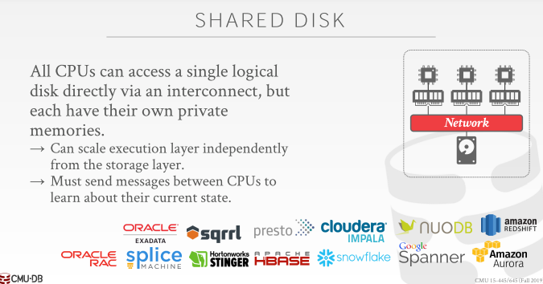
14:42 - 14:49
so pretty much every sort of cloud-native database system that you've heard about is gonna be running this environment
So，你们所听过的那些云原生数据库系统都会在这种环境下运行
14:50 - 14:52
because one big advantage you can get is that
因为你所能获得的其中一个优势是
14.52-14.57
you're able to scale up the compute resources and the disk resources separately
你能够分别对计算资源和磁盘资源进行扩展
14:59 - 15:01
because the compute resources are stateless
因为计算资源都是无状态的
15.01-15.04
, the state of the database is down here
数据库状态则是在它之下的
15:04 - 15:07
so if these all these compute resources crash and go away
So，如果这些计算资源崩溃消失了
15.07-15.13
assuming I you know of log things out correctly, everything is still here
假设我做好了日志记录，那么所有数据依然都还在磁盘中
15:13 - 15:18
and then I can bring up another instance and pick up where the other guys left off
那么，我就可以将这些东西放到另一个实例中，并从它们故障的地方开始继续工作
15:19 - 15:20
we'll see in a second
我们稍后会看到这些
15.20-15.24
, that's not so easy to do in a shared-nothing environment
这在shared-nothing环境下，并不容易做到
15:25 - 15:27
because every node hold state
因为每个节点都是有状态的
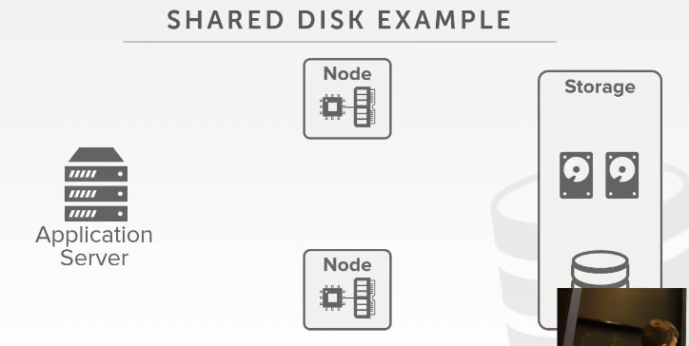
15:29 - 15:30
so let's look at a high-level example like this
So，我们来看个高级例子
15.30-15.32
again so we have our application server
So，这里我们有一个应用程序服务器
15:32 - 15:36
it's gonna send requests to these front-end compute nodes, right
它会将请求发送给这些前端计算节点
15:36 - 15:39
this is where we have the workers running on CPUs and the local memory
我们的worker运行在这些节点上的CPU和本地内存上
15:39 - 15:42
and then we have some back-end storage device
接着，我们还有一些后台存储设备
15.42-15.44
that everyone can read-write to
所有人都可以对它们进行读写
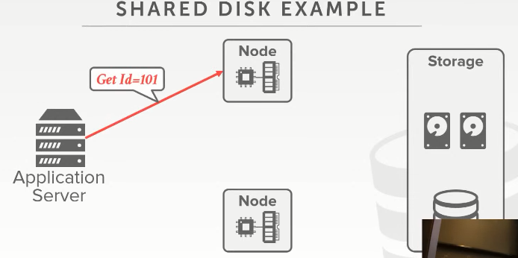
15:45 - 15:48
so let's say that the application says I want to get record 101
So，假设应用程序想获取id为101的记录
15:49 - 15:50
it goes to this node
它会将请求发送到这个节点处
15.50-15.55
how it the application knows to go to this node
应用程序是如何知道它要跑到这个节点去获取数据呢？
15.55-15.56
will cover in a second
我们稍后会介绍这一点
15.56-15.57
, but assume it does
但我们假设它就是知道
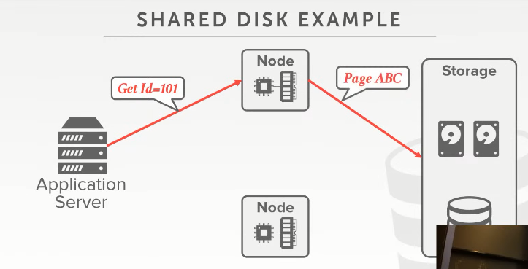
15:57 - 15.58
so then this says
So，接着，这个节点表示
15.58-16.01
some kind of look up that says well record 101
它要去查找id为101的记录
16.01-*16.03
,if I look at my index, I see that it's on page ABC
我查看了下我的索引，我看到这条记录是在page ABC上的

16:04 - 16:05
so I go to my shared disk storage
So，我跑到我的共享磁盘存储设备这里
16.05-16.07
and I say get me page ABC
并说，请给我page ABC
16.07-16.08
,and I bring that to my buffer pool
然后，我将这个page放入我的buffer pool中
16:08 - 16:10
same thing this guy wants 200
如果我要获取id为200的记录也是如此
16:10 - 16:12
he doesn't have it in its buffer pool
如果该节点中的buffer pool里面并没有这个数据
16.12-16.13
so it goes out the disk and fetches it in
So，它就会跑到磁盘这里，获取这个数据
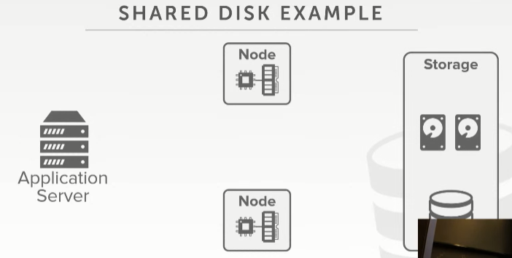
16:15 - 16:20
so now if I want to scale up compute resources
So，现在我想去扩展我的计算济资源
16:20 - 16:23
because again the state of the database is always here on own shared disk
因为数据库状态始终是放在共享磁盘上的
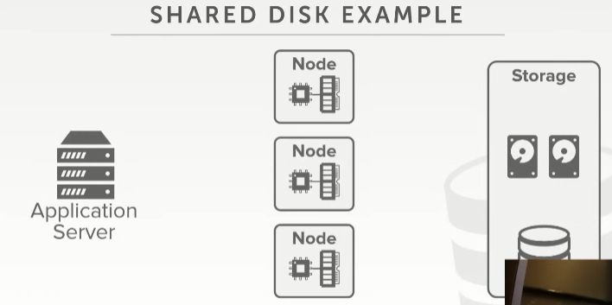
16:25 - 16:27
I can just bring him a new guy here
这里我可以放一个新的节点
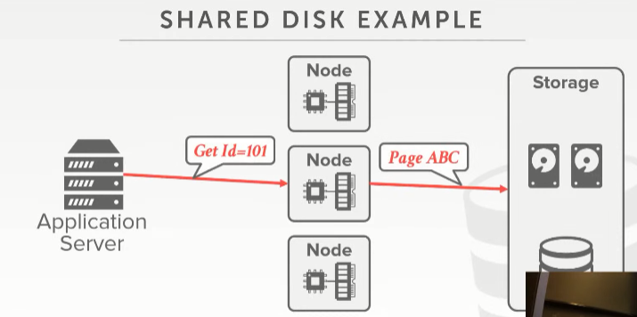
16:27 - 16:29
I don't have to copy anything immediately
我不需要立刻去复制任何东西
16.29-16.32
because if I now request say 101
如果我的请求要去获取id为101的记录
16:33 - 16:33
same thing
这里我只需做和之前相同的操作即可
16.33-16.36
I just go to disk and bring it back to my buffer pool
我只需跑到磁盘那里获取对应数据，并将它放入我的buffer pool中
16:36 - 16:38
and I could serve the request
这样，我就可以处理这个请求了
16:41 - 16:42
tricky sorry yes
请问
16.42-16.44
his question is
他的问题是
16.44-16.47
how does the lock manager work in a setting like this
lock manager在这种情况下是如何工作的
16:47 - 16:49
and then we'll cover this yes
我们稍后会讲
16.49-16.50
not yet
而不是现在
16.50-16.53
to reduce simplicity we're talking about how do we ever get things in now yeah
这里我们是出于方便起见，先不讲这个
17:02 - 17:03
yes so this question is
So，他的问题是
17.03-17.06
in a shared memory architecture
在这种共享内存架构下
17.06-17.12
how is that different than a Multi multi socket, multiprocessor shared everything system
它和那种多处理器共享系统有什么不同
17.12-17.12
they're the same
它们是一样的
17:13 - 17:22
but think of like so there are, there are there are, there are distributed DBMS
它们是分布式DBMS
17:22 - 17:25
that have a unified memory cross multiple physical machines
它们拥有一个跨多台物理机器的统一内存

17:26 - 17:31
so each machine has its own motherboard has its own like physical memory that it can read and write to
So，每台机器都有自己的主板以及它可以进行读写的物理内存
17:31 - 17:33
but there's a layer
但这里有一个层
17.33-17.38
that it says all the processors think ,they have this one giant block of memory
它表示所有处理器都会觉得它们有一块很大的内存
17:38 - 17:40
nobody does that for databases
没有人会为数据库做这种事情
17.40-17.41
you see that in HPC world
你会在高性能计算中看到这些东西
17.41-17.45
like all those people are doing like nuclear bomb or particle physics simulations
比如那些做核弹或者物理模拟的人们
17:45 - 17:46
they're writing those Fortran programs
他们会去编写这些Fortran程序
17.46-17.52
assuming they had this like you know terabytes of memory across multiple machines ,they can do computation on
假设他们拥有一块跨多台机器的数TB级大小的内存，他们可以通过这块内存进行计算
17.52-17.53
,yes
请讲
18:05 - 18:06
So this question is
So，他的问题是
18.06-18.08
, if you assume in a shared disk architecture like this
假设，我们是在这种共享磁盘架构下
18:09 - 18:14
if a databases vendor is using a shared disk architecture
如果数据库厂商使用的是这种共享磁盘架构
18:14 - 18:20
does that mean that they either have to have all the the data for a database in one location
这是否意味着他们必须将该数据库的所有数据放在一个地方
18:21 - 18:21
no
No
18:22 - 18:24
well we'll get to that
Well，我们之后会讲
18:28 - 18:36
again I mean think about this there's an abstraction between the physical location and the logical location of the disk
在磁盘的物理位置和逻辑位置之间存在一个抽象层
18:36 - 18:39
these guys don't know anything about where these things are
这些节点并不清楚这些数据存放在磁盘中的什么位置
18:39 - 18:46
right so like it just says ,hey here's this file I can I can read and write to just as you would as if it was a local disk
So，它表示，这里有一个我可以进行读写的文件，这就像和我在本地磁盘上对文件进行操作一样
18:46 - 18:48
when in case Amazon or Azure
以Amazon和Azure为例
18.48-18.52
you get like a like a block base or object based API
你会通过一个block-based或者Object-Based API
18.52-18.54
,give me this bucket ,give me that bucket
来得到这个bucket的数据
18:54 - 18:58
that thats sending a restful request to go to some back-end service
它会发送一个restful请求到某个后端服务那里
18.58-18.59
you don't know where that data's actually is
你并不清楚这些数据实际在哪里
19:12 - 19:15
yeah yeah so we'll get to that as well
So，我们稍后会讲
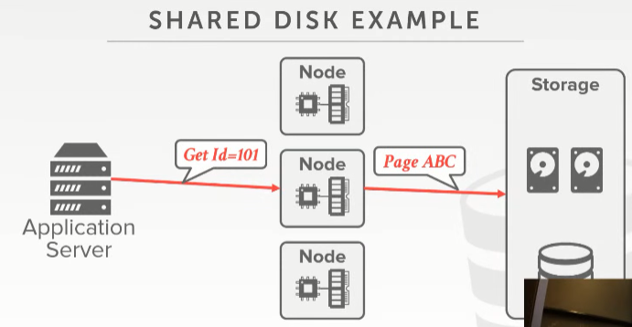
19:15- 19:16
so his question is
So，他的问题是
19.16-19.18
in my example here
在我的例子中
19.18-19.19
when I'm sending this request
当我发送这个请求时
19:21 - 19:22
in this example here,
在这个例子中
19.22-19.24
this application says
这个应用程序表示
19.24-19.26
I'm going to this node to get this record
我会跑到这个节点处拿到这个记录
19:27 - 19:32
you could have something in front of this that could hide that ,or this thing can maintain to say where to go get the thing I need
你可能会在此前面去维护一些信息，这些信息会告诉我们该去哪里获取我需要的东西
19:33- 19:34
we'll come to that
我们会去获取这个东西
19:35 - 19:38
just the third thing I'm gonna focus on here is like it's like
这里我重点要讲的第三件事情是
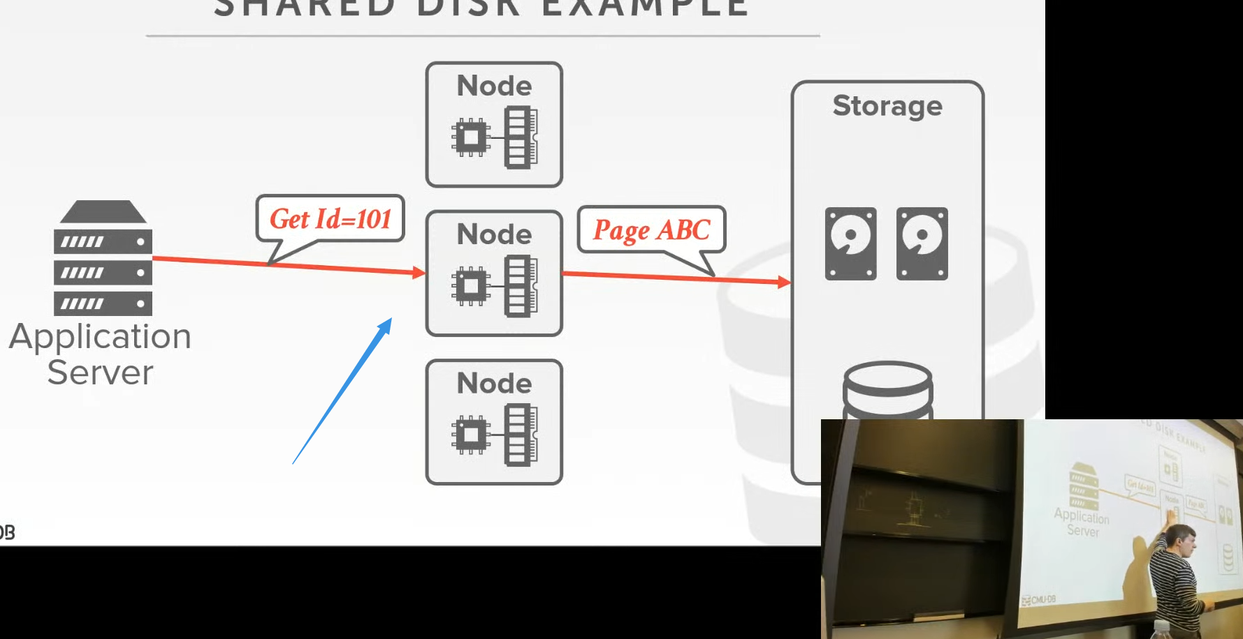

19:39 - 19:43
this guy has no state of the database other than within its buffer pool
在这个节点中，除了buffer pool中的数据以外，它里面并没有保存数据库的状态
19:43 - 19:49
but that's not considered to be that's not consider be you know durable or persistent its ephemeral
我们不能将它里面的数据视作是持久化的，它是临时的
19:49 - 19:53
so this guy crashes anything we had in here it goes away
So，如果这个节点出现了故障，那么我们放在该节点中的东西也就灰飞烟灭了
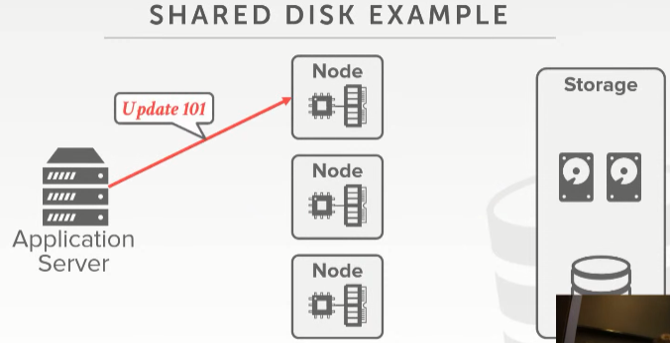
19:56 - 19:57
all right

19.57-19.59
so now the tricky things gonna be if I do an update
So，如果我进行更新操作，那么我就会遇上些棘手的事情

