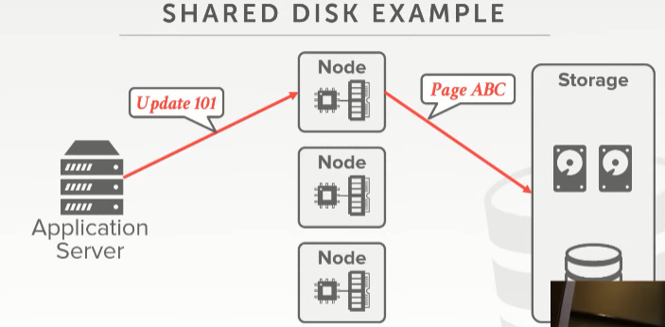
20:00 - 20:06
right so update page 101 ,oh sorry, an ID record of 101, I have to update page ABC
So，这里我要对id为101的记录进行更新，我需要对page ABC进行更新

20:06 - 20:11
these guys all read that same record they have page ABC in the buffer pool
这些节点都读取到了同一条记录，并且它们的buffer pool中都有page ABC
20:12 - 20:17
but they're not going to know about the the changes, because these shared disk architectures
但它们并不清楚这里的修改，因为它们使用的是shared-disk架构
20:17 - 20:21
they don't provide a notification say hey by the way somebody updated this
这种架构并没有提供一种通知机制，比如说：hey，有人更新了这个东西
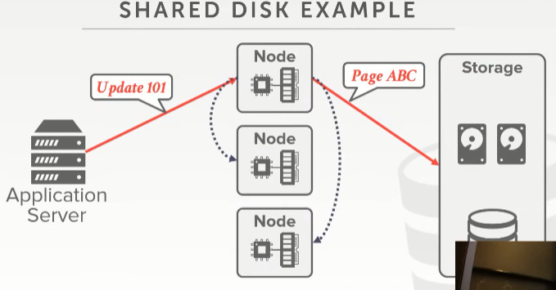
20:23 - 20:31
so I have to have additional messages these nodes to say, hey I think you have page ABC by the way I just modified it
So，我需要给这些节点发送额外消息，以此来告诉它们：hey，我你手上有page ABC的话，我得通知你一声，我刚刚修改了这个page
20:31 - 20:33
and here's the latest version
这是该page的最新版本
20.33-20.35
,or if you're gonna find out what the latest version is come asking me about it
或者，如果你想拿到该page的最新版本，可以来找我
20:36 - 20:40
so that's all the stuff that we have to build in our database system right
So，这就是我们在构建我们数据库系统时所要做的所有事情
20:40 - 20:43
This is just reading writing to some disk
这里我们只是对磁盘进行读写
20:43 - 20:47
and so related his question that it's all transparent
So，这与他所提的问题相关，这里都是透明的
20:47 - 20:52
so right now I'm showing the database and this diagram is on two disk
So，在这张图上，我的数据库是放在这两个磁盘上的
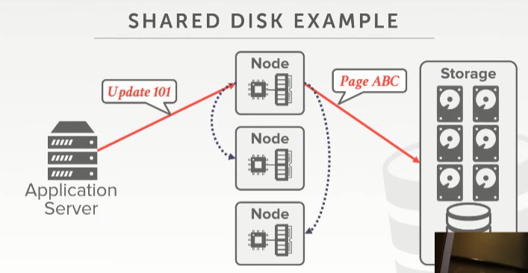
20:52 - 20:57
but I can easily add a bunch more to now split up the data cross more disk
但我可以很容易地添加更多磁盘，并将数据拆分到这些磁盘上
20:57 - 21:00
so I'm getting better parallelism better better replication better reliability
So，这样我就获得了更好的并行性、更好的replication以及更好的可靠性
21:01 - 21:04
but none of these guys in the compute layer
但对于计算层面的这些节点来说
21:04 - 21:05
they don't know anything about that
它们对此一无所知
21.05-21.07
, because that's all hidden from me
因为我将这些东西隐藏了起来
21:07 - 21:09
so you had this nice separation
So，我们就将这些东西很好地隔离开来
21.09-21.10
where you can scale things out independently
即我们可以单独对这些东西进行扩展
21:10 - 21:14
but you're gonna pay a penalty in terms of locality of access
但你要对某个地方进行访问时，你要付出一定成本
21:14 - 21:18
because for the locality I can't run queries over here
因为我没法在大部分地方执行查询
因为我没办法在数据存储的层面来运行查询
21:19 - 21:21
s3 allows you do some basic filtering
S3允许你做些基本的过滤
21.21-21.23
, but about anything like a join I have to do over here
但诸如join之类的操作，我就得在这些节点处进行了
21:23 - 21:25
so that means I have pooled the data to my compute nodes
So，这就意味着，我要将数据放入我的计算节点处
21.25-21.26
yes
请讲
21:35 - 21:36
so his question is,
So，他的问题是
21.36-21.38
this is different in sharding or partitioning
因为数据存储使用了分片或分区
21.38-21:43
, we have explicit divisions of who has what data, we'll get to there
我们要去哪个目的地，得明确区分出哪个分片或分区拥有哪些数据才行
21:43 - 21:45
I'm just showing you what shared disk is at a high level
这里我只是向你们展示，从高级层面来看，什么是shared-disk
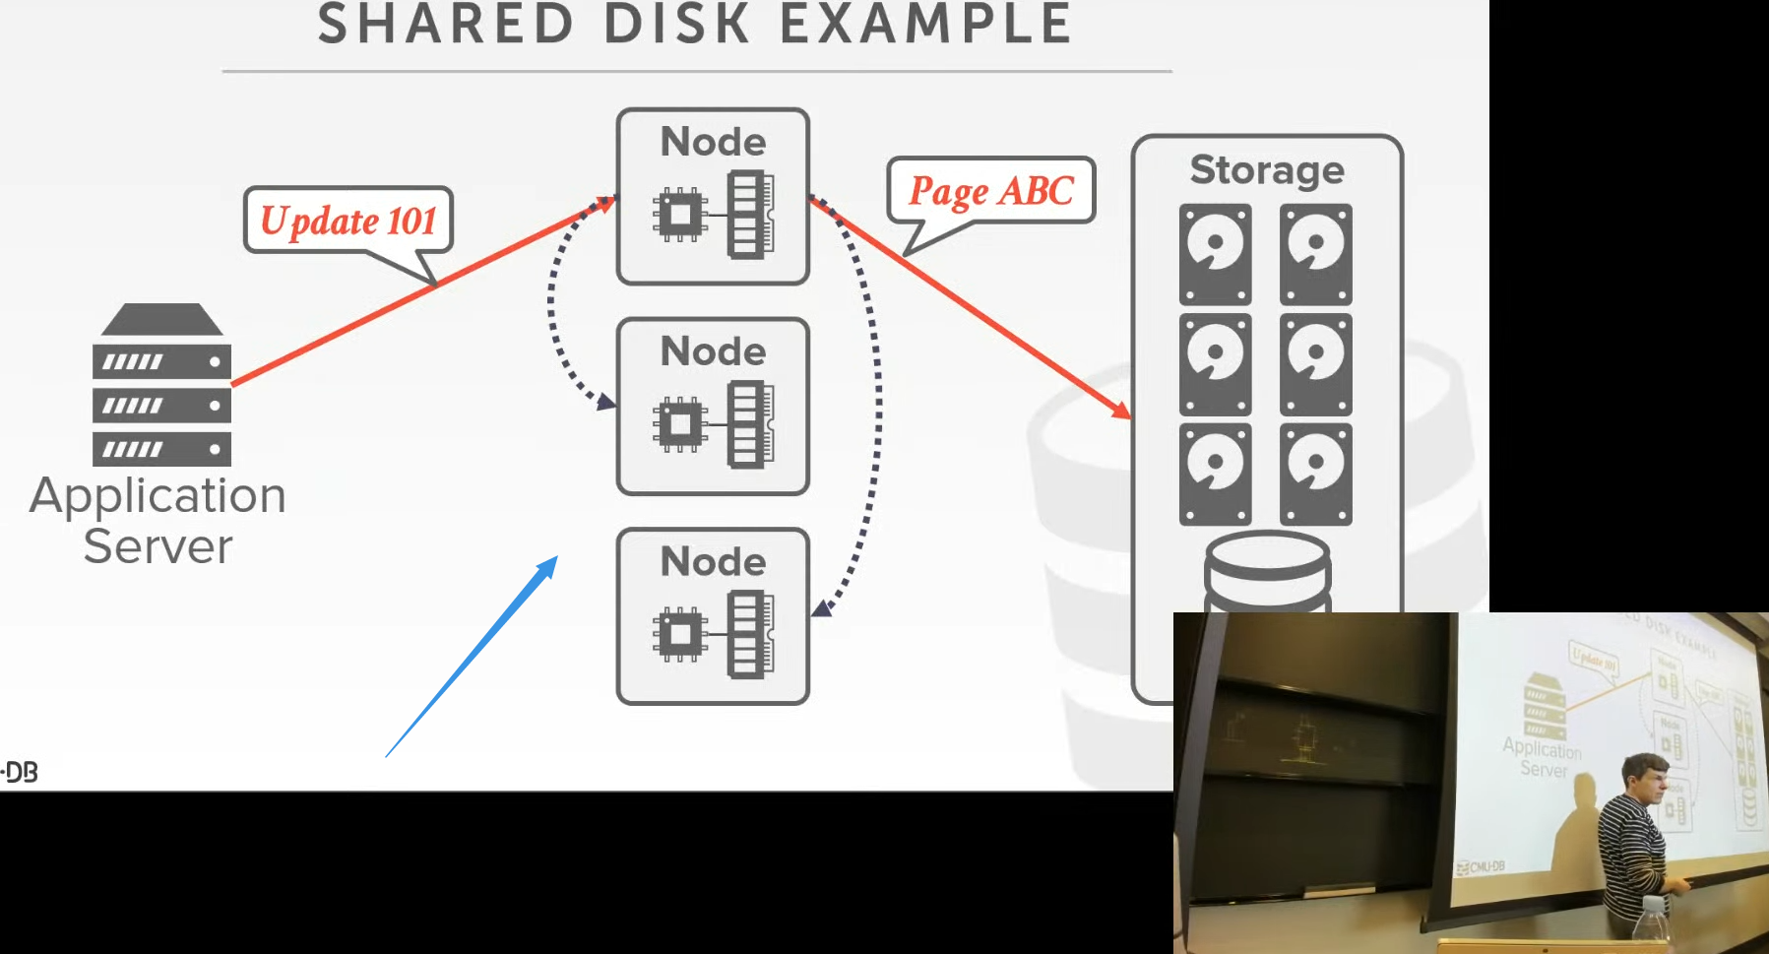

21:46 - 21:49
you can still partition at this level
但你依然可以在计算节点层面进行分区
21:50 - 21:53
there's nothing about share disk precludes you from doing partitioning at the compute level
shared-disk无法让你在计算层面进行分区
21:57 - 21.58
Correct
没错
21.58-22.01
if you're not doing partitioning
如果你不做分区的话，就是这样的
22:16 - 22:16
her question is
她的问题是
22.16-22.18
in this example here
在这个例子中
22.18-22.18
I said
我说过
22.18-22.21
when I update page ABC in this node
当我在这个节点处更新page ABC时
22:21 - 22:24
it sent a message to the other guys updated and say hey I haven make a change
该节点会发送消息给其他节点，并说：我更新了这个page
22.24-22.30
is it always like this or what all over the alternative
就像这里展示的一样或是通过其他备选方案来更新其他节点
22:30 - 22:33
yeah yeah so what I said it in this case here
So，在这个例子中，我所说的是
22:34 - 22:35
I update a page ABC
我更新了page ABC
22.35-22.38
it has to the compute node at the top is update these compute nodes to the bottom
它得自顶到底将更新信息推送到各个节点的
22.38-22.42
an alternative would be a way to do a push notification
一种备用方案就是去推送通知
22:42 - 22:44
and say hey I just got an update ABC
并说：hey，我更新了page ABC
22.44-22.47
by the way everybody needs to update and refresh themselves
你们其他人（node）都需要更新并刷新一下
22:49 - 22:57
I'm not aware of any shared disk architecture, like EBS s3 whatever the address up they don't do that
我不会意识到我存储数据的地方是类似EBS s3这样的云存储，它们不会这么做的
22:57 - 22:58
because that would be super expensive
因为这样成本就会变得超级高
22:58 - 22.59
because if you think about it
如果你稍微思考下它
22.59-23.01
it's like a pub sub system
这就像是一种发布/订阅系统
23.01-23.04
, I need to know who needs to know about my change
我需要去知道哪些节点该知道我所做的修改
23:05 - 23:07
because otherwise I'm sending messages that are wasteful
不然，我发送信息其实就是在浪费系统性能
23:07 - 23:10
so as far as I know nobody actually does this
So，据我所知，实际没有人使用这种方案
23.10-23.12
you have to coordinate at this layer here
你需要在计算层面进行协调
23.12-23.13
and this is the database system does this
数据库系统为我们做了这些（知秋注：要涉及到多核并行处理，所以要做这些事情）
23:13 - 23:16
the distributed file system or the object store doesn't do that
分布式文件系统或者对象存储则不会做这些
23:17 - 23:17
yes
请讲
23:22 - 23:23
his question is
他的问题是
23.23-
are we assuming here that the notification is reliable or fast enough no
假设我们这里的通知很可靠，足够快，no！
23:28 - 23:31
I didn't say what this is I'm saying how we're doing the same thing you have to do this
我要说的不是这个，我这里要说的是同一件事情在不同场景下，我们该如何去做（知秋注：一个是单机多核，一个是分布式情形）
23:36 - 23:36
his question is
他的问题是
23.36-
can't you run an issue stale reads absolutely yes
我们能否运行一个stale reads,完全可以的
23:38 - 23:40
that's that's concurrency control we'll get there
这是关于并发控制方面的东西，我们之后会讲
23:41 - 23:41
yes
Yes
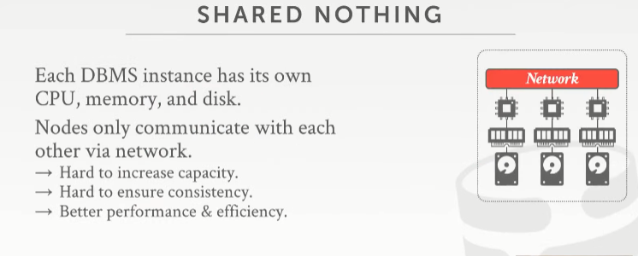
23:45 - 23:45
okay

23:47 - 23:54
so the the again most people think about ,when they think about distributed databases is the shared nothing architecture
So，大部分人在考虑分布式数据库时，他们会考虑这种shared-nothing架构
23:54 - 23:58
where you have each node has its own local disk and local memory
每个节点都有它自己的本地磁盘和本地内存
23:58 - 24:02
and the only way for me to coordinate as I run queries is to communicate directly between my nodes
对我来说，唯一能够去协调这些节点的方式是，当我执行查询时，这些节点之间会直接进行通信
24:03 - 24:04
so if I want to get data
So，如果我想去获取数据
24.04-24.08
If I query shows up and need accessed data on another machine
如果我的查询要去访问另一台机器上的数据
24:08 - 24:11
I can't go to disk and get the shared disk and get it ,because that doesn't exist
我没法跑到共享磁盘处获取这个数据，因为这个架构中没有共享磁盘
24:11 - 24:13
I can't read the memory from the other guy
我也不能去读取其他机器内存中的数据
24.13-24.15
because I can't do that
因为我没法这么做
24:15 - 24:22
I have sent a message to say hey I think you have this data either run this query for me and give me back the result or send me that data
我会发送一条消息说：嘿，我认为你有该数据或者为我运行此查询，并将结果返回给我或发送给我
24:22 - 24:26
and then now you get the issue of like who should have what copy of what data, right we'll get that
然后，我们就会有一个问题，这份数据拷贝应该给谁，right，正是我们要得到的
24:27 -24:35
so this is gonna be the hardest architecture to increased capacity and ensure consistency
扩容和并确保一致性是这个架构方案最难的地方
24.34-24.36
that's the stale read issue that he talked about
这就是他所谈论的stale read的问题
24:36 - 24:45
Because, I need to be able to run the system and move data around in a way to I'm not losing things
因为我需要能够运行系统，并以某种方式移动数据，以避免我丢失数据
24:45 - 24:47
I'm not having false negatives or false positive as I execute queries
当我执行查询时，我就不会遇上假阴性或假阳性的问题
24:49 - 24:52
right otherwise I shut the whole system down
否则，我就会关闭整个系统
24.52-24.54
then move data around and add new capacity
然后，移动数据，并进行增容
24:54 - 24:55
but I don't want to do that
但我不想这么做
24.55-24.57
because I want my system to always be online
因为我想让我的系统始终能在线提供服务
24:58 - 25:00
so now you say well that this sounds hard
So，你现在会说：Well，这听起来好难啊
25.00-25.01
why would I want to do this
为什么我想这么做呢？
25:02 - 25:05
well the advantage you're gonna get over a shared disk system, is that
Well, 我们从这种shared nothing disk系统中所获得的好处是
25.05-25.10
you're gonna get better performance and better efficiency，if the system is written correctly
如果该系统写操作正确的话，那么我们会获得更好的性能以及更高的效率

25:11 - 25:16
because I can now be mindful of the locality of data
因为我现在可以只关注局部性数据

25.16-25.20
and try to move the least amount of data over the network as much as possible
并试着尽可能多地通过网络来移动最少的数据量
并尽可能多地通过网络移动最少的数据量
25:20 - 25:20
yes
请问
25:36 - 25:36
Yes,it do
没错是这样
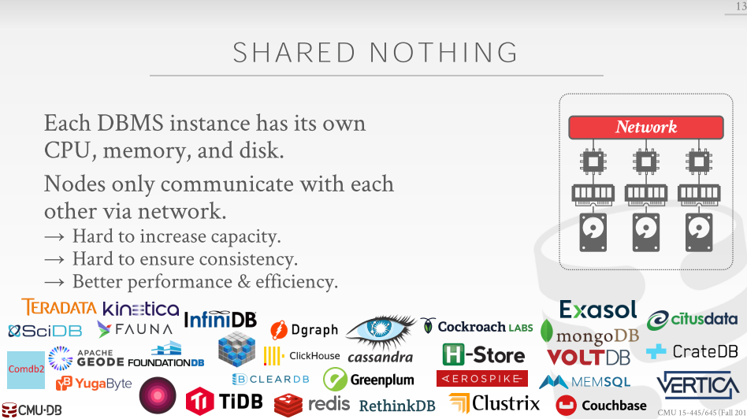

25:42 - 25:43
correct
正确
25.43-25.47
so his statement is
So，他所说的是
25.47-25.51
if you assume that your distributed databases partitioned
假设你的分布式数据库已经分区了
25.51-25.52
which we'll get to in a second
这个我们稍后会讲
25:54 - 25.56
if now I need to add a new partition
如果我现在需要添加一个新分区
25.56-25.59
and I need to potential reshuffle data
我可能需要对数据重新进行洗牌
25.59-26.02
depending on how I'm doing partitioning
洗牌的方式取决于我分区的方式
26:02 - 26:06
I may have to move the whole database I'm do segment of it
我可能需要移动整个数据库，或者对数据库数据进行切片
26:06 - 26:09
but again I don't want to have to stop the world while I move that
但当我移动数据库的时候，我不希望让数据库停止工作
26:09 - 26:12
and so depending how much data I have a single node
So，根据我单节点上所保存数据的数量
26:12 - 26:15
and I'm going with a network to some other machine ,where's that machine, how long does that take
我会通过网络来访问其他机器，并询问该机器多久才能完成数据移动
26:15 - 26:18
right it's if I'm doing this
如果我这样做的话
26.18-26.21
if I don't care about consistency which we haven't talked about yet
如果我不关心一致性，虽然我们现在还没讨论一致性
26:22 - 26:23
then who cares
那么谁会在意这些事情呢？
26.23-26.24
just move data around
我们只管移动数据就行了
26.24-26.26
and if you miss a read， whatever
如果你错过了一次读操作，那又怎么样
26:26 - 26:28
because I do care and I am running transaction
因为当我执行事务时才会关心这些问题
26.28-26.31-
then I'm gonna be very careful how I do this
那么，关于我该怎么做，我就会非常小心
因为这执行事务的时候，我对这些非常敏感
26:31 - 26:32
and people get burned by this a lot
人们会因此而特别上火
26:34 - 26:35
so as I said
So，正如我说的
26.35-26.47
this is just a brief smattering of ,or a very limited subset of the some of, the shared-nothing distributed DBMS that was out there
这些还只是shared-nothing架构分布式DBMS系统中的很小一部分
26:47 - 26:52
most of the time for the NoSQL systems that came in around maybe ten years ago
对于过去十年间所出现的大部分NoSQL系统来说
26:52 - 26:54
they're all considered shared nothing
你可以认为它们使用的都是shared-nothing这种架构
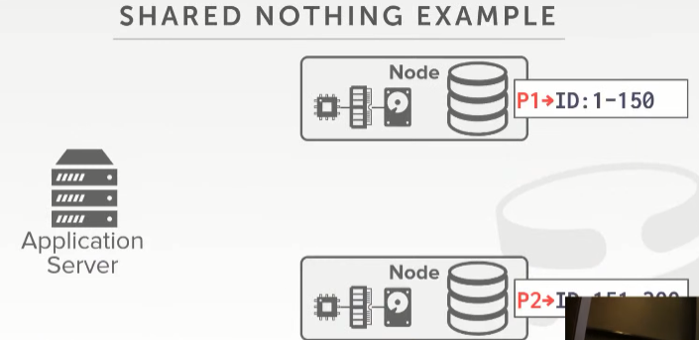
P2->ID:151-300
26:55 - 26:57
so let's look how this works again
So，我们来看下这是如何工作的
26:57 - 26.59
so no longer we have a shared disk
So，这里我们不再使用共享磁盘
26.59-27.00
on every single node
在每个节点上
27:00 - 27:06
we have the CPU workers, we have our local memory, we have our local disk
我们有CPU worker、本地内存以及本地磁盘
27:06 - 27:08
and then now what I'm showing is
现在，我这里所展示的是
27.08-27.13
we've partitioned the database or shard the database into subsets
这里我们将数据库拆分成多个节点
27.13-27.18
such that each node has some portion of of the database
每个节点上都拥有该数据库中的一部分数据
27:18 - 27:23
and so now I have explicit information about what data I'm having in each node
So，这里我在每个节点上显式标注了该节点所拥有的数据范围
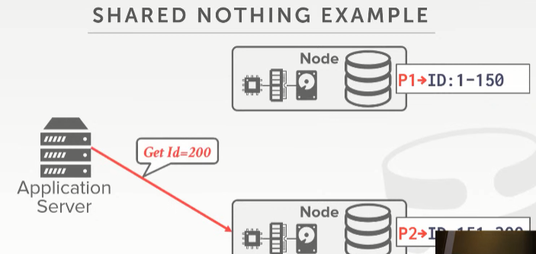
27:24 - 27:25
so now the application says
So，应用程序表示
27.25-27.27
well if I want to get ID equal 200
Well，如果我想去获取id等于200的那条记录
27.27-27.31
, it has to know that this node has the data that it needs
它需要知道拥有它所需要的数据的那个节点
27:32 - 27:33
so go ahead and get that
So，跑到那个节点，并获取该数据
27.33-27.38
and again now this is operating as the same single node shared everything data so we had before
这和我们之前在shared-everything那种架构下所做的事情是一样的
27:39 - 27:41
like it's it's not my buffer pool， I go to disk， bring it in
如果该page不在我的buffer pool中，我就会跑到磁盘中，将这个page放入buffer pool中
27:41 - 27:44
and then do whatever it is that I want to do to answer the query and return results
接着，做我想做的事情，以此给出该查询所要的答案，并返回结果
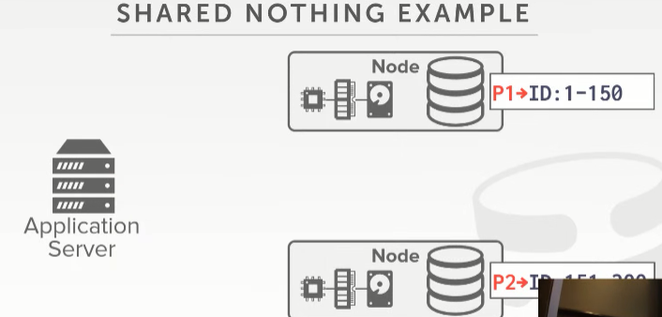
27:45 - 27:49
so if all your queries are accessing a single node
So，如果你所有的查询访问的都是单个节点
27:50 - 27:51
this is super fast
它的速度就超级快
27.51-27.54
because again this is just a single node database system
因为这就是一个单节点数据库系统
27:54 - 27:56
the tricky thing is
棘手的地方在于
27.56-27.58
then when you start touching data that's across multiple machines
当你开始接触的数据是跨多台机器时
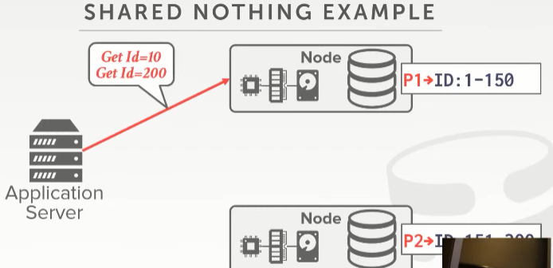
27:59 - 28:05
so let's say I have a transaction that says one get ID = 10 and get ID = 200, like a single query wants to do this
So，假设有一个事务要去获取id等于10和200的记录，就比如说某个查询想做这种事情
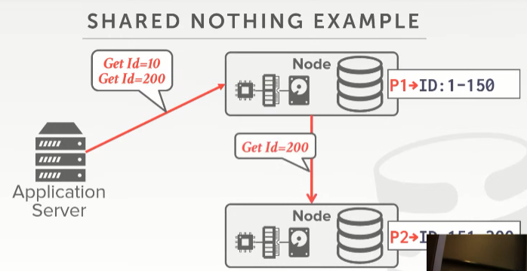
28:05 - 28:11
so now I need to somehow get that data that this other guy has up here
So，我现在需要通过某种方式来获取另一个节点上的数据
28:11 - 28:12!!!!!!!1
but what am I sending
但我这里所发送的是
28.12-28.14
, I`m sending the request to run the query
我发送请求来执行查询
28:15 - 28:17
or am I just asking this guy
或者，我直接去询问下面这个节点
28.17-28.20
hey I know you have this piece of data send it up to me and I'll run the query up here
并说：hey，我知道你有这份数据，请将它发往上面这个节点，我在上面这个节点处执行查询，需要这份数据才能继续前进
28:20 - 28:22
alright back back in every
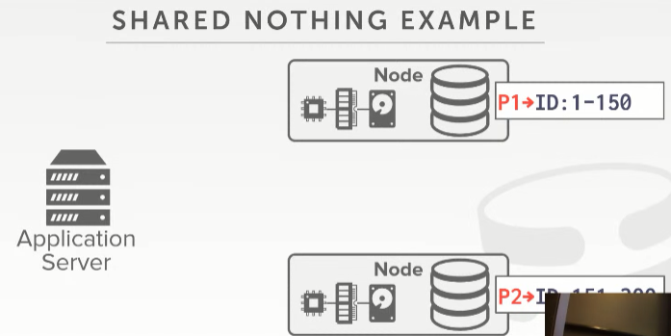
28:24 - 28:27
now in terms of the the scale out issue
我们现在来讨论下水平扩展的问题
28:27 - 28:29
right on the shared disk architecture
在shared-disk架构下
28.29-28.31
I just bring up a new compute node
我只需添加一个新的计算节点即可
28.3128.33
every compute node it's stateless
每个计算节点都是无状态的
28:33 - 28:37
so therefore it comes along and start executing queries
So，因此当我们添加完新节点，并开始执行查询后
28.37-28.40
and brings things from the back end shared disk into a buffer pool as needed
我们会根据需要将数据从后端的共享磁盘处放入buffer pool中
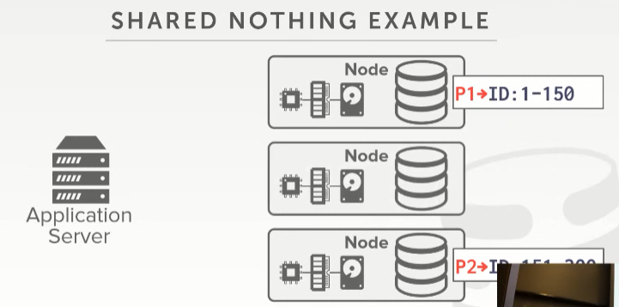
P2->ID:151-300
28:40 - 28:42
but now and I shared nothing architecture,
但现在，我使用的是shared-nothing架构
28.42-28.44
if I have to say bring up a new node
如果我需要添加一个新的节点
28:44 - 28:48
it now needs to get some portion of the database from these other nodes here,
它现在需要从其他节点处获取该数据库的某一部分数据
28.48-28.50
so that I balance things out.
这样的话，我需要将各个节点数据都匀给它一点
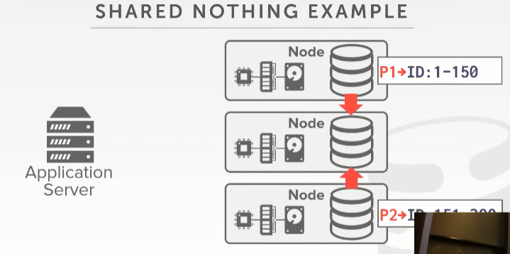
28:51 - 28:52
right so let's say that
So，也就是说
28.52-29.01
this guy is gonna send it you know a some some number tuples from this guy from this bottom partition
下面这个节点会将它保存的一部分tuple发送给中间这个节点
28:59 - 29:01
the other guy here is it sent some other tuples with another partition
最上面这个节点会发送一些tuple给这个中间这个新分区
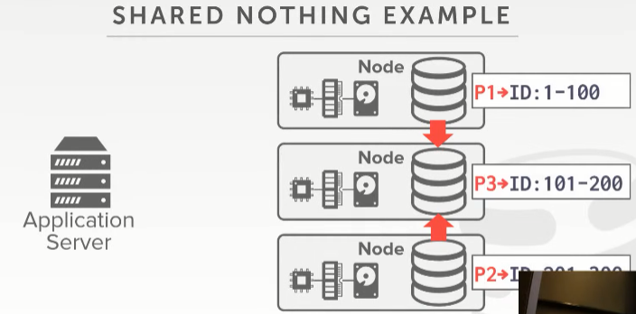
P2->ID:201-300
29:01 - 29:04
and then once I've new I've copied the data
接着，一旦我复制完了数据
29.04-29.05
now I update some global state to say
我会去更新下某些全局状态，并说
29.05-29.10
all right well this node is now responsible for the range 101 to 200
这个节点是负责处理id为101到200这个范围的记录
29:10 - 29:12
this guy's 201 to 300, a guy up about 1 to 100
下面这个节点处理的范围是201到300，最上面那个节点负责的是1到100
29:13 - 29:17
and I was saying to his point like this is this would be hard to do
就像他所说的，这做起来很难
29:17 - 29:20
if I care about transactions and I don't want to lose any data
如果我在意事务的话，我不想丢失任何数据
29:20 - 29:26
because I don't want to have a query show up but maybe that wants to access ID equal 150
因为我不想有这么一个查询，我想去访问id=150的数据条目
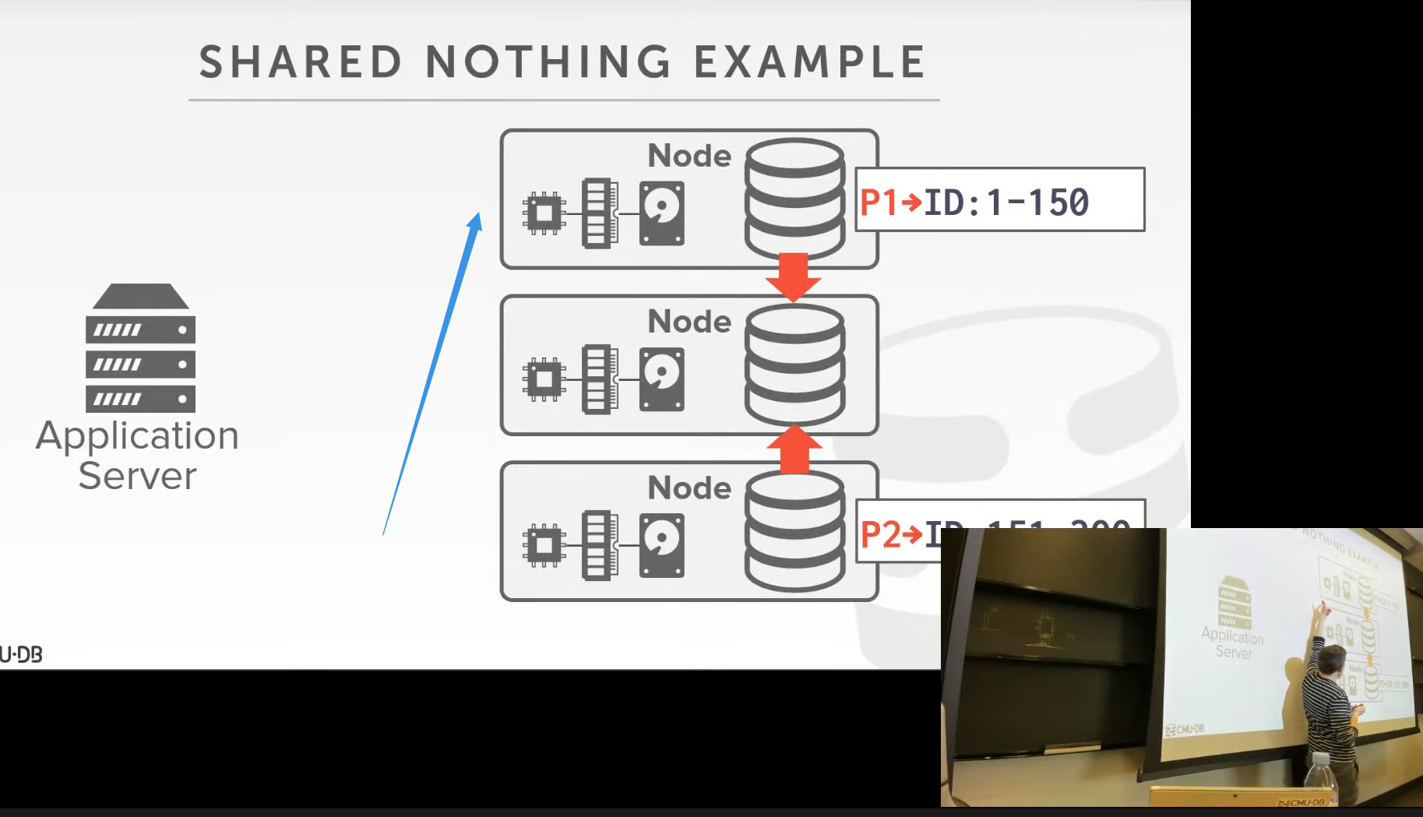

29:26 - 29:29
and I'll land here
我落到了这个节点处
29.29-29.32
and the data hasn't been transferred yet
该节点处的数据还未被转移到中间这个节点
29:32 - 29:34
so maybe I can answer but maybe it has been transferred yet
so 也许我可以回应这个查询，但也许该数据已经被迁移走了
29:35 - 29:38
and I go here and it says I don't have that data anymore
那在我走到这里的时候，它就会说，我不再拥有这个数据了
29:38 - 29:39
so it returns back nothing
So，它就什么也不返回
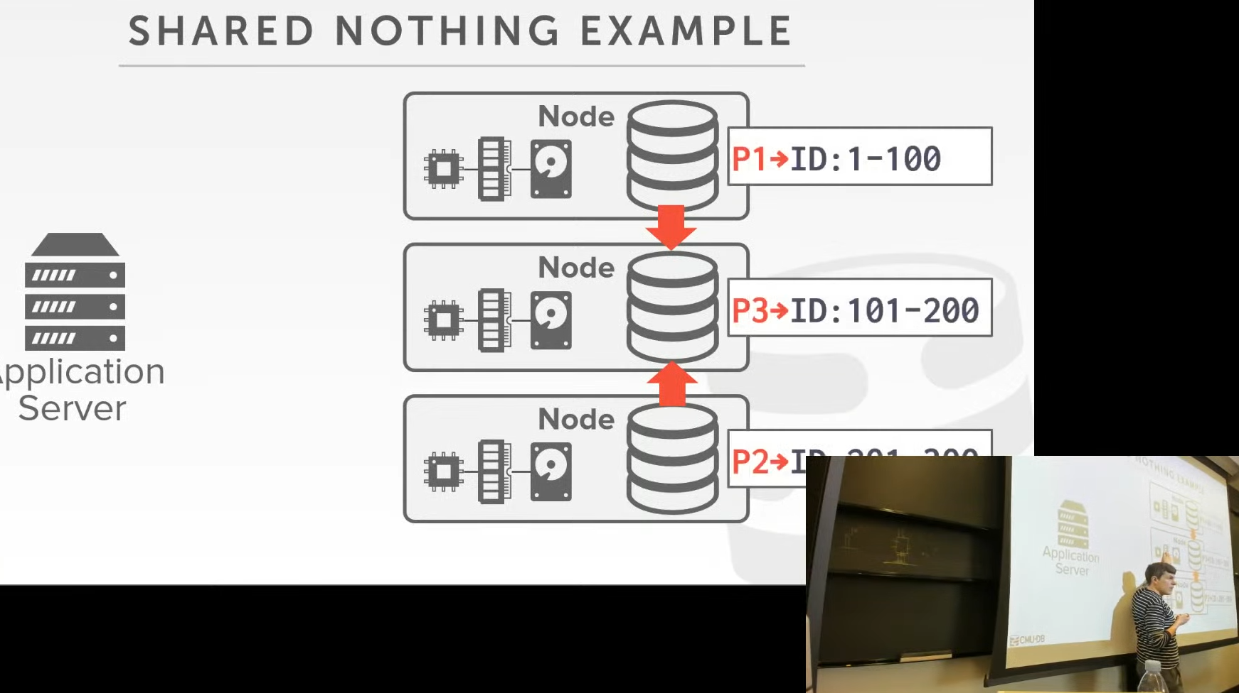

29.39-29.42
even though it existed this node down here
虽然我们要的数据存在于该节点下方这个节点
29:42 - 29:47
so how did it how to actually do this in a transactional safe manner is tricky ,and not not easy to do
So，实际上，我们在保证事务安全的情况下要做到这点非常棘手，并且也不容易做
29:48 - 29:50
yes in the back
后面那位同学请问
29:58 - 30.00
his question is
他的问题是
30.00-30.03
how often you have to scale capacity
通常我们需要每隔多久进行一次扩容呢？
30:03 - 30:07
can I shut the database down once a month and add new nodes
我是否能每个月关闭下数据库，并添加新节点？
30:07 - 30:08
but what if I won't go to the other way
但如果我使用的是其他方式呢？
30:09 - 30:13
but so what so let's say it's singles day or black or Black Friday or Cyber Monday
So，我们假设我们处于黑五或者剁手星期一的时候
30:13 - 30:16
it's the one day of the year where like I have a huge spike
这是一年中我数据库负载最大的一天
30.16-30.18
that one I can plan ,I know it's coming so I can prepare ahead of time
我知道它什么时候来，我可以提前为它进行准备
30:19 - 30:20
but let's say I have like a flash mob
假设我是一个快闪族
30:21 - 30:24
right everybody wants DJ drop tables new album all of a sudden
所有人突然之间都想要DJ Drop Table的新专辑
30.24-30.27
so also we have a huge spike in traffic that's unexpected
So，我们就会遇上一个意外的流量巅峰
30:28 - 30:32
I want to be able to scale up without having to shut everything down and scale up gradually
我想能够在不关闭任何东西的情况下渐进式地进行扩展
30:33 - 30:36
the older systems will do exactly you're saying
那些较老的系统会做你所说的那些事情
30:36 - 30:41
any time you see any kind of financial website says we're down you know Sunday at 3:00 a.m.
每当你们看到那些金融网站说他们在早上3点的时候会暂停网站使用
30:41 - 30:44
there probably may probably not running a distributed system
他们用的可能并不是分布式系统
30.44-30.46
but they they're moving data around and doing maintenance things
但他们会去移动数据，并做些维护工作
30:47 - 30:48
but if you're an online website
但如果你是一个在线网站，比如电商网站之类的
3.0.48-30.49
you can't do that
你就不能这么做
30:49 - 30:50
yes
请问
31:02 - 31:02
your question is
你的问题是
31.02-31.06
what's the advantage of doing this versus having a single node with like
这种做法与单节点数据库系统相比有什么优势
31:06 - 31:13
like you know instead of having two nodes run these to hold these two partitions what have a single node
如果我们不使用这两个节点来保存这两个分区的数据，而是用一个节点来保存，那会怎么样呢？
31:13 - 31:17
and you say well this CPU socket has this disk in this memory to run this partition
假设这个节点上，我们有CPU、磁盘以及内存，以此来处理这个分区的相关工作
31:17 - 31:20
and then another socket has this memory and this disk
接着，另一台机器上，也拥有CPU、内存以及磁盘
31:20 - 31:22
that you're asking
这就是你要问的吗？
31:29 - 31:31
all right so her question yeah
So，她的问题是
31.31-31.36
,instead of having two separate machines that have you know disk memory and the CPU
这里我们不使用两台单独的机器，这里的单独的机器是指每个上面都有磁盘、内存以及CPU
31:36- 31:37
, what if I had one machine
如果我使用的是一台机器呢？
31:37 - 31:41
that just had the same amount of resources that it has put across two machines
它上面拥有的资源等同于原来两台机器上的资源
31:41 -31:43
but now in you know a single unit .
即现在，这一台机器相当于之前两台机器上的资源
31:49 - 31:49
so question is
So，她的问题是
31.49-31.51
what were the advantages of doing the distributed databases
使用分布式数据库的优势是什么
31:51 - 31:55
so one is if
So，其中一个优势是
31:59 - 32:03
the you get diminishing returns as you scale up Hardware vertically
当你对你的硬件进行垂直扩展时，你的收益会递减
32:03 - 32:08
so there's horizontal represent scalability as is adding new machines
So，水平扩展的意思是添加新机器
32:08 - 32:12
vertical scale voting to take my one machine and adding more resources to make it more powerful
垂直扩展的意思是，我往一台机器上添加更多的资源，以此来让它更为强大
32:14 - 32:17
going vertically is way more expensive usually
通常情况下，这种垂直扩展的成本更加昂贵
32:18 - 32:20
and you get diminishing returns
并且你所得到的收益会递减
32:20 - 32:23
and there's obviously an upper bound how big you can make a machine, right
显然，对于你能搞出硬盘 内存多大，cpu多强的机器来说，这存在着上限
32:26 - 32:27
let me give one example
我给你们说个例子
32.27-32.29
in the early days when I was in grad school
在很久以前，当我还是研究生的时候
32.29-32.31
,we visited PayPal
我们参观过Paypal
32:31 - 32:34
because PayPal was running Oracle
因为Paypal使用的Oracle数据库
32:34 - 32:37
and they were freaking out that because every Christmas
他们每个圣诞节都会是心惊肉跳的一天
32:37 - 32:41
they would hit the they were running Oracle on a single machine
他们在一台机器上运行Oracle数据库
32.41-32.43
they bought the most expensive machine you could buy from IBM
他们从IBM处购买了最贵的机器
32:43 -32:44
right and you had to buy two of them
你需要买两台这样的机器
32.44-32.46
, because you need a hot standby right
因为你需要双机热备
32:46 - 32:51
so the every holiday season ,they were freaking out
So，每逢过节，他们就会紧张的要死
32:51 - 32:55
because that Oracle machine was hitting the in the limit what the hardware can do
因为这些运行着Oracle数据库的机器会达到硬件所能达到的极限
32:55 - 32:57
and they couldn't buy a more expensive machine
他们没法再去买一台更加昂贵的机器了
32:57 - 32:59
right so they couldn't scale any more vertically
So，他们无法进行垂直扩展
32:59 - 33:02
so they were mainly moving portions of the database off
So，他们主要做的事情就是移走数据库的一部分
33:02 - 33:08
that the humans are moving the portions databases off in like November to these separate machines on the side, just to get to the holidays
工作人员会在十一月的时候移走数据库中的部分内容，并放到旁边单独的机器上，以应对这种购物节问题
33:08 - 33:10
and then they moved it all back
之后，他们会将这些数据再次移回来
33:10 - 33:11
so in that environment
So，在这种场景下
33.11-33.14
if they had a distributed database system with cheaper machines
如果他们使用更加便宜的机器来运行分布式数据库系统
33:15 - 33:16
then they'd say oh the holidays coming up
接着，他们说：购物节要到了
33.16-33.18
,I'm going to buy or turn on a bunch of new machines
我要去购买并启动些新机器了
33:19 - 33:23
and had the systems scale out that way handle my high demand
我们让系统进行水平扩展，以处理我的高流量需求
33.23-33.24
then when the demand goes down
当流量变低的时候
33:24 - 33:28
I can start turning them off and coalesce into smaller machines
我就可以关闭这些机器，然后将这些数据合并到更小的机器中
33:45 - 33:46
your question is
你的问题是
33.46-33.52
so these is the advantage of distributed database system scaling horizontal versus scaling vertically
So，分布式数据库系统水平扩展和垂直扩展的优势是什么
33:52 - 33:56
is the advantage that you can scale out much more cheaply horizontally for
水平扩展的成本是否更低？
33:58- 33.59
correct
没错
33.59-34.00
but it is there's trade-offs right
但这里面存在着取舍
34:00 - 34:04
like as we'll see as we talk about how we actually manage a distributed database system
当我们管理一个分布式数据库系统时
34.04-34.06
communication is now more expensive
通信成本更加昂贵
34:06 - 34:09
I can definitely run faster if I'm on a single node
如果我使用的是一个单节点系统，那么速度肯定超快
34:09 - 34:12
because I don't need to coordinate between other different nodes and send messages over the network
因为我不需要在其他不同节点之间进行协调并通过网络发送消息
34:12 - 34:12
but as I said like
但正如我说的
34.12-34.16
you can start to hit scale go to bottlenecks right
你可以对系统进行扩展到极限
一个系统的垂直扩展是有极限的
34:21 - 34:27
the trend in database systems up into the 90s was always scale vertically
在1990年代的时候，数据库系统的扩展方式始终是垂直扩展
34:27 - 34:29
the trend now is to scale horizontally
现在的趋势则是水平扩展
34.29-34.35
because it's considered you get better performance and
因为这样做，我们能获得更好的性能
34:35 - 34:42
for getting the better performance you pay less you pay less is that always true
付出更少的成本获得更高的性能，这种做法始终是正确的
34:43 - 34:45
yeah I think that's that's the convention wasn't that's always true yes
我认为这是一贯想法，虽然不一定总是这样（知秋注：因为有时候我们就想追求简单，可能这个简单需要花很多金钱，而也可以花很少的钱也可以做到这个效果，但做起来复杂，维护成本很高，长期来看就很贵），请讲
34:54 - 34:55
his statement is like
他想说的是
34.55-34.57
isn't it better for disaster
对于容灾来说，这样是不是会更好
34:58 - 35:03
because well again if you're running like a five million dollar machine from IBM
因为如果你运行的是IBM那里买的价值五百万美金的机器
35:03 - 35:05
you're not plugging into the wall outlet
你不会将它往墙上的插座上插
35.05-35.10
right you have generators ,you have backup power, right
你会使用发电机和备用电源
35:10 - 35:14
but I would say that the issues really would be the never get severed, right
但我要说的是有些问题永远不会被解决
35:14 - 35:21
if the the network to the Machine, even then even then you'll still have redundant Knicks going into it
假设，有人踹断了机器的网线
35:21 - 35:23
but even then if you can't communicate the database
如果你无法和数据库通信
35:23 - 35:26
but potentially on how you design your distributed database system
取决于你设计分布式数据库系统的方式
35:26 - 35:30
you could have the database spread across different data centers
你可能会将数据库分散到不同的数据中心
35:30 - 35:32
And then you can still be available
那么，你的数据库依然是可用的
35:32 - 35:35
well it discuss more of this on Wednesday
我会在周三的时候对此深入讨论
35:36 - 35:45
but this is one of the trade-offs you get between the NoSQL guys versus the traditional or NewSQL or relational database systems
但这是NoSQL、SQL或NewSQL以及关系型数据库之间的其中一个权衡点
35:45 - 35:48
the NoSQL guys were caring about availability
NoSQL那群人考虑的是可用性
35:48 - 35:51
so no matter what they wanted a website to be online and available
So，他们希望网站是在线且可用的
35:52 - 35:57
and so in exchange they would give up transactions to make that happen
So，作为交换，他们放弃了对事务的支持，以达到这个目标
35:57 - 35.59
because if you have to do new transactions
因为如果你需要执行新事务
35.59-36.02
then that the communication is more expensive
那么，通信成本则会更加昂贵
36:02 - 36:05
you make sure that everybody is up in order to make changes
你要确保所有人都是在线的，以此来执行修改
36:06 - 36:09
and they argue that was less than ideal
他们认为这种是不理想的
36:11 - 36:14
for some applications I think that makes sense， for anything financial that doesn't make sense
对于某些应用程序来说，我觉得是有意义的，对于金融方面来说，我觉得没有任何意义
36:15 - 36:17
I will cover the next class
我会在下节课的时候介绍
36:19 - 36:19
okay
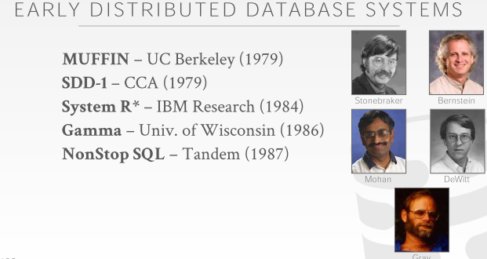
36:23 - 36:26
so distributed database system are old
So，分布式数据库系统其实很早就出现了
36:27- 36:31
some of the first ones were built in the late 1970s
第一批分布式数据库系统是在1970年代末构建出来的
36:31 - 36:34
muffin was created by one of my advisers Michael Stonebraker,
Muffin是由我的指导教授Michael Stonebreaker所创造
36.34-36.38
the guy who built Postgras and ingress and vertical and VOLTDB
他也构建了PostgreSQL、Ingres、Vertical以及VoltDB
36:38 - 36:43
he had a system called muffin that was a distributed version of of ingress
他写的这个叫做Muffin的系统其实是Ingres的分布式版
36:43 - 36:48
SDD-1 was a I actually thought it was actually a real system
实际上，我原本以为SDD-1是一个真正的系统
36.48-36.49
turns out it was just a prototype
事实证明，它只是一个原型
36.49-36.51
they actually never actually had anything running
实际上，从来没有机器运行过这个系统
36:51 - 37:00
but there's a lot of seminal papers in the late 70s written by the great Phil Bernstein on how to build a distributed database and do transactions across them
1970年代末的时候，Phil Bernstein写了大量的paper，内容是关于如何构建分布式数据库，以及如何在它们之上执行事务
37:00 - 37:03
a lot of a transaction theory that we talked about in this class
在这门课上，我们讨论了大量的事务理论
37:04 - 37:04
all right

37.04-37.08
all that early work was done by Phil
所有早期工作都是由Phil所完成
37:08 - 37:10
System R* was a research project at IBM
System R*是IBM的研究型项目
37.10-37.15
that was the distributed version of System R
它是System R的分布式版
37:15 - 37:16
that never became a product
它并未成为一个产品投入使用
37.16-37.18
although there is a distributor version of DB2 today
虽然，当下有一个分布式版的DB2
37:18 - 37:22
Gamma was an influential system out of Wisconsin by David DeWitt
Gamma是一个极具影响力的系统，它是由威斯康星大学的David DeWitt所编写
37.22-37.26
that was one of the first like high-performance distributed Database systems
它是第一批高性能分布式数据库系统中的一个
37:26 - 37:32
and then NonStop SQL of all these is the only was the only commercial distributed database system
接着，NonStop SQL是唯一一个商用分布式数据库系统
37:32 - 37:36
and that was that was helped built or Jim Gray helped build this
Jim Gray帮助构建了这个系统
37:36 - 37:42
Jim Gray was the guy, who was at IBM invented like two-phase locking, and a lot of the early stuff, that we talked about under system R
Jim Gary在IBM的时候发明了两阶段锁，以及我们很多在讨论System R时说过的早期东西
37:43 - 37:45
so NonStop was an interesting company
So，NonStop是一个令人感兴趣的公司
37:46 - 37.49
they originally were selling these like super fault-tolerant machines
他们最初对外出售的就是这种具备很强容错能力的机器
37.49-37.51
like think of like redundant hardware
把它想象成：冗余的硬件
37.51-37.53
like space shuttle level redundancy
比如，航天飞机级的冗余
37.53-37.54
like you have 4 CPU is running
比如，你有4个CPU正在运行
37.54-37.55
and if one goes down
如果其中一个CPU出现了故障
37.55-37.57
the other three you can keep on running
其他3个CPU依然能执行
37:57 - 38:00
so they would sell a database system that would sort of build on this architecture
So，他们会销售一种基于这种架构的数据库系统
38:01 - 38:02
um it's still round today
当下依然有人使用它
38.02-38.069
a lot of financial systems actually still use this
很多金融系统实际依然使用这种数据库系统
38:06 - 38:08
and it's amazing how long it still runs
它能运行这么长时间真的令人惊叹
38.08-38.09
I guess it's nonstop right
我猜这和它的名字一样，真的是永不停止
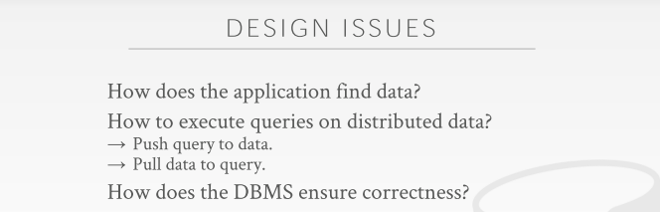
38:11 - 38:13
all right

38.12-38.13
so uh, all right
++++++++++++++++++++++++++++++++++++++=++++++++
38.13-38.18
so now we now that we understand the the what the architecture looks like
So，现在我们已经理解这种架构是怎么样的了
38:19 - 38:21
a lot of you have these questions that like
你们可能会有很多这样的问题
38.21-38.22
hey, how is this thing actually gonna work
比如：这种东西实际是如何工作的
38.22-38.24
how to actually find data
它实际是如何找到数据
38.24-38.26
, how do we actually make sure that everything is consistent
我们实际如何确保所有东西都是一致的
38:26 - 38:31
so all these things we need to be mindful of now when we build a distributed database system
So，当我们构建一个分布式数据库系统时，所有这些东西都需要我们去考虑
38:31 - 38:31
and there's trade-offs
这里面存在着取舍
38.31-38.33
because we do not be able to do everything
因为我们没法做到面面俱到
38:33 - 38:37
so we're not gonna have a system to be guaranteed online all the time
So，我们无法保证我们的系统始终在线
38:37 - 38:42
and make sure that we always support transactions and and not lose any data or have inconsistent results
也无法确保我们始终支持事务，并且不丢失任何数据或者产生不一致的结果
38:43 - 38:44
so as we go along
So，随着我们的讨论
38.44-38.46
we'll see what these trade-offs are
我们会看到这些取舍是什么
38.46-38.49
and why you're not gonna achieve everything
以及为什么我们没法做到面面俱到
38:49 - 38:51
the other big question we're gonna have is
我们会遇到的另一个重要问题是
38.51-38.54
how we actually execute the queries on this distributed data
我们如何对这些分布式数据执行查询
38:55 - 38:57
and so I showed two examples so far
So，目前为止我展示了两个例子
38:57 - 38.59
I showed the example on shared disk
我展示了一个关于shared-disk的例子
38.59-39.06
where the compute nodes pull the data from the shared disk system ,into their local memory and compute the result
计算节点会从shared-disk系统中拉取数据并放入它们的本地内存，以及计算结果
39:07 - 39:11
and then in the case of the share nothing system
接着，在这个share-nothing系统中
39:11 - 39:15
we would send the query to where the data was located run that locally
我们会将查询请求发送给数据所在节点进行本地计算
39.15-39.17
and then get back the result
然后返回结果
39:17 - 39:21
so there's trade-off between how you actually want to better doing a push or a pull
So，实际上，我们在Push和Pull之间要做取舍
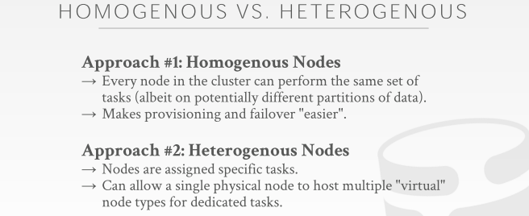
39:22 - 39:24
so the last thing to talk about too is
So，我们最后要讲的事情是
39.24-39.26
what does the architecture look like
这种架构是什么样的
39.26-39.30
in terms of what are the nodes doing in the cluster for the distributed database
分布式数据库集群中这些节点做什么呢
39:30 - 39:33
and there's basis you know there's just two approaches
这里有两种方案
39.33-39.36
you either have a homogeneous cluster or a heterogeneous cluster
你可以使用Homogeneous Cluster，也可以使用Heterogeneous Cluster
39:36 - 39:37
so in a homogeneous cluster
在Homogeneous Cluster中
39.37-39.45
every single node in the database cluster is can perform every single kind of task you'd ever have
数据库集群中每个节点可以执行你想要的任何任务
39:45 - 39:46
so I mean like
So，我的意思是
39.46-39.48
you could send a query to any single node
你可以将一个查询发送给任意节点
39.48-39.52
and that node will figure out how to get the result that you're looking for
该节点会弄清楚你所寻找的结果是什么
39:53 - 39:56
and they're all gonna give me potentially background tasks and other things
然后它们会进行一些后台任务和其他东西
39:57 - 40:00
so the advantage of this approach is that
So，这种方案的优势在于
40.00-40.05
it makes provisioning and failover potentially easier to handle and support
它使故障预防和故障转移变得更易处理和更好地支持

