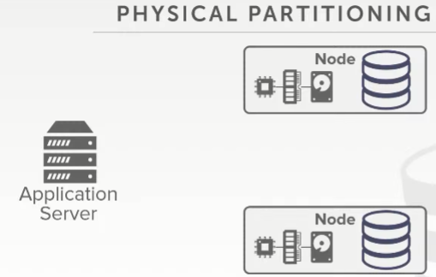
01:00:01 - 01:00:04
shared-nothing systems are running when you do physical partitioning
在shared-nothing系统下，你使用的是物理分区
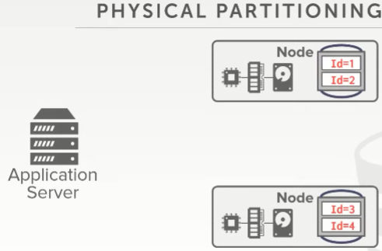
01:00:05 - 01:00:13
again this is where you have the each node is assigned a portion of the data that's managed by partition
每个节点会管理着数据库中属于自己这一份的分区数据
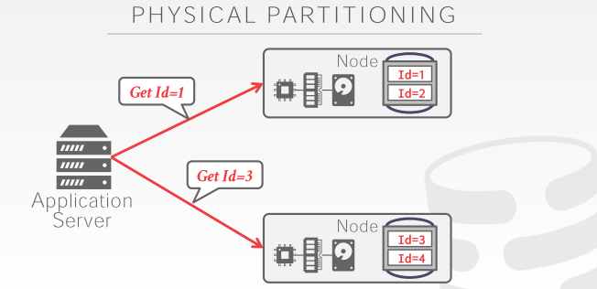
01:00:13 - 01:00:18
so again same thing I know how to get the data that I'm looking for from these different nodes
So，同样，我知道该如何从这些不同节点处获取数据
01:00:21 - 01:00:22
alright so we have like ten minutes left
So，我们还剩10分钟左右
1.00.22-1.00.23
so let's finish up
So，让我们赶快结束吧
1.00.23-1.00.25
and then that'll set us up for Wednesday's class
接着让我们为周三的课做好点准备
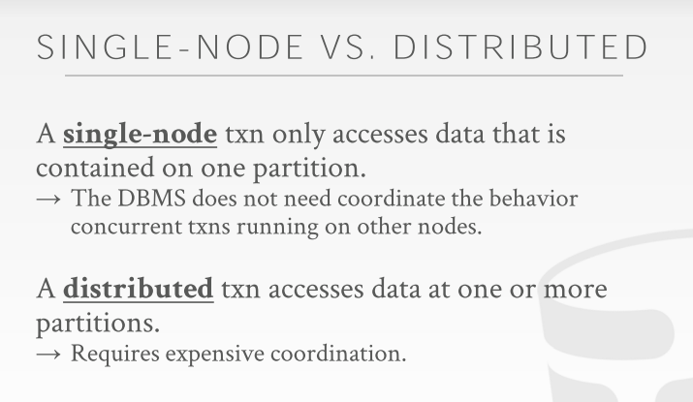

01:00:27 - 01:00:29
so when we want to start actually transactions
So，当我们想开始执行事务的时候
1.00.29-1.00.30
this is when things get hard
这也是这些东西变得很难的时候
01:00:31 - 01:00:33
and this one things get expensive
这些东西的成本就会变得更高
01:00:33 - 01:00:36
this is why I see her question is, her question before was
这也与她之前提的问题有关
1.00.36-1.00.39
Oh doesn't always make sense maybe try to scale vertically
垂直扩展并不是一直很有用
1.00.39-1.00.42
why would you ever want to scale horizontally
为什么我们想使用水平扩展呢？
01:00:42 - 01:00:45
there are gonna be just as I said if there's diminishing returns
正如我说的，使用垂直扩展所给我们带来的收益会递减
01:00:45 - 01:00:46
if you scale vertically
如果你进行垂直扩展
1.00.46-1.00.47
the hardware can't actually get any better
硬件性能实际也不会变得更好
01:00:47 - 01:00:51
because you can't buy a machine that gets in you know there's immediately faster
因为你无法买到那种可以让你系统立刻变得更快的机器
01:00:51 - 01:00:53
it's also assumed your software can actually scale
这里我们假设你的软件也能进行扩展
1.00.53-1.00.59
and it's not gonna be plagued by concurrency bottlenecks and other things
并且它并不会因为并发瓶颈和其他事情而困扰
01:00:59 - 01:01:01
if you're not scaled horizontally
如果你不进行水平扩展
1.01.01-1.01.04
then you're also gonna have diminishing returns and performance gains
那么你也会遇上收益递减，虽然性能会有所提升
01:01:04 - 01:01:08
because now you're gonna end up with what are called distributed txn
因为现在你将会遇上分布式事务的情况
01:01:08 - 01:01:12
so if I have something that has to update data on a single-node
So，如果我要对单节点上的数据进行更新
01:01:12 - 01:01:13
we know how to do that
我们知道该怎么做
1.01.13-1.01.14
we've card an entire semester about this
我们这整个学期都在讨论这个
01:01:14 - 01:01:23
and that's gonna be the best-case scenario where my transaction ,that I needed mean to touch data it's all in a single-node
最好的情况是，我事务需要接触的数据都放在一个节点上

1.01.21-1.01.23
I can run that with ever without having to correlate with anybody else
在不与其他节点接触的情况下，我就可以进行更新
01:01:24 - 01:01:26
if I need to touch data across multiple nodes
如果我需要接触的数据跨多个节点
01:01:26 - 01:01:31
then now I need a way to make sure that if I make a write here and I make a write here
那么，我现在需要通过某种方式去确保，如果我在这里执行了一个写操作，另一个地方我又执行了一个写操作
01:01:31 - 01:01:32
when my transaction says commit
当我的事务要提交的时候
1.01.32-1.01.34
that it actually does commit
它实际上就会进行提交
01:01:35 - 01:01:39
because I only make sure that all my change their atomic and durable just as just as I was a single-node system
因为我只确保我所有的修改都具备原子性并且被持久化，这就如同我在单节点系统中所做的那样
01:01:40 - 01:01:41
and that's gonna get expensive
这样成本就会变得很高
1.01.41-1.01.42
because how do I make sure that
我该如何确保这个呢？
1.01.42-1.01.44
if I say I commit
如果我说我要提交事务
1.01.44-1.01.46
then everyone actually truly commits
那么实际上所有人都应该进行提交
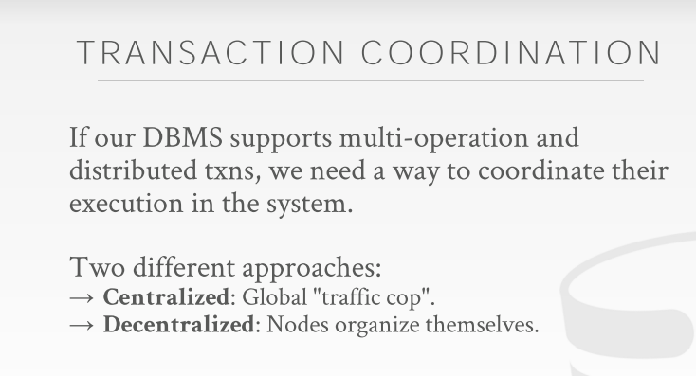

01:01:49 - 01:01:54
so the way we can do this is through a transaction coordinator
So，我们可以通过事务协调器来做到这点
01:01:55 - 01:01:58
so you sort of think of this is like a traffic cop for the entire system
So，你可以将它想象为整个系统中的交警
01:01:58 - 01:02:05
it allows a way to determine who's allowed to do what ,and when it goes time to commit
它以某种方式来决定允许谁去做哪些事情，以及什么时候去提交事务
01:02:05 - 01:02:08
that everyone agrees that we're actually going to go ahead and commit
当所有人都赞同的话，我们就会去进行提交
01:02:09 - 01:02:12
so the two different approaches are do centralized decentralized
So，这里有两种不同的方案，即中心化和去中心化
01:02:12 - 01:02:13
a centralized one is
中心化方案指的是
1.02.13-1.02.15
where everyone goes to some centralized location
所有人都会跑到某个中心
1.02.15-1.02.19
that has a complete view of everything going on inside the system
这个地方能看到系统中所发生的一切
01:02:19 - 01:02:21
and then it makes decisions about whether you're allowed to commit
它会去判断是否允许你进行提交
01:02:22 - 01:02:23
and it is decentralized approach
接着，就是去中心化方案
1.02.23-1.02.29
where the nodes try to organize themselves, and make a decision about, yes we this this transaction made these changes
这些节点会去组织它们自己做出判断，比如这个事务是否能做这些修改
01:02:29 - 01:02:30
and we're allowed to commit
我们是否能提交该事务
01:02:30 - 01:02:35
and we can notify whoever else is involved in the transaction that they've committed successfully
我们可以通知涉及该事务的其他人，他们已经成功提交了这个事务
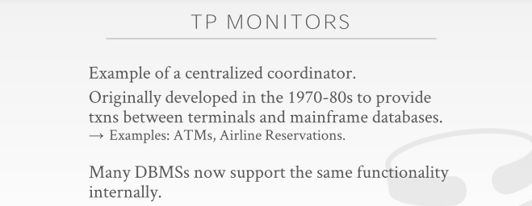
01:02:36 - 01:02:43
so the very first version of one of these transaction coordinators was this thing called a TP monitors from the 1970s to 1980s
So，这些事务协调器最开始是出现在1970年代到1980年代，当时其中一种事务协调器叫做TP monitor
01:02:43 - 01:02:45
nowadays I think if you look at the Wikipedia article,
现在，我相信如果你们去看下维基百科上的文章
1.02.45-1.02.48
TP stands for a transaction processing monitor
TP monitor的意思是事务处理监视器
01:02:48 - 01:02:50
back in the 70s
在1970年代的时候
1.02.50-1.02.53
they call these things telecom processing monitors
他们将这个叫做电信处理监视器
01:02:53 - 01:02:57
because these things are built for like the early you know the phone companies that come back in the day
因为这些东西当时是为了那些电话公司所构建的
01:02:57 - 01:02.59
because they were the ones that had most of the traffic
因为他们当时掌握了大部分的流量
1.02.59-1.03.02
I mean you know most of the data
我的意思是大部分数据
01:03:02 - 01:03:07
so the way to think about this TP monitor is that
So，我们思考这种TP monitor的方式是
1.03.07-1.03.09
it's the standalone piece of software
它是软件中独立的一部分
01:03:09 - 01:03:17
that everybody has to talk to in order to figure out whether they're do certain operations on a distributed database
所有人都必须和它进行通信，以此来弄清楚它们是否要在分布式数据库中执行某个操作
01:03:17 - 01:03:21
so the database system itself could be stored across different nodes
So，数据库系统自身可能被存储在不同节点上
01:03:21 - 01:03:25
and they don't really know that they're actually involved in the distributed transaction or distributed database
它们并不清楚它们实际参与了某个分布式事务或者分布式数据库
01:03:25 - 01:03:30
if you just take MySQL whatever single-node system you want run that separately
这就好比你使用了MySQL之类的单机数据库系统，单独执行这些事务一样
01:03:30 - 01:03:31
and then up above you have this TP monitored
接着，在此之上，你会拥有一个TP monitor
1.03.31-1.03.33
allow you to figure out ,whether you're allowed to do certain things
它会让你去弄清楚你是否能做某些事情
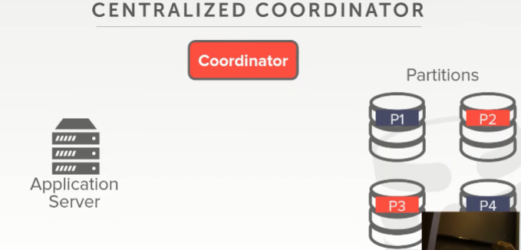
01:03:35 - 01:03:36
so it looks like this right
So，它看起来就像是这样
1.03.36-1.03.37
so we have application server
So，我们有一个应用程序服务器
1.03.37-1.03.38
, we have four partitions
我们有4个分区
01:03:39 - 01:03:43
so say your transaction touch these three partitions
So，假设你的事务要涉及这3个分区
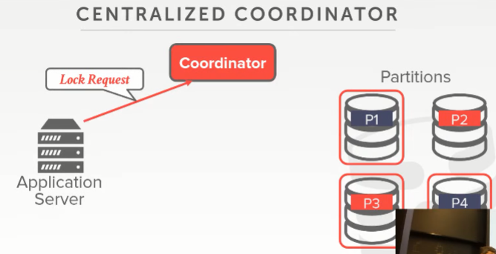
01:03:43 - 01:03:50
so we're gonna begin our transaction by going to coordinator, and say hey we want to modify some data at these partitions
So，我们会开始执行我们的事务，我们会先跑到协调器这里，并说：我们想修改这些分区中的数据
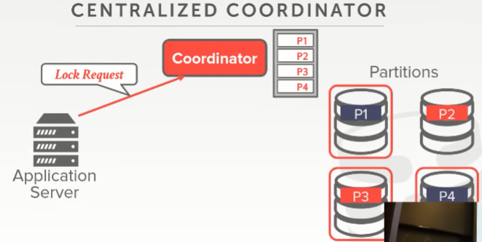
01:03:50 - 01:03:53
we need to acquire the locks for them are we allowed to do that
我们会去获取它们所对应的lock，以获取我们对它们进行修改的权限
01:03:54 - 01:03:55
and then the coordinator says
协调器表示
1.03.55-1.03.57
well I know it's where else is running the system
Well，我知道它在系统中的哪个地方
1.03.57-1.03.58
because everyone has to go through me
因为所有人都必须经过我才行
01:03:59 - 01:04:00
yes well I see these locks are available
事务协调器表示：Well，我看了下，这些lock都是可用的
1.04.00-1.04.01
so I'm gonna assign them to you
So，我会将这些lock分配给你
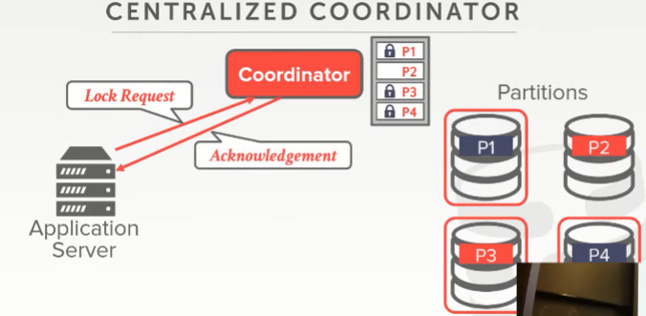
01:04:02 - 01:04:05
And then tell you that you've acquired them
接着，事务协调器会告诉你，你已经获取到这些lock了
01:04:05 - 01:04:13
and then now the application server can go to the different partitions ,do whatever it is that wants to do to make the changes it wants to make
那么，应用程序服务器可以跑到这些分区去做它想做的那些修改
01:04:13 - 01:04:15
and then when it wants to go to ahead and commit
接着，当它想去提交事务的时候
1.04.15-1.04.18
it goes to the coordinator ,and says hey I want to commit I made these changes at these partitions
它会跑到事务协调器这边，并说：hey，我想提交该事务，我在这些分区做了这些修改
01:04:19 - 01:04:21
am I allowed to do this
我是否能提交该事务呢？
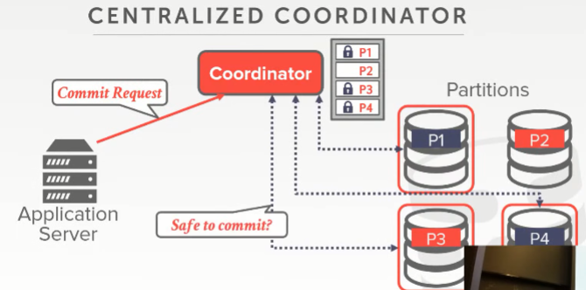
01:04:21 - 01:04:25
and the coordinator is responsible for going and communicating with these guys down here and say
事务协调器会负责与下面这些家伙们（知秋注：事务在各个分区服务器执行的相关方）进行通信，并说
1.04.25-1.04.28
hey I think you know about this transaction
hey，我觉得你们知道这个事务
01:04:28 - 01:04:29
because it told me it was gonna touch you
因为它告诉我，它和你们是一起的
1.04.29-1.04.31
did it actually do anything
它实际是否做了一些事情呢？
01:04:31 - 01:04:37
and then they come back and say, yes you know these changes were what happened ,and they're okay or safe to commit
这些分区就会表示：Yes，确实有这些修改，它们是Ok的，你可以安全地提交这个事务
这些分区会响应信息，即这些修改都已就绪（包括我们自己的），可以安全地提交这个事务了
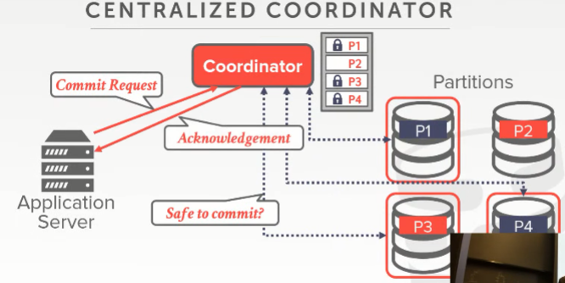
01:04:38 - 01:04:43
and then once we everybody agrees once the coordinator recognized that everyone agrees that we can go and commit
一旦事务协调器意识到所有人都同意我们进行提交，那我们就可以进行提交
01:04:43 - 01:04:44
we can send back acknowledge
我们就可以去返回提交成功的通知
1.04.44-1.04.45
question
有任何问题吗？
01:04:49 - 01:04:49
So question is
So，他的问题是
1.04.49-1.04.52
I know what scenario would it be not safe to commit
在什么情况下，提交事务是不安全的
01:04:52 - 01:04:57
so let's say I violate a you know integrity constraint here ,
So，假设这里我违反了完整性约束
1.04.57-1.04.59
my transaction aborts
我的事务就中止了
01:04:59 - 01:05:02
right I try to insert a duplicate key
这里，我试着插入一个重复的key
01:05:02 - 01:05:03
the coordinator doesn't know what you did
事务协调器并不清楚你做了什么
1.05.03-1.05.05
it says hey I want to acquire the locks on these things
它表示：hey，我想去获取这些东西对应的lock
01:05:06 - 01:05:08！！！！！！！！
and I want to commit in a distributed fashion
我想在分布式环境下提交这个事务
01:05:09 - 01:05:12
you have to go ask them whether they were allowed to do that
你需要去询问它们（是否可以提交事务），是否允许这么做
01:05:14 - 1.05.17
for simplicity his question are we like the whole partition simplicity, yes
他的问题是我们该怎样做才能更简单

01:05:20 - 01:05:24
right I think it's like the XA if there's a protocol that allows you do more fine-grained locking
如果这里有个协议能让你使用粒度更细的lock
1.05.24-1.05.27
just stupid partitions makes it simple
你就可以减少工作量，整个也会变得简单
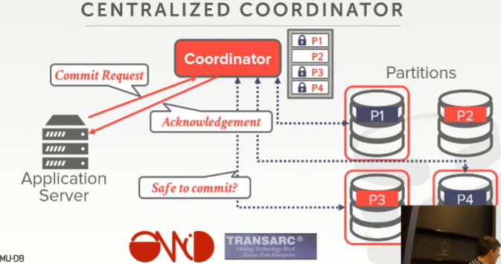
01:05:31 - 01:05:31
Okay

1.05.31-1.05.43
so again there's a bunch of a lot of the enterprise ,software vendors, sell you something that that is a TP monitor
So，这里有很多企业或者软件厂商会向你销售TP monitor之类的东西
01:05:43 - 01:05:44
Oracle has this thing called tuxedo
Oracle有一个叫做Tuxedo的东西
01:05:44 - 01:05:46
IBM sells this thing called transrac
IBM卖的那个产品叫做Transarc
1.05.46-1.05.51
which actually was a senior startup like the guy that did the afs ,stuff in the 80s
实际上，1980年代某位做了Afs的老兄创办了一家初创企业
01:05:51 - 01:05:54
they did a startup called tranzarc, I got bought by IBM and IBM still sells us
他们创立了一个叫做Transarc的初创企业，之后被IBM收购，IBM现在依然向我们销售这个产品
01:05:55 - 01:05:59
there's a project you can't really read the logo ,it's called Apache Omid, it was built by Yahoo,
这里还有个项目，你们可能看不懂它的logo是什么意思，它叫做Apache Omid，它是由雅虎构建的
01:05:59 - 01:06:04
it's basically a TP monitor for HBase, or NewSQL system
简单来说，它是一个供HBase或NewSQL系统使用的TP monitor
01:06:04 - 01:06:06
that's actually used by a couple other systems today
实际上，当下有两个系统在使用它
01:06:06 - 01:06:10
so you can build a distributed database without worrying about transactions
So，在无须关心事务的情况下，你可以去构建一个分布式数据库
1.06.10-1.06.13
could you just rely on these guys to figure things out for you
你可以依赖这些产品去帮你们弄清楚这些事情
01:06:13 - 01:06:16
and you just do all the single-node stuff that you're normally
这就和你们在单节点数据库下平时所做的那些操作一样
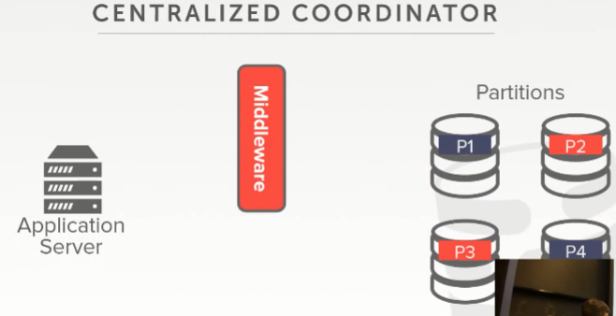
01:06:19 - 01:06:23
but pi more common is to use a centralized coordinator as a middleware where
更常见的是使用中心式协调器作​​为一个中间件（middleware ）
01:06:23 - 01:06:27
you had this piece of software that sits between the application server and the database partitions
它是位于应用程序服务器（application server）和数据库分区之间的软件
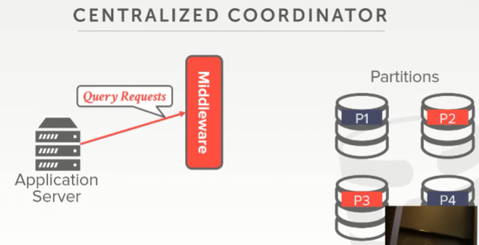
01:06:28 - 01:06:36
all queries go through this middleware, and the middleware is responsibly figuring out, oh this query touch this data this partition
所有的查询请求都会通过这个middleware，这个middleware会弄清楚，这个查询所涉及的数据分别在这些个分区上
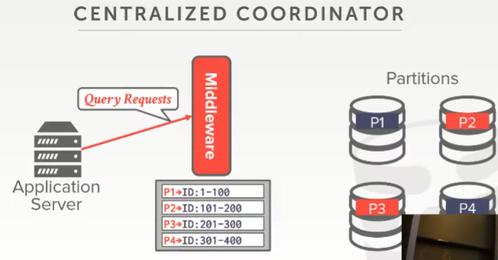
01:06:37 - 01:06:42
so it looks at its it's it's you know it's its global lock table or information about partitions are there
so 它看起来就是一个全局lock表或者说它存放了关于这些分区的信息
01:06:42 - 01:06:45
and it routes the queries as needed for you
通过它可以将你的查询路由到对应的地方
01:06:45 - 01:06:51
so you look like you're talking to a single single-node database system through the middleware
so 通过middleware 你看起来好像是在和一个单节点数据库系统进行通信
01:06:51 - 01:06:54
but in the backend its distributed and broken across these different partitions
但在这背后，它在分布式存在的，横跨这些不同的分区
01:06:55 - 01:06:58
so when the commit request shows up by the application server
so 当application server发出提交请求，
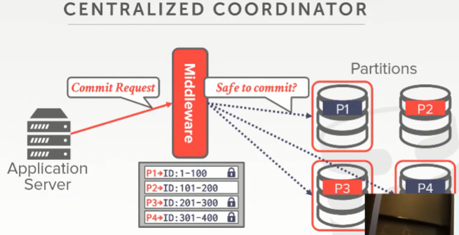
01:06:58 - 01:07:03
the middleware does the same thing as the TP monitor does, it communicate to these guys and say hey are we allowed to commit
middleware所做的事情和 TP monitor一样，它与这些分区服务器沟通，并说嘿，大伙允许它提交么？
01:07:04 - 01:07:08
and only when everyone agrees do you then send back the acknowledgment
只有当每一个人都同意的时候，middleware 会返回一个ack确认信息
01:07:09 - 01:07:14
so this one this this approach is actually very very common, like Facebook is probably most famous one
这种方式实际上非常普遍，例如Facebook可能是这种方案使用者中最著名的一个
01:07:14 - 01:07:16
Facebook runs the world's largest MySQL cluster
Facebook运行着世界上最大的MySQL集群
01:07:17 - 01:07:20
and they have a middleware assistant to do all this routing for you
他们有一个middleware 为我们进行所有路由
01:07:21 - 01:07:24
Google used to do this for for MySQL in the ads
Google在它的广告业务中为它的MySQL集群使用了这个方案
01:07:24 - 01:07:26
there's a planet-scale that came out of YouTube
YouTube 同样也应用了
01:07:27 - 01:07:33
but this approach is actually very very common, you take us you know Postgres MySQL whatever you know your favorite single-node database system is
这种方案实际上非常普遍，无论你喜欢哪种单节点数据库系统，比如Postgres MySQL，都可以使用这种方案
01:07:34 -01:07:36
and you build this little wrapper layer in front of it
你可以在这个数据库之前构建一层这个东西
01:07:36 - 01:07:38
eBay did this with Oracle
eBay 在使用的Oracle之上做了这一层
01:07:40 - 01:07:41
it's very common
它很通用
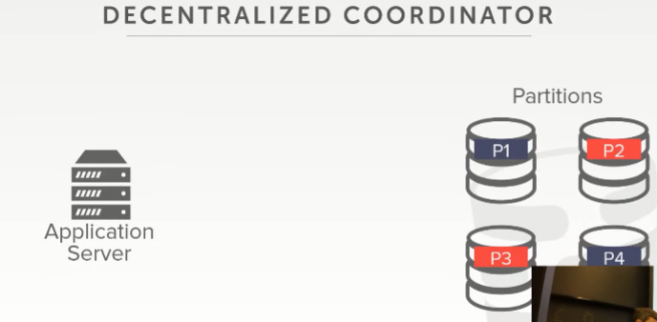
01:07:43 - 01:07:47
the other approach is the last versions to decentralized coordination
另一种方法是通过数据的最新版本来进行去中心化协调
01:07:47 - 01:07:51
where you don't have a coordinator, you don't have a centralized view of what's going on in the system
你不需要有这么一个协调器（coordinator），你无须通过一个中心化的视角来看系统正在进行的事务
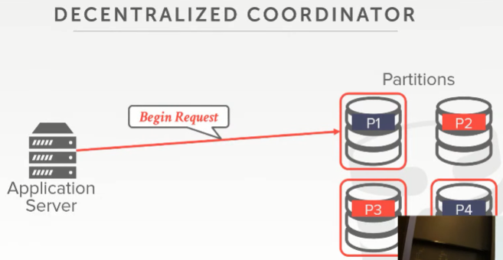
01:07:52 - 01:08:00
the application Server communicates with some home partition or base partition ,some master node that's been responsible for this given transaction
application Server会和分区中的某些服务器通信（也就是我们的分区其实是主备形式的），主节点用来对给定事务进行响应
01:08:01 - 01:08:04
all their notes will be master nodes, if you're assume you're a homogeneous architecture
能和application Server进行通信的都是主节点，如果假设你是在homogeneous architecture下
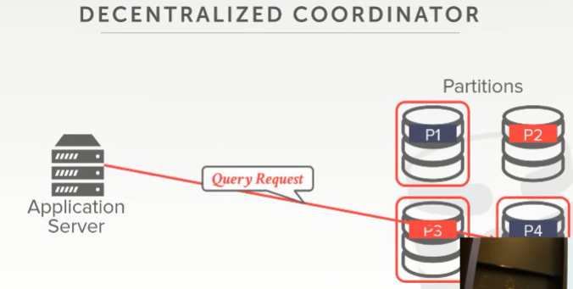
01:08:05 - 01:08:11
so you send all the query requests either to directly to the master node or to individual partitions, it doesn't matter
so 你可以将所有查询请求直接发送到主节点或单个分区，这没关系
01:08:11 - 01:08:18
but it's when you want to go commit ,you go to the master node, and say hey I made these changes I want to go ahead of commitment transaction
但当你想要去做提交，你就必须去主节点，并说，我做了这些更改，我想进行提交事务操作
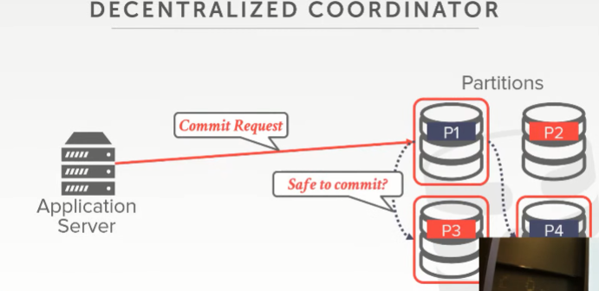
01:08:19 - 01:08:23
and then it's responsible for communicating with the other partitions and deciding whether you're allowed to commit
然后，主节点负责与其他分区进行通信并确定是否允许提交
01:08:23 - 01:08:25
and if yes then you send back the acknowledgment
如果yes，那它就会返回一个ack
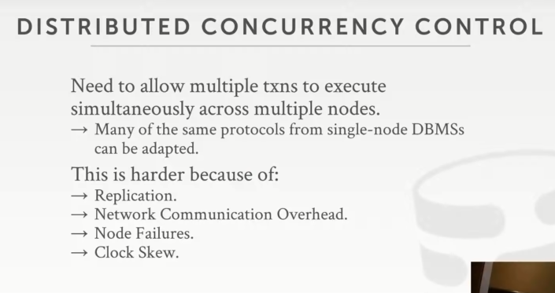

01:08:28 - 01:08:34
all right so the thing that I call Stover is that part of a how do we figure out whether it's safe to commit
so 现在我们要考虑的事情就是，我们该怎么做，才能弄清楚它是否可以安全的提交
01:08:35 - 01:08:35
question
请讲
01:08:39 - 01:08:41
this question is how do you take the locks
他的问题是我们该怎么拿到锁
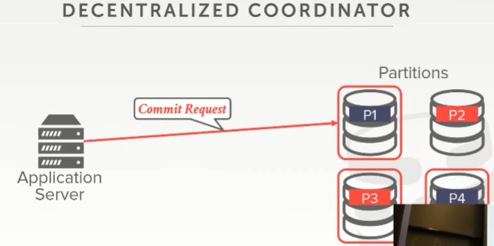
01:08:42 - 01:08:48
so it would be say again assume I'm doing a lot project locking the whole partition
假设，我在整个分区上做了大量的lock
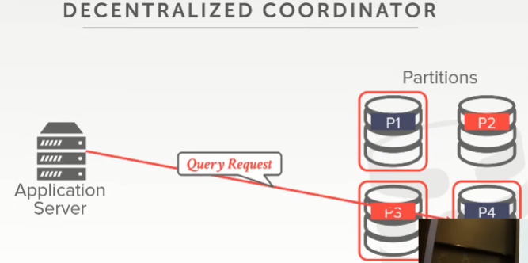
01:08:48 - 01:08:50
so when the query shows up ，right
当你进行这里所示的查询时
01:08:50 - 01:08:53
you try to acquire the lock at that point
你要在这个点（非主节点）来尝试获取这个lock
01:08:57 - 01:09:04
so the master node would only know information potentially about, what partitions you touched, doesn't know what you did at them
主节点只会知道一些有关你接触过的分区的潜在信息，但不知道你对它们做了什么
01:09:04 - 01:09:10
right and it's response to the application responsible are saying ,hey I couldn't get the lock of this partition I have to abort my transaction
它是对所负责的应用程序响应说，嘿，我无法获得此分区的锁，我必须中止事务
01:09:10 - 01:09:12
so you go back to this guy hey say I aborted
你给这家伙回复说，我被中止了
01:09:12 - 01:09:17
alternatively, you send all the requests that this guy ,and he's responsible for farming out to the different machines
或者，你可以将所有请求发送给P1，它将其询问这些不同的机器
01:09:20 - 01:09:23
at the master node, if you touch the data at the master node sure yes
如果你发送数据修改请求在主节点上，那没问题
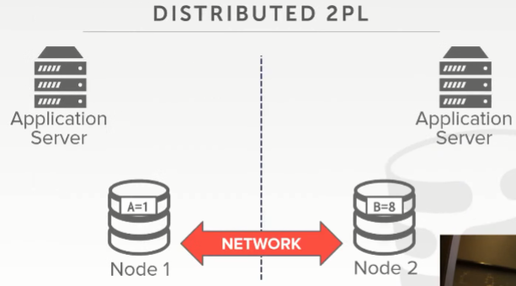
01:09:29 - 01:09:35
okay so we'll cover this in more detail next class
ok，关于这些更多的细节我们将在下一节课涉及
01:09:35 - 01:09:41
it's an impress upon you and then you'll think about it and see on Wednesday why you know how hard it actually is
看来这给你留下了深刻的印象，你回去思考一下，在周三的时候，你会看到为什么这么难
01:09:42 - 01:09:44
say we're doing two-phase locking my last example
我们会做两阶段锁
01:09:44 - 01:09:50
and say that my node or over the white or never one node is in Pittsburgh,one node is in San Francisco
我这里有两个节点，一个节点在匹兹堡，一个在旧金山
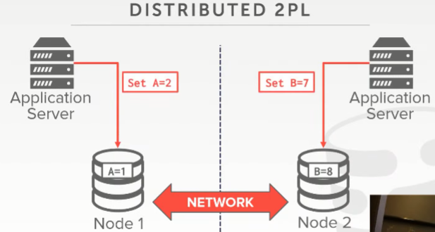
01:09:50 - 01:09:55
so at the same time I have two applications trying to update the database right
在同一时间，我有两个应用程序试图更新数据库
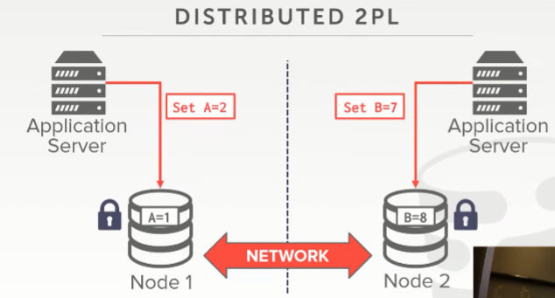
01:09:55 - 01:10:00
and the very beginning I get a lock on my node here for A, this guy gets the lock on B
在最初，我获取到了节点A的锁，这家伙获取到了B上的锁
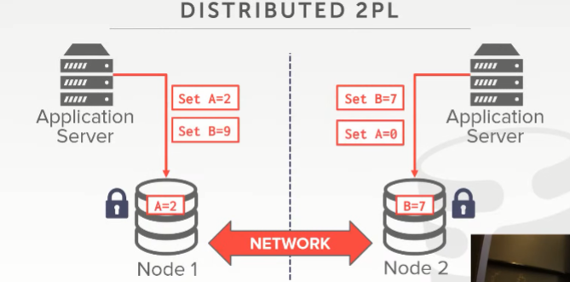
01:10:00 - 01:10:05
but now I want to update this guy wants to update B, the other guy wants to update A
但现在，这个家伙想更新B，另一个家伙想更新A
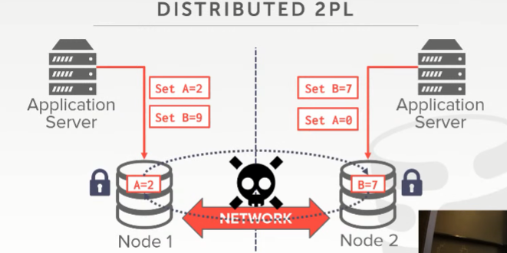
01:10:06 - 01:10:11
so now I got to go over the network and send a lock request to get the other lock on the other thing
现在我必须通过网络发送锁请求，以获取另一个节点的锁
01:10:11 - 01:10:15
the other guys doing the same thing, I'm obviously ending up with the deadlock here
另外一方也做着同样的事情，很明显，我最终死锁了
01:10:15 - 01:10:19
so how do I actually figure out who's actually should be allowed to commit
so 我该怎么做才能搞清楚到底应该允许谁提交
01:10:20 - 01:10:24
this again if I'm doing a decentralized architecture if I don't have that TP monitor
如果我是基于去中心化架构（decentralized architecture），即我没有TP monitor
01:10:24 - 01:10:30
but even if I do, I mean have not the fine-grained information about what exactly it's doing on each node
我的意思是我没有关于每个节点上的确切在做什么的详细信息
01:10:30 - 01:10:33
because you can't always know what the queries gonna do before you actually run it
因为你在实际运行查询之前并不总是知道查询将要做什么
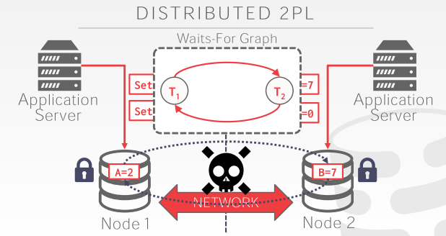
01:10:34 - 01:10:38
someone needs to figure out I have this weight to a graph of a cycle I need to kill somebody
我需要有个权重来弄清楚该如kill掉哪一个来解除这个死循环

01:10:40 - 01:10:46
and then so this guy says ,oh I'm gonna back off, I have a deadlock ,if I'm doing prevention I kill myself
这个家伙说，哦，我要退一步海阔天空，要不就会有一个死锁，如果我做提前准备的话，我会kill 掉我自己
01:10:46 - 01:10:47
this guy could be doing the same thing
这家伙可能做了同样的事情
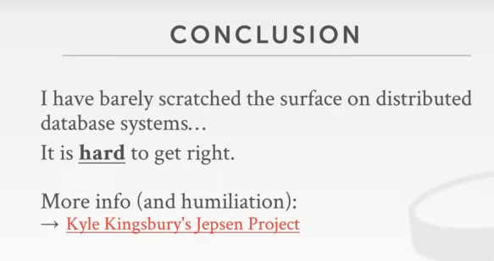

01:10:49 - 01:10:52
so this is what we're gonna talk about on Wednesday
So，这就是我们会在周三要讨论的东西
01:10:52 - 01:10:54
how do you actually do to distributed concurrency control
即我们实际该如何做到分布式并发控制
01:10:54 - 01:10:58
how do you figure out you take two phase locking、 timestamp ordering and run it in distributed environment
你如何在分布式环境下使用两阶段锁或timestamp ordering之类的东西
01:10:58 - 01:11:04
, we don't have a complete global view of everything's going on ,the side the submitting a and a given time
我们无须去设定一个全局的视野来获知所发生的所有事情，并以此来应对事务提交
01:11:05 - 01:11:11
we're also gonna spend time on, when my transaction says go ahead and commit, how do I guarantee that I that I commit everywhere
当我的事务要去提交的时候，我该如何保证每个地方这个事务都进行了提交呢？
01:11:13 - 01:11:15
because what happens if a node goes down while I'm trying to commit
因为如果当我试着提交的时候，某个节点挂掉了
1.11.15-1.11.16
what should I do
我应该做什么呢？
01:11:17 - 01:11:19
that's actually super hard to get right
这实际上难以做到正确
01:11:20 - 01:11:22
so if you're ensure these kind of things
So，如果你能保证这些东西
1.11.22-1.11.27
there's this great is this great website called the Jepsen project
这里有一个很棒的网站，它叫做Jepsen Project
1.11.27-1.11.28
by this guy called Kyle Kingsbury
它是由一个叫做Kyle Kingsbury的人创建
01:11:28 - 01:11:37
so he's basically he built this torture chamber for distributed databases, Britain enclosure which is a bit gnarly
基本上可以这么说，他为分布式数据库构建了严格的测试环境
01:11:37 - 01:11:43
but he basically has this test suite where he can take your distributing database run through these weird edge cases
简单来讲，他使用测试工具来对这些分布式数据库进行测试，比如使用一些奇怪的边界案例来对它们进行测试
01:11:43 - 01:11:52
and identify that it's not always correct, and has problems on a guaranteeing reliability availability or correctness of transactions
以确定它哪里是不正确的，找出在保证可靠性可用性或事务的正确性方面存在的问题
01:11:52 - 01:11:54
so right now he he has a consult company
So，现在他创办了一家咨询公司
1.11.54-1.11.56
people pay him money to go actually run this
人们会付他钱来测试这些东西
01:11:56 - 01:12:01
so build his website he has these write-ups, which are super super detailed
So，他将这些报告放到了网站上，并且写的超级详细
1.12.01-1.12.04
and take a long time to read to understand ,what he's actually talking about
你们需要花很长时间去理解他实际讨论的是什么
01:12:04 - 01:12:06
but he talks about how these different DBMS he's tried this against
但他讨论了他是如何测试这些不同DBMS的
01:12:07 - 01:12:09
they claim that there may be transactions correctly
这些DBMS声称正确执行了这些事务
1.12.09-1.12.13
they claim that they can always support high availability or good performance
并且声称他们始终可以支持高可用或者具备良好的性能
01:12:13 - 01:12:15
and his thing shows that that they don't
但这位老兄写的文章表示这些DBMS并没有做到他们所说的那些事
01:12:16 - 01:12:19
so they paying him money to go run his thing on their database system
So，这些DBMS厂商会付给他钱来让他测试他们的数据库系统
1.12.19-1.12.19
and then if they pass
如果他们通过了这些测试
1.12.19-1.12.21
they can announce that they're certified
他们就能宣布他们被认证了
01:12:21 - 01:12:25
there's one day to his company was aerospike which is a distributed key-value store
曾经有一天有家叫做aerospike数据库的公司，这个aerospike是一个分布式的key-value数据库
01:12:25 - 01:12:29
they used to claim on their website they had you know they had strong consistency guarantees
他们曾经声称他们提供强一致性保证
01:12:30 - 01:12:32
he ran his thing against theirs crushed it showed how it wasn't
这位老兄用他的测试工具证明他们所说的并不成立
01:12:32 - 01:12:36
and they had to go back and change all the marketing crap to remove it, because t humiliated it
他们就必须从他们的营销用语中移除这个认证，因为太打脸了
01:12:37 - 01:12:38
says websites awesome
这个网站很棒
1.12.38-
his Twitter feed not so much
他的推特则没有那么多内容
01:12:40 - 01:12:42
you'll see why to go look at it uh
你们去看下就知道原因了
01:12:42 - 01:12:44
it's not my thing
这不关我事
01:12:44 - 01:12:46
but he's a really sharp dude
但他是个极端的家伙
1.12.46-1.12.47
, I think there's a really good website
我觉得这是一个很棒的网站
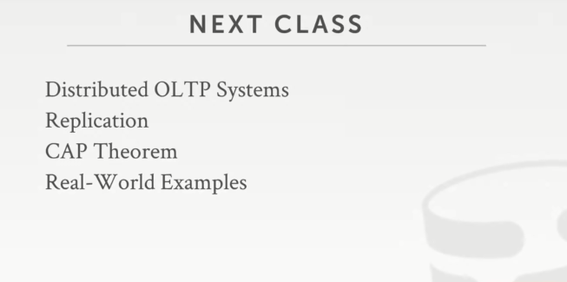

01:12:48 - 01:12:52
alright next class Distributed OLTP systems, replication, cap theorem
下节课我们会去讨论分布式OLTP系统，replication以及CAP定理
01:12:52 - 01:12:53
and then real-world examples
以及现实中的例子
01:12:53 - 01:12.58
again we'll go through start worrying about how we're actually gonna run transactions in a distributed environment
我们会去关心如何在分布式环境下执行事务
1.12.58-1.12.59
will tell them about NoSQL systems,
我们会去讲下NoSQL系统相关的事情
1.12.59-1.13.01
and see why they don't want to do transactions
并看看他们为什么不想执行事务
01:13:01 - 01:13:04
because it's gonna affect performance and availability
因为这会影响性能和可用性
01:13:04 - 01:13:07
okay all right guys awesome see you on Wednesday
Ok，孩儿们，周三再会

