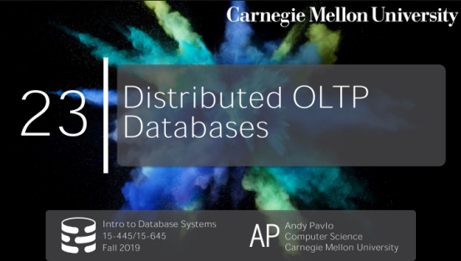

00:16 - 00:21
they're an event I'm missing on campus or so what is today
我是不是错过了今天学校的活动？
00:22 - 00:22
free cake
免费的蛋糕？
0.22-0.25
that's pretty weak
这没啥吸引力
0.25-0.27
,all right DJ drop tables thank you always
感谢DJ Drop Table一直以来的节奏
00:27 - 00:33
all right let's those are here let's look at through this
我们来看下今天要讲的东西
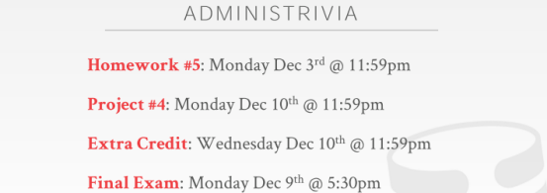

00:33 - 00:39
so again this is just the outline for the many things for you guys in the semester
So，这是你们这学期要经历的一些东西
00:40 - 00:42
again these dates are all available on the website
它们的截止日期我都贴在网站上了
00:43 - 00:50
and then the first feedback review of the extra credit what we do this Sunday
我们会在这周日的时候对你们Extra Credit作业给出第一次反馈
00:50 - 00:53
and then I also post on Piazza last night
这个我昨晚就在Piazza上贴出来了
00:53 - 00:54
if you haven't done this to already
如果你还没完成
0.54-0.58
please go vote for what database systems you want me to cover on the last day
请先去投一下你想让我最后一天要讲的数据库系统
0.58-0.58
yes
请问
01:09 - 01:13
Bi~ result of what sorry, the result of what sorry
什么东西的结果？
01:14 - 01:18
Bi~ result oh yeah right yeah no I have not heard back yet
亲子鉴定的结果，其实我现在也还不知道
01:19 - 01:23
I will try if it comes in I will announce on the last day of class
如果报告能在最后一节课前出来的话，我就会在那个时候宣布
01:25 - 01:30
I send a send on Monday
我在周一递交的
1.30-1.31
I don't it takes whatever week or two or something
检测可能需要花一两周的时间
01:31 - 01:34
so well see, any other questions related to class
So，关于这门课，你们还有其他问题吗？
01:37 - 01:39
again I don't think it looks like me
我觉得我小孩长得不像我
01:41 - 01:46
Bi~ alright this is say my wife lives a certain lifestyle where I would have questions ,ok
这其实在说我对我老婆的生活作风抱有疑问

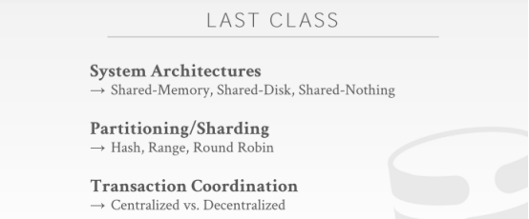

01:47 - 01:54
so last class we talked about it was an introduction to distribute databases
So，上节课我们对分布式上节课进行了介绍
01:55 - 01.58
and sort of the main three things we focus on was
我们主要关注了三个东西
1.58-2.01
what the system architecture of a system looks like
一个系统的系统架构是怎么样的
02:01 - 02:03
right we talked about shared memory shared disk show nothing
我们讨论了shared-memory、shared-disk以及shared-nothing这三种架构
02:03 - 02:04
and I said that
我之前说过
2.04-2.11
most distributed databases are actually every distributed databases out there, is either gonna be shared disk or shared nothing
几乎所有的分布式数据库系统使用的要么是shared-disk，要么就是shared-nothing
02:11 - 02:16
shared nothing is traditionally the more popular approach people take with distributed databases
一般来讲，在分布式数据库系统中，人们更倾向于使用shared-nothing这种方案
02:16 - 02:20
but shared disk is becoming more prevalent in cloud architectures
但shared-disk这种方案在云架构中变得越来越常见
02:20 - 02:22
then we talk about are you partitioning /sharding
接着，我们讨论了partitioning/sharding方面的事情
2.22-2.25
the hash partitioning, range partitioning, round robin
我们讨论了hash partitioning、rang partitioning和Round Robin这三种分区方案
02:25 - 02:31
just in a way to take a database to break it up into disjoint subsets
通过这些分区方式，我们以此将数据库拆分为多个不相交的子集
2.31-2.33
that we assigned to different nodes
然后，我们将这些子集分配给不同的节点
02:33 - 02:37
and then we talked a little bit about how we want to make transaction coordination
接着，我们讨论了如何对事务进行协调
2.37-2.39
of whether we have a centralized approach
一种是中心化方案
02:40 - 02:46
that has a global view of what's going on throughout the entire system in the context of what transactions are trying to do
对于整个系统会发生什么、这些事务试着去做什么，它会有一个全局视角
我会有一个全局的视角，来获知整个系统在发生什么、这些事务试着去做什么
02:46 - 02:48
or a decentralized approach
或者就是一种去中心化方案
2.48-2.53
where the the nodes themselves are responsible for figuring out, you know whether things are allowed to commit or not
节点自身会去弄清楚这些事务是否允许去提交
02:54 - 03:02
so the last class all these topics are sort of except for transaction coordination
So，上节课的时候，除了事务协调以外，这些东西我都讲了
03:02 - 03:08
but it for the most part everything, I talked about last class or applicable to both distributed databases that are designed to run transactions
但我上节课所讲的所有东西几乎都能用在用于分布式数据库的事务执行上
03:10 - 03:12
or distributed databases are trying to run designed around analytics
也能用于那些执行分析任务的分布式数据库上
03:12 - 03:16
so for this class and then Monday's class next week
So，在这节课以及下周一的那节课上
03:16 - 03:20
we're now going to buy it up talking about specific issues for each of those two classes or workloads
我们会去讨论这两种workeload中的特定问题
03:21 - 03:23
because there's different trade-offs that they're gonna make that
因为在这两种workload中，我们会做出不同的取舍
3.23-3.26
, may be good for transactions, but not good for analytics and vice-versa
有的可能对于事务来说不错，但对于分析任务来说并不好，或者反过来也是一样
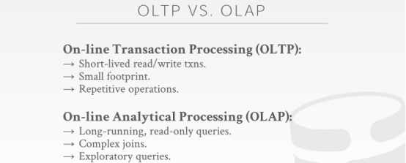

03:26 - 03:33！！！
it's again just as a reminder for what I mean when I say transaction processing, we're just an analytical processing OLTP OLAP
这里要提醒下，当我说事务处理的时候，我讲的是OLTP，当我讲分析处理的时候，我讲的是OLAP
03:33 - 03:35
again I think we've covered this a couple times throughout the semester
我们已经在这整个学期中对此介绍过几次
3.35-3.40
just to reiterate this the dichotomy, so that everyone's on the same page
这里只是重申下它们两者，以确保所有人都能跟上
03:40 - 03:41
and in OLTP workloads
在OLTP workload中
3.41-3.49
we're worrying about operations that are trying to update or read a small amount of data in the database
我们所关心的是那些试着更新或读取数据库中少量数据的操作
03:49 - 03:52
so again using Amazon as an example
So，这里以Amazon为例
3.52-3.53
when you go to the Amazon website
当你访问Amazon网站时
03:54 - 03:55
you add things to your cart
你会往你的购物车中添加东西
3.55-3.56
you make purchases for your account
你会为你账户中的东西买单
3.56-3.57
you update your payment information
你会去更新你的支付信息
03:58 - 04:00
all those operations are transactions
所有这些操作都是事务
4.00-4.04
that are only touching, you know as we know when you invoke those changes
当你执行这些修改时
4.04-4.05
, they're only touching your data
它们只会去接触你的数据
04:06 - 04:08
so the Amazon database is quite large
So，Amazon的数据库是相当大的
04:08 - 04:14
but for your transactions to update you know do your operations the amount of data you're touching is small
但对于你的事务来说，它们更新操作所涉及的数据量非常小
04:15 - 04:16
and essentially
本质上来讲
4.16-4.18
the database system is doing the same set of operations over and over again
数据库系统会去反复执行相同的一系列操作
04:19 - 04:23
because you're going through the website application code
因为当你遍历网站程序代码时
04:23 - 04:26
that you know when you click on you know Add to Cart
当你点击添加到购物车时
04:26 - 04:27
that invokes a function on the application code
它会去调用应用程序中的一个函数
4.27-4.31
which then goes through and execute queries to make those changes
接着，它会去执行这个查询，并应用这些修改
04:31 - 04:32
in OLAP workload
在OLAP workload中
4.32-4.40 !!!!!!!
this is where we're now started doing analytics to try to extrapolate new information from all the data we've ingested on the OLTP side
我们现在开始在其中对数据进行分析，并试着从OLTP端提取的所有数据中推断出新信息
04:40 - 04:42
so again using Amazon as example
So，这里我们再以Amazon为例
04:42 - 04:55
an analytical workload would be something like trying to figure out, what was the most popular item for Carnegie Mellon students during the month of November， when the temperature was you know above 30 degrees
分析型workload指的是，我们要去弄清楚当温度在30度（华氏，即中国的零下一度）以上，CMU学生在11月时购买最多的商品是什么

04:55 - 04.56
so that's not something you do in OLTP
So，不会在OLTP中做这种事情
4.56-5.00
because that's you know that's not a transactional thing
因为这和事务无关
5.00-5.01
,this is something you do in the OLAP side
这是你要在OLAP中所做的事情
05:02 - 05:05
so these workloads are the queries much running longer
So，处理这些workload的时候，查询运行的时间会更长
5.05-5.06
because they're touching more data
因为它们会接触更多数据
05:06 - 05:08
they're doing joins and doing aggregations
它们会去执行join，会去执行聚合操作
5.08-5.11
and oftentimes they are one-off queries
它们有时候会去执行one-off query（一次性查询）
05:11 - 05:14
because someone's trying to say you know answer that question
因为有时候有人会去试着让你回答这种问题
5.14-5.17
oh what's the most bought item for a particular group of people
比如：对于这群人来说，他们买的最多的东西是什么
05:17 - 05:23
and you know they're filling out some dashboard or using a analytical tool to compose the query
他们会去借助某种dashboard或者分析型工具来编写查询语句
05:23 - 05:27
and then firing that off, and maybe the data that may never see that query ever again
当执行了这个查询后，这些数据可能就不会再看到这个查询了
05:27 - 05:29
so again for today's class
So，在今天这节课上
5.29-5.31
we're going to focus on the first part OLTP
我们会将重心放在第一部分OLTP上
5.31-5.33
next class we'll talk about OLAP
下节课我们再讨论OLAP
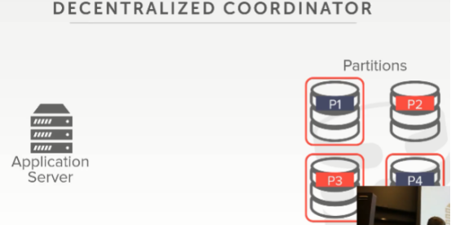

05:34 - 05:40
so the again just to go at a high level to discuss what we're talking about in the distributed database
So，我们会从高级层面来讨论分布式数据库
5.40-5.42
so we're going to focus on today
So，这也是我们今天讨论的重点
05:42 - 05:44
we talked to the set up before
我们之前讨论过这种设置
05:44 - 05:45
we have some partitioned database
这里我们有一些数据库分区
5.45-5.48
whether it's logical partitioning or physical partitioning
这里不管它使用的是逻辑分区还是物理分区
5.48-5.51
meaning is it shared nothing or shared disk
也不去管它使用的是shared-nothing架构还是shared-disk架构
05:52 - 05:55
we you know I'm not explaining just yet
我现在还未对此进行解释
5.55-5.56
it doesn't matter for what we're talking about here today
对于我们今天这里所讨论的东西来说，这都不重要
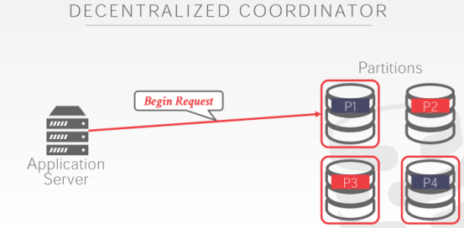

05:57 - 05.59
but the scenario we're concerned about is
但我们所关心的情况是
5.59-6.02
we have an application server that wants invoking transaction
这里我们有一个应用程序服务器，它想去执行事务
06:03 - 06:05
it picks some partition node to be the master one
它会将某个分区节点作为master节点使用
06:05 - 06:08
so it tells that guy hey I want to execute a transaction
So，它告诉这个节点：hey，我想去执行一个事务
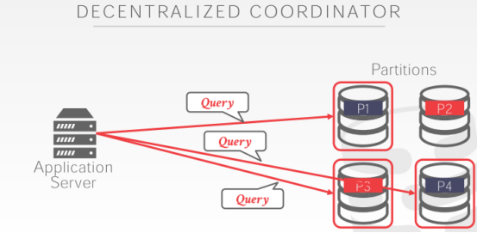

06:08 - 06:13
then it goes ahead and does a bunch of updates or reads a bunch of data on our various partitions
接着，它就会对我们不同分区中的数据进行更新或者读取
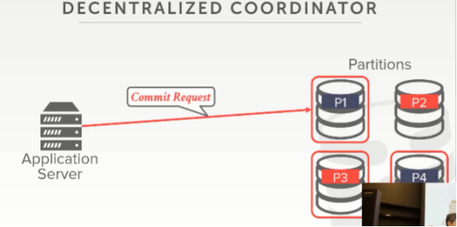

06:14 - 06:15
and then now when a transaction complete
接着，当一个事务完成的时候
6.15-6.17
it goes to the master guy
它就会跑到master节点处
6.17-6.19
that it started off with and says, hey I want to go ahead and commit
并对该节点说：hey，我想提交这个事务
06:20 - 06:22
and assuming this is a decentralized architecture
假设这是一个去中心化架构
6.22-6.24
,meaning we don't have that middleware
这意味着我们并没有那种中间件结构
06:24 - 06:27
we don't have that the TP monitor that's coordinating all our transactions
我们并没有那种用于协调所有事务的TP monitor

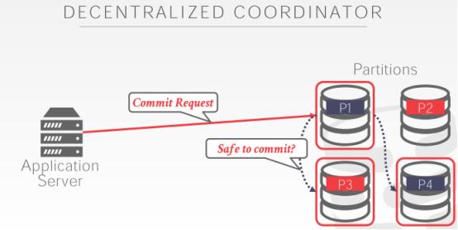

06:28 - 06:33
now these nodes at the figure out amongst themselves whether they're allowed to commit this transaction
这些节点自身就会去弄清楚它们是否能提交该事务
06:33 - 06:37
so last class I was very vague about this step here,
So，在上节课的时候，这一步我讲得很含糊
6.37-6.40
how to determine whether it's safe to commit
即如何判断提交该事务是否是安全的
06:40 - 06:41
and what does it mean
这是什么意思呢？
6.41-6.44
to say hey we're all going to go ahead and commit this transaction
这里表示：hey，我们要去提交这个事务
06:44 - 06:46
so this is what we're primarily going to focus on today,
So，这就是我们今天主要讲的内容
6.46-6.48
this last step here
即这里的最后一步
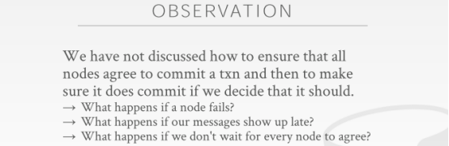

06:49 - 06:51
and so essentially what we're trying to do is
So，本质上来讲，我们试着做的事情是
6.51-6.58
in our database system, we're trying to have all the nodes agree that we should commit a transaction
我们试着让数据库系统中所有的节点都同意我们去提交一个事务
06:58 - 07:00
and if everyone agrees that we commit this transaction
如果所有节点都同意我们去提交这个事务
7.00-7.01
and we go ahead and commit it
我们就会去提交这个事务
07:02 - 07:08
we don't want any sort of nomaly a weird reversal of you know one node-set is gonna commit
我们不想遇上这种奇怪的异常，即一个节点同意我们提交这个事务
07:08 - 07:10
and then an all sudden it doesn't，that transaction got rollback
然后其他节点突然不同意我们提交这个事务，接着该事务被回滚了
07:11 - 07:13
once everyone agrees that we're gonna go to commit
一旦所有节点都同意我们去提交事务
7.13-7.14
, then we go ahead and commit this
那么，我们就会去提交这个事务
07:15 - 07:21
so now there are many issues we have to deal with in order to make this happen correctly and safely
为了让它正确且安全地执行，我们需要处理很多问题
07:21 - 07:23
when we were on a shared everything system
当我们使用的是一个shared-everything系统
7.23-7.26
meaning we our database system was running on a single box
意思是我们的数据库系统是在一个单机环境下运行
07:26 - 07:30
and we wanted to do our you know validation protocol for OCC concurrency control
我们想去使用乐观并发控制（OCC）下的验证协议
07:31 - 07:38
all the participants in deciding whether this things allowed to commit was running together in a single machine
所有用来判断该事务是否能被提交的参与者都是在同一台机器中运行的
07:38 - 07:40
all in the same memory possibly
它们可能都在同一块内存中
7.40-7.44
,and it was really fast and for us to figure out whether we're allowed to go ahead and commit
这能让我们快速弄清楚是否能提交这个事务
07:44 - 07:45
and then if we said commit
接着，如果我们说要进行提交
7.45-7.47
and it truly was committed
该事务就会被真正提交
7.47-7.48
,because we know everything was on that single box
因为我们知道所有东西都是在这个单机环境中的
07:49 - 07:51
but now in distribute environment
但在分布式环境下
7.51-7.52
we have the issue of
我们会有这种问题
7.52-7.53
let's say we go ahead and say to commit
假设我们要去进行提交
07:54 - 07.55
everyone comes back and says we go commit
所有节点都告诉我们，我们可以进行提交了
7.55-7.57
and then maybe I you know during that time
在这段时间里
7.57-7.58
one node goes down
某个节点挂掉了
7.58-8.00
what should happen
这会发生什么呢？
08:00 - 08:03
I know all the same ACID properties we talked about before
我知道我们之前讨论过的所有ACID特性
8.03-8.07
then we don't need partial updates that you're persisting to our database
我们不想让这种部分更新落地到我们数据库的情况发生

08:07 - 08:08
all of those things we have to account for
我们必须解决所有事情
08:09 - 08:10
so if a node goes down
So，如果一个节点挂掉了
8.10-8.11
I've got to deal with that
我必须去处理这个问题
8.11-8.13
but what if the node doesn't go down
但如果该节点并没有挂掉呢？
08:15 - 08:17
and instead our commit messages just shorter show up late
而是我们的commit消息出现的时间晚了点
08:18 - 08:22
right the packet got delayed somehow on the network on the way over
该数据包通过网络传输的时候，延迟了一会
08:22 - 08:24
or which is probably more common say
或者，这里还有一种更常见的情况
8.24-8.29
our database system was you know using the JVM like it's written in Java ,written in Scala ,it's using the JVM
我们的数据库系统是使用Java或Scale之类的语言编写的，它会使用JVM
08:30 - 08:33
and all sudden the JVM decides to do a real expensive garbage collection sweet
突然，JVM决定要进行一次成本很高的垃圾回收时
08:33 - 08:35
and now our process pauses
那么，我们的进度就会被暂停
08:36 - 08:41
and so we're gonna look like we're unavailable while during this GC pass
当JVM在进行垃圾回收的时候，我们的系统看起来就会是不可用的状态
08:41 - 08:43
and then all of a sudden we come back after the GC
当垃圾回收结束后，我们的系统突然恢复了正常
8.43-8.44
and now our messages are arrived
现在，我们的消息到达了
8.44-8.46
,and it's you know a second has passed
你知道的，时间已经过去了1秒钟
08:48 - 08:56
and then what happens if we decide that how we determine, how many nodes have to agree that we're gonna commit a transaction to decide that we committed the transaction
我们该如何判断有多少节点同意我们提交该事务
08:58 - 08:59
Should be all of them, should it be some of them
是所有节点都同意我们提交该事务呢？还是部分节点同意就行了
09:01 - 09:03
right so these the things that we're gonna worry about today
So，这些就是我们今天要关心的东西
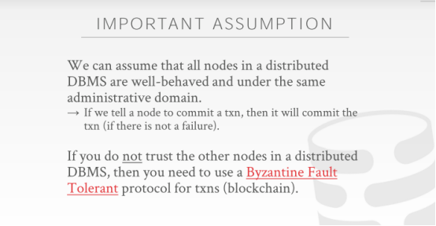

09:04 - 09:09
so one important assumption we're gonna make about this entire lecture
So，在这整节课上，我们要做的一个重要假设是
09:09 - 09:16
is that we are going to assume that the software running on the nodes in our distributed database are our friends
我们会假设运行着我们分布式数据库的那些节点都是友好的，值得信任的，非恶意节点
09:16 - 09:17
meaning gonna be well behaved
这意味着，它们的行为值得信任
9.17-9.19
,they're not gonna trying to screw us over, right
它们并不会搞砸我们的事情
09:19 - 09:23
there it's software that we we as the database system developer
我们作为数据库系统开发人员
9.23-9.24
,software that we wrote
是我们编写了这些软件
09:25 - 09:27
and that we've deployed on the same administrative domain
我们会将这些软件部署在同一个管理域之下
09:27 - 09:31
so we asked a transaction, we asked the node to commit a transaction
So，当我们让一个节点去提交一个事务时
9.31-9.33
,and they come back so yeah we're going to commit that
它们就会回过头来跟我们说：我们会去提交这个事务
09:33 - 09:39
we assume you know a modulo hardware failure or you know software bug
假设我们遇上了一个硬件故障，或者是软件bug
09:39 - 09:41
we assume if a node tells us they're going to commit a transaction
假设一个节点告诉我们，它们要去提交一个事务
9.41-9.43
they will commit that transaction
那么，它们就会去提交一个事务
09:44 - 09:44
all right
9.44-9.48
that's going to simplify in some ways how we're gonna do our commit protocol
某种程度上，这会简化我们的提交协议
09:48 - 09:51
if you assume that the nodes could be bad actors
如果你假设这些节点是些糟糕的演员（知秋注：比如伪造的节点）
09:52 - 09:55
right if they say yeah we committed that，with our screw you we're not actually do that
如果它们表示它们提交了这个事务，但实际它们并没有提交
09:56 - 9.58
then you don't need some of the things we'll talk about today
那么，你就不需要用到我们今天所谈论的部分东西
9.58-10.01
you actually need what it's called a byzantine fault tolerant protocol
实际上，你需要用到一种叫做Byzantine fault tolerant协议的东西
10:01 - 10:04
and this is essentially what the blockchain is under Bitcoin
本质上来讲，这就是比特币中的区块链
10:05 - 10:09
Right, a blockchain is essentially just a distributed database
本质上来讲，一个区块链就是一个分布式数据库
10:09 - 10:12
it's just a log you append things but transactions
它其实就是一个日志，你往日志中追加的就是这些事务
10:12 - 10:14
but in that environment you soon
但在这种环境下
10.14-10.16
,because there's Bitcoin mining right or whatever you're trying to do
你们要去挖比特币或者干类似的事情
10:16 - 10:20
that the participants in your distributed database are not your friend
在这个分布式数据库中的其他参与者并不是你信任的节点
10.20-10.22
and they can lie to you
他们可以对你撒谎
10:22 - 10:23
so you need a way to deal with that
So，你需要一种能够处理它的方式
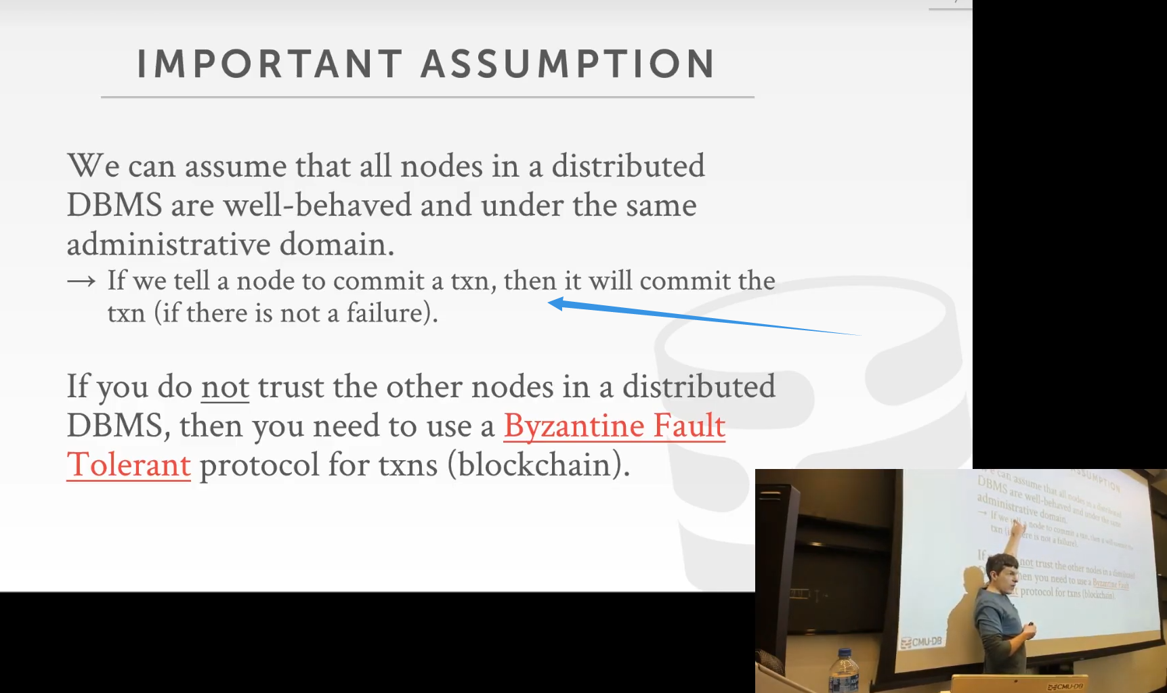

10.23-10.25
we are not in that world
我们并不是处于这种环境下（彼此信任的环境下）
10:25 - 10:28
most DBMS, distributed DBMS are not in this world
大部分DBMS，或者说分布式DBMS都不是处于这种环境下的
10:28 - 10:33
most DBMS can assume that everybody is gonna play alone Correctly
大部分DBMS都会假设所有人都会独自正确地执行操作
10:35 - 10:36
most people don't need a blockchain
大部分人都不需要用到区块链
10.36-10.38
very few things need a blockchain
很少地方才会需要用到区块链
10:38 - 10:39
so if you think you're building something and you use a blockchain
So，如果你在构建某个东西的时候用到了区块链
10.39-10.42
you rethink your life ,okay
你要重新思考下你的做法
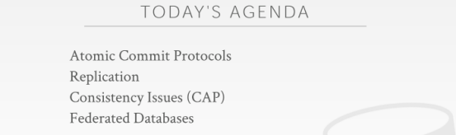

10:43 - 10:44
all right

10.44-10.47
so the things were talked about today are listed here
So，这里列出的就是我们今天要讨论的东西
10:47 - 10:49
so yeah I didn't say this last class I wanna sort of say it again
So，有些东西我们上节课并没有讲，但我今天要讲
10:50 - 10:52
I'm trying to cover in three lectures
我会试着用三节课的时间来对此进行介绍
10.52-10.57
what would normally be like an entire year of studying distributed databases
通常这三节课要讲的东西相当于你花一整年来学习分布式数据库要学的知识
10:57 - 10.59
so we can't obviously cover everything in detail
So，我们显然没法详细地介绍所有东西
10.59-11.09
and I consider my goal here so just to expose you to like the issues, the problems, the difficulties of building a distributed database, even using a distributed database system
这里我的目标就是向你们展示构建分布式数据库或者使用分布式数据库时所遇见的那些问题和难点

11:09 - 11:12
so that you know when you leave CMU and you go out in the real world
So，当你离开CMU，踏入社会的时候
11:12 - 11:17
if you find yourself in a situation where you think you either need a distributed database
如果你发现你需要用到分布式数据库时
11:17 - 11:20
or you think you want to build one,
或者你想去构建一个分布式数据库时
11.20-11.22
usually know what are the issues you should be thinking about and
通常你应该去考虑我列出来的这些问题
11:22 - 11:25
so you can reason about you know whether you're doing the right thing
So，你可以推断出你做的事情是否正确
11:26 - 11:27
and also to say upfront
这里我要提前说的东西是
11.27-11.29
that most people probably don't need distributed database,
大部分人可能不需要分布式数据库
11.29-11.32
there's obviously some useful cases
显然，这里有些有用的案例
11:32 - 11:34
but I would say I mean I can't prove this
但我的意思是我无法证明这一点
11.34-11.37
but 90% of the world's databases comes running on a single box
但世界上90%的数据库系统都是在单机环境下运行
11:37 - 11:41
now I should have replication and once you bring that in that becomes a distributed database
现在对于该数据库，我应该拥有复制（replication）容错的功能，一旦你想将此功能引入，你的数据库就会变为一个分布式数据库
11:41 - 11:42
but most the times
但大多数情况下
11.42-11.42
you don't need a partition database
你无须对数据库进行分区
11.42-11.47
most workloads can be handled on a single box
大部分workload可以在单机环境下进行处理
11:47 - 11:51
right alright so let's talk about atomic commit protocol
So，我们来讨论下原子提交协议
11.51-11.52！！！！！！
is how do you get everyone to agree that we're gonna commit
我们如何让所有人都同意我们去提交事务呢？
11:53 - 11:56
how do we handle replication to make sure that we have multiple copies of our data
我们该如何去进行replication (复制)，以保证我们拥有多个数据副本
11:56 - 11:58
so we can always stay online
这样，我们的服务就可以一直在线了
11:58 - 12:00
then we'll get into the CAP theorem I'm talking about consistency issues
然后，我们会深入CAP定理，我会去聊一致性问题
12:00 - 12:08
how do we you know what kind of guarantees can distribute database, and provide for us given our commit protocol
这个一致性协议是用来保证我们分布式数据库提交的
12:08 - 12:12
and then we have time at the end well quickly talking about federated databases
如果我们在最后有时间的话，我们可以快速讨论下联合数据库
12:12 - 12:15
the idea of composing distribute databases together, and to make a single database instance
它的思路是将分布式数据库放在一起让它变成单个数据库实例
12:16 - 12:16
okay
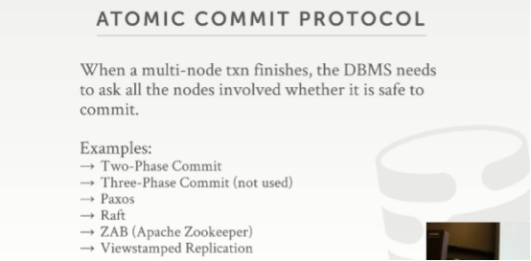

12:18 - 12:23
alright so that example I showed in the beginning of when we went to go ahead and commit the transaction
在一开始，我通过ppt中examples展示的这些东西，我们可以借助它们来实现分布式事务的提交，首先，当我想要提交事务的时候，
12:23 - 12:26
and then the the one know how to talk to the other nodes
接着，某个节点知道该如何与其他节点进行通信
12.26-12.27
and say hey is it safe to commit
并说：现在提交事务是否安全？
12:28 - 12:31
this is what is called an atomic commit protocol
这种东西叫做原子提交协议
12:31 - 12:32
the idea here is that
这里的思路是
12.32-12.41
we want to get everyone's feedback that participated in our transaction to decide ,whether it's okay to commit that transaction
我们想收到参与该事务的所有人的反馈，以此来判断是否能够提交该事务
12:41 - 12:46
and then if one node or enough nodes depending what protocol are using
取决于我们使用的协议
12:47 - 12:54
if a certain amount of nodes above the threshold that we're gonna define in our protocol all agree that we should commit this transaction
如果一定数量的节点都同意我们去提交这个事务（节点数量超过我们协议中所定义的阈值）
12:54 - 12:56
then we tell everyone we will commit this transaction ,
然后，我们会告诉所有节点，我们会提交这个事务
12.56-12.59
and then it becomes committed
那么，这个事务就会被提交
12:59 - 13:03
so there's a bunch of different variants of atomic commit protocol ,that you can use
So，你可以去使用原子提交协议的很多变种
13:03 - 13:06
so the two that we're going to focus on is two-phase commit and Paxos
So，我们的重心是其中两种，即两阶段提交和Paxos
13.06-13.08
two-phase commit is probably the most prevalent one
两阶段提交可能是其中最流行的一种
13:09 - 13:11
right goes back into the 1980s
在1980年代
13.11-13.14
paxos has certain guarantees that two-phase commit cannot provide
Paxos提供了一种两阶段锁无法提供的保证
13:15 - 13:16
some systems can use this
有些系统使用了Paxos
13.16-13.20
,but it's this is sort of a degenerate case of this
但两阶段提交其实是Paxos的降级版
13:20 - 13:21
there's also a three-phase commit
这里还有一个三阶段提交
13.21-13.23
that was actually developed by Mike Stonebraker
实际上，它是由Mike Stonebraker所开发
13.23-13.25
the guy had invented Postgres in the 1980s
他在1980年代发明了PostgreSQL
13:25 - 13:27
no one actually ever does this
实际上没有人使用这种三阶段提交
13.27-*13.31
there's too much you know too much network traffic
你知道的，因为网络流量太大了
13:31 - 13:34
there's actually a four phase commit as well from Microsoft
实际上，这里还有微软所提出的四阶段提交
13.34-13.37
they using in this distributed database called FaRM
他们在一个叫做FaRM的分布式数据库中使用了这个
13:37 - 13:38
they have to do that
他们必须这么做
13.38-13.41
because they're using RDMA sort of special remote memory access
因为他们使用了RDMA（远程内存访问）这种东西
13.41-13.42
again we're not going to cover that
我们这里不会去介绍它 （知秋注：若想了解，可以前往simviso翻译的MIT 6.824分布式系统）
13:43 - 13:44
okay Paxos
Ok，我们讲完了Paxos
13.44-13.50
so we'll talk about raft is was developed by Stanford about ten years ago
So，Raft是十年前由斯坦福的人所开发出来的东西
13.50-13.54
, as a more easily understood variant of paxos
它是Paxos的一种更简单易懂的变体
13:54 - 13:55
but it basically provides the same guarantees
但基本上来讲，它提供了与Paxos相同的保证
13.55-13.59
, raft actually shows up a lot more often in newer distributed systems
实际上，Raft在一些较新的分布式数据库系统中出现的次数非常多
13:59 - 14:04
because there's a lot of existing or that people basically wrote like Lib raft, right
因为有很多人写了像Raft之类的库
14:05 - 14:06
they were at libraries that implement raft
有一些库实现了Raft
14.06-14.11
that you can then incorporate into their database for a ton of different languages,
你可以使用不同的编程语言将Raft放入你们的数据库中使用
14.11-14.13
like there's no Lib Paxos that everyone can use
但并没有那种可供使用的Paxos库
14:13 - 14:16
Zab was developed for Apache zookeeper
Zab则是为Apache ZooKeeper所开发的
14:17 - 14:19
and the viewstamped replication is not that common
Viewstamped Replication并不常见
14:19 - 14:23
but this actually turned out to be the first purely correct atomic commit protocol
但实际上，它被认作是第一个真正正确的原子提交协议
14.23-14.25
, it actually came out before Paxos
实际上，它在Paxos之前出现
14:25 - 14:30
but people didn't recognize that the properties of this thing had until paxos came along much later
但人们直到Paxos出现很长一段时间后，才认知到Viewstamped Replication的特性
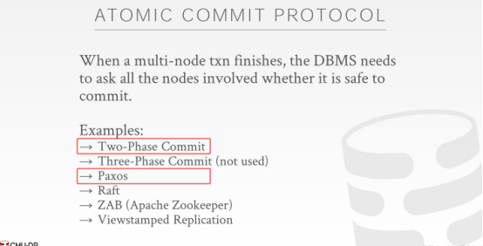

14:30 - 14:34
so again for distributed databases that are not the blockchain
So，对于那些非区块链的分布式数据库来说
14.34-14.38
that are actually you probably an encounter in the real world
实际上，你们可能在现实生活中已经遇到它们了
14:38 - 14:41
use mostly you most likely see two-phase commit or paxos
你们最常见的可能就是两阶段提交或者Paxos
14:41 - 14:43
and then from new system apply raft
对于那些新系统来说，它们会使用raft
14.43-14.43
,but for this lecture
但在这节课上
14.43-14.45
I will just cover those two there
我只会去介绍其中的两个
14.45-14.47
they're the two phase commit and Paxos
即两阶段锁和Paxos
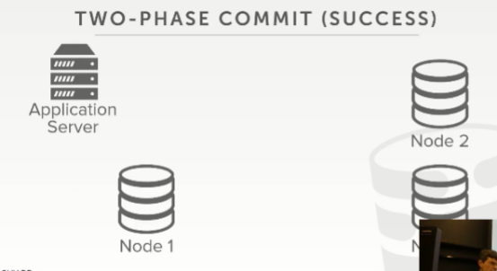

14:48 - 14:51
so actual quick show of hands who here has ever heard of two-phase commit before
So，你们之前有谁听过两阶段提交，快速举下手，让我看下
14:51 - 14:53
alright,less than half okay
看来只有不到一半的人知道
14:54 - 14:59
so two-phase commit sounds exactly the way you know it sounds like it's a two-phase commit protocol has two phases
So，两阶段提交的意思就如同它名字一样，它有两个阶段
15:00 - 15:01 ！！！！！！
so let's look an example here
So，我们来看个例子
15.01-15.04
where we're gonna have everyone agreed to commit a transaction
在所有节点都同意我们提交事务的情况下，我们才会提交事务
15:04 - 15:05
so assume at this point
So，假设在此时
15.05-15.11
the application server has executed whatever queries that it wants to make changes on the database
应用程序服务器执行了一些查询，这些查询想对数据库中的数据进行修改
15.11-15.14
or read whatever data once on our different nodes
或者去读取我们不同节点中的数据
15:14 - 15:16
and it wants to go ahead and commit
接着，它想去提交该事务
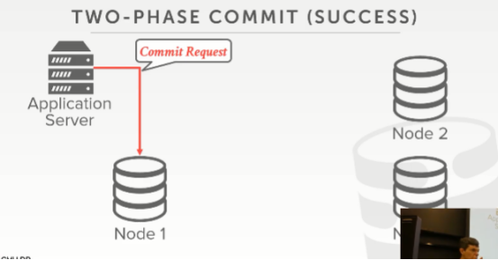

15:16 - 15:19
so it's gonna send a commit message to this guy here
So，应用程序服务器会发送一条commit消息给这个节点
15.19-15.20
,assume this is the master node
假设这是一个master节点
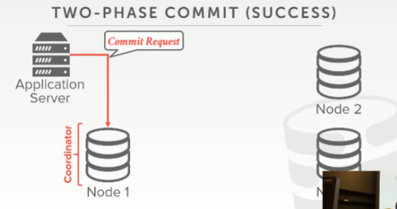

15:21 - 15:23
so under two-phase commit
So，在两阶段提交中
15.23-15.26
a vernacular we are gonna say this guy is going to be centered the coordinator
这里我们假设节点1是协调器
15:26 - 15:33
so that's in charge of asking around to its friends involved in the transaction ,whether it's allowed to commit this transaction
So，它的作用就是询问涉及该事务的其他同伴，它是否能提交该事务
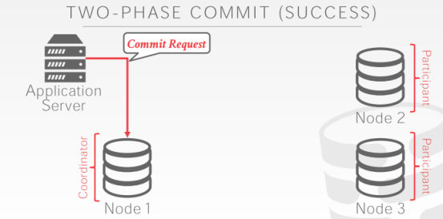

15:34 - 15:36
and then the other two nodes here we call participants
接着，这里的两个节点我们将它们称为参与者（participant）
15:37 - 15:39
now I'm not going to show examples of this,
我不会去展示这个例子
15.39-15.44
but the node that participant node itself can also be a participant
但node1节点自身也可以是一个参与者
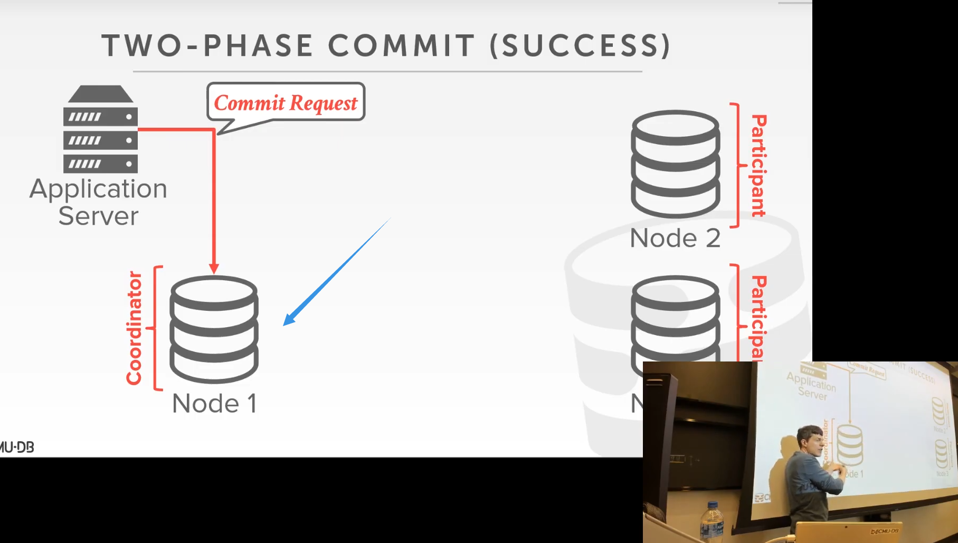

15:44 - 15:48
right this node here could also have been modified by this transaction
假设这个节点中的数据已经被该事务所修改
15:48 - 15:50
and then it's involved in this two-phase commit process
那么，它就会参与到这个两阶段提交的过程中
15.50-15.52
or simplicity assume
或者，我们简单假设下
15.52-15.56
that this transaction here only modified data on the two other nodes
该事务只修改了其他两个节点上的数据
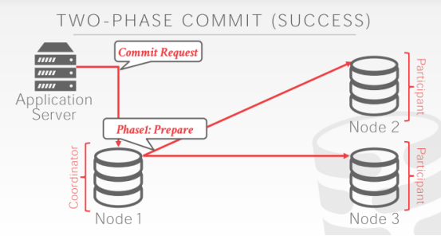

15:58 - 16:00
so in the first phase called prepare phase
So，第一个阶段叫做准备阶段
16:00 - 16:06
we sent out a network message to our participants from the coordinator to participants
我们会让协调器发送一条网络消息给该事务的参与者
16.06-16.08
to ask them hey here's this transaction, we think you know about it
并告诉它们，这里有一个事务，我们觉得你们应该知道这个事务
16:09 - 16:11
is it okay to commit
我们是否能提交该事务呢？
16:11 - 16:14
and they're gonna do whatever validation
这两个节点就会执行某种验证
16.14-16.16
, or whatever they need to do to determine whether this transaction allowed to commit
它们就需要去决定这个事务是否允许被提交
16.16-16.18
and if they determine that it's okay
如果它们决定提交该事务是ok的
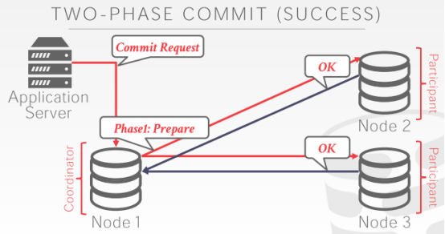

16:18 - 16:21
then they send back an okay message
那么，这两个节点就会返回一条OK消息
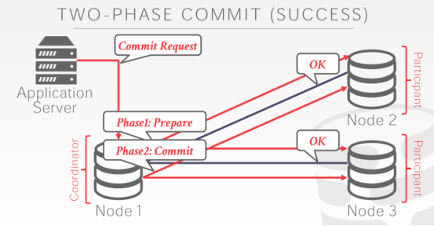

16:22 - 16:25
then now once you get back the okay's from all the participants
一旦你收到了来自所有参与者所发送的OK消息
16.25-16.29
, the coordinator goes into the second phase called the commit phase
协调器就会进入第二个阶段，即提交阶段
16:29 - 16:36
where it tells the all the participants hey good news ,everybody said we can commit this transaction go ahead and commit this
它就会告诉该事务的所有参与者：hey，这里有个好消息，我们可以提交该事务。然后，它就提交了这个事务
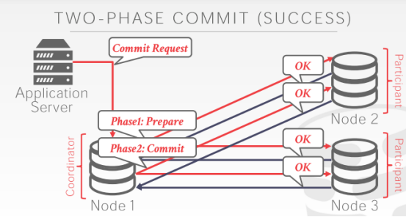

16:36 - 16:38
and then likewise
接着，同样
16.38-16.39
these guys now have to send a response
这些参与者现在必须发送一个响应给协调器
16.39-16.41
, and say okay we did that this transaction is committed
并说：Ok，我们已经提交了这个事务
16:41 - 16:43
and then at this point here
接着，在此处
16.43-16.47
when we get back and in the second phase ,the okay's from all our participants
当我们处于第二阶段时，收到了所有参与者所发送的OK消息
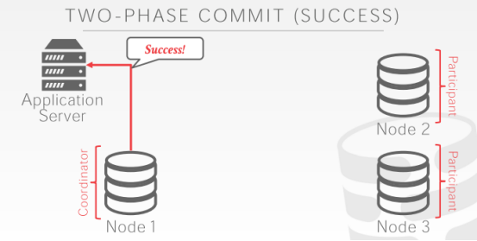

16:47 - 16:51
we can then go tell the outside world that our transaction has successfully committed
那么，我们就可以告诉外界，该事务已经被成功提交了
16:54 - 16:56
so there's one thing I'm not showing here
So，这里我有一个东西并没有展示出来
16.56-16.58
and I think that the textbook talks about this
我觉得教科书讨论了这个东西
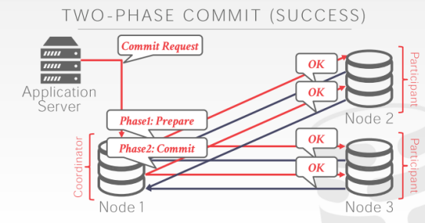

16:59 - 17:03
is that at every step of the protocol on every single node involved in it
在执行该协议的每一步骤时，对于参与事务的每个节点来说
17:04 - 17:10
we're writing out log messages to keep track of what messages we got and what responses we sent out
我们会记录下日志消息，以此来跟踪我们收到了哪些消息，以及我们发出了哪些响应
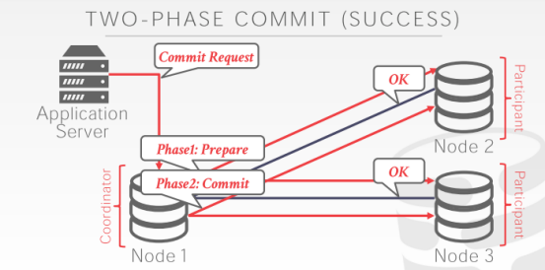

17:11 - 17:12
so at this point here
So，在此处
17.12-17.15
when I sent hey we'll go ahead and commit this
当我说我们要提交这个事务时
17:15 - 17:16
these guys are gonna write a log message
这些节点就会写下一条日志记录
17.16-17.18
, and say hey for this transaction,
并表示，在这个事务中
17.18-17.20
I saw I entered the commit phase,.
我进入了提交阶段
17.20-17.21
and I said that was okay to do
该节点表示提交该事务是Ok的
17:23 - 17:25
right so that way if we crash and come back
So，如果我们遇上系统崩溃，并进行回滚恢复
17.25-17.27
we would say oh we were involved in this transaction
我们就会说：Oh，我们之前参与过这个事务
17:28 - 17:33
how far and in the two-phase commit process did we get to determine whether we need to undo it or redo it
并且我们知道我们执行该事务的进度到哪里了，我们可以去决定我们是否要撤销该事务所做的修改，或者是重新执行该事务
17:36 - 17:38
and so another point distinguish about this
So，这里有一点要区别一下
17.38-17.39
and this will differ from Paxos
这与Paxos不同
17.39-17.40
and a few more slides is that
我们会通过一些幻灯片来讲这个
17:41 - 17:46
all of the nodes prevent all participant nodes in the commit protocol for this transaction
对于两阶段提交协议中所有参与该事务的节点来说
17:46 - 17:49
they all have to say we have to commit this transaction
它们全员必须表示：我们需要提交这个事务
17:50 - 17:52
it's either everyone or no one
要么全员同意，要么一个都不同意
17:55 - 17:56
so we go to the next sample here
So，我们来看下一个例子
17.56-17.58
when we already have an abort
即当我们遇上事务中止的话，这会怎么样呢？
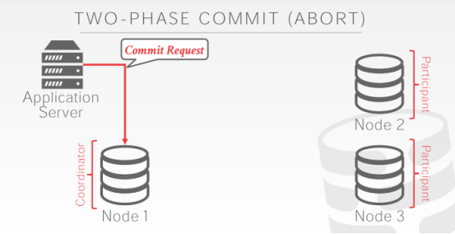

17:58 - 18:00
it's again the same thing transaction finishes
这里同样，事务执行结束
18:00 - 18:02
I send a commit request to my coordinator
我发送了一个commit请求给我的协调器
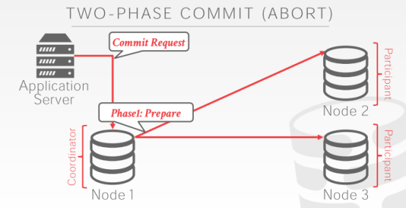

18:03 - 18:04
the coordinator enters the first phase
协调器进入了第一阶段
18.04-18.07
sent the prepare message to the participant nodes
它向参与者节点发送了prepare消息
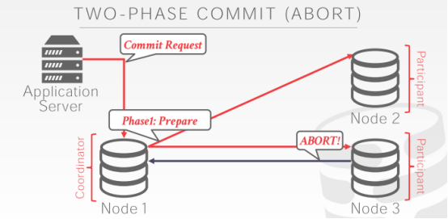

18:07 - 18:14
let's say this bottom guy here for whatever reason, you know for its concurrency control protocols ,the size that we cannot commit this transaction
假设节点3不知道出了什么问题导致我们无法提交这个事务
18:15 - 18:17
so it sends back an abort message
So，它返回了一条abort消息
18:18 - 18:22
so as soon as the coordinator gets the first abort message from any of the participants
So，一旦协调器收到了来自任意参与者节点所发送的第一条abort消息
18:22 - 18:24
it is no longer in the prepare phase
协调器就不会再处于准备阶段了
18.24-18.27
and now it immediately goes into the next phase
它现在就会立刻进入下一阶段
18.27-18.28
in this case we're for the abort
在这个例子中，我们来看下中止阶段
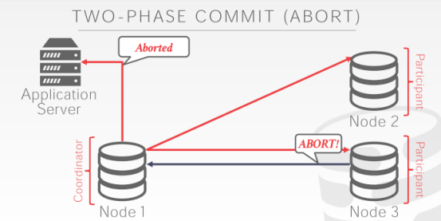

18:29 - 18:30
and so at this point
So，在此时
18.30-18.36
we can really go back to our client our application ,and say hey this transaction can't finish we're going to abort
我们会告诉我们的应用程序，并说：这个事务无法结束，我们会中止该事务
18:36 - 18:40
even before we and go to the second phase or even from before we hear back from anybody else
在我们进入第二阶段之前，或者在我们收到来自任何参与者返回的消息之前
18:40 - 18:42
one abort message will kill this entire thing
一条abort消息就会干掉这整个过程
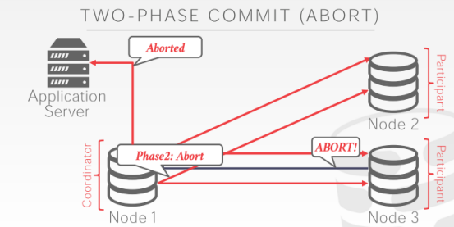

18:43 - 18:45
so now in the abort phase
So，在中止阶段中
18.45-18.46
we say hey we're aborting this
我们表示：hey，我们中止了这个事务
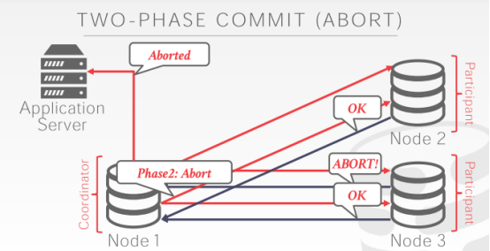

18:46 - 18:49
and then everyone comes back says okay we've aborted
然后，每一个参与者都会返回响应，说，OK，我们已经中止了
18:50 - 18:52
and at this point the the transaction is done
在此时，这个事务就完事了
18:54 - 18:59
so the idea is here that we need to network round trips to get everyone to agree that were to commit this transaction
这里的想法是，我们需要通过网络来让每一个参与者都同意提交这个事务
18:59 - 19:04
and then we go ahead and our commit or abort this transaction ,and we go ahead ,and then apply that change, yes
然后，我们就可以去提交或中止这个事务，同意，那就落地这个事务所发生的修改（知秋注：日志先行！）
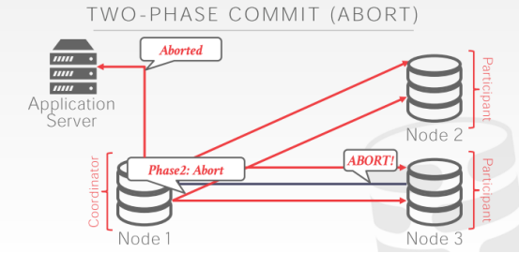

19:11 - 19:20
so this question for the abort commit, the question is do I need this second round here, to tell that the, do I need to go to the nodes here and say yes you've committed ，
他问的是我在这里是否需要发起第二轮请求，我是否需要去这里这些节点处，告诉它们，说，yes ，你已经提交了
19:20 -19:23
Before I tell the application run before I tell who
这个请求是在我告诉Application Server你可以继续运行之前，还是在我告诉这些节点之前？

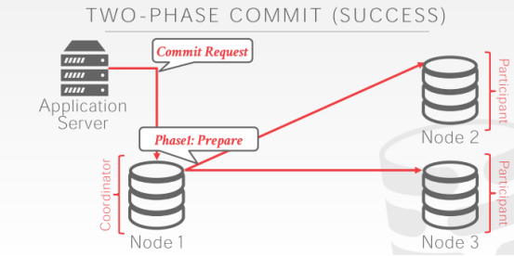

19:34 - 19:39
Right ,so his question is same here ,I'm in the prepare phase this rule action should commit
他的问题同样在这里，在准备阶段，这里的规则动作是是不是准备好提交了
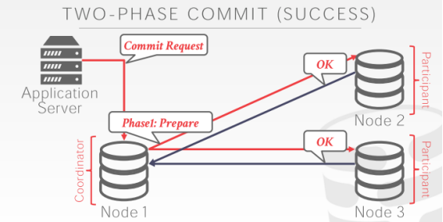

19:39 - 19:43
a semi semi prepare request these guys send back okay
如果准备好了，那这些节点就会返回OK
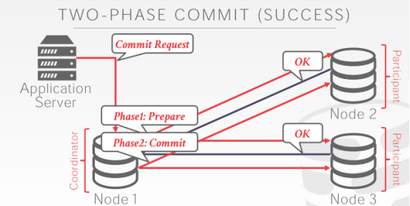

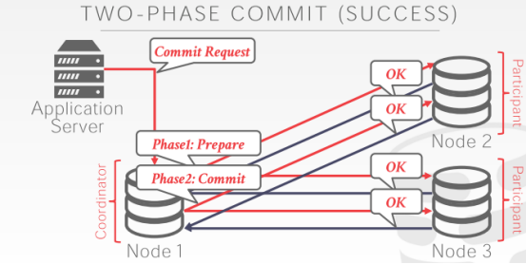

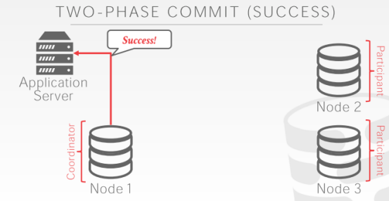

19:45 - 19:53
is do I really need to wait for the next round trip to say ,okay go ahead and commit this and get here back from them ,before I can tell the application I need to commit
在我要告诉Application Server我已经提交之前，我是否真的需要去等下一轮请求去问到底落地了没，并从它们那里得到肯定的回答
19:54 - 19:59
in practice no, for absolute correctness ,yes
在实际生产中，no！不需要等待，真实状况就是这样，毋庸置疑！

